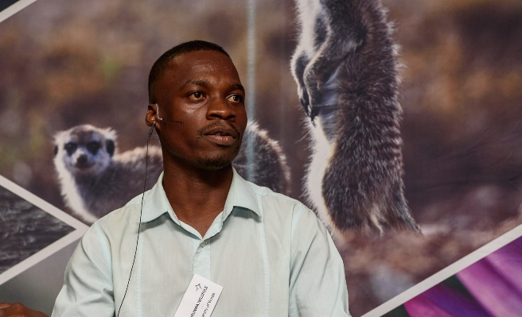

Title: Insectivorous bat diversity in relation to proximity and type of water source in the Limpopo Valley, South Africa
Name: Murunwa Nelufule
Uiversity Of Mpumalanga School of Biology and Environmental Sciences, Nelspruit 1200

Water availability plays an important role in the habitat requirements of bats. Previous studies have shown that water bodies (both natural and artificial) are used by bats and other animals for drinking water and foraging. I collected my data in the semi-arid landscape of the Venetia Nature Reserve (VNR) and the Mapungubwe National Park (MNP) which is bordered by the Limpopo River. I sampled bats acoustically for 25 nights in total at VNR and MNP, and in three austral seasons (autumn, winter and summer). A total of 12957 bat echolocation calls were recorded and 23 different species were identified. The species were of the families Vespertilionidae, Molossidae, Emballanuridae, Miniopteridae and Rhinolophidae. Mops condylurus, Chaerephon pumilus, Rhinolophus smithersi were the most commonly recorded species at MNP, while Neoromicia capensis and Mops condylurus were the most commonly recorded species at VNR. The rarefaction analysis showed no difference in the estimated richness between MNP and VNR. However, sites at artificial water bodies had a higher species richness and diversity compared to sites 500-750 m away at VNR. MNP did not exhibit such a trend, likely because all sampling sites were not more than two kilometers away from the Limpopo River. These results show both the importance of riparian habitats (contributing to higher diversity and activity associated with proximity to the Limpopo River) and how important artificial water bodies are for bats in semi-arid habitats. Although not the focus of this study, I also opportunistically obtained data on the importance of Baobab (Adansonia digitata) trees as roosting sites for three species of insectivorous bats as well as a source of food (nectar) for insects which attracted insectivorous bats in the study area. My results illustrate that MNP has higher overall bat diversity and activity compared with VNR, probably because of its proximity to the Limpopo River. My results also support the notion that artificial water bodies provide important foraging habitat for a number of species in arid landscapes. VNR and MNP are protected areas where future research about the biology, morphology and behaviour of bats which are biological indicators should take place in order to improve the understanding of challenges such as climate change.

Biography

I am a young and coming researcher who just completed my masters degree. I am a hardworking, honest polite and friendly individual that is able to work independently in busy environments, as well as within a team. I am outgoing and tactful, and able to listen effectively to solve problems. I would like to pursue a career in the sciences that allows me to develop skills for rigorous scientific research, while also learning about new technologies and research subjects.

Presenting author details
Full name: Murunwa Nelufule
Contact number: +27764299592/murunwanelufule@gmail.com
Twitter account:@murunwanelufule
Linked In account: N/A
Session name/ number: Murunwa
Category: Oral presentation

