Sustainable harvesting, conservation and analysis of genetic diversity in Polygonatum verticillatum Linn.
Anchal Rana
Division of Genetics & Tree Propagation
Forest Research Institute, Dehradun 248 195, Uttarakhand
(anchalrana001@gmail.com)
Abstract
Indian Himalayas with their diverse climatic conditions are home to rare and endangered medicinal flora. One such species is Polygonatum verticillatum Linn., popularly known as Solomon’s Seal. Its mention as an incredible medicinal herb comes from 5000 years ago in Indian Materia Medica as a component of Ashtavarga, a poly-herbal formulation comprising of eight herbs illustrated as world’s first ever rejuvenating nutraceutical food, which is now commercialised in the name ‘Chaywanprash’. It is an erect tall (60 to 120 cm) perennial herb with sessile linear leaves and white pendulous flowers. The species grows well in altitudes ranging from 1600 to 3600 m amsl, and propagates mostly through rhizomes. The rhizomes are potential source for significant phytochemicals like flavonoids, phenolics, lectins, terpenoids, allantoin, diosgenin, β-Sitosterol and quinine. Having profound concentrations of macro and micro nutrients, species has fine prospects of being used as a diet supplement. However due to unscientific and gregarious uprooting, it has been assigned status of ‘Vulnerable’ and ‘Endangered’ according to IUCN Red-List Criteria. Further, destructive harvesting, land use disturbances, heavy livestock grazing, climatic changes and habitat fragmentation have substantially contributed towards anomaly of species. It therefore became imperative to conserve diversity of the species and make judicious use in future research. A Gene Bank was therefore established at High Altitude Herbal Garden of Forest Research Institute, Dehradun, India situated at Chakarata (30⁰42’52.99’’N, 77⁰51’36.77’’E, 2205 m amsl) consisting 149 accessions collected from thirty one geographical locations spread over three Himalayan States of Jammu and Kashmir, Himachal Pradesh and Uttarakhand. The present investigations purport towards sampling and collection of divergent germplasm followed by planting and cultivation techniques. The ultimate aim is thereby focussed on analysing genetic diversity of the species, and capturing promising genotypes for carrying out further genetic improvement programme so to contribute towards sustainable development.
Key words : Polygonatum verticillatum Linn., phytochemicals, genetic diversity, conservation, gene bank
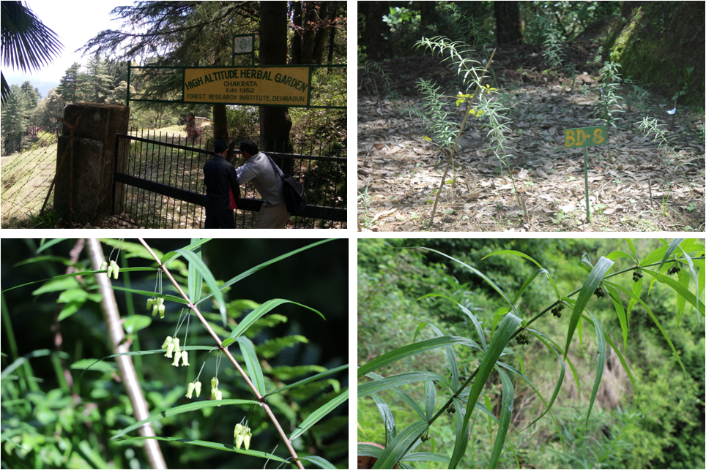

- Balkrishna A, Srivastava A, Mishra R K, Patel, S P, Vashistha R K, Singh A, Jadon V, Saxena P (2012) Astavarga plants –Threatened Medicinal Herbs of The North-West Himalaya. Int. J. Med. Arom. Plants, 2(4) : 661-676.
- Bhatt D, Kumar R, Tewari L M, Joshi G C (2014) Polygonatum cirrhifolium Royle and Polygonatum verticillatum (L.) Allioni : Status assessment and medicinal uses in Uttarakhand. Indian J. Medicinal Plant Research, 8 (5): 253-259.
- Khan H, Saeed M, Muhammad N, Ghaffar R, Khan S A, Hassan S (2012) Antimicrobial activities of rhizomes of Polygonatum verticillatum : attributed to its total flavonoidal and phenolic contents. Pak J Pharm Sci, 25: 463–467.
- Lohani N, Kumar R, Tiwari L M, Joshi G C (2012) Ex-situ conservation of Polygonatum verticillatum (L.) Allioni under different types of organic treatments. International J. Biodiversity and Conservation, 4 (1): 22-31.
- Sharma B D, Singh L, Kaur M J (2014) Nutritional Composition of Rare Himalayan Herbs Constituting the World’s First Health Food. International Journal of Agriculture and Food Science Technology, 5(2) : 75-80.

