Strengthening indigenous informal seed systems in Southeast Asia
Ricky M. Bates, PhD, Penn State University, USA

Seed is a fundamental agriculture input and access to locally adapted, quality seed is an essential component of sustainable crop production. In much of the developing world, informal seed systems, such as farmer-to-farmer exchanges and farmer self-saved seed, are critical components of resource poor farming systems. Indeed, planted seed from this informal system comprise the majority of planted acreage in many regions of the world. This local seed production and distribution facilitates maintenance of crop biodiversity by preserving in situ locally adapted varieties and by broadening the genetic base of production with multiple varieties adapted to specific production systems and micro-climates. These informal seed systems are also critical for seed and food security during periods of instability or natural disaster, including changing environmental conditions. A rich diversity of underutilized species function within informal seed systems in Southeast Asia, and represents a valuable resource for the development and improvement of crop species. Current efforts to conserve, improve, and disseminate indigenous species are failing or insufficient. To optimize these informal seed systems, research has been conducted to better understand their germplasm characteristics, distribution pathways and gatekeepers, and to improve local stakeholder access to seed information and value chains. Research and extension projects to conserve and promote neglected and underutilized species within these informal seed systems have resulted in 1) surveys of key indigenous crops and collection of local crop knowledge, 2) training and development of regional community-based seed banking enterprises, 3) seed quality conferences including seed exchange activities, and 4) improved human and institutional capacity, strategically focused on entrepreneurial women.

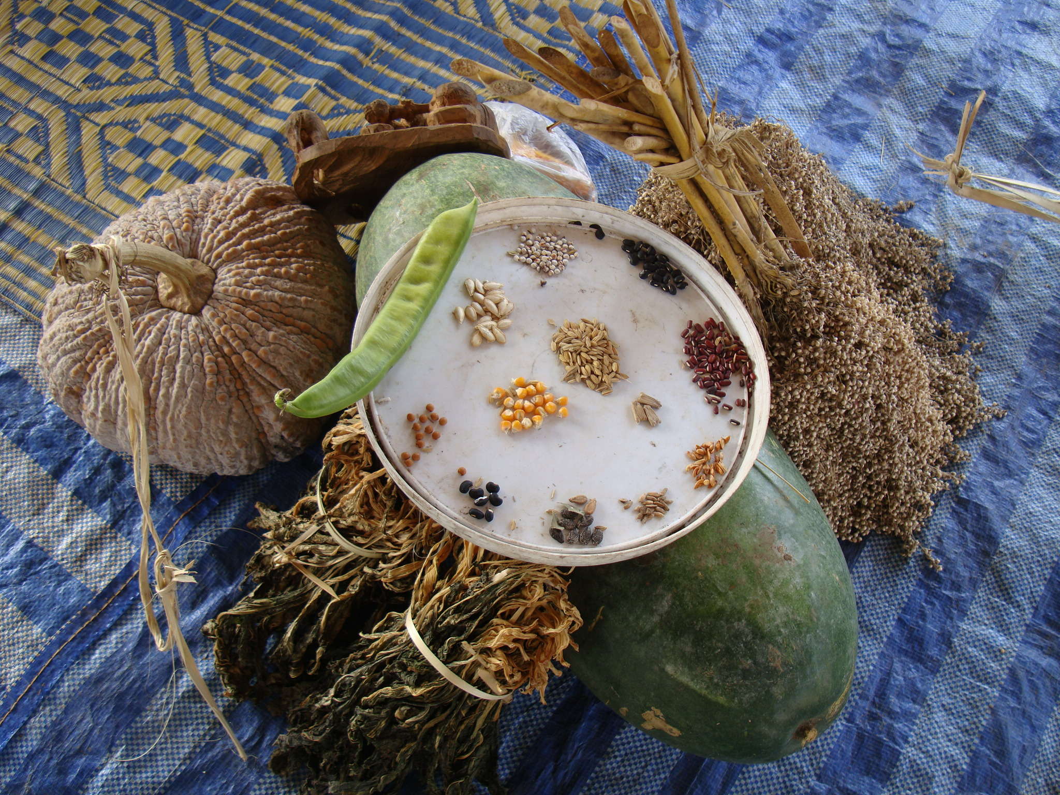
- Tobin, D., R. Bates, M. Brennan and T. Gill, 2016, “Peru Potato Potential: Biodiversity Conservation and Value Chain Development” Renewable Agriculture and Food Systems, pg. 1-14
- Bicksler, A.J., Bates, R.M. and Burnette, R.R., 2016, “The current and future roles of the small farm resource center in horticulture extension and advisory services: lessons learned from seven case studies in SE Asia,” Acta Hortic. 1129, 111-116
DOI: 10.17660/ActaHortic.2016.1129.16
- Chien-Chih Chen, R.M. Bates and J Carlson, 2014, “Effect of environmental and cultural conditions in medium pH and plant growth performance of Douglas-fir (Pseudotsuga menziesii) shoot culture,” F1000 http://f1000research.com/articles/3-298/v1
- Bates, R.M., T. Gill, A. Bicksler, L. Meitzner Yoder, R. Burnette and V. Ricciardi, 2013, “Designing strategies and systems to identify, preserve and promote underutilized indigenous crop species. Acta Hort. 979:569-576
- Gill, T. B., R.M. Bates, A. Bicksler, R. Burnette, V. Ricciardi, and L.Yoder, 2013, “Strengthening informal seed systems to enhance food security in Southeast Asia. Journal of Agriculture, Food Systems, and Community Development, http://dx.doi.org/10.5304/jafscd.2013.033.005


Ricky Bates is a Professor of Horticulture in the Department of Plant Science at Penn State University and holds a B.S. and M.S. in Horticulture from West Virginia University, and a Ph.D. in Horticulture from Virginia Tech. Throughout his career he has aspired to use horticultural science as a tool to: 1) increase the profitability of horticulture enterprises, 2) protect and restore the environment, and 3) alleviate poverty in developing parts of the world. Dr. Bates’ research, teaching and outreach programs have emphasized sustainable, scalable solutions to problems affecting horticulture value chain development and low-input food production systems. His work in Southeast Asia focuses on human and institutional capacity building involving implementation of innovative, field-based approaches, grounded in appropriate technology, entrepreneurship, and market engagement. Recent and ongoing projects include:

Email: rmb30@psu.edu

Notes/Comments:

