ISOLATION AND MOLECULAR IDENTIFICATION OF HALOPHILIC BACTERIA (Part–II) FROM SALINE SOIL.
Arpita R. Dave, Dr. Ajit V Pandya
C.U. Shah Science College, Ahmedabad, Gujarat, INDIA.
davearpita2905@gmail.com
ajit1sujit@gmail.com 9726140083

Abstract: The use of phenotypic, chemotaxonomic and genotypic data includes polyphasic approach which is used today in the taxonomy and systematics of the Bacteria and Archaea. The use of 16S rRNA gene sequence data has revolutionized our understanding of the microbial world and led to a rapid increase in the number of descriptions of novel taxa especially at the species level. Here efforts to obtain complete genome sequences of all type strains which are critical for the future of microbial systematic were obtained. The incorporation of genomics into the taxonomy and systematics of the Bacteria and Archaea coupled with computational advances will boost the credibility of taxonomy in the genomic era. This special issue articles covering the isolation and characterization of halophilic bacteria with Phylogenetic identification of the halophlic isolates. Halophiles are the salt-loving organisms that inhabit in hypersaline environments. They include mainly prokaryotic and eukaryotic microorganisms as they have capacity to balance the osmotic pressure of the environment and will resist the denaturing eﬀects of salts. The description of workflows includes outlines of approaches which describes materials and methods for isolation, morphological and cultural characterization, cultivation and phylogenetic analysis of isolates. And the experimental results showing cultural characteristics, growth requirements, phylogenetic trees and conclusion and discussion are included.

Key words: Biotechnology, Extremophiles, Halophiles, Phylogenetic Analysis

Introduction: Bacteria are one of the most diverse forms of life on earth. Only a fraction of these species have been identified, even fewer have been studied and are available in culture collections centres. Bacterial diversity influences nutrient cycling and decomposition, soil structure and biological interactions [1]. They are the smallest and most numerous of the free-living micro-organisms in soil. There are about many bacterial cells in a gram of soil [2]. Most of the bacteria live in the top 10 cm of soil where organic matter is present. Bacteria convert energy in soil organic matter into forms useful to the rest of the organisms in the soil food web. A number of bacteria decomposers can break down pesticides and pollutants in soil and transform them into less harmful non-hazardous compounds. There is a general interest in studying the diversity of indigenous microorganisms capable of degrading different pollutants because of their varied effects on the environment. Efforts have been made to characterize bacterial communities and their responses to pollutants, to isolate potential degraders and to identify the genes involved in degradation processes [3].The diversity of these microorganisms in hypersaline environment is also growing interest. Few hypersaline environments have been carefully surved using various molecular methods. Halophiles are considered to be an interesting class of extremophilic organism because they have adapted to harsh, hypersaline condition. Molecular mechanisms of adaptation to hypersaline conditions have only recently been studied. Halophilic organisms appear either to exclude salts by synthesis of an equally high concentration of uncharged compatible solutes or osmolytes, or to contain stable macromolecules that can with stand the denaturing eﬀects of salts. The genes involved in synthesis and accumulation of compatible solutes and their regulation have become the focus of recent investigations. For halobacteria, early studies showed the intracellular concentration of salts to be extremely high, but, with few exceptions, their highly acidic salt-resistant proteins have not been studied in detail. Interestingly, some halobacterial DNA sequences have been shown to adopt a left-handed Z-DNA conformation, but many biological role of this unusual structure is unknown. Recent development of tools for genetic and biochemical analysis of halophiles will aid future work with these organisms. Their novel characteristics and capacity for large-scale culturing make halophiles potentially valuable for biotechnology [4]. On the basis of classification of Kushner and Kamekura [5,8] there is a different categories of halophilic microorganisms which is based on their optimal salt concentration where they show optimal growth, and it includes in four categories: 1) non-halophilic organisms are defined as those requiring less than 1% NaCl, whereas if they can tolerate high salt concentrations are considered as halo tolerant microorganisms. And with respect to halophilic microorganisms, the classification distinguishes among 2) slight halophiles (marine bacteria), which grow best in media with 1% to 3% NaCl, 3) moderate halophiles, growing best in media with 3% to 15% NaCl and 4) extreme halophiles, which show optimal growth in media containing 15% to 30% NaCl. Various Halophiles have developed two different adaptive strategies to cope with the osmotic pressure induced by the high NaCl concentration of the normal environments where they inhabit [6,7,8].
Table 1: Classification and examples of extremophiles
Environmental parameter | Type | Definition | Examples
Temperature | Hyperthermophile | growth >80°C | Pyrolobusfumarii, 113°C
Temperature | Thermophile | Growth 60-80°C | Synechococcuslividis
Temperature | Mesophile | 15-60°C | Homo sapiens
Temperature | Psychrophile | <15°C | Psychrobacter, some insects
Gravity | Hypergravity | >1gm | Unknown
Gravity | Hypogravity | <1gm | Unknown
Vaccum |  | Tolerates vaccum(spaces devoid of matter) | Tardigrades,insects,microbes, fungi, lichens
Salinity | Halophile | Salt loving (2-5 M NaCl) | Halobacteriacea, Dunaliellasalina
Oxygen tension | Anaerobe | Cannot tolerate oxygen | Methanococcus jamaschii
Oxygen tension | Microaerophile | Tolerates some oxygen | Clostridium
Oxygen tension | Aerobe | Required oxygen | Homo sapien
Chemical | Gases | Can tolerate | Cyanidium caldarium (pure CO2)
Extremes | Metals | High concentration of metal(metal tolerant) | Ferroplasmaacidarmanus(Cu , As ,Cd , Zn),Ralstonia sp.CH3(Zn,Co, Cd, Hg , Pb)

Gomes et.al., 2004[9]

2. Materials & Method
2.1 Sampling
Sample collection site
Soil and Water samples were provided by Gujarat Biodiversity Gene Bank, GSBTM. The samples were: 370,350, S-2 and S-5. pH of the soil samples was 7.5-8.0 and electrical conductivity was 60-100 ms/s. Soil sample for viable bacterial counts were taken in sterile containers from Rann of Kutch.
2.2 Procedural workflow
1.Bacterial Colony | 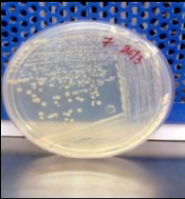
2.DNA Extraction | 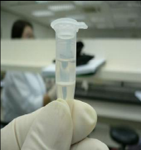
3.PCR | 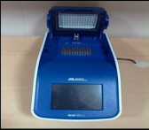
4.Cycle Sequencing | 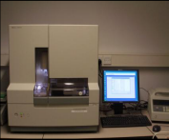
5.Sequencing  & Sequence Analysis | 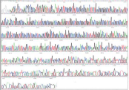

2.3 Materials and reagents

2.3.1 Media
- Halophilic Broth
- Agar Agar

2.3.2 Reagents
- 1X TE buffer
- 10 % SDS
- 20 mg/ml Proteinase K
- Phenol: chloroform (1:1)
- Chloroform:Isoamylalcohol (24:1)
- Isopropanol
- 70 % ethanol
- 3 M sodium acetate (pH 5.2)
- Crystal violet (primary stain)
- Iodine solution/Gram's Iodine
- Decolourizer (e.g. ethanol)
- Safranin (secondary stain)
- PCR master mix
- PCR purification buffer
- Cycle sequencing mix
- Mili-Q-water
- Formamide

2.4 Enrichments of Bacterial culture Media
Halophiles were enriched in halophiles broth containing(gm/lit): Casamino acids 7.5g, Yeast extract 10.0g, Trisodium citrate 3.0g, Potassium chloride 2.0g, Magnesium sulphate heptahydrate 20.0g, Ferrous sulphate heptahydrate 0.05g, Manganese sulphate monohydrate .20mg, Sodium chloride 250.0g(15%-35%), Agar 20.0g, D/w 1000.00ml , pH-7.0 for 10 -12 days for bacteria[10].

2.5 Isolation and characterization of halophiles
The bacterial cultures were isolated from mixed cultures by streaking method and spreading method on above mentioned solid medium agar. These plates were incubated in incubator at 37 for 7 to 10 days. Individual colonies were sub cultured into mentioned agar plates containing different colonies until pure culture was isolated. Once all the isolates obtained were purified. Then After incubation time, colony characteristics and morphological properties were noted. Then DNA isolation is been done using Isolated colonies from bacterial culture were picked with the help of sterilized wire loop and added in the different reagent. Agarose gel Electrophoresis and PCR is performed to amplify the product, cycle sequencing and resulted in linear amplification of extension products. The extension products were then loaded into a genetic analyzer (DNA Sequencer) to determine the extension products.
2.6 Identification of microbes
The purified bacterial strains were identified based on its morphological, biochemical and 16S rRNA sequence. The 16S rRNA sequencing from isolated strains was accomplished by BioGene-Gujarat Biodiversity Gene Bank, India. Similarity analysis of the 16S rRNA sequences was conducted using the blast function of NCBI Gene Bank.

3. Result

3.1 Isolation of halophiles and Identification of bacterial isolates
Bacteria were isolated and enumerated using the standard plate method. 0.1 ml of the proper dilution was used to surface inoculate nutrient agar media. From each dilution, five plates were inoculated at 37°C. Colonies were observed every day until optimal growth was observed. Colonies obtained on nutrient agar, were isolated and further purified. The isolates were stored at 4°C.For Identification of bacterial strain to carry out by 16S rRNA sequence analysis from the diff0078xerent isolates which have been submitted in the NCBI Gene Bank database under the different Bank ID. On the basis of morphological, biochemical characteristics and 16S rRNA sequences, isolated strains were identified as is showed in Table 2.

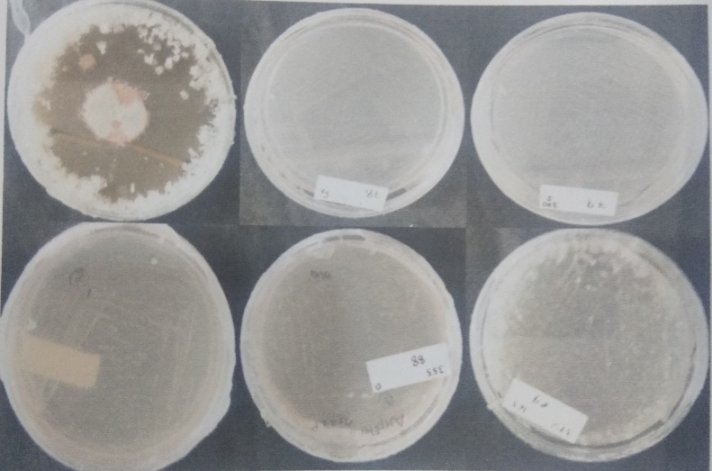

Fig: 1 Images of Bacterial cultures grown in media
3.2 DNA isolation and gel electrophoresis
DNA isolation from halophiles was carried out with two different protocols named as protocol 1 and 2. Protocol 1 was manual and protocol 2 was perpman protocol.1% agarose gel electrophoresis was performed for visualization of DNA band. Concentration of DNA was checked by taking the absorbance at 260 nm and 280 nm on nanophotometer. Purity of DNA was checked by taking ratio of 260/280 nm
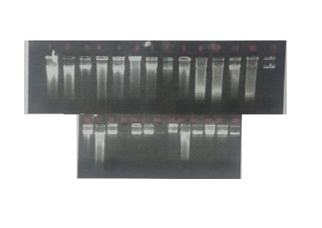

Fig: 2 Concentration and purity of DNA
  - PCR amplification of DNA
Isolated DNA was amplified by using PCR amplification which was carried out in Thermocycler. Amplified product was visualized on 2% agarose gel by electrophoresis. PCR product was further purified by Exo/Sap method.

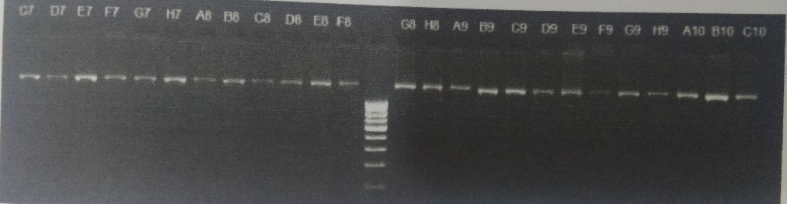

Fig: 3 Purified PCR product

3.4 BLAST results
The sequences were interpreted and online local alignment tool BLAST was used to search and identify organism with same or similar sequences on NCBI database. The result of BLAST is given in table below.

Table 2 : Bacterial Identification by BLAST
No. | Sample ID | Identified Organism | Query Coverage | Identity (%) | Bankit ID
1. | BAB 4192 | Alkalibacillus flavidus | 99% | 98% | 1721995
2. | BAB 4188 | Salimicrobium lutem | 100% | 99% | 1721992
3. | BAB 4191 | Pseudomonas halophile | 98% | 99% | 1721992
4. | BAB 4198 | Halobacillus trueperi | 99% | 99% | 1721992
5. | BAB 4196 | Pontibacillus chungwhensis | 100% | 99% | 1721992
6. | BAB 4190 | Pontibacillus chungwhensis | 87% | 98% | 1721992
7. | BAB 4194 | Halobacillus halophilus | 100% | 99% | 1721992
8. | BAB 4195 | Alkalibacillus flavidus | 98% | 98% | 1721992
9.  10. | BAB 4206  BAB 4188 | Alkalibacillus flavidus  Halobacillus salinus | 99%  99% | 98%  98% | 1721992  1721992
11. | BAB 4193 | Alkalibacillus salilacus | 100% | 99% | 1721995
12. | BAB 4197 | Pseudomonas halophile | 87% | 99% | 1721992

3.5 Colony characteristics and Gram reaction
Colonies of different strain on above mentioned agar plates appeared with irregular clusters, arranged in pairs, and tetrads. It grew in circular, entire, smooth, opaque, convex and creamy yellow, non-diffusible pigmented colonies. The strain was a Gram-positive, Gram negative, spherical, aerobic arranged.

Table 3: Colony characteristics
Colony  Morphology | BAB No.
Colony  Morphology | 4188 | 4192 | 4196
Size | Large | Small | Medium
Shape | Circular[rod] | Circular | Irregular
Elevation | Convex | Umbonate | Flat
Margin | Entire | Entire | Undulate
Appearance | Shiny | Shiny | Shiny
Optical  Property | Opaque | Opaque | Translucent
Pigmentation | Red | Creamish | Yellow
Texture | Smooth | Smooth | Smooth
Gram  Reaction | Gram positive | Gram positive | Gram positive

  - Sample run on DNA sequencer
Purified product from cycle sequencing was run on 3500xl Genetic analyser to obtain 16S rRNA gene sequence. Specific sequence was obtained for each of bacteria and archaea. After completion, sequences were presented as electropherogram by the CCD camera.

    - BAB 4188

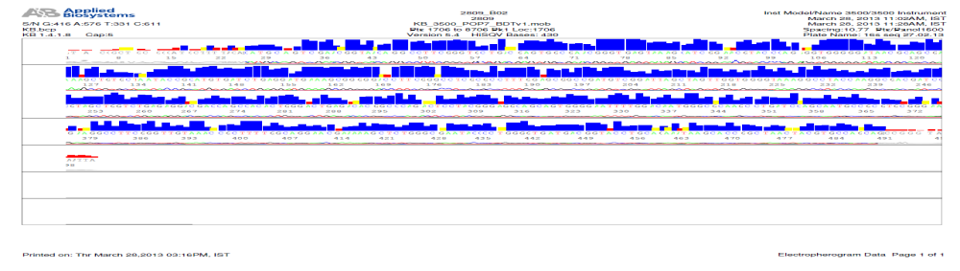

    - BAB 4192

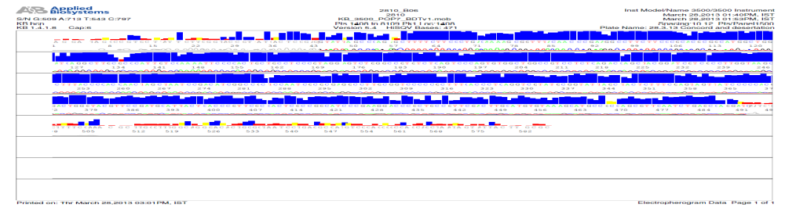
    - BAB 4196

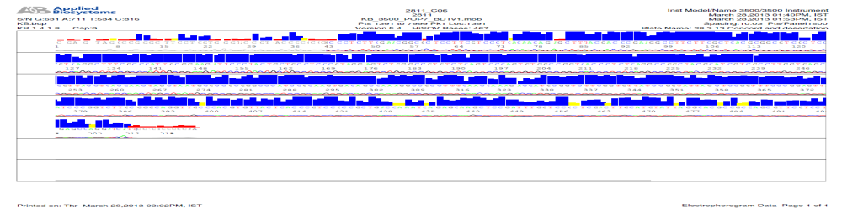
Fig.4: Electrophorogram of Halophiles

  - Phylogenetic Analysis
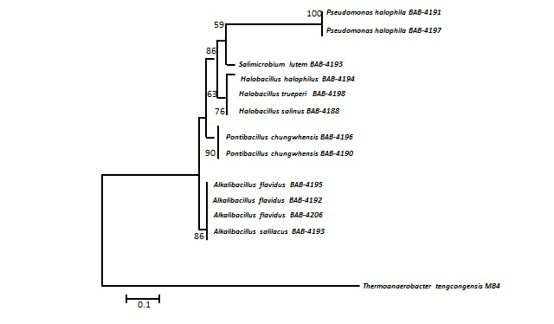
Fig: 4 Phylogenetic trees of Halophilic Bacteria.

4. Discussion:
Future applications this using halophiles include the extraction of carotene from carotene rich halobacteria and halophilic algae that can then be used as food additives or as food-coloring agents. Also there is use of halophilic organisms in the fermentation of soy sauce and Thai fish sauce. Many possible applications using halophiles are being exploring such as genetically engineering halophilic enzymes, encoding DNA into crops to allow for salt tolerance treatment of waste water increasing crude oil extraction. Other new halophiles can also be isolated from other geothermal conditions on earth and further application of their product can be find out.
5. Conclusion:
Halophiles were isolated from Rann of Kutch in Gujarat, India. DNA isolation was carried from the Halophiles for molecular identification of bacteria. Further identification of Halophiles was performed by 16s rRNA gene sequencing. 16s rRNA gene is universal gene for the identification of bacteria. This gene is further amplifying by PCR and then sequenced using genetic analyser. Nucleotide BLAST was carried out to identify the bacteria. Results from nucleotide BLAST showed that 4188 bacteria 4192 has 99% similarity with Alkalibacillus flavidus strain and 4196 has 99% similarity with Pontibacillus chungwhensis. From 99% similarity it was confirmed that 4194 was Halobacillus halophilus, 4197 was Pseudomonas halophile.Various halophilic enzymes have been isolated from different halophilic organisms. Further work can be carried out on the production and isolation of the enzymes from these many halophiles and application of them in various industries can be find out.

6. Acknowledgements:
The authors thank the support of Shri A.K Saxena, IFS (Mission Director),Dr.Snehal Bagatharia, Dr. Madhavi Joshi (Sector Specialist) and Aanal Pandit, Research Associate in Gujarat Biodiversity Gene Bank, GSBTM as well as the Department of Biochemistry, Dr. N.K. Jain, Dr. H.N Highland. The authors thank the three anonymous reviewers for making essential comments and suggestions to improve the manuscript.
Important
This publication is based on review work and primary research work related to my PhD study.
References:
- J, U. Vora. H, A. Modi. Bacterial diversity of saline sites in Kharaghoda. International journal of research in pure and applied microbiology, 2013; pp 2277-3843.
- Patrick, D. Schloss. Jo, Handelsman. Towards a Census of Bacteria in Soil. PLoS Computational Biology, 2006; 2(7): pp 92.
- James, J. Hoorman. The Role of Soil Bacteria. Agriculture and Natural Resources, 2011; pp 11-13.
- Das Sarma, S., Arora, P. Halophiles: Encyclopedia of Life Science; Nature Publishing Group: 2001.
- Kushner, D.J.; Kamekura, M. Physiology of halophilic eubacteria and Halophilic Bacteria, Rodríguez-Varela, F., Ed.; CRC Press: Boca Raton, FL, USA,; 1988 pp 109-138.
- Madigan, M.T.; Oren, A. Thermophilic and halophilic extremophiles. Curr. Opin. Microbiol, 1999; 2: pp 265-269.
- Oren, A. Diversity of halophilic microorganisms: Environments, phylogeny, physiology, and applications. J. Ind. Microbiol. Biotechnol, 2002; 28: pp 58-63.
- María de Lourdes Moreno, Dolores Pérez, María Teresa García and Encarnación Mellado Halophilic Bacteria as a Source of Novel Hydrolytic Enzymes Life Journal,2013;No.3:pp 38-51.
- Gómez, J.; Steiner, W. The biocatalytic potential of extremophiles and extremozymes. Food Technol. Biotechnol, 2004; 2: pp 223-235.
- MarkA.Schneegurt R.H.Vreeland (ed.) Advances in Understanding the Biology of Halophilic Microorganisms, Springer Science Business Media Dordrecht.2012, pp 35.

