Super High Oleic Safflower–Australia’s new high value broad acre crop producing industrial grade plant-derived oil
Carl M Ramage, PhD, GO Resources, Australia
David Hudson, GO Resources, Australia
Michael Kleinig, GO Resources, Australia

Abstract (300 word limit)
Plant-derived oils are mixtures of saturated, monounsaturated and polyunsaturated fatty acids in ratios that are less than ideal for industrial uses that often demand high purity in feedstock composition. Large volumes of crude vegetable oil containing near-pure levels of oleic acid have long been considered a desirable industrial feedstock, offering unique physical and chemical properties for oleochemical purposes.
Safflower (Carthamus tinctorius L.) seed produces oil that predominantly contain monounsaturated fatty acid (C18:1; oleic acid) and polyunsaturated fatty acid (C18:2; linoleic acid). While both have commercial uses, it is the valuable oleic acid that is used as a replacement to petroleum-based precursors in the manufacture of plastics, lubricants and cosmetics, etc. Traditional breeding programs have developed safflower seed with oleic acid levels in the range of 75–85%, and are the highest purity sources of oleic acid in any oilseed. However, like other oilseeds, the remaining linoleic acid component, at 12-18%, is not desirable for industrial use because it is unstable and difficult to remove during oil processing. Therefore, it is desirable to develop a safflower seed that accumulates high oleic acid (C18:1), but contains very low linoleic acid (C18:2) content.
Two genetically modified safflower events were developed by the Commonwealth Scientific Industrial Research Organisation (CSIRO) and are being commercialized by GO Resources Pty Ltd. The events contain a construct designed to down regulate two safflower fatty acid biosynthesis genes. Down regulation is achieved using RNAi technology and is targeted to the seed using a seed specific promotor. Down regulation of the two safflower genes leads to accumulation of 92% oleic acid (C18:1) and very low (less than 2%) linoleic acid (C18:2) in the seed, Super High Oleic Acid Safflower Oil (SHOSO).
Details of the development and commercialization of this new GM crop in Australia will be presented.

Image

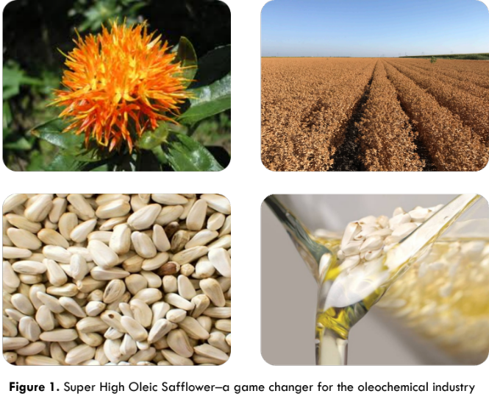
Recent Publications (minimum 5)
- Belide S, Hac L, Singh S, Green A, Wood C (2011). Agrobacterium-mediated transformation of safflower and the efficient recovery of transgenic plants via grafting. Plant Methods 7.
- FSANZ (2018) Application A1156–Food derived from Super High Oleic Safflower Lines 26 and 40.
- GRDC (2010). Raising the bar with better safflower agronomy. Grains Research and Development Corporation ACT, Australia.
- Liu Q, Cao S, Zhou XR, Wood C, Green A, Singh S. (2013). Nonsense-mediated mRNA degradation of CtFAD2-1 and development of a perfect molecular marker for olol mutation in high oleic safflower (Carthamus tinctorius L.). Theor Appl Genet. 2013 Sep;126(9):2219-31
5. OGTR (2017). DIR158: Commercial release of safflower genetically modified for high oleic acid composition - GO Resources Pty Ltd

Biography (150 word limit)
Carl is the Managing Director of Rautaki Solutions, a consultancy company that specializes in supporting innovation and excellence across the life sciences sector. Over the past 20 years Carl has supported the development of novel agbiotech products in Australia and overseas through various roles across the value chain. He is a regulatory strategist, nationally recognized for his strengths and leadership in the navigation of complex regulatory landscapes and has a strong process development, implementation and review skill set backed by a solid peer reviewed publication record.
Carl is Chair of the La Trobe University Institutional Biosafety Committee and a member of the National AusBiotech Agriculture and Food Committee, positions where integrity, passion and respect are core values for the provision of strategic direction, governance and risk management.
Carl maintains a significant national and international network with government agencies, innovation leaders and stakeholders and a member of several key industry associations.
Email: carl@rautakisolutions.com.au

Notes/Comments:

