Effects of 1-MCP on plant growth characteristics and spikelets development under salt stress in rice

Qianyu Jin, China National Rice Research Institute, China

Junhua Zhang, China National Rice Research Institute, China

Jie Huang, China National Rice Research Institute, China

Sajid Hussain, China National Rice Research Institute, China
Zhigang Bai, China National Rice Research Institute, China

Abstract
Statement of the Problem: Rice growth and development was badly affected by its salt sensitivity. It faces osmotic, ionic as well as hormonal (ethylene) stress due to salt stress. High ethylene production effects inferior and superior spikelets development in rice cultivars under salt stress. 1-Methylecyclopropne (1-MCP) is an excellent ethylene inhibitor in plants, which has been recently explored as an important ethylene inhibitor in rice. However, effects of 1-MCP in rice growth and development under salt stress is a novel study.
Methodology & Theoretical Orientation: Two rice cultivars, Liangyoupiejiu (LYP9, Indica) and Nipponbare (NPBA, Japonica, sensitive to salt stress) were grown in green house with three salt stress levels: 0 (Control, CK), 1.5 g NaCl/kg dry soil (Low Salt Stress, LS), and 4.5g NaCl/kg dry soil (Heavy Salt Stress, HS).
Findings: The results showed that 1-MCP significantly improved photosynthesis rate (Pn), transpiration rate (Tr), stomatal conductance (Gs), and SPAD values of flag leaf in both cultivars than no 1-MCP. It was higher effective in increasing grain weight and grain filling rate of LYP9 than NPBA under all salt levels. 1-MCP significantly inhibits ethylene production in inferior spikelets in LYP9 and NPBA than superior spikelets. Application of 1-MCP positively improved rice plant dry matter and improved grain yield and yield components for LYP9 and NPBA, especially for LYP9.
Conclusion & Significance: -MCP favorably improved plant growth characteristics and development of superior and inferior spikelets in rice under slat stress, LYP9 showed better performance than NPBA after application of 1-MCP under salt stress.

Image
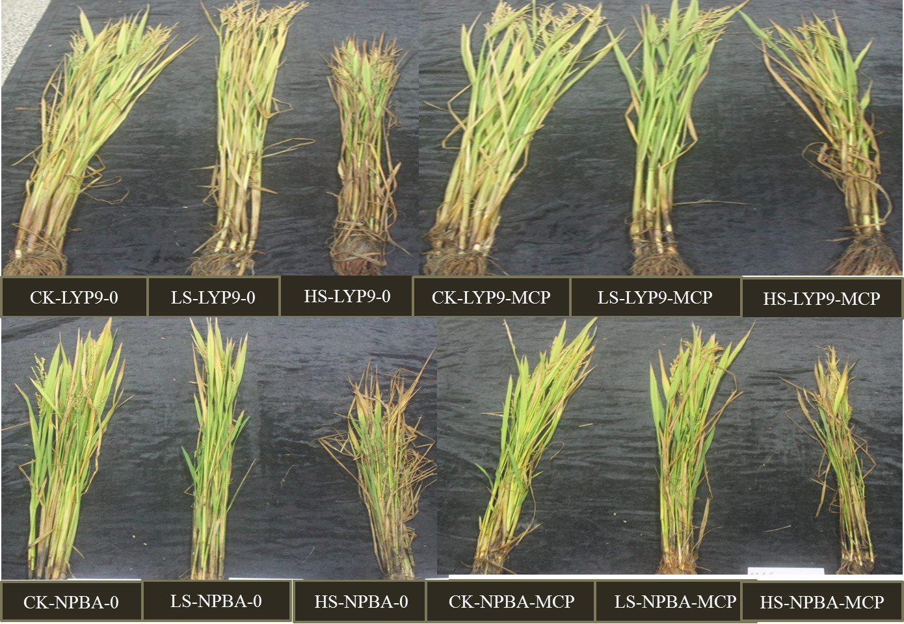
Fig.1 Effects of 1-MCP on rice leaf colour for LYP9 and NPBA at maturity.

Recent Publications
- Mostofa GM, Saegusa D, Fujita M, Phan TL (2015) Hydrogen Sulfide Regulates Salt Tolerance in Rice by Maintaining Na+/K+ Balance, Mineral Homeostasis and Oxidative Metabolism Under Excessive Salt Stress. Frontier of Plant Science 6, 1-15.
- Qian Q, Guo LB, Smith SM, and Li JY (2016) Breeding high-yield superior quality hybrid super rice by rational design. National Science Review 3, 283–294.
- Su HW, Finlayson S (2012) 1-Methylcyclopropene prevents cotton physiological and molecular responses to ethylene. Plant Growth Regulation 68, 57–66
- Wang Z, Xu Y, Chen T, Zhang H, Yang J, and Zhang J (2015) Abscisic acid and the key enzymes and genes in sucrose-to-starch conversion in rice spikelets in response to soil drying during grain filling. Planta 241, 1091–1107.
- Zhang HW, Zhang JF, Quan RD, Pan XW, Wan LY, Huang RF (2013) EAR motif mutation of rice OsERF3alters the regulation of ethylene biosynthesis and drought tolerance. Planta 237, 1443–1451.

Biography

Qianyu Jin conducts researches on rice high yield production and physiology with emphasis on improving nutrient use efficiency, root function and identifying the morphological traits and physiological processes that limit the advance of rice yield potential in the irrigated ecosystem. His group have developed an aerated water irrigation method which has obtained a national invention patent and published papers. The current researches of Qianyu Jin focus on improving the nutrient use efficiency and reducing the nitrogen fertilizer input in rice production. He conducts experiments to study the regulation mechanism of rhizosphere oxygen on nitrogen transform and nitrogen metabolism of rice. Simultaneously, try to develop a high-yielding rice cultivation technique with reduced nitrogen input and improved nitrogen use efficiency based on the regulation of rhizosphere oxygen concentration.

Email: jinqianyu@caas.cn

Notes/Comments:

