Encapsulation of Recombinant Proteins in Induced Protein Bodies in Plant Seed and Vegetative Tissues.

Imran Khan
Gomal Centre for Biochemistry and Biotechnology, Gomal University Pakistan.
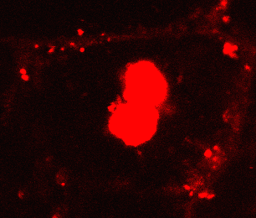
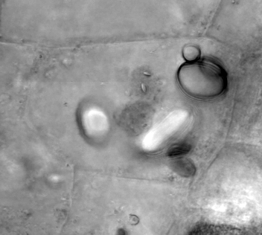
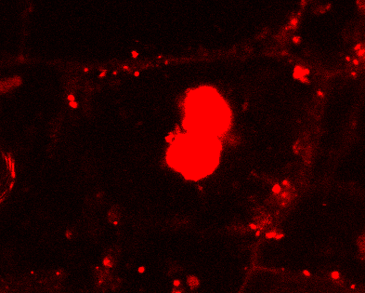
Cereals offer advantages for molecular farming because seeds have naturally evolved for protein storage. In seeds, the recombinant proteins can be targeted to storage organelles, such as Protein Bodies (PBs) derived from the endoplasmic reticulum (ER) and Protein Storage Vacuoles (PSVs) for stable accumulation and storage. γ-Zein, the maize prolamin storage protein, and partial sequences thereof can be fused to proteins of interest to induce the formation of novel PB-like organelles not only in its native environment (maize endosperm) but also in other plant cells and in eukaryotic cells generally. We report the constitutive expression of recombinant fusion protein i.e. repeated and Pro-X domain of γ-Zein and red fluorescent protein (DsRed) in transgenic wheat plants. The red fluorescent protein (DsRed) was used as tool for tracking subcellular localization of recombinant proteins and also as fluorescent selection marker to monitor transgene expression during wheat transformation. In the present study we explored endogenous and ectopically induced protein storage organelles as preferred intracellular destination for recombinant protein in wheat different tissues i.e. leaf, endosperm and embryo. Our finding has confirmed that the model fusion protein has induced the formation of an additional population of protein bodies containing the recombinant protein in seed and vegetative tissues. To better understand the trafficking of recombinant proteins in ectopic tissues, the subcellular localization of recombinant proteins in seed and green tissues were examined. We confirmed the feasibility of using γ-Zein for targeting recombinant protein into artificial protein bodies those were preferably retained in the protein storage vacuoles (PSV) in seed tissues. In vegetative tissues, the induced protein bodies were found highly mobile organelles, exhibiting different pattern of movement with no specific direction. The presence of the model fusion protein was validated in all three transgenic wheat plant tissues tested. Also, no degradation products were detected in transgenic wheat seeds after five months storage. The expression of recombinant fusion proteins had no harmful effect on the viability and development of transgenic wheat plants.
Publications
- Conley, A. J., Joensuu, J. J., Richman, A., and Menassa, R. (2011). Protein body-inducing fusions for high-level production and purification of recombinant proteins in plants. Plant Biotechnol J 9, 419-433.
- Khan, I., Twyman, R. M., Arcalis, E., and Stoger, E. (2012). Using storage organelles for the accumulation and encapsulation of recombinant proteins. Biotechnol. J. 7, 1099–1108. doi: 10.1002/biot.201100089
- Saberianfar, R., Joensuu, J. J., Conley, A. J., and Menassa, R. (2015). Protein body formation in leaves of Nicotiana benthamiana: a concentration-dependent mechanism influenced by the presence of fusion tags. Plant Biotechnol. J. 13, 927–937. doi: 10.1111/pbi.12329
- Takagi, H., Hiroi, T., Hirose, S., Yang, L., and Takaiwa, F. (2010). Rice seed ER-derived protein body as an efficient delivery vehicle for oral tolerogenic peptides. Peptides 31, 1421–1425. doi: 10.1016/j.peptides.2010.04.032
- Joensuu, J. J., Conley, A. J., Lienemann, M., Brandle, J. E., Linder, M. B., and Menassa, R. (2010). Hydrophobin fusions for high-level transient protein expression and purification in Nicotiana benthamiana. Plant Physiol. 152, 622–633. doi: 10.1104/pp.109.149021
Figure I. Accumulation of recombinant DsRed protein bodies in transgenic wheat endosperm cells. (A) Confocal images show the accumulation of DsRed in the protein bodies in a large central protein storage vacuole (PSV) of transgenic wheat endosperm cells (arrow). The induced protein bodies containing recombinant proteins can also be seen in the cytoplasm (arrow). (B). Corresponding transmission light image.
A
B
A
Biography.
Dr. Imran Khan currently working as Director, Quality Assurance Cell (QEC), Gomal University Pakistan. Dr. Imran also worked as founder Director of Centre for Interdisciplinary Research in Basic Sciences (CIRBS), International Islamic University, Islamabad, Pakistan. The main focus of his research is Molecular farming, the new term for production of recombinant proteins of industrial importance in plants as cheaper alternative to existing production systems. Dr. Imran focus is to explore plant, cereals in particular, for production of various recombinant proteins of industrial important. His major interest is improve the yield of recombinant proteins via protein targeting. Dr. Imran’s research is focusing to achieve goal of providing safe, efficacious and inexpensive oral vaccines to the developing world such as Pakistan. The ultimate goal of the research is to help the developing countries for sustainable Immunization against various diseases

