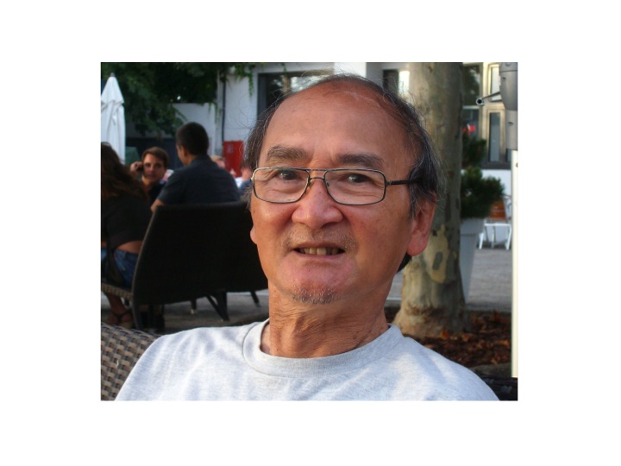
I.N.S.E.R.M.

Institut National de la Santé
et de la Recherche Médicale
FF

BioAmerica 2017

Title:

« Impacts of the extremes conditions of environments on the RNA’ flexibility and self-catalytic activity of the « Avocado sunblotch » viroid: application of NIR Raman spectroscopy and a bio-reactor with sampling in and out, at constant pressure and perturbation agents for the study »

Abstract:

The typical environment for biomolecules in vivo is highly crowded. In such conditions, conformational changes, structural flexibility as well as chemical activity of biomolecules may be affected by molecular crowding effects. To mimic in vitro, the crowding effects, high pressure, D₂O solvent and crowding agents are excellent tools for the study. In such a propose, we have recently developed two innovating techniques to follow the alteration of bio-molecular structure and function submitted to extremes conditions of environments in vitro. This approach is applied to the study of the structure and function of the « Avsunviroidae » Avocado sunblotch viroids. They are non encapsidated RNA plant pathogens. They are able to infect dramatically a broad range of plants. The Avocado sunblotch viroid minus strand (ASBVd(-)) is a compact rod-like circular RNA which possess a catalytic hammerhead ribozyme (HHR) motif responsible for crucial cleavage step during viroid replication. To date little is known regarding the structure and conformation of ASBVd(-) viroid, the catalytic role of Mg2+ and the ways by which such viroid induce diseases. This prompts us to develop a NIR Raman spectroscopy which is a sensitive technique for monitoring RNA’s molecular structure and a bio-reactor designed to allow rapid injections of effectors and sampling out products under constant pressure and perturbation agents, for activity measurements. ASBVd(-) viroid exhibits a typical A-type RNA conformation with ordered double helical content and a C3’-endo/anti sugar pucker configuration. Deuteration and temperature perturbed differently the RNA’s phosphodiester conformation. Mg2+-activated self-cleavage does not significantly alter the secondary RNA’s structure but noticeable Raman frequency downshifts were observed, suggesting that several phosphodioxy structure, internal loops and hairpins of the cleaved viroids have changed. RNA self-cleavage activity decreased upon deuteration indicating some accessibility of H-bonding network and a rigidity of RNA’s structure. A pressure-induced RNA’s self- cleavage obtained pH-profile is interpreted as a consequence of some compaction of the structure and a release of catalytic water molecules during catalysis. All these data will constitute the basis for further studies of the interactions of such viroid with therapeutic agents and cell membranes.
Gaston HUI BON HOA National Institute of Health and Medical Research, (I.N.S.E.R.M.).
94276 Le Kremlin Bicêtre, France.

Biography:
Gaston HUI BON HOA has completed his Ph.D. in 1974 from the University of Paris XI and obtained his positions in I.N.S.E.R.M. since 1975. He is an Emeritus Director of Research, since 2000, in the Hospital Kremlin Bicêtre Center, France. His expertise is focus on the studies of cryo- enzymology and enzyme intermediates (1978-1980), cytochrome P450’s structure and function (1981-1992), pressure-induced protein’s stability, compressibility and dynamics as well as osmotic stress study (1992-2015). In 2012, he starts in the study of plant viroid’s structure, conformation and function. He has published more than 90 papers in reputed international journals and has been serving as an editorial board member.

