Factor 5 Leiden study of genetic polymorphisms as genetic factors that cause cardiovascular disease in the population of Tabriz, Iran

Shahin Asadi (student of Molecular Genetics)
Saeedeh Habibi (MS.c Molecular Biology-Genetics)
Ali Nazirzadeh (phd. Molecular Biology-Biotechnology)
Young Researchers and Elite Club,Tabriz,Ahar Branch,Islamic Azad University,Tabriz,Iran.

New biological Tabriz University of Medical Sciences, Department of Molecular Biology.

Authors;Shahin Asadi and Saeedeh Habibi
Email;shahin.asadi1985@gmail.com
Tell;+989379923364
Genetic Diseases Research Center, Ministry of Health and Medical Education of Iran.

Cardiovascular disease
Cardiovascular disease (CVD) is a class of diseases that involve the heart or blood vessels.^{[1]} Cardiovascular disease includes coronary artery diseases (CAD) such as angina and myocardial infarction (commonly known as a heart attack).^{[1]} Other CVDs are stroke, hypertensive heart disease, rheumatic heart disease, cardiomyopathy, heart arrhythmia, congenital heart disease, valvular heart disease, carditis, aortic aneurysms, peripheral artery disease, and venous thrombosis.^{[1][2]}
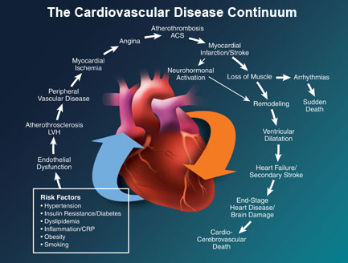
The underlying mechanisms vary depending on the disease in question. Coronary artery disease, stroke, and peripheral artery disease involve atherosclerosis. This may be caused by high blood pressure, smoking, diabetes, lack of exercise, obesity, high blood cholesterol, poor diet, and excessive alcohol consumption, among others. High blood pressure results in 13% of CVD deaths, while tobacco results in 9%, diabetes 6%, lack of exercise 6% and obesity 5%. Rheumatic heart disease may follow untreated strep throat.^{[1]}
It is estimated that 90% of CVD is preventable.^{[3]} Prevention of atherosclerosis is by decreasing risk factors through: healthy eating, exercise, avoidance of tobacco smoke and limiting alcohol intake.^{[1]} Treating high blood pressure and diabetes is also beneficial.^{[1]} Treating people who have strep throat with antibiotics can decrease the risk of rheumatic heart disease.^{[4]} The effect of the use of aspirin in people who are otherwise healthy is of unclear benefit.^{[5][6]} The United States Preventive Services Task Force recommends against its use for prevention in women less than 55 and men less than 45 years old; however, in those who are older it is recommends in some individuals.^{[7]} Treatment of those who have CVD improves outcomes.^{[1]}
Cardiovascular diseases are the leading cause of death globally.^{[1]} This is true in all areas of the world except Africa.^{[1]} Together they resulted in 17.3 million deaths (31.5%) in 2013 up from 12.3 million (25.8%) in 1990.^{[2]} Deaths, at a given age, from CVD are more common and have been increasing in much of the developing world, while rates have declined in most of the developed world since the 1970s.^{[8][9]} Coronary artery disease and stroke account for 80% of CVD deaths in males and 75% of CVD deaths in females.^{[1]} Most cardiovascular disease affects older adults. In the United States 11% of people between 20 and 40 have CVD, while 37% between 40 and 60, 71% of people between 60 and 80, and 85% of people over 80 have CVD.^{[10]} The average age of death from coronary artery disease in the developed world is around 80 while it is around 68 in the developing world.^{[8]} Disease onset is typically seven to ten years earlier in men as compared to women.^{[11]}
Cardiovascular disease
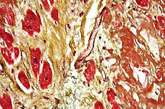
Micrograph of a heart with fibrosis (yellow) and amyloidosis (brown). Movat's stain.

Risk factors
There are several risk factors for heart diseases: age, gender, tobacco use, physical inactivity, excessive alcohol consumption, unhealthy diet, obesity, family history of cardiovascular disease, raised blood pressure (hypertension), raised blood sugar (diabetes mellitus), raised blood cholesterol (hyperlipidemia), psychosocial factors, poverty and low educational status, and air pollution.^{[13][14][15][16][17]} While the individual contribution of each risk factor varies between different communities or ethnic groups the overall contribution of these risk factors is very consistent.^{[18]} Some of these risk factors, such as age, gender or family history, are immutable; however, many important cardiovascular risk factors are modifiable by lifestyle change, social change, drug treatment and prevention of hypertension, hyperlipidemia, and diabetes.

Calcified heart of an older woman with cardiomegaly
Age is by far the most important risk factor in developing cardiovascular or heart diseases, with approximately a tripling of risk with each decade of life.^{[19]} Coronary fatty streaks can begin to form in adolescence.^{[20]} It is estimated that 82 percent of people who die of coronary heart disease are 65 and older.^{[21]} At the same time, the risk of stroke doubles every decade after age 55.^{[22]}
Multiple explanations have been proposed to explain why age increases the risk of cardiovascular/heart diseases. One of them is related to serum cholesterol level.^{[23]} In most populations, the serum total cholesterol level increases as age increases. In men, this increase levels off around age 45 to 50 years. In women, the increase continues sharply until age 60 to 65 years.^{[23]}
Aging is also associated with changes in the mechanical and structural properties of the vascular wall, which leads to the loss of arterial elasticity and reduced arterial compliance and may subsequently lead to coronary artery disease.^{[24]}

Sex
Men are at greater risk of heart disease than pre-menopausal women.^{[19][25]} Once past menopause, it has been argued that a woman's risk is similar to a man's^{[25]} although more recent data from the WHO and UN disputes this.^{[19]} If a female has diabetes, she is more likely to develop heart disease than a male with diabetes.^{[26]}
Coronary heart diseases are 2 to 5 times more common among middle-aged men than women.^{[23]} In a study done by the World Health Organization, sex contributes to approximately 40% of the variation in sex ratios of coronary heart disease mortality.^{[27]} Another study reports similar results finding that gender differences explains nearly half the risk associated with cardiovascular diseases^{[23]} One of the proposed explanations for gender differences in cardiovascular diseases is hormonal difference.^{[23]} Among women, estrogen is the predominant sex hormone. Estrogen may have protective effects through glucose metabolism and hemostatic system, and may have direct effect in improving endothelial cell function.^{[23]} The production of estrogen decreases after menopause, and this may change the female lipid metabolism toward a more atherogenic form by decreasing the HDL cholesterol level while increasing LDL and total cholesterol levels.^{[23]}
Among men and women, there are notable differences in body weight, height, body fat distribution, heart rate, stroke volume, and arterial compliance.^{[24]} In the very elderly, age-related large artery pulsatility and stiffness is more pronounced among women than men.^{[24]} This may be caused by the women's smaller body size and arterial dimensions which are independent of menopause.^{[24]}
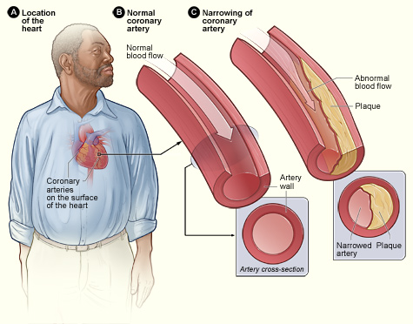

Tobacco
Cigarettes are the major form of smoked tobacco.^{[1]} Risks to health from tobacco use result not only from direct consumption of tobacco, but also from exposure to second-hand smoke.^{[1]} Approximately 10% of cardiovascular disease is attributed to smoking;^{[1]} however, people who quit smoking by age 30 have almost as low a risk of death as never smokers.^{[28]}
Insufficient physical activity (defined as less than 5 x 30 minutes of moderate activity per week, or less than 3 x 20 minutes of vigorous activity per week) is currently the fourth leading risk factor for mortality worldwide.^{[1]} In 2008, 31.3% of adults aged 15 or older (28.2% men and 34.4% women) were insufficiently physically active.^{[1]} The risk of ischemic heart disease and diabetes mellitus is reduced by almost a third in adults who participate in 150 minutes of moderate physical activity each week (or equivalent).^{[29]} In addition, physical activity assists weight loss and improves blood glucose control, blood pressure, lipid profile and insulin sensitivity. These effects may, at least in part, explain its cardiovascular benefits.^{[1]}
High dietary intakes of saturated fat, trans-fats and salt, and low intake of fruits, vegetables and fish are linked to cardiovascular risk, although whether all these associations are a cause is disputed. The World Health Organization attributes approximately 1.7 million deaths worldwide to low fruit and vegetable consumption.^{[1]} The amount of dietary salt consumed is also an important determinant of blood pressure levels and overall cardiovascular risk.^{[1]} Frequent consumption of high-energy foods, such as processed foods that are high in fats and sugars, promotes obesity and may increase cardiovascular risk.^{[1]} High trans-fat intake has adverse effects on blood lipids and circulating inflammatory markers,^{[30]} and elimination of trans-fat from diets has been widely advocated.^{[31]} There is evidence that higher consumption of sugar is associated with higher blood pressure and unfavorable blood lipids,^{[32]} and sugar intake also increases the risk of diabetes mellitus.^{[33]} High consumption of processed meats is associated with an increased risk of cardiovascular disease, possibly in part due to increased dietary salt intake.^{[34]}
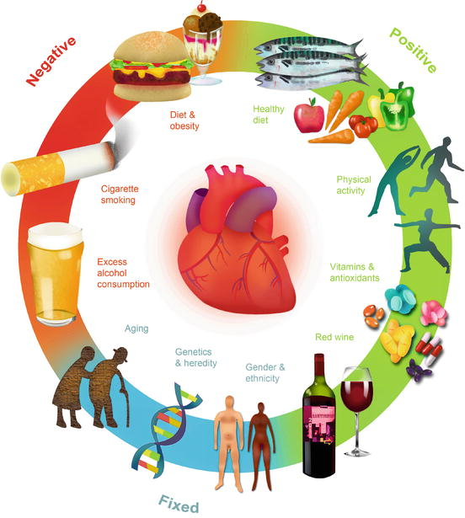
The relationship between alcohol consumption and cardiovascular disease is complex, and may depend on the amount of alcohol consumed. There is a direct relationship between high levels of alcohol consumption and risk of cardiovascular disease.^{[1]} Drinking at low levels without episodes of heavy drinking may be associated with a reduced risk of cardiovascular disease.^{[35]} Overall alcohol consumption at the population level is associated with multiple health risks that exceed any potential benefits.^{[1][36]}
Cardiovascular disease affects low- and middle-income countries even more than high-income countries.^{[37]} There is relatively little information regarding social patterns of cardiovascular disease within low- and middle-income countries,^{[37]} but within high-income countries low income and low educational status are consistently associated with greater risk of cardiovascular disease.^{[38]} Policies that have resulted in increased socio-economic inequalities have been associated with greater subsequent socio-economic differences in cardiovascular disease^{[37]} implying a cause and effect relationship. Psychosocial factors, environmental exposures, health behaviours, and health-care access and quality contribute to socio-economic differentials in cardiovascular disease. ^{[39]} The Commission on Social Determinants of Health recommended that more equal distributions of power, wealth, education, housing, environmental factors, nutrition, and health care were needed to address inequalities in cardiovascular disease and non-communicable diseases.^{[40]}
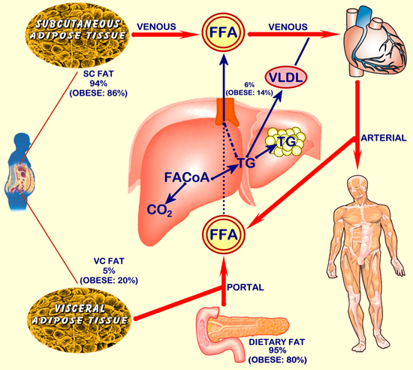

Air pollution
Particulate matter has been studied for its short- and long-term exposure effects on cardiovascular disease. Currently, PM_{2.5} is the major focus, in which gradients are used to determine CVD risk. For every 10 μg/m³ of PM_{2.5} long-term exposure, there was an estimated 8–18% CVD mortality risk.^{[41]} Women had a higher relative risk (RR) (1.42) for PM_{2.5} induced coronary artery disease than men (0.90) did.^{[41]} Overall, long-term PM exposure increased rate of atherosclerosis and inflammation. In regards to short-term exposure (2 hours), every 25 μg/m³ of PM_{2.5} resulted in a 48% increase of CVD mortality risk.^{[42]} In addition, after only 5 days of exposure, a rise in systolic (2.8 mmHg) and diastolic (2.7 mmHg) blood pressure occurred for every 10.5 μg/m³ of PM_{2.5}.^{[42]} Other research has implicated PM_{2.5} in irregular heart rhythm, reduced heart rate variability (decreased vagal tone), and most notably heart failure.^{[42][43]} PM_{2.5} is also linked to carotid artery thickening and increased risk of acute myocardial infarction.^{[42][43]}
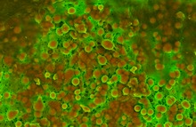
Density-Dependent Colour Scanning Electron Micrograph SEM (DDC-SEM) of cardiovascular calcification, showing in orange calcium phosphate spherical particles (denser material) and, in green, the extracellular matrix (less dense material)^{[49]}
Population-based studies show that atherosclerosis, the major precursor of cardiovascular disease, begins in childhood. The Pathobiological Determinants of Atherosclerosis in Youth Study demonstrated that intimal lesions appear in all the aortas and more than half of the right coronary arteries of youths aged 7–9 years.^{[50]}
This is extremely important considering that 1 in 3 people die from complications attributable to atherosclerosis. In order to stem the tide, education and awareness that cardiovascular disease poses the greatest threat, and measures to prevent or reverse this disease must be taken.
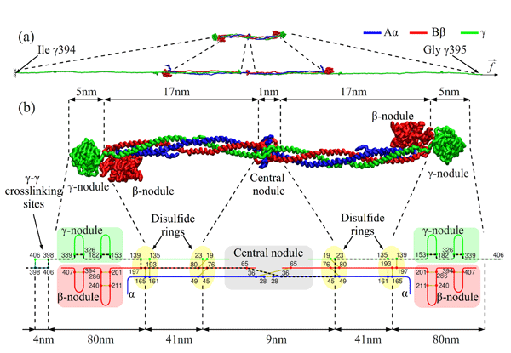
Obesity and diabetes mellitus are often linked to cardiovascular disease,^{[51]} as are a history of chronic kidney disease and hypercholesterolaemia.^{[52]} In fact, cardiovascular disease is the most life-threatening of the diabetic complications and diabetics are two- to four-fold more likely to die of cardiovascular-related causes than nondiabetics.^{[53][54][55]}
Screening ECGs (either at rest or with exercise) are not recommended in those without symptoms who are at low risk.^{[56]} This includes those who are young without risk factors.^{[57]} In those at higher risk the evidence for screening with ECGs is inconclusive.^{[56]}
Additionally echocardiography, myocardial perfusion imaging, and cardiac stress testing is not recommended in those at low risk who do not have symptoms.^{[58]}
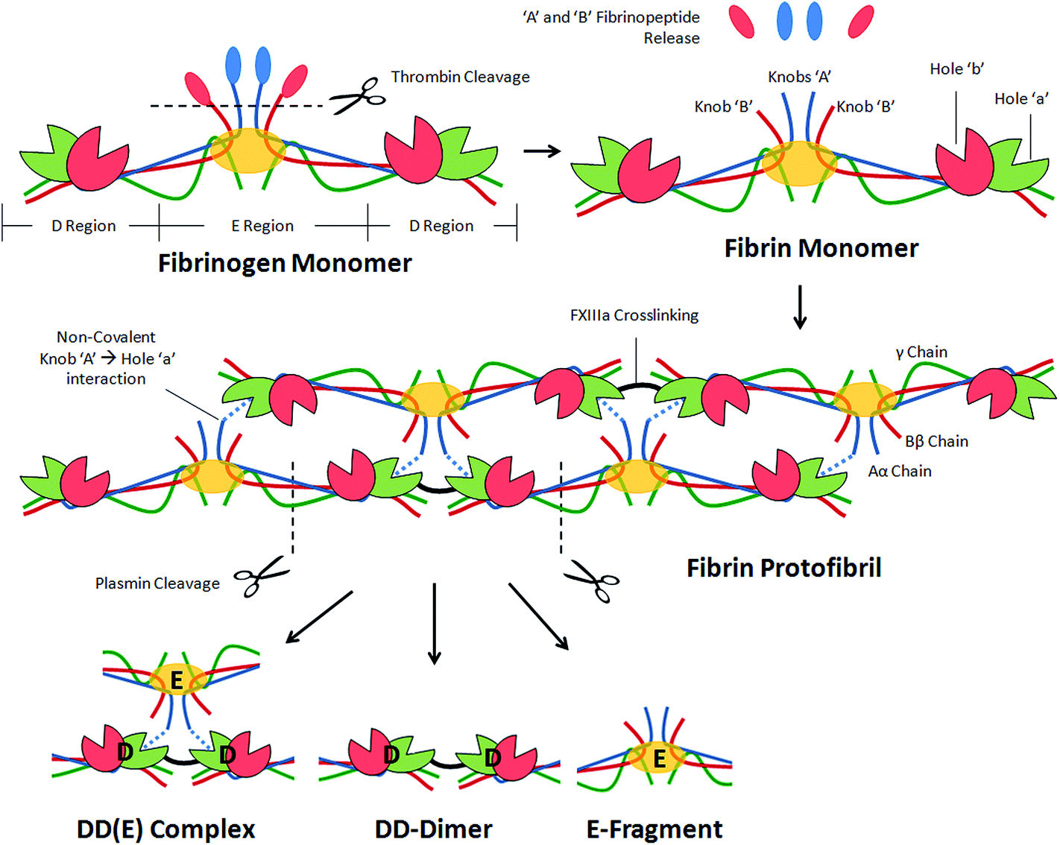
See also: Saturated fat and cardiovascular disease controversy and Salt and cardiovascular disease
A diet high in fruits and vegetables decreases the risk of cardiovascular disease and death.^{[63]} Evidence suggests that the Mediterranean diet may improve cardiovascular outcomes.^{[80]} There is also evidence that a Mediterranean diet may be more effective than a low-fat diet in bringing about long-term changes to cardiovascular risk factors (e.g., lower cholesterol level and blood pressure).^{[81]} The DASH diet (high in nuts, fish, fruits and vegetables, and low in sweets, red meat and fat) has been shown to reduce blood pressure,^{[82]} lower total and low density lipoprotein cholesterol^{[83]} and improve metabolic syndrome;^{[84]} but the long-term benefits outside the context of a clinical trial have been questioned.^{[85]} A high fiber diet appears to lower the risk.^{[86]}
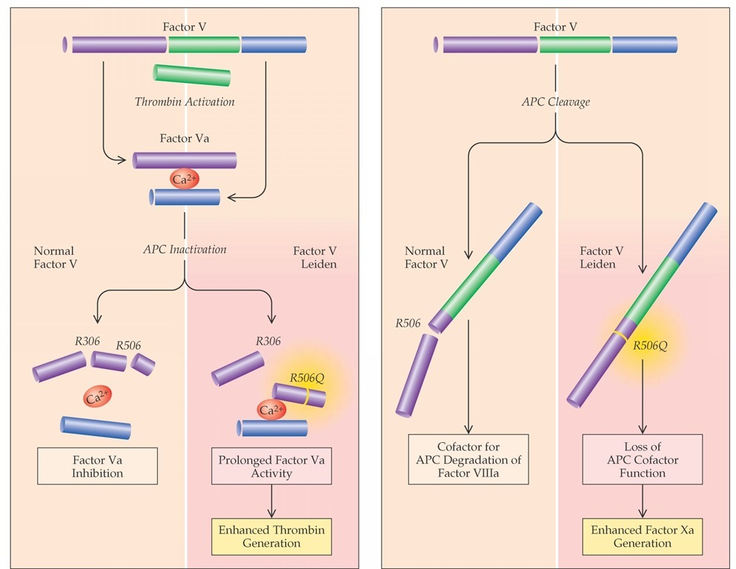

Factor V Leiden
Factor V Leiden thrombophilia^{[1]} is a genetic disorder of blood clotting. Factor V Leiden is a variant (mutated form) of human factor V (one of several substances that helps blood clot) that causes an increase in blood clotting (hypercoagulability). With this mutation, the protein secreted that helps blood not clot is unable to do so, and therefore clotting is more likely.^{[2]} Factor V Leiden is the most common hereditary hypercoagulability (prone to clotting) disorder amongst ethnic Europeans.^{[3][4][5]} It is named after the Dutch city Leiden, where it was first identified in 1994 by Prof R. Bertina et al.^{[6]}
In the normal person, factor V functions as a cofactor to allow factor Xa to activate the enzyme thrombin. Thrombin in turn cleaves fibrinogen to form fibrin, which polymerizes to form the dense meshwork that makes up the majority of a clot. Activated protein C (aPC) is a natural anticoagulant that acts to limit the extent of clotting by cleaving and degrading factor V.
Layman's terms: Normally, Factor V works with other proteins and enzymes to create the substances the body needs to regulate clotting. Factor V works along with factor Xa (another protein related to clotting) to activate thrombin, which is an enzyme that lays dormant until activated, or "turned on". When Thrombin is activated, it creates fibrinogen, which is the enzyme that creates fibrin, which is the enzyme responsible for helping clots to form. This is how factor V functions in a healthy person without this genetic mutation.
SNP: Factor V Leiden
Name(s) | Factor V Leiden, Arg506Gln, R506Q, G1691A
Gene | Factor V
Chromosome | 1
External databases
Ensembl | Human SNPView
dbSNP | 6025
HapMap | 6025
SNPedia | 6025
HgenetInfoDB | 6025
ALFRED | SI001216K
Factor V Leiden is an autosomal dominant genetic condition that exhibits incomplete penetrance, i.e. not every person who has the mutation develops the disease. The condition results in a factor V variant that cannot be as easily degraded by aPC (activated Protein C). The gene that codes the protein is referred to as F5. Mutation of this gene—a single nucleotide polymorphism (SNP) is located in exon 10.^{[7]} As a missense substitution of base G to base A, it changes the protein's amino acid from arginine to glutamine. Depending on the chosen start the position of the nucleotide variant is either at position 1691 or 1746.^{[8]} It also affects the amino acid position for the variant, which is either 506 or 534. (Together with the general lack of nomenclature standard, this variance means that the SNP can be referred to in several ways, such as G1691A, c.1691G>A, 1691G>A, c.1746G>A, p.Arg534Gln, Arg506Gln, R506Q or rs6025.) Since this amino acid is normally the cleavage site for aPC, the mutation prevents efficient inactivation of factor V. When factor V remains active, it facilitates overproduction of thrombin leading to generation of excess fibrin and excess clotting.
The excessive clotting that occurs in this disorder is almost always restricted to the veins, where the clotting may cause a deep vein thrombosis (DVT). If the venous clots break off, these clots can travel through the right side of the heart to the lung where they block a pulmonary blood vessel and cause a pulmonary embolism. It is extremely rare for this disorder to cause the formation of clots in arteries that can lead to stroke or heart attack, though a "mini-stroke", known as a transient ischemic attack, is more common. Given that this disease displays incomplete dominance, those who are homozygous for the mutated allele are at a heightened risk for the events detailed above versus those that are heterozygous for the mutation.
Suspicion of factor V Leiden being the cause for any thrombotic event should be considered in any Caucasian patient below the age of 45, or in any person with a family history of venous thrombosis.
There are a few different methods by which this condition can be diagnosed. Most laboratories screen 'at risk' patients with either a snake venom (e.g. dilute Russell's viper venom time) based test or an aPTT based test. In both methods, the time it takes for blood to clot is decreased in the presence of the factor V Leiden mutation. This is done by running two tests simultaneously; one test is run in the presence of activated protein C (APC) and the other, in the absence. A ratio is determined based on the two tests and the results signify to the laboratory whether APC is working or not. These are quick, three-minute, automated tests that most hospital laboratories can easily perform.
There is also a genetic test that can be done for this disorder. The mutation (a 1691G→A substitution) removes a cleavage site of the restriction endonuclease MnlI, so PCR, treatment with MnlI, and then DNA electrophoresis will give a diagnosis.

Epidemiology
Studies have found that about 5 percent of Caucasians in North America have factor V Leiden. The condition is less common in Latin Americans and African-Americans and is extremely rare in people of Asian descent.
Up to 30 percent of patients who present with deep vein thrombosis (DVT) or pulmonary embolism have this condition. The risk of developing a clot in a blood vessel depends on whether a person inherits one or two copies of the factor V Leiden mutation. Inheriting one copy of the mutation from a parent (heterozygous) increases by fourfold to eightfold the chance of developing a clot. People who inherit two copies of the mutation (homozygous), one from each parent, may have up to 80 times the usual risk of developing this type of blood clot.^{[9]} Considering that the risk of developing an abnormal blood clot averages about 1 in 1,000 per year in the general population, the presence of one copy of the factor V Leiden mutation increases that risk to between 4 in 1,000 to 8 in 1,000. Having two copies of the mutation may raise the risk as high as 80 in 1,000. It is unclear whether these individuals are at increased risk for recurrent venous thrombosis. While only 1 percent of people with factor V Leiden have two copies of the defective gene, these homozygous individuals have a more severe clinical condition. The presence of acquired risk factors for venous thrombosis—including smoking, use of estrogen-containing (combined) forms of hormonal contraception, and recent surgery—further increase the chance that an individual with the factor V Leiden mutation will develop DVT.
Women with factor V Leiden have a substantially increased risk of clotting in pregnancy (and on estrogen-containing birth control pills or hormone replacement) in the form of deep vein thrombosis and pulmonary embolism. They also may have a small increased risk of preeclampsia, may have a small increased risk of low birth weight babies, may have a small increased risk of miscarriage and stillbirth due to either clotting in the placenta, umbilical cord, or the fetus (fetal clotting may depend on whether the baby has inherited the gene) or influences the clotting system may have on placental development.^{[10]} Note that many of these women go through one or more pregnancies with no difficulties, while others may repeatedly have pregnancy complications, and still others may develop clots within weeks of becoming pregnant.
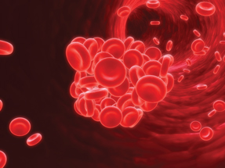

Prothrombin G20210A
Prothrombin G20210A (also the prothrombin 20210 mutation, the factor II mutation, or the prothrombin mutation) is a genetic variant that approximately doubles or triples the risk of forming blood clots in the veins. The variant is commonly associated with the disease venous thromboembolism (VTE), which includes both deep vein thrombosis and pulmonary embolism. Most carriers, though, never develop VTE in their lifetime.^{[1]}
Prothrombin G20210A was identified in the 1990s, is almost exclusively present in Caucasians,^{[1]} and is estimated to have originated in that population slightly over 20,000 years ago.^{[2]} About 2 to 3% of Caucasians carry the variant,^{[3]} and it confers a 2- to 3-fold higher risk of VTE. Deficiencies in the anticoagulants Protein C and Protein S give a higher risk (5- to 10-fold).^{[1]} Behind non-O blood type^{[4]} and factor V Leiden, prothrombin G20210A is one of the most common genetic risk factors for VTE.^{[5]}
The polymorphism is located in a noncoding region of the prothrombin gene (3' untranslated region nucleotide 20210^{[a]}), replacing guanine with adenine.^{[5][7]} The position is at or near where the pre-mRNA will have the poly-A tail attached.^{[7]} The variant causes elevated plasma prothrombin levels (hyperprothrombinemia),^{[5]} possibly due to increased pre-mRNA stability.^{[7]} Prothrombin is the precursor to thrombin, which plays a key role in causing blood to clot (blood coagulation). G20210A can thus contribute to a state of hypercoagulability, but not particularly with arterial thrombosis.^{[5]} A 2006 meta-analysis showed only a 1.3-fold increased risk for coronary disease.^{[8]}
Heterozygous carriers who take oral contraceptives are at a 15-fold increased risk of VTE,^{[3]} while carriers also heterozygous with factor V Leiden have an approximate 20-fold higher risk.^{[1]} In a recommendation statement on VTE, genetic testing for G20210A in adults that developed unprovoked VTE^{[b]} was disadvised, as was testing in asymptomatic family members related to G20210A carriers who developed VTE.^{[9]} In those who develop VTE, the results of thrombophilia tests (wherein the variant can be detected) rarely play a role in the length of treatment.^{[10]}
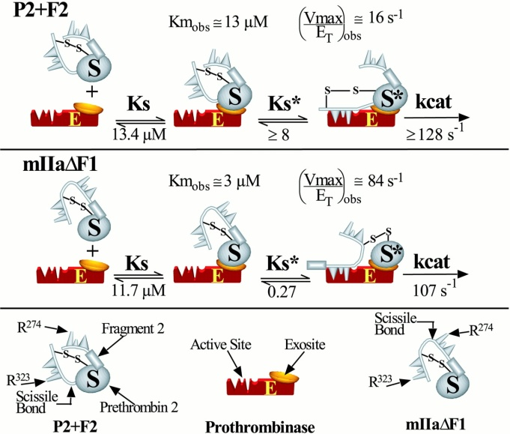

The overall absolute risk of venous thrombosis per 100.000 woman years in current use of combined oral contraceptives is approximately 60, compared to 30 in non-users.^{[18]} The risk of thromboembolism varies with different types of birth control pills; Compared with combined oral contraceptives containing levonorgestrel (LNG), and with the same dose of estrogen and duration of use, the rate ratio of deep venous thrombosis for combined oral contraceptives with norethisterone is 0.98, with norgestimate 1.19, with desogestrel (DSG) 1.82, with gestodene 1.86, with drospirenone (DRSP) 1.64, and with cyproterone acetate 1.88.^{[18]} Venous thromboembolism occurs in 100–200 per 100.000 pregnant women every year.^{[18]}
Regarding family history, age has substantial effect modification. For individuals with two or more affected siblings, the highest incidence rates is found among those ≥70 years of age (390 per 100 000 in male and 370 per 100 000 in female individuals), whereas the highest incidence ratios compared to those without affected siblings occurred at much younger ages (ratio of 4.3 among male individuals 20 to 29 years of age and 5.5 among female individuals 10 to 19 years of age).^{[19]}

Pathophysiology
In contrast to the understanding for how arterial thromboses occur, as with heart attacks, venous thrombosis formation is not well understood.^{[20]} With arterial thrombosis, blood vessel wall damage is required for thrombosis formation, as it initiates coagulation,^{[20]} but the majority of venous thrombi form without any injured epithelium.^{[4]}
Red blood cells and fibrin are the main components of venous thrombi,^{[4]} and the thrombi appear to attach to the blood vessel wall endothelium, normally a non-thrombogenic surface, with fibrin.^{[20]} Platelets in venous thrombi attach to downstream fibrin, while in arterial thrombi, they compose the core.^{[20]} As a whole, platelets constitute less of venous thrombi when compared to arterial ones.^{[4]} The process is thought to be initiated by tissue factor-affected thrombin production, which leads to fibrin deposition.^{[5]}
The valves of veins are a recognized site of VT initiation. Due to the blood flow pattern, the base of the valve sinus is particularly deprived of oxygen (hypoxic). Stasis excacerbates hypoxia, and this state is linked to the activation of white blood cells (leukocytes) and the endothelium. Specifically, the two pathways of hypoxia-inducible factor-1 (HIF-1) and early growth response 1 (EGR-1) are activated by hypoxia, and they contribute to monocyte and endothelial activation. Hypoxia also causes reactive oxygen species (ROS) production that can activate HIF-1, EGR-1, and nuclear factor-κB (NF-κB), which regulates HIF-1 transcription.^{[5]}
HIF-1 and EGR-1 pathways lead to monocyte association with endothelial proteins, such as P-selectin, prompting monocytes to release tissue factor filled microvesicles, which presumably initiate fibrin deposition (via thrombin) after binding the endothelial surface.^{[5]}
Evidence supports the use of heparin in people following surgery who have a high risk of thrombosis to reduce the risk of DVTs; however, the effect on PEs or overall mortality is not known.^{[21][22][23]} In hospitalized non-surgical patients, mortality decreased but not statistically significant.^{[24]} Heparin may also decrease the risk of PE and DVT, but it increases major bleeding events yielding little or no overall clinical benefit.^{[24][25]} It does not appear however to decrease the rate of symptomatic DVTs.^{[24]} Using both heparin and compression stockings appears better than either one alone in reducing the rate of DVT.^{[26]}
In hospitalized people who have had a stroke and not had surgery, mechanical measures (compression stockings) resulted in skin damage and no clinical improvement.^{[24]} Data on the effectiveness of compression stockings among hospitalized non-surgical patients without stroke is scarce.^{[24]}
The American College of Physicians (ACP) gave three strong recommendations with moderate quality evidence on VTE prevention in non-surgical patients: that hospitalized patients be assessed for their risk of thromboembolism and bleeding before prophylaxis (prevention); that heparin or a related drug is used if potential benefits are thought to outweigh potential harms; and that graduated compression stockings not be used.^{[27]} As an ACP policy implication, the guideline stated a lack of support for any performance measures that incentivize physicians to apply universal prophylaxis without regard to the risks.^{[27]} Goldhaber recommends that people should be assessed at their hospital discharge for persistent high-risk of venous thrombosis, and that people who adopt a heart-healthy lifestyle might lower their risk of venous thrombosis.^{[28]}
In those with cancer who are still walking about yet receiving chemotherapy LMWH decreases the risk of VTE.^{[29]} Due to concerns of bleeding its routine use is not recommended.^{[29]} In adults who have had their low leg casted or placed in a brace for more than a week, LMWH decreased VTE risk.^{[30]} Following the completion of warfarin in those with prior VTE, long term aspirin is beneficial.^{[31]}
Evidence-based clinical guidelines from the American College of Chest Physicians were published in February 2012 for the treatment of VTE.^{[32]} Medications used to treat this condition include anticoagulants such as heparin, fondaparinux and more recently dabigatran has shown promise.^{[33]} Vitamin K antagonists such as warfarin are also commonly used.
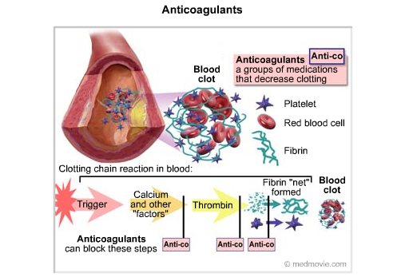
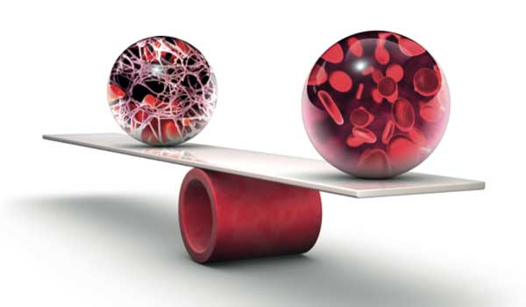
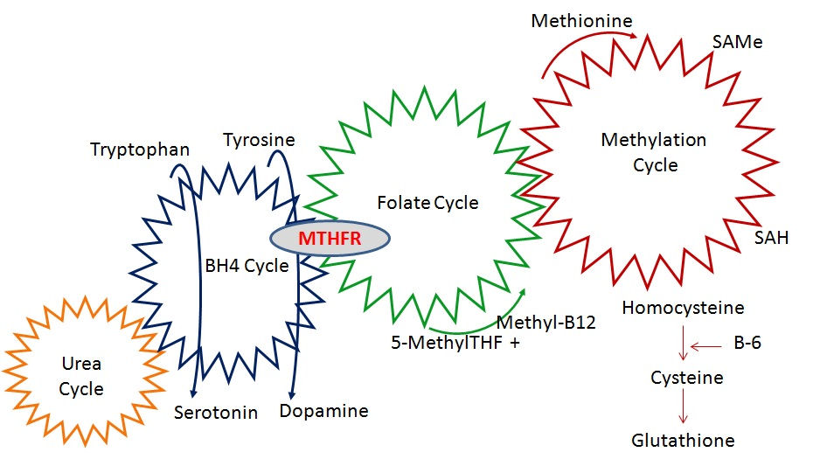
Protein C deficiency may cause purpura fulminans, a severe clotting disorder in the newborn that leads to both tissue death and bleeding into the skin and other organs. The condition has also been described in adults. Protein C and protein S deficiency have also been associated with an increased risk of skin necrosis on commencing anticoagulant treatment with warfarin or related drugs.^{[2][11]}
Thrombophilia can be congenital or acquired. Congenital thrombophilia refers to inborn conditions (and usually hereditary, in which case "hereditary thrombophilia" may be used) that increase the tendency to develop thrombosis, while, on the other hand, acquired thrombophilia refers to conditions that arise later in life.
The most common types of congenital thrombophilia are those that arise as a result of overactivity of coagulation factors. They are relatively mild, and are therefore classified as "type II" defects.^{[12]} The most common ones are factor V Leiden (a mutation in the F5 gene at position 1691) and prothrombin G20210A, a mutation in prothrombin (at position 20210 in the 3' untranslated region of the gene).^{[1][13]}
The rare forms of congenital thrombophilia are typically caused by a deficiency of natural anticoagulants. They are classified as "type I" and are more severe in their propensity to cause thrombosis.^{[12]} The main ones are antithrombin III deficiency, protein C deficiency and protein S deficiency.^{[1][13]} Milder rare congenital thrombophilias are factor XIII mutation^{[13]} and familial dysfibrinogenemia (an abnormal fibrinogen).^{[13]} It is unclear whether congenital disorders of fibrinolysis (the system that destroys clots) are major contributors to thrombosis risk.^{[12]} Congenital deficiency of plasminogen, for instance, mainly causes eye symptoms and sometimes problems in other organs, but the link with thrombosis has been more uncertain.^{[14]}

Abstract of My Research Article

In this study, 208 persons without clinical symptoms of heart disease - cardiovascular and venous thrombosis history of Tabriz were evaluated by different tribes. To assess the distribution of the polymorphism of factor 5 Leiden, a genetic heart disease - cardiovascular (CVD), in the city of Tabriz reverse hybridization method was used for the rapid and accurate diagnosis. Under the Multiplex PCR and hybridization experiments on the test strip. The oligonucleotide probes containing allele-specific tape parallel lines. Leiden mutation rate of 5 (%1/2) in the study population than previously published figures in Tehran (% 2/7), respectively. In this study, the distribution of mutant alleles of the 5 Leiden tribal population in the city of Tabriz. The results are compared with other studies. This study is the most comprehensive study to date on the 5-Leiden gene polymorphism was done in the city.

Keywords: venous thrombosis, polymorphism, Factor 5 Leiden, allele frequency, Tabriz - Iran.
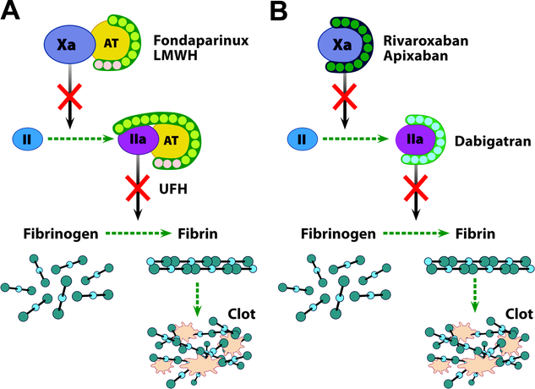

Introduction of My Research Article

Heart disease - cardiovascular (CVD), refers to a group of multiple failure in which the heart, arteries and veins lose their normal function. Among these diseases, Venous thrombosis (VTE), third heart failure - a common vessel in the world that year, 1 out of every 1000 people involved makes ¹. The main trend is to safeguard the coagulation cascade by setting the exact reactions between the components of the vessel wall, platelets and plasma proteins, blood loss ². Defects in the regulation of the activity of this cascade may lead to the formation of arterial and venous thrombosis and life-threatening adverse. The most common form of inherited thrombosis, Factor 5 Leiden variant G1691A gene is located on chromosome 1q23 and is No. 1 in the form of resistance to activated protein C (APC) leads. Factor 5 Leiden gene mutation point in the surrogate instead of guanine, adenine at nucleotide 1691 is created. Factor 5 Leiden mutation in heterozygous carriers, inactivation of activated factor 5 (FVa), and disrupted by APC leads to a prothrombotic state ³. 5 times the risk of thrombosis in individuals heterozygous and homozygous individuals increases the risk by 50 to 100 times ⁴. The purpose of this study was to determine the frequency of polymorphisms in the population of Tabriz Factor 5 Leiden That genetic factors influencing coronary heart disease - specific vascular and epidemiologic data for future research to ⁵.

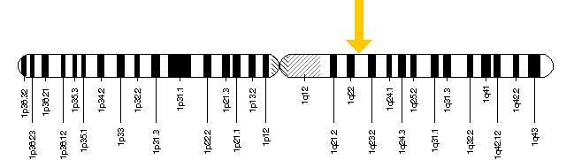
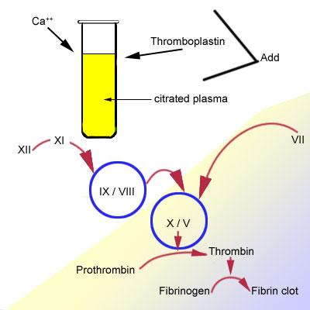

Materials and methods
In this study of 180 healthy subjects without symptoms of cardio - vascular and venous thrombosis history, including 96 men and 84 women with an average age between 23 to 61 years, were examined at ⁶. These individuals were selected from all the geographical Tabriz. After obtaining informed consent from participants, peripheral blood smear mixed with sodium EDTA and are prepared using saturated salt, DNA was extracted genomic ⁷. Reverse hybridization method was used to identify carriers of the CVD Strip Assay kit was labeled Austria. The next steps were performed according to protocol test kit ⁸.
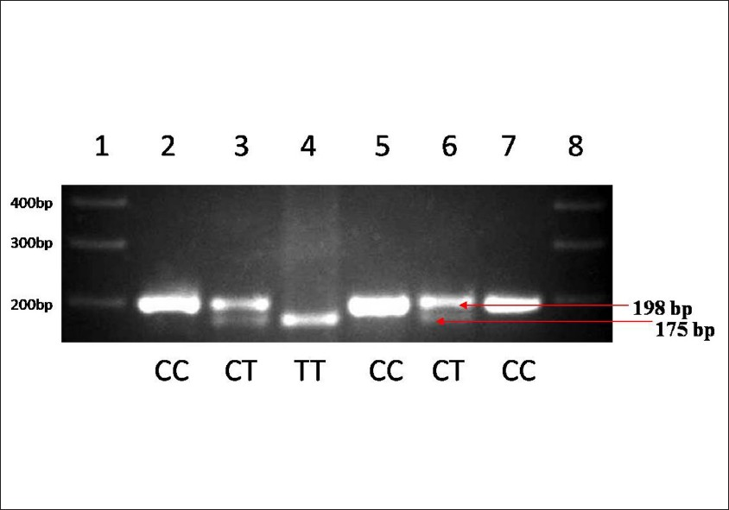
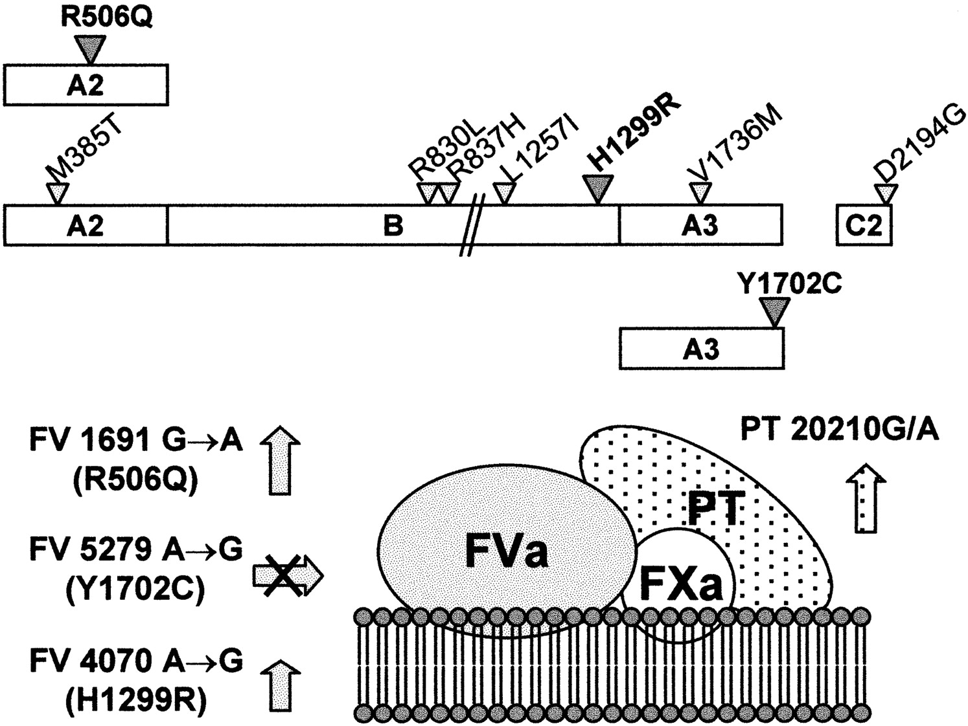
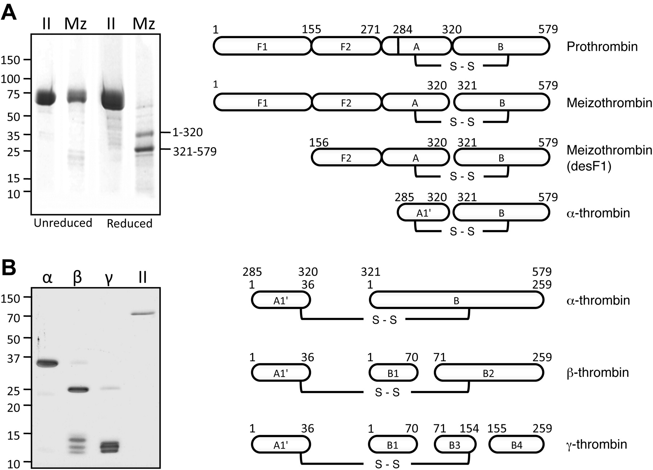
Findings
180 people from different geographical locations were studied in Tabriz. Genotype and allele frequencies of polymorphisms in Tabriz geographical locations are listed in Table 1. The most common allele observed in this project belongs to FV1691G frequency is 0.96. None of the studied individuals were homozygous for the polymorphism Factor 5 Leiden ⁹. Population of Hardy - Weinberg equilibrium was.
 |  | Center | North | North East | North West | South | South East | South West | West
Genotype GG |  | 92/1 | 98/965 | 98/979 | 91/6 | 79/476 | 100 | 99/675 | 95/2
Genotype GA |  | 2/35 | 0/011 |  | 9/4 | 20/524 | - | 0/325 | 4/8
Allele G |  | 0/969 | 0/992 | 1 | 0/932 | 0/86 | 1 | 0/9 | 0/939
Allele A |  | 0/031 | - | - | 0/068 | 0/14 | - | 0/1 | 0/061
Table 1: Frequency of genotypes and allele frequencies of polymorphisms Factor 5 Leiden (FV1691G / A) in different geographical locations in Tabriz.
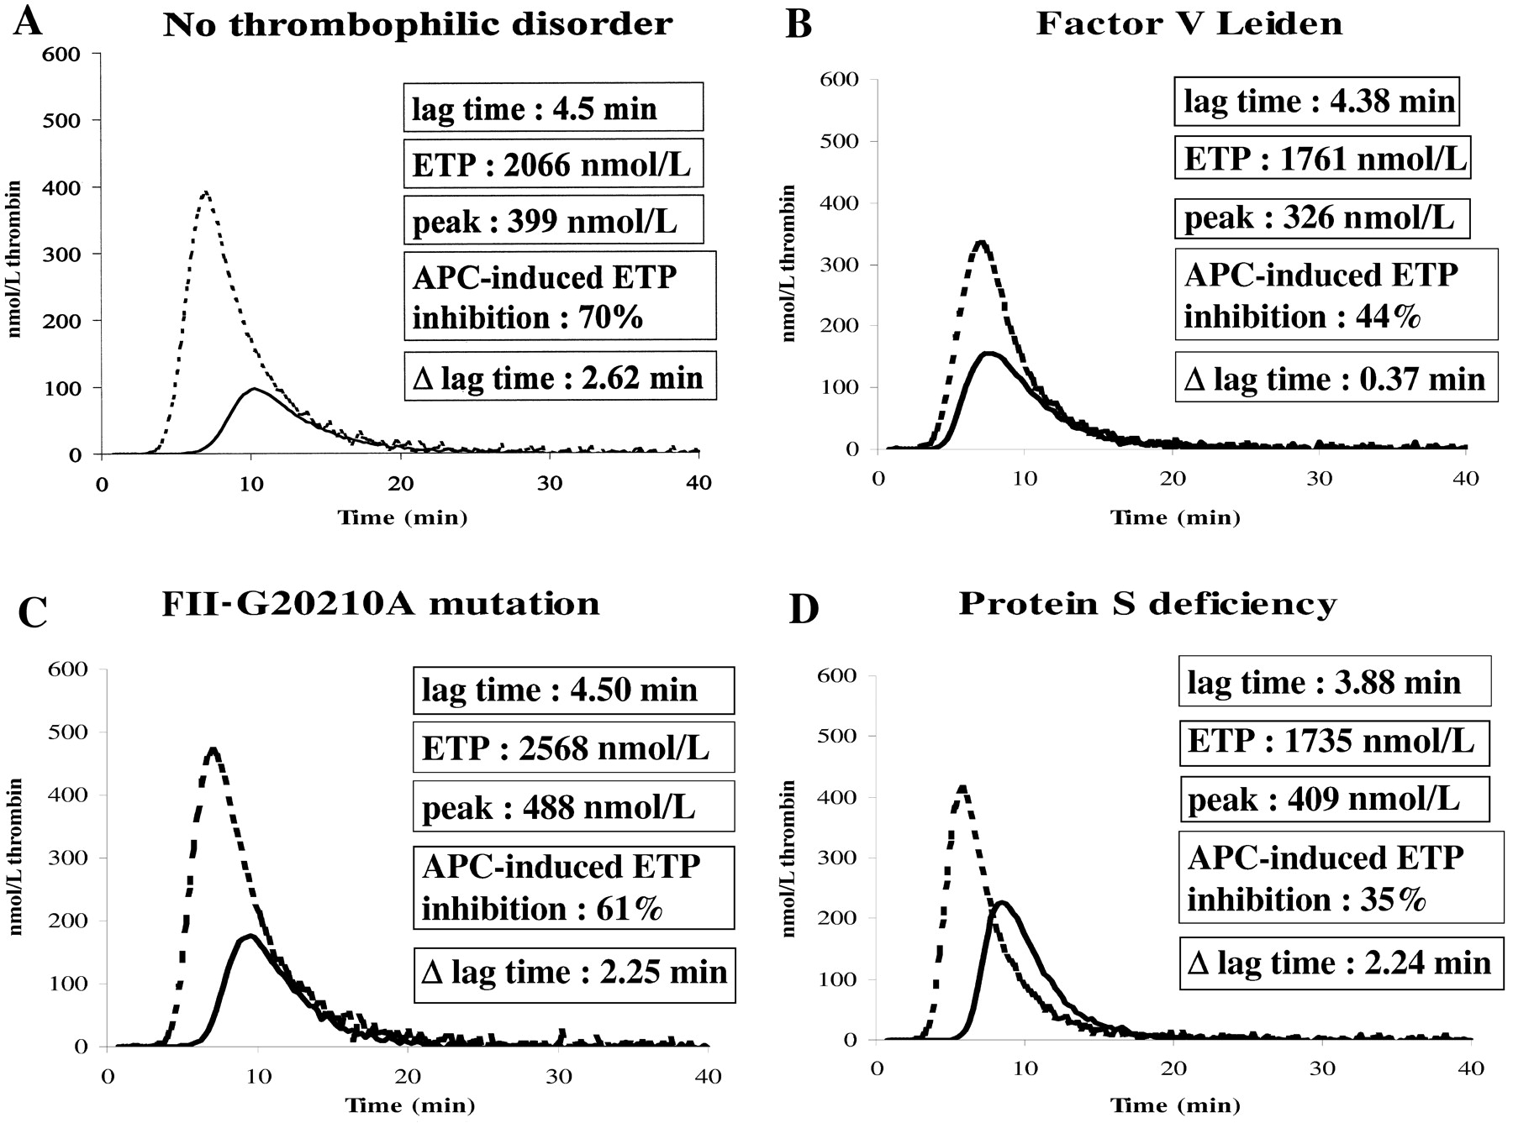
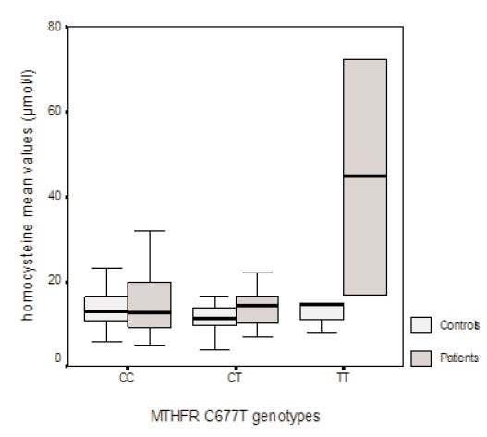
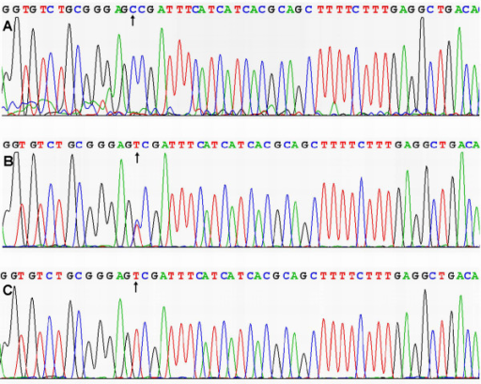

Discussion and Conclusion
Cardiovascular diseases - cardiovascular, sudden onset, and one of the major health problems in developing countries, such as Iran. This group of diseases with a prevalence of 39 percent, are the leading cause of death in ¹⁰. United States of America every year more than 300,000 people have lost their lives due to heart disease. Factor 5 Leiden, prothrombin G20210A and MTHFR C677T frequency 5, 3, and 10% heterozygous carriers, three are the most important cause of thrombophilia polymorphism in Caucasian populations are known.
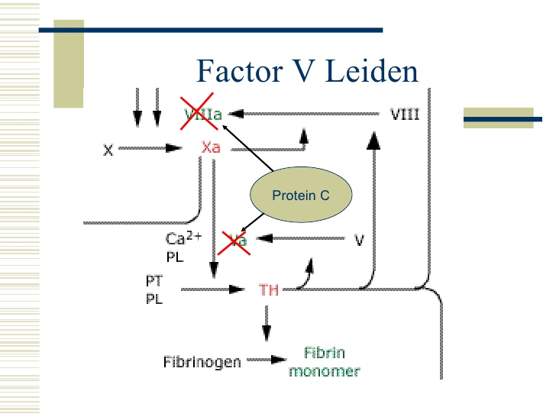
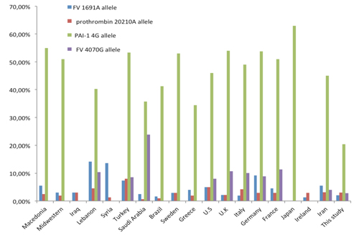
The three polymorphisms of the derivation of such a Caucasian population of Asians were formed. Mutation prevalence in Europe and North America is higher mutation frequency in China, Japan, Africa is almost equal to zero ¹¹. Greece and Cyprus, with a frequency of 13% and 14% of the most common places for this mutation among European countries. Most of the mutations on the study of the southern city of Tabriz is the frequency 20/524 percent. According to the information obtained from this project can be concluded that the study of polymorphisms involved in venous thrombosis May be the basis for future research on the population of other cities in the diagnosis of venous thrombosis is.
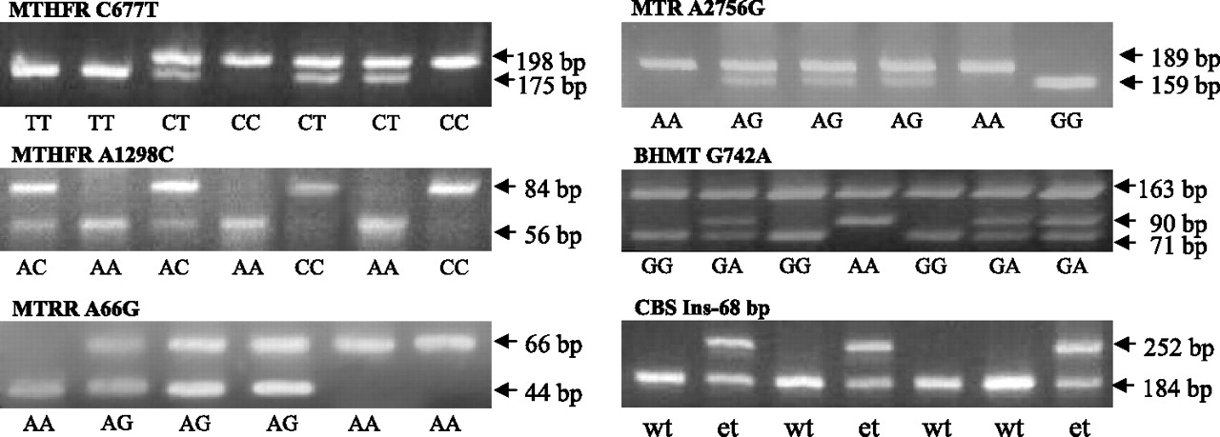
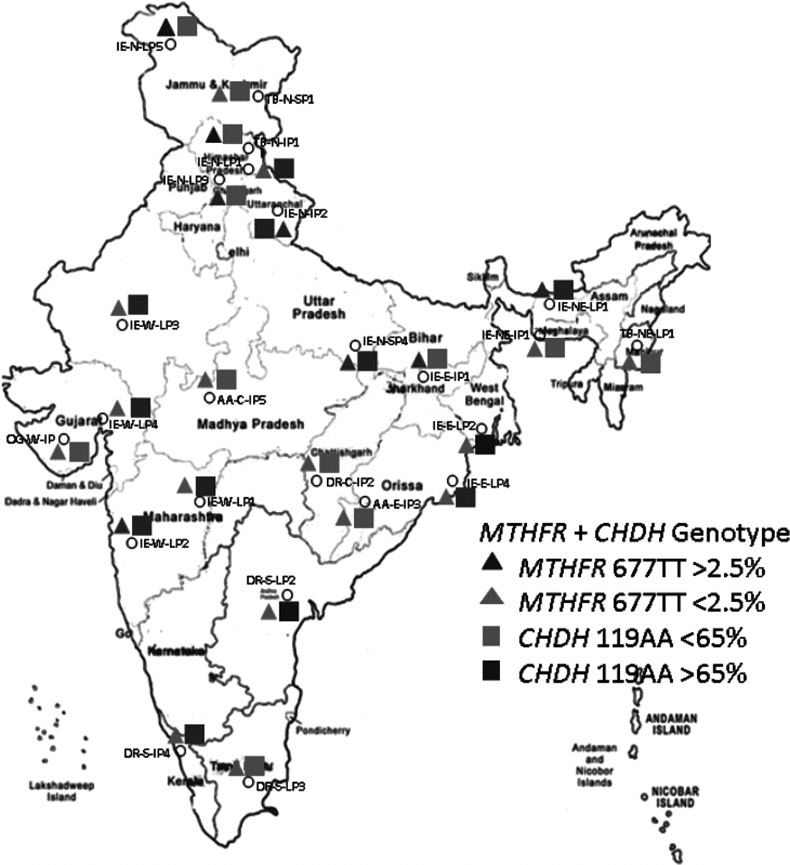

References
1. Ridker PM, Miletich JP, Hennekens CH, Buring JE (1997). "Ethnic distribution of factor V Leiden in 4047 men and women. Implications for venous thromboembolism screening". JAMA 277 (16): 1305–7.
2. Gregg JP, Yamane AJ, Grody WW (December 1997). "Prevalence of the factor V-Leiden mutation in four distinct American ethnic populations". American Journal of Medical Genetics 73 (3): 334–6.
3. De Stefano V, Chiusolo P, Paciaroni K, Leone G (1998). "Epidemiology of factor V Leiden: clinical implications". Seminars in Thrombosis and Hemostasis 24 (4): 367–79.
4. Bertina RM, Koeleman BP, Koster T, et al. (May 1994). "Mutation in blood coagulation factor V associated with resistance to activated protein C". Nature 369 (6475): 64–7.
5. Rodger MA, Paidas M, McLintock C, et al. (August 2008). "Inherited thrombophilia and pregnancy complications revisited". Obstetrics and Gynecology 112 (2 Pt 1): 320–24.
6. Bertina RM, Koeleman BP, Koster T, et al. (1994). "Mutation in blood coagulation factor V associated with resistance to activated protein C". Nature 369 (6475): 64–7.
7. Heeb, M J; Kojima Y; Rosing J; Tans G; Griffin J H (Dec 1999). "C-terminal residues 621-635 of protein S are essential for binding to factor Va". J. Biol. Chem. (UNITED STATES) 274 (51): 36187–92.
8. Heeb, M J; Mesters R M; Tans G; Rosing J; Griffin J H (Feb 1993). "Binding of protein S to factor Va associated with inhibition of prothrombinase that is independent of activated protein C". J. Biol. Chem. (UNITED STATES) 268 (4): 2872–7.
9. Owren, PA (1947). "Parahaemophilia. Haemorrhagic diathesis due to absence of a previously unknown clotting factor". Lancet 1 (6449): 446–51.
10. Andreassi MG, Botto N, Maffei S (2006). "Factor V Leiden, prothrombin G20210A substitution and hormone therapy: indications for molecular screening". Clin. Chem. Lab. Med. 44 (5): 514–21
11. Segers K, Dahlback B, Nicolaes GA (2007). "Coagulation factor V and thrombophilia: background and mechanisms". Thrombosis Haemost. 98 (3): 530–542.
12. The discovery of factor V: a tricky clotting factor". J. Thromb. Haemost. 1 (2): 206–13.
13. Mitchell RS, Kumar V, Abbas AK, Fausto N (2007). "Chapter 4". Robbins Basic Pathology (Eighth ed.). Philadelphia: Saunders.
14. Kyrle PA, Rosendaal FR, Eichinger S (December 2010). "Risk assessment for recurrent venous thrombosis". Lancet 376 (9757): 2032–9.
15. de Moerloose P, Boehlen F (April 2007). "Inherited thrombophilia in arterial disease: a selective review". Semin. Hematol. 44 (2): 106–13.
16. Rai R, Regan L (August 2006). "Recurrent miscarriage". Lancet 368 (9535): 601–11.
17. Ruiz-Irastorza G, Crowther M, Branch W, Khamashta MA (October 2010). "Antiphospholipid syndrome". Lancet 376 (9751): 1498–509.
18. Papadakis E, Hoffman R, Brenner B (November 2010). "Thrombohemorrhagic complications of myeloproliferative disorders". Blood Rev. 24 (6): 227–32.
19. Prandoni P, Falanga A, Piccioli A (June 2005). "Cancer and venous thromboembolism". Lancet Oncol. 6 (6): 401–10.
20. Quera R, Shanahan F (October 2004). "Thromboembolism--an important manifestation of inflammatory bowel disease". Am. J. Gastroenterol. 99 (10): 1971–3.
21. Dominguez-Rodriguez, Alberto (January 2012). "Melatonin and Cardiovascular Disease: Myth or Reality?". Rev Esp Cardiol 65: 215–218.
22. Andraws R, Berger JS, Brown DL (Jun 2005). "Effects of antibiotic therapy on outcomes of patients with coronary artery disease: a meta-analysis of randomized controlled trials".
23. Venuraju SM, Yerramasu A, Corder R, Lahiri A (May 2010). "Osteoprotegerin as a predictor of coronary artery disease and cardiovascular mortality and morbidity". J. Am. Coll. Cardiol. 55 (19): 2049–61.
24. Karakas M, Koenig W (December 2009). "CRP in cardiovascular disease". Herz 34 (8): 607–13.
25. Ignarro, LJ; Balestrieri, ML; Napoli, C (Jan 15, 2007). "Nutrition, physical activity, and cardiovascular disease: an update.". Cardiovascular research 73 (2): 326–40.
26. Spence JD (2006). "Technology Insight: ultrasound measurement of carotid plaque—patient management, genetic research, and therapy evaluation". Nat Clin Pract Neurol 2 (11): 611–9.
27. Kwak, SM; Myung, SK; Lee, YJ; Seo, HG; for the Korean Meta-analysis Study, Group (Apr 9, 2012). "Efficacy of Omega-3 Fatty Acid Supplements (Eicosapentaenoic Acid and Docosahexaenoic Acid) in the Secondary Prevention of Cardiovascular Disease: A Meta-analysis of Randomized, Double-blind, Placebo-Controlled Trials.". Archives of Internal Medicine 172 (9): 686.
28. Reitsma PH, Versteeg HH, Middeldorp S (2012). "Mechanistic view of risk factors for venous thromboembolism". Arterioscler Thromb Vasc Biol 32 (3): 563–8.
29. Ye Z, Liu EH, Higgins JP, Keavney BD, Lowe GD, Collins R, et al. (2006). "Seven haemostatic gene polymorphisms in coronary disease: meta-analysis of 66,155 cases and 91,307 controls". Lancet 367 (9511): 651–8.
30. Gregg JP, Yamane AJ, Grody WW (December 1997). "Prevalence of the factor V-Leiden mutation in four distinct American ethnic populations". American Journal of Medical Genetics 73 (3): 334–6.
31. Hylek EM, Evans-Molina C, Shea C, Henault LE, Regan S (2007). "Major hemorrhage and tolerability of warfarin in the first year of therapy among elderly patients with atrial fibrillation". Circulation 115 (21): 2689–96.
32. Wittkowsky AK (September 2001). "Drug interactions update: drugs, herbs, and oral anticoagulation". J. Thromb. Thrombolysis 12 (1): 67–71.
33. Aissaoui, Nadia; Martins, Edith; Mouly, Stéphane; Weber, Simon; Meune, Christophe (2009). "A meta-analysis of bed rest versus early ambulation in the management of pulmonary embolism, deep vein thrombosis, or both". International Journal of Cardiology 137 (1): 37–41.
34. Anderson, Cathy M.; Overend, Tom J.; Godwin, Julie; Sealy, Christina; Sunderji, Aisha (2009). "Ambulation after Deep Vein Thrombosis: A Systematic Review". Physiotherapy Canada 61 (3): 133–140.
35. Werdan, Karl; Braun-Dullaeus, Rüdiger; Presek, Peter (Aug 2013). "Anticoagulation in Atrial Fibrillation: NOAC’s the Word". Deutsches Ärzteblatt International 110 (31-32): 523–524. doi:10.3238/arztebl.2013.0523. PMC 3782018. PMID 24069072. Things have changed dramatically with the introduction of the new oral anticoagulants (NOACs) — dabigatran, a factor IIa (thrombin) inhibitor, and the factor Xa inhibitors rivaroxaban and apixaban. Clinical trials have shown them therapeutically superior, or at least non-inferior, to VKAs, with less serious side effects.
36. Ron Winslow; Avery Johnson (2007-12-10). "Race Is on for the Next Blood Thinner". Wall Street Journal. p. A12. Retrieved 2008-01-06. ...in a market now dominated by one of the oldest mainstay pills in medicine: the blood thinner warfarin. At least five next-generation blood thinners are in advanced testing to treat or prevent potentially debilitating or life-threatening blood clots in surgery and heart patients. First candidates could reach the market in 2009.
37. Di Nisio M, Middeldorp S, Büller HR (2005). "Direct thrombin inhibitors". N. Engl. J. Med. 353 (10): 1028–40.
38. Steg, PG; Mehta, SR; Jukema, JW; Lip, GY; Gibson, CM; Kovar, F; Kala, P; Garcia-Hernandez, A; Renfurm, RW; Granger, CB; Ruby-1, Investigators (2011).
39. Costantinides, Fulvia; Rizzo, Roberto; Pascazio, Lorenzo; Maglione, Michele (2016-01-28).
40. Stadelmann C, Brück W (November 2004). "Lessons from the neuropathology of atypical forms of multiple sclerosis". Neurol. Sci. 25 (Suppl 4): S319–22.
41. Burton JM, O'Connor PW, Hohol M, Beyene J (12 December 2012). "Oral versus intravenous steroids for treatment of relapses in multiple sclerosis.". The Cochrane database of systematic reviews 12: CD006921.
42. He D, Xu Z, Dong S, Zhang H, Zhou H, Wang L, Zhang S (12 December 2012). Zhou, Hongyu, ed. "Teriflunomide for multiple sclerosis". Cochrane database of systematic reviews (Online) 12: CD009882.
43. Qizilbash N, Mendez I, Sanchez-de la Rosa R (January 2012). "Benefit-risk analysis of glatiramer acetate for relapsing-remitting and clinically isolated syndrome multiple sclerosis". Clin Ther 34 (1): 159–176.e5.
44. Freedman MS (January 2011). "Long-term follow-up of clinical trials of multiple sclerosis therapies". Neurology 76 (1 Suppl 1): S26–34.
45. Bates D (January 2011). "Treatment effects of immunomodulatory therapies at different stages of multiple sclerosis in short-term trials". Neurology 76 (1 Suppl 1): S14–25.
46. Fred D. Lublin; et al. (Jul 15, 2014). "Defining the clinical course of multiple sclerosis, The 2013 revisions". Neurology. 83 (3): 278–286.
47. Pittock SJ, Rodriguez M (2008). "Benign multiple sclerosis: a distinct clinical entity with therapeutic implications". Curr. Top. Microbiol. Immunol. Current Topics in Microbiology and Immunology 318: 1–17.
48. Feinstein A (2007). The clinical neuropsychiatry of multiple sclerosis (2nd ed.). Cambridge: Cambridge University Press. p. 20.
49. Miller D, Barkhof F, Montalban X, Thompson A, Filippi M (May 2005). "Clinically isolated syndromes suggestive of multiple sclerosis, part I: natural history, pathogenesis, diagnosis, and prognosis". Lancet Neurol 4 (5): 281–8.
50. Rovaris M, Confavreux C, Furlan R, Kappos L, Comi G, Filippi M (April 2006). "Secondary progressive multiple sclerosis: current knowledge and future challenges". Lancet Neurol 5 (4): 343–54.
51. Miller DH, Leary SM (October 2007). "Primary-progressive multiple sclerosis". Lancet Neurol 6 (10): 903–12.
52. Stadelmann C, Brück W (November 2004). "Lessons from the neuropathology of atypical forms of multiple sclerosis". Neurol. Sci. 25 (Suppl 4): S319–22.
53. Burton JM, O'Connor PW, Hohol M, Beyene J (12 December 2012). "Oral versus intravenous steroids for treatment of relapses in multiple sclerosis.". The Cochrane database of systematic reviews 12: CD006921.
54. The National Collaborating Centre for Chronic Conditions (2004). Multiple sclerosis : national clinical guideline for diagnosis and management in primary and secondary care (pdf). London: Royal College of Physicians. pp. 54–57.
55. He D, Xu Z, Dong S, Zhang H, Zhou H, Wang L, Zhang S (12 December 2012). Zhou, Hongyu, ed. "Teriflunomide for multiple sclerosis". Cochrane database of systematic reviews (Online) 12: CD009882.
56. "FDA approves new multiple sclerosis treatment Aubagio" (Press release). US FDA. 12 September 2012. Retrieved 21 January 2013.
57. "Biogen Idec’s TECFIDERA™ (Dimethyl Fumarate) Approved in US as a First-Line Oral Treatment for Multiple Sclerosis" (Press release). Biogen Idec. 27 March 2013. Retrieved 4 June 2013.
58. "FDA Approves Lemtrada". Biogen Idec Press Release. 14 November 2013.
59. Manouchehrinia A, Constantinescu CS (October 2012). "Cost-effectiveness of disease-modifying therapies in multiple sclerosis". Current neurology and neuroscience reports 12 (5): 592–600.
60. Hassan-Smith G, Douglas MR (November 2011). "Management and prognosis of multiple sclerosis". British journal of hospital medicine (London, England : 2005) 72 (11): M174–6.

