Edible insects in acquaculture: microbial dynamics in the expolitation of Hermetia illucens as fish meal replacement

Andrea Roncolini¹, Riccardo Sabbatini¹, Vesna Milanovic¹, Cristiana Garofalo¹, Lucia Aquilanti¹, Paola Riolo¹, Sara Ruschioni¹, Ike Olivotto², Matteo Zarantoniello², Andrea Osimani¹

¹Department of Agricultural, Food and Environmantal Sciences, Polytechnic University of Marche
²Department of Marine Sciences, Polytechnic University of Marche

In 2015, EFSA listed a few insect species for their potential as food and feed in the European Union (EFSA Scientific Committee, 2015). Between those species Hermetia illucens (black soldier fly) represents a potential feed for animal rearing, due to its ability in efficiently converting organic wastes into biomass – rich in high-quality protein and fat (Diener et al., 2011; van Huis et al., 2013). Indeed in this study, Danio rerio, a fish species considered as a model for the study of vertebrate development, was fed with three different diets: (i) H. illucens reared on waste obtained from roasting coffee process; (ii) H. illucens reared on insects commercial growth substrate; (iii) a typical fish meal as control diet (Wixon, 2000).
In this context, in order to satisfy EFSA request (ANSES Opinion, 2015), the aim of the present study was to investigate the microbial dynamics along the entire D. rerio rearing chain using H. illucens as fish meal replacement. In more detail, typical fish meal, H. illucens and its growth substrates and frasses were subjected to microbial viable counts for the enumeration of total mesophilic areobes, spore forming bacteria, lactic acid bacteria, Enterobacteriaceae and eumycetes. Moreover the microbiota of the already cited samples and D. rerio gut samples reared with the three different diets was studied by PCR DGGE and metagenomic sequencing.
Among the different insect rearing chains microbial enumeration showed several distinct trends depending on rearing chain or analyzed microbes. Furthermore, PCR DGGE and metagenomic sequencing results highlighted a high biodiversity in the analyzed samples.

The present study was supported by Cariverona scientific research 2017, project n° PJ 2017.0571 - NUTRIFISH.

References
ANSES Opinion Request No 2014-SA-0153, 2015. OPINION of the French Agency for Food, Environmental and Occupational Health & Safety on “the Use of Insects as Food and Feed and the Review of Scientific Knowledge on the Health Risks Related to the Consumption of Insects”. French Agency for Food, Environmental and Occupational Health & Safety, 14 rue Pierre et Marie Curie, 94701 Maisons-Alfort Cedex.
Diener, S., Zurbrügg, C., Roa Gutiérrez, F., Nguyen Dang Hong, M.A., Koottatep, T., Tockner, K., 2011. Black soldier fly larvae for organic waste treatment–prospects and constraints. In: WasteSafe 2011 – 2nd Int. Conf. on Solid Waste Management in the Developing Countries, 13–15 February, Khulna, Bangladesh, pp. 52–59.
EFSA Scientific Committee (2015). Scientific Opinion on a risk profile related to pro- duction and consumption of insects as food and feed. EFSA Journal, 13(10), 4257.
van Huis, A., Van Itterbeeck, J., Klunder, H., Mertens, E., Halloran, A., Muir, G., Vantomme, P., 2013. Edible Insects – Future Prospects for Food and Feed Security. FAO Forestry Paper 171.
Wixon, J. (2000). Danio rerio, the zebrafish. International Journal of Genomics, 1(3), 225-231.

Biography
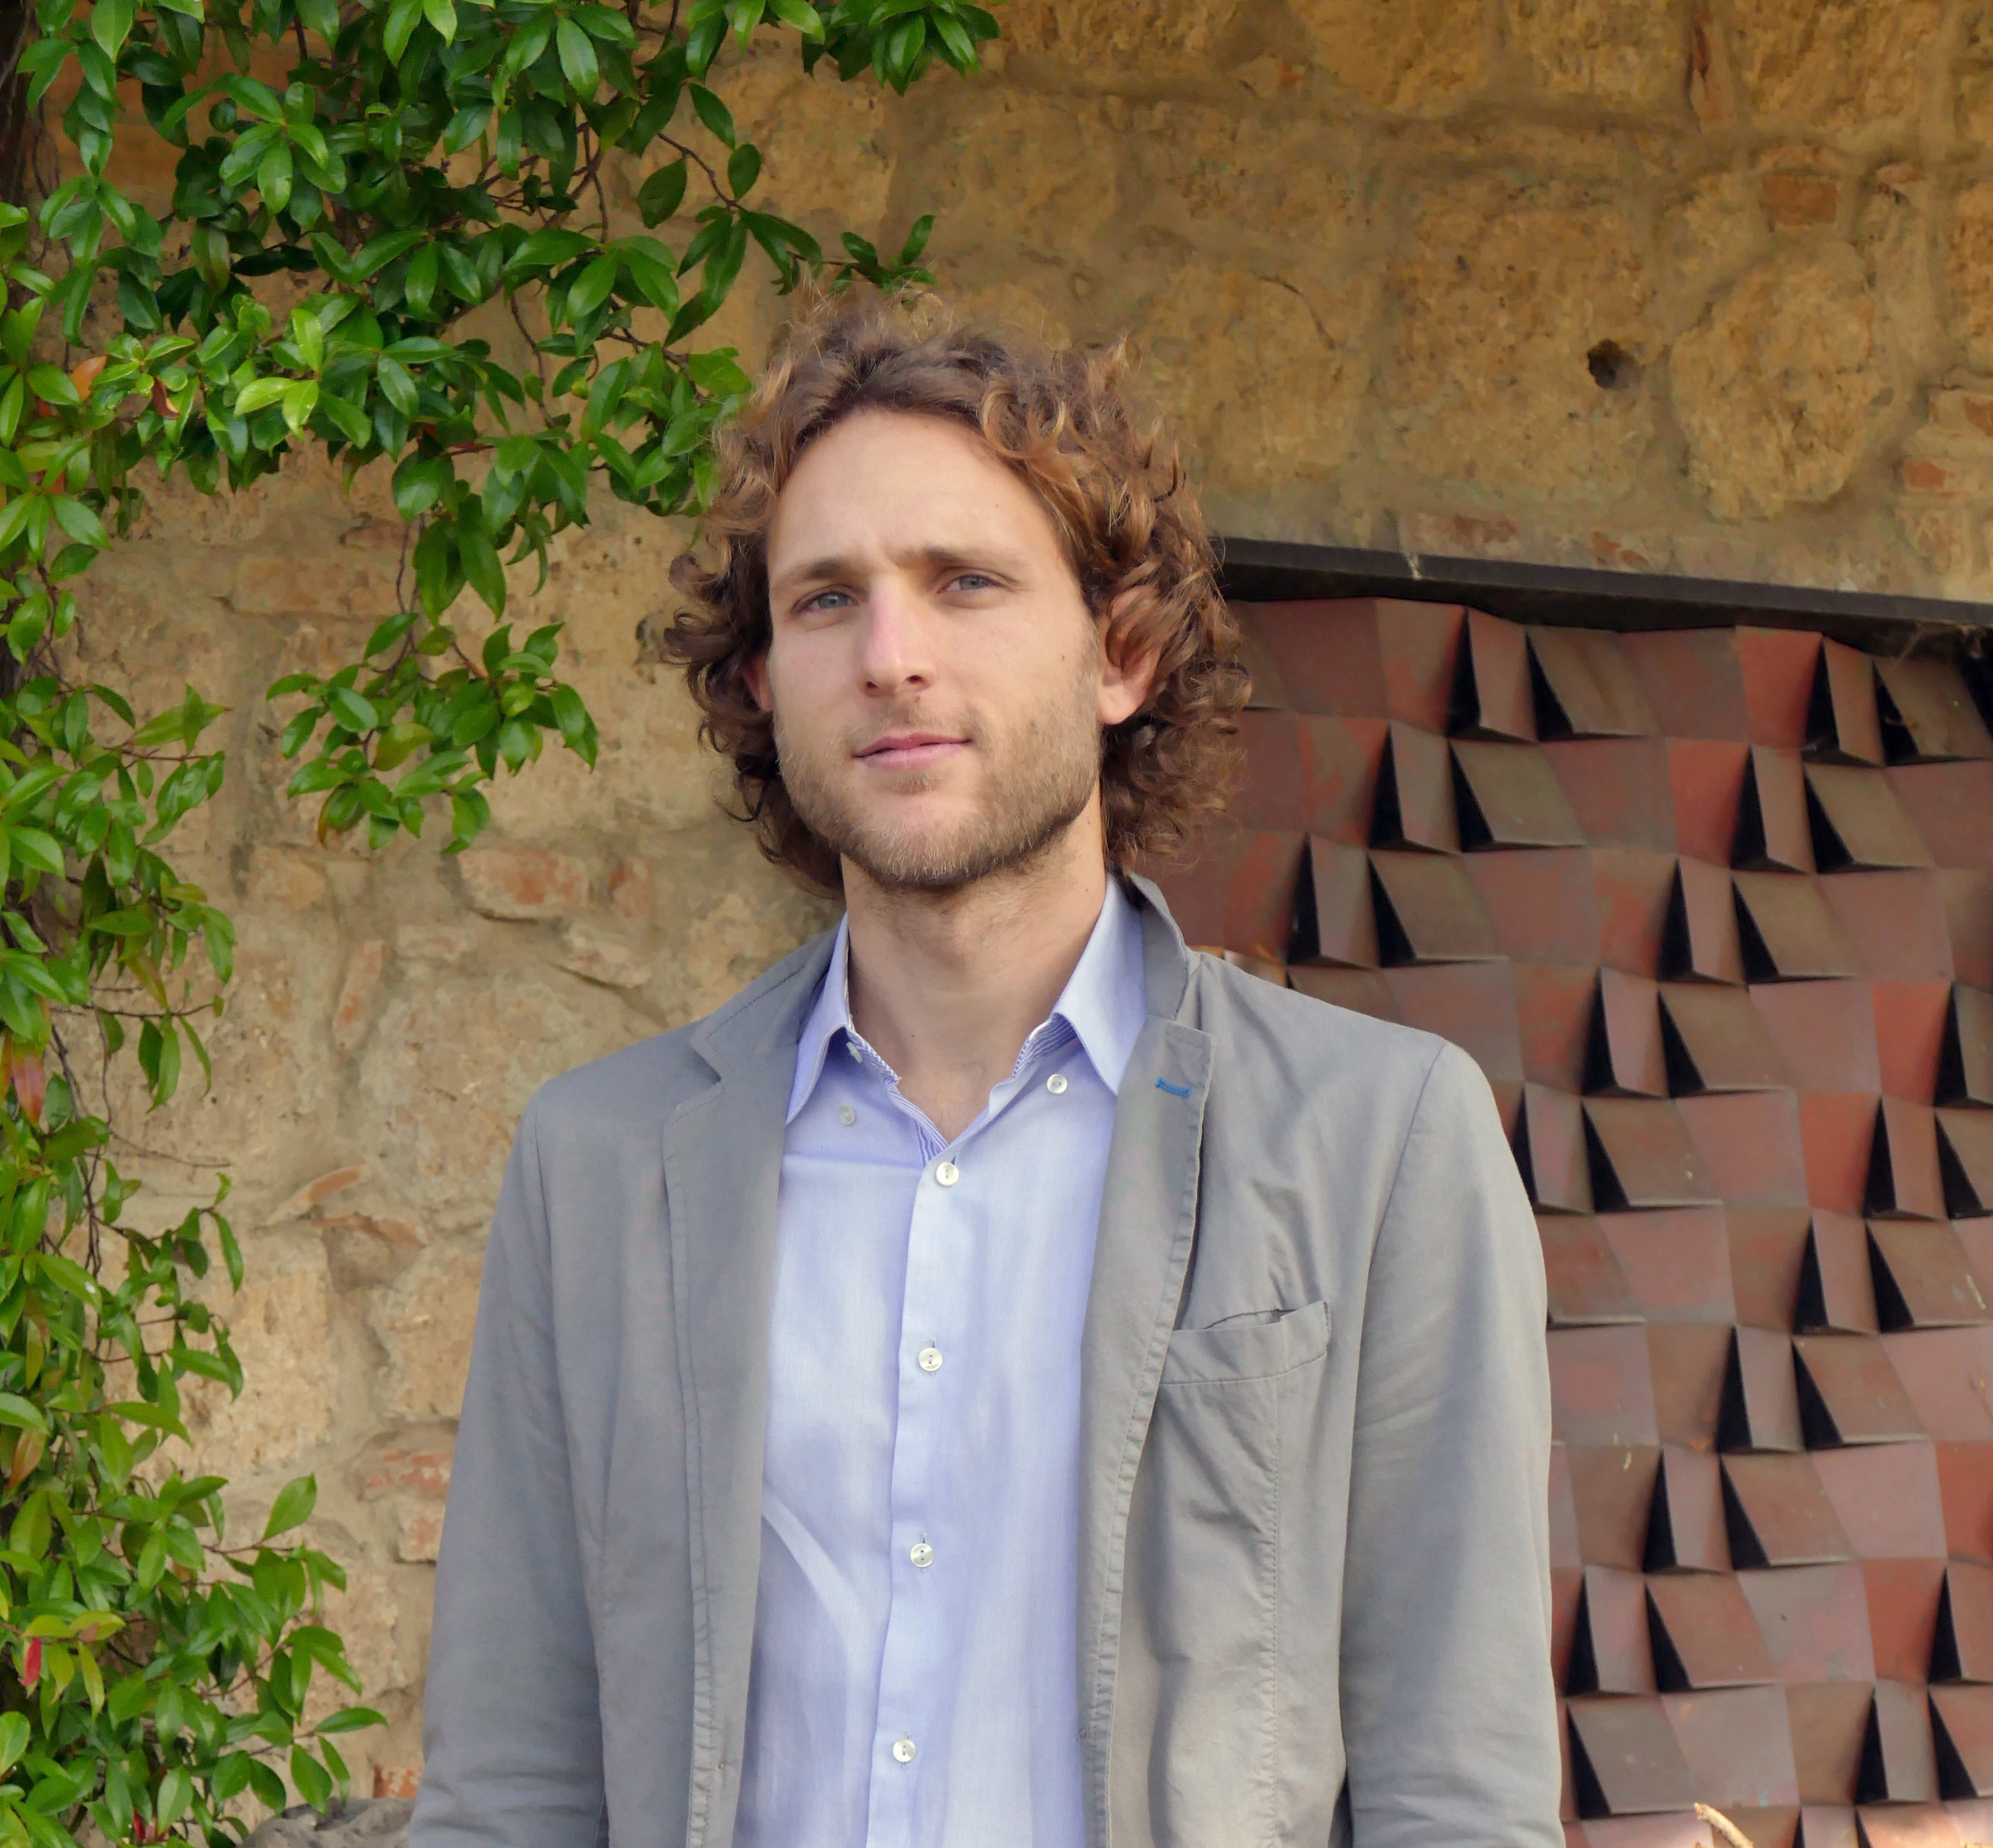
ANDREA RONCOLINI
Doctoral candidate at D3A-UNIVPM. His doctoral project concerns the investigation about microbiological aspects of edible insect as food and feed. Through culture-dependent (microbial cultivation, isolation and enumeration) and independent methods (molecular biology methods) he studies edible insects microbiota charachterization, occurrence of transferable resistance genes in edible insects and exploitation of insect powder in bread making. He is also involved in other projects concerning the exploitation of lactic acid bacteria (isolation, characterization and development of starters) for the production of fermented foods, the microbiological food safety analysis, the use of biotracers for environmental assays. He had a Master’s degree in Agricultural and Environmental Biotechnology at University of Perugia and his Thesis concerned the taxonomic and ecologic characterization of yeasts isolated from Alpine soils. He had a Professional Master’s Programme with merit-based scholarship in “Characterization and technologies for the remediation of polluted sites” at University of Rome “La Sapienza”.

Email: a.roncolini@pm.univpm.it
- Full Name: Andrea Roncolini
- Personal Email: a.roncolini@pm.univpm.it
- Mobile Number: +39 3333276562
- Session Name/ number: Microbiome/ 3. The Animal Microbiome
- Category; Oral presentation
- Date of Birth: 12.06.1986

