Graphene oxide coated S particles with long cycle life for lithium sulfur battery

Liu Shuangke,Hong Xiaobin,Xie Kai
College of Aerospace Science and Engineering, National University of Defense Technology, Changsha, China

Abstract
Lithium sulfur battery has been regarded as one of the most promising high energy density rechargeable energy storage system for next generation, due to its high theoretical specific capacity/ energy density, natural abundance and environmental friendliness [1]. However, the rapid capacity fade during long cycles which caused by polysulfide shuttle and volume expansion during cycles tremendously inhibits its practical application. Building coated architecture of sulfur is one effective way to confine sulfur in the sulfur cathode thus enables stable cycle life [2]. For example, Zhou et al [3] reported a sulfur/GO core-shell particle, in which sulfur particle were well wrapped by GO, demonstrating very stable cycle performance up to 1000 cycles.
Herein, we also prepared GO-coated sulfur particles to enhance the cycle performance of lithium sulfur battery. Different from the above example which use milled nano-sulfur particles, we use sodium sulfide and sodium sulfite to generate sulfur particles in aqueous GO solution followed by centrifugation and freeze-drying process, which results in in-situ coating structure. The SEM (Fig. 1a) and TEM (Fig. 1b, c) images clearly demonstrate sulfur particles are well wrapped by wrinkled GO sheets, the high resolution TEM result indicate the crystal phase of sulfur particles. Due to the intact coating structure of GO and good chemical bond between sulfur and GO, the GO-coated sulfur particle cathode shows excellent cycling performance. Figure 1d demonstrates its cycle performance at 1C rate, the initial discharge capacity is 513.4 mAhg-1, with 467.4 mAhg-1 retained after 400 cycles, corresponding to capacity retention of 91%. However, after 400 cycles, the capacity fade starts to speed up, with 260.6 mAhg-1 and 225.1 mAhg-1 left after 800 and 1000 cycles. These results indicate the physical GO coating could effectively suppress polysulfides shuttle effect and enhance the cycling performance but cannot completely eliminate it.

Image
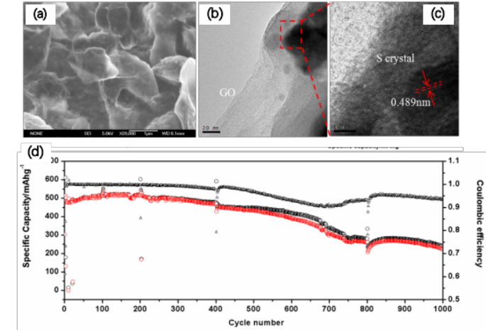
Figure 1 (a) SEM, (b) TEM, (c) high resolution TEM and (d) cycling performance at 1C rate of GO-coated S particles

Recent Publications
- Manthiram A, Fu Y, Chung S.H, Zu C, Su Y.S. Rechargeable Lithium-Sulfur Batteries, Chem. Rev. 2014, 114(23):11751-11787.
- Wang D W, Zeng Q, Zhou G, Yin L, Li F, Cheng H M, Gentle I, Lu G. Carbon-sulfur composites for Li-S batteries: status and prospects. J. Mater. Chem. A, 2013, 1 (33): 9382~9394.
- Rong J.P, Ge M.Y, Fang X, Zhou C.W. Solution Ionic Strength Engineering as a Generic Strategy to Coat Graphene Oxide (GO) on Various Functional Particles and Its Application in High-Performance Lithium-Sulfur (Li-S) Batteries, Nano Lett., 2014, 14,473-479.



Biography
Liu Shuangke studies energy materials and their electrochemistry, including synthesis of metal oxides, nano-carbons, sulfur-carbon composites as well as their applications in lithium storage and conversion. He received his bachelor degree in materials science & engineering from Hunan University, China in 2010. He obtained his master degree in applied chemistry in 2012 and doctor degree in materials science & engineering in 2016 from National University of Defense Technology, China. He is now an assistant professor in Department of Materials Science & Engineering, National University of Defense Technology, China.

Email: liu_sk@139.com

