Viral Variation Influences HIV Transmission and Progression to AIDS

A H Bandivdekar National Institute for Research in Reproductive Health
J M Street, Parel, Mumbai 400 012 INDIA
Image
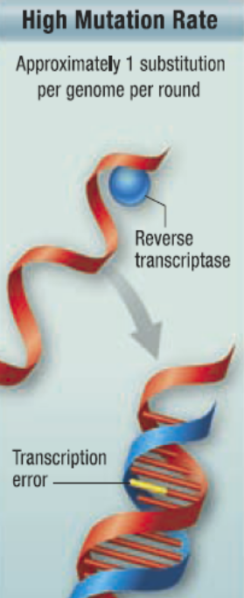
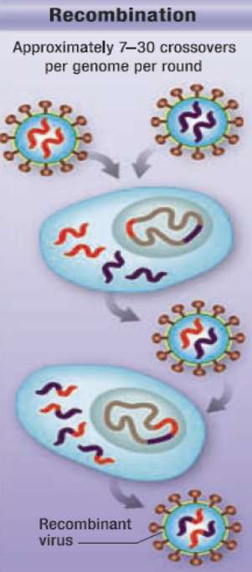
Poor proof reading activity HIV reverse transcriptase enzyme results in to presence of distinct and multiple DNA and RNA variants in different cells and secretions of the same individual. This may influence the viral affinity to host and immune cells and therefore may affect HIV transmission, infectivity, response to antiretroviral drug therapy and pathogenicity. Genotypic and phenotypic characterization of C2-V3 region of HIV1 C env gene in PBMCs, sperm, vaginal epithelial cells and cervical cells showed presence of distinct variants in the same individual with variable infectivity with different numbers of N-linked glycosylation (NLG) sites suggesting variation in coreceptor affinity in different cells of same individual which may influence disease progression and risk of HIV transmission. Additionally genotypic characterization of HIV1 gp41 by next generation sequencing showed presence of multiple variants in blood of the same individual. HIV variants may have variable affinity to different host cell receptors including human Mannose Receptor (hMR), DC-SIGN, Galactosyl Ceramide, Syndecan-Syndecan-3 Heparan Sulfate Proteoglycan receptors as well as immune cells. HIV is known to be sexually transmitted by binding to hMR on human sperm, vaginal epithelial which are devoid of conventional CD4 receptor. Localization of hMR was found to be in lower number of vaginal epithelial cells of HIV negative female partner of serodiscordant couples as compared to normal females suggesting association of hMR in sexual transmission of HIV suggesting for development of formulation for prevention of sexual transmission of HIV need to be primarily prevent HIV binding to hMR and also CXCR4 and CCR5 coreceptors. The study suggests that the presence of HIV variants and their variable affinity to different host and immune cells remains the challenge in development of effective vaccine and/or formulation for prevention of sexual transmission of HIV.
Figure1. Poor proof reading activity of HIV reverse transcriptase results in to Viral Variation
Recent Publications (minimum 5)
1.Seema P. Ajbani, Shilpa M. Velhal, R. B. Kadam, V. V. Patel, A H.Bandivdekar (2015) Immunogenicity of Semliki Forest virus based self-amplifying RNAexpressing Indian HIV-1C genes in mice. International Journal of Biological Macromolecules 81 : 794–802.
2.S K Jadhav , Shilpa M.Velhal, Alaka Deshpande and A H Bandivdekar (2013) Association of Human Mannose Receptor in Sexual Transmission of Human Immunodeficiency Virus in Serodiscordant Couples. AIDS Research and Human Retroviruses 29 : 158, 2013.
3.S K Jadhav , S M.Velhal, A Deshpande, A Maitra, S Chinnaraj and A H. Bandivdekar (2011) Characterization of Human Immunodeficiency Virus [HIV1C] Variants in Peripheral Blood Mononuclear Cells and Spermatozoa J. Med. Virol. 83:760–767.
4.S. E. Fanibunda, S. M. Velhal, V. P. Raghavan and A. H. Bandivdekar (2008) CD4 Independent Binding of HIV gp120 to Mannose Receptor on Human Spermatozoa. J Acquired Immune Deficiency Syndromes (JAIDS). 48(4):389-397.
5.P. Polacino, K. Larsen, L. Galmin, J. Suschak, Z. Kraft, L. Stamatatos, D. Anderson, S. W. Barnett, R. Pal, K. Bost, A. H.Bandivdekar, C. J. Miller and S. L.Hu, (2008) Differential pathogenicity of SHIVSF162 P4 infection in pig-tailed and rhesus Macaques J of Medical Primatology 37 (2) : 13-23.



Biography
Dr Atmaram Bandivdekar completed his Ph D Degree from Mumbai University. He was Post-Doctoral and subsequently Carrier fellow at Population Council, New York. He was also the visiting scientist at UC Davis Primate Center. He has major research contributions at National Institute for Research in Reproductive Health in the field of Reproductive Health and understanding mechanism of sexual transmission and pathogenesis of HIV. He has developed recombinant vaccine which elicited significant cell mediated and humeral immune responses against HIV. Also developed formulation for prevention of sexual transmission of HIV which prevents HIV binding to hMR and CXCR4 and CCR5 coreceptors. He has also developed non surgical method of fertility regulation using synthetic peptide of sperm specific antigen. He has published more than 80 papers in peer reviewed journals and also the book and two conference proceedings. He also has six National and International awards for his scientific contributions.
email : batmaram@gmail.com

