Epidemiology, prevention and Treatment of Leishmaniasis in Afghanistan

Mohammad Reza Mohammadi¹*, Layegheh Daliri², Elham Rezaei Niaraki³, Hamida Musawi⁴
1- Department of Bacteriology, Faculty of Medical Science, Tarbiat Modares University,Tehran-Iran
2- Department of Bacteriology, Faculty of Medical Science, Tarbiat Modares University,Tehran-Iran
3- Department of Bacteriology, Faculty of Medical Science, Tarbiat Modares University,Tehran-Iran
4- Mia San Hospital, Bavaria, Germany

Abstract (300 word limit)
Introduction: Leishmaniasis occurs in an infectious disease of Leishmania protozoa in Afghanistan, anthroponotic leishmaniasis and common cutaneous leishmaniasis (ZCL). Anthroponotic skin leishmania tropica may cause urban diseases and transmitted by Phlebotomus Sergenti. In different parts of Afghanistan, different species of Leishmania are observed. We report the epidemiological characteristics of prevention and treatment in this study.
Methods: This study examines epidemiology and prevention of religious disease in Afghanistan. Knowledge gaps were analyzed and collected with our own data
Results : In Afghanistan, most of the Leishmania Tropic seekers are. Four species of Leishmania in northern Afghanistan, including Leishmania Tropica, L. Major and L. Donovani, cause skin lesions, but L. Donovani and L. infantum are visible. Even combined prevention can significantly reduce the amount of infection
Conclusion: Skinny, as well as visceral leishmaniasis, can occur among the returnees from Afghanistan. Unusual and poor skin lesions can be created by L. Donovani. In most pathogenic areas, the transmission of common disease between humans and animals. Home dogs are the main reservoir, transferring in some areas such as India and Sudan

Image

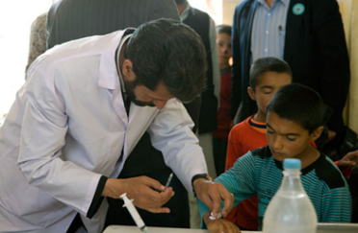

Figure 1: High quality anti-leishmaniasis drugs are essential to prevent infection and transmission. More than 20000- treatment vials have been distributed in Kabul and the southern region, treating more than 5,000 patients annually.
Recent Publications (minimum 5)

- Torres-Guerrero E, Quintanilla-Cedillo MR, Ruiz-Esmenjaud J, Arenas R. Leishmaniasis: a review. F1000Res. 2017;6:750.
- Faulde M, Schrader J, Heyl G, Amirih M. Differences in transmission seasons as an epidemiological tool for characterization of anthroponotic and zoonotic cutaneous leishmaniasis in northern Afghanistan. Acta tropica. 2008;105(2):131-8.
- Karmaoui A, El Qorchi F, Hajji L, Zerouali S. Eco-epidemiological aspects of Zoonotic cutaneous leishmaniasis in Ouarzazate Province, Morocco. Journal of parasitic diseases : official organ of the Indian Society for Parasitology. 2021;45(2):341-50.
- Sanei-Dehkordi A, Soleimani-Ahmadi M, Zare M, Mirzaei H. Epidemiological features of cutaneous leishmaniasis and distribution of sand flies in an endemic area in southeast of Iran. Parasite epidemiology and control. 2021;14:e00220.
- Fakhar M, Karamian M, Ghatee MA, Taylor WR, Pazoki Ghohe H, Rasooli SA. Distribution pattern of anthroponotic cutaneous leishmaniasis caused by Leishmania tropica in Western Afghanistan during 2013-2014. Acta tropica. 2017;176:22-8.

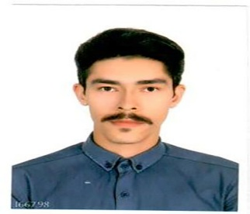
Biography (150 word limit)
Paste your Logo here
Mohammad Reza Mohammadi Master of Clinical Microbiology at Tarbiat Modares University, Tehran, who researches clinical microbiology, virology and parasitology and has also worked in Afghan health. It is useful.
Email:
mohammadi.mreza73@gmail.com

Notes/Comments:

Presenting author details
Full name: Mohammad Reza Mohammadi
Contact number: 0989374301164
Twitter account:
Linked In account: https://www.linkedin.com/in/mohammad-reza-mohammadi-249aa6110
Session name/ number:
Category: (Oral presentation/ Poster presentation)

