Assessing bioﬁlm formation abilities of selected multidrug-resistant bacteria in meat production lines
Anna Ławniczek-Wałczyk, PhD, Małgorzata Gołofit-Szymczak, PhD, Marcin Cyprowski, PhD, Agata Stobnicka-Kupiec, PhD,
Rafał L. Górny, PhD, Professor, Central Institute for Labour Protection – National Research Institute, Warsaw, Poland

Abstract
Statement of the Problem: Over the past 50 years, global meat consumption has increased several times and contributed to the concentration of animal farming and growth of employment in the meat production sector. Among many biological hazards occurred in this working environment, antibiotic resistant bacteria such as ESBL, VRE and MRSA are identified as an emerging threat for both occupational and public health. Ability of bacteria to adhere to contact surfaces is a serious problem for meat production. Biofilm-forming cells are more resistance to disinfectants than single ‘unbound’ cells and are more difficult to remove mechanically from the surface. The purpose of this study was to assess the ability of antibiotic resistant bacteria to form biofilm on surfaces in meat production lines. Methodology: 52 swab samples were collected from contact surfaces (worktops, floors, machine parts, cutting instruments) and hands of workers in two meat processing plants in Poland. Biofilm formation was spectrophotometrically investigated using the microtiter plate method (at wavelength of 570 nm). The antibiotic resistance profile was determined by disc diffusion method according to the EUCAST requirements. Findings: 18 ESBL, 15 VRE and 14 MRSA strains were isolated from studied surfaces and hands. Among isolates, 43 (91%) were able to form biofilm. Of these, 76% were strong and 24% were moderate biofilm producers. More than 86% of VRE and 72% ESBL strains showed strong biofilm formation abilities. All strains showed resistance to at least one antimicrobial drug in tested categories: aminoglycosides (gentamicin, streptomycin), cephalosporins (cefotaxime, cefoxitin), macrolides (erythromycin, clindamycin), fluoroquinolones (ciprofloxacin), carbapenems (Imipenem, ertapenem), glycopeptides (tigecyclin, vancomycin), and penicillins. Conclusion & Significance: The strong resistance to several drugs and high adherence ability of MRSA, VRE and ESBL isolates suggests that these factors may play an important role in the spread of these pathogens in the meat production chain through contaminated surfaces and workers’ hands.
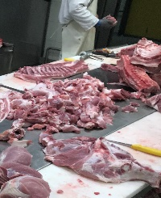

Figure 1: Cutting line in meat processing plant.

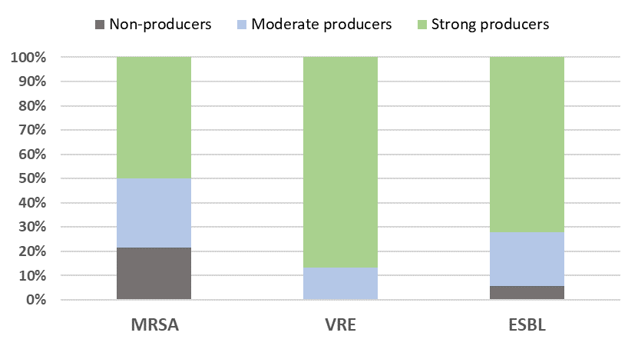

Figure 2: Bioﬁlm-formation abilities among antibiotic resistant bacterial isolates (classiﬁed as strong, moderate and non-producers).

Recent Publications
- EUCAST (2021) The European Committee on Antimicrobial Susceptibility Testing. Breakpoint tables for interpretation of MICs and zone diameters. Version 11.0, 2021. http://www.eucast.org.
- Giaouris E, Heir E, Hébraud M, Chorianopoulos N, Langsrud S, et al. (2014) Attachment and biofilm formation by foodborne bacteria in meat processing environments: causes, implications, role of bacterial interactions and control by alternative novel methods. Meat Sci. 97(3):298-309.
- Hammerum AM, Larsen J, Andersen VD, Lester CH, Skovgaard Skytte TS, et al. (2014) Characterization of extended-spectrum beta-lactamase (ESBL)-producing Escherichia coli obtained from Danish pigs, pig farmers and their families from farms with high or no consumption of third-or fourth-generation cephalosporins. J. Antimicrob. Chemother. 69 (10):2650-2657.
- Ma F, Xu S, Tang Z, Li Z, Zhang L (2021) Use of antimicrobials in food animals and impact of transmission of antimicrobial resistance on humans. Biosafety and Health 3(1):32-38.
- Wu S, Huang J, Wu Q, Zhang J,Zhang F, et al. (2018) Staphylococcus aureus isolated from retail meat and meat products in China: incidence, antibiotic resistance and genetic diversity. Front. Microbiol. 9:2767.



Biography
Anna Ławniczek-Wałczyk, PhD (environmental engineering), is research assistant in the Laboratory of Biohazards at the Central Institute for Labour Protection–National Research Institute, Warsaw, Poland. For over 12 years, her scientific activities has been focusing on occupational exposure to biological hazards (especially bioaerosols) including the methods of their quantification, assessment of relationship between work exposure and health outcomes, monitoring the transmission of airborne pathogens in human communities using genotypic methods and understanding the basis of their resistance to antibiotics and disinfectants. She has authored or co-authored more than 35 peer-reviewed scientific publications, training materials, and participated in numerous conferences. She is also actively involved in teaching at the academic level.
Email: anlaw@ciop.pl

Presenting author details
Full name: Anna Ławniczek-Wałczyk
Contact number: (+48 22) 623 46 92
Mail id: anlaw@ciop.pl
Category: Poster presentation

