PknG supports mycobacterial adaptation in acidic environment
Ruchi Paroha, Rashmi Chourasia#, Rajesh Mondal, Shivendra K Chaurasiya*
Host-Pathogen Interaction and Signal Transduction Laboratory, Department of Microbiology, School of Biological Sciences, Dr. Hari Singh Gour University, Sagar, MP-470003, India
# Department of Chemistry, School of Chemical Sciences, Dr. Hari Singh Gour University, Sagar, MP-470003, India
*Corresponding author: shivendrachaurasiya@gmail.com
Phone - +919893178179

Abstract
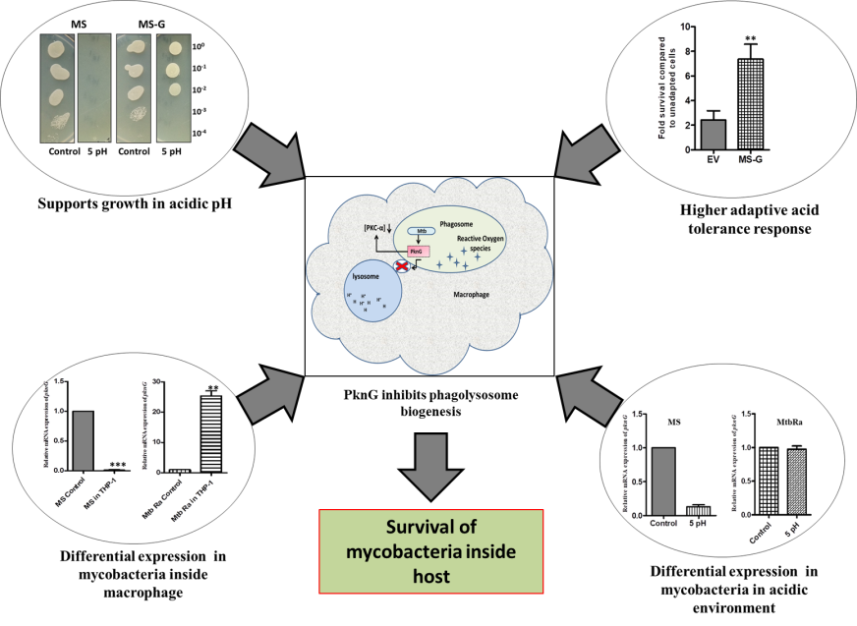
Mycobacterium tuberculosis (Mtb), causative agent of human tuberculosis (TB), has the remarkable ability to adapt to the hostile environment inside host cells. Eleven eukaryotic like serine-threonine protein kinases (STPKs) are present in Mtb. Protein kinase G (PknG) has been shown to promote mycobacterial survival inside host cells. A homolog of PknG is also present in Mycobacterium smegmatis (MS), a fast grower, non-pathogenic mycobacterium. In the present study, we have analysed the role of PknG in mycobacteria during exposure to acidic environment. Expression of pknG in MS was decreased in acidic medium. Recombinant MS ectopically expressing pknG (MS-G) showed higher growth in acidic medium compared to wild type counterpart. MS-G also showed higher resistance upon exposure to 3.0 pH and better adaptability to acidic pH. Western blot analysis showed differential threonine but not serine phosphorylation of cellular proteins in MS at acidic pH which was restored by ectopic expression of pknG in MS. In Mtb H37Ra (Mtb-Ra), expression of pknG was increased at acidic pH. We also observed decreased expression of pknG in MS during infection in macrophages while the expression of pknG in Mtb-Ra was increased in similar conditions. Taken together our data strongly suggests that pknG regulates growth of mycobacteria in acidic environment and is differentially transcribed in MS and Mtb under these conditions.

Image

Recent Publication
- Paroha, R., Chourasia, R., Mondal, R. et al. Mol Cell Biochem (2017). https://doi.org/10.1007/s11010-017-3211-

Biography
Ruchi Paroha is pursuing PhD in department of Microbiology, Dr Hari Singh gour university, Sagar (MP), India. Her research area is mycobacterial pathogenesis. Protein kinase G (PKnG) is a virulent factor of mycobacteria so she was trying to elucidate macrophage proteins (target proteins)/pathways altered by PknG and to investigate the role of identified target protein substrates/pathways in the regulating survival of mycobacteria within macrophages. While doing so she found some very interesting data that this virulent factor is supporting the mycobacterial growth in acidic pH. Since PknG inhibits phagosome lysosme fusion during mycobacterial infection and by supporting mycobacterial growth in acidic environment it is basically increasing the survival of mycobacteria inside host.
.
Email: ruchi.paroha99@gmail.com

