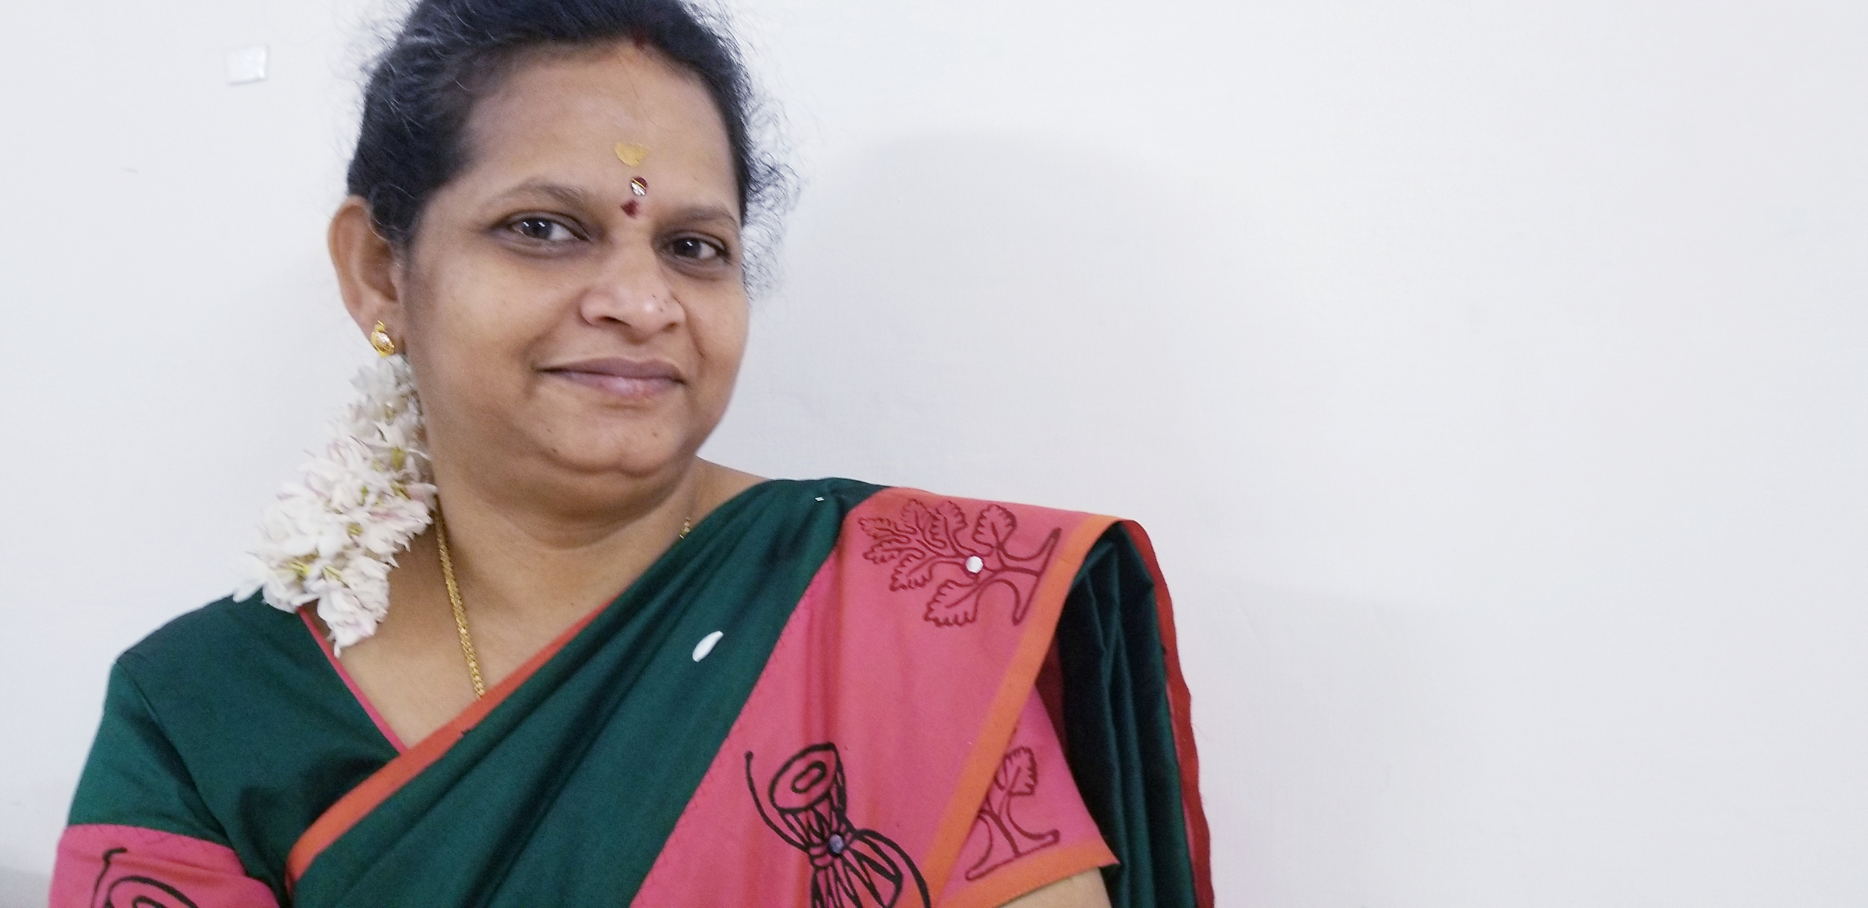

Title: CHANGING TRENDS IN GONOCOCCAL INFECTIONS – SHIFT TO MSM—EMERGING RESISTANCES
Name: Dr.Kavitha M
Kilpauck Medical College, Chennai ,TN, India

Introduction:-Gonococcal Infections are a major part of sexually transmitted infections among MSM. The rising trend of Gonococcal Infections in male is alarming & screening of antibiotic resistance is important to treat them. To isolate Gonococci and detect the resistance of Gonococci by phenotypic methods from patients attending venereology department.Methodology: All the patients with cervical discharge or urethral discharge attending venereology department were screened by grams stain and culture was done on Thayir Martin Medium. Antibiotic Resistance was detected by disc diffusion method as per CLSI guidelines.Results:A total of 50 Gonococcal Isolate were identified from males with Urethral Discharge. None were isolated from females. Out of 50 isolates 60% (30) were B-lactamase producers and resistance to penicillin and 34% (17) to tetracycline. 64% (32) of isolates had developed chromosomal resistance to ciprofloxacin and 12% (6) were resistance to azithromycin.4% (2) of the isolate was resistant to Cephalosporins.1 isolate was resistant to 4 drugs. Conclusion:The isolation of Gonococci from male has been increasing along with resistance to penicillins, fluoroquinolone and tetracycline. Resistances to cephalosporins are beginning to appear. Emergence of multidrug resistance makes treatment of Gonococcal infections a challenge. Hence it is mandatory to screen for resistance and treat the infections so as to prevent spread of infections especially in male with multiple sex partners all of whose identity may not be known to treat the partner as well.

Biography
Dr.Kavitha.M has completed her MD Microbiology at the age of 34 years from Stanley Medical College 14 years of teaching experience.Area of interest immunology, Infection Control, Sexually Transmitted infection, and medical education. Has worked in Regional reference Lab for STI for 2 years, State reference Lab for HIV for 5 years and State reference Lab fro Dengue and Chickungunya for 3 years.I am undergoing Advanced Course In Medical Education At Regional Center Sri Ramachandra Medical University. She Has been in Bio-Medical Waste Management Traning And Monitoring for more than10 years. Published 5 Articles and Presented 4 Topic in National Conferences Has been a speaker in National Conference for STI.

Presenting author details
Full name: Dr.Kavitha M
Contact number:9841265184
Twitter account: Dr Kavitha M‏ @DrKavithaM1
Linked In account: https://www.linkedin.com/in/dr-kavitha-muthusamy
Category: Oral presentation/ Poster presentation

