Introduction

It has been thirty years since the Global Polio Eradication Initiative (GPEI) was launched however since October 2018 there have still been 8 reported polio cases in Pakistan. As of August 18th 2018 Pakistan entered a new era with the election of a new prime minister Imran Khan who sold his vision to the Pakistani people via the “100 day agenda”. In this document he expressed his desire to stomp out corruption and prioritise healthcare, with polio eradication (PE) at the forefront. This abstract aims to discuss whether how his appointment will address polio eradication in Pakistan.

Methods
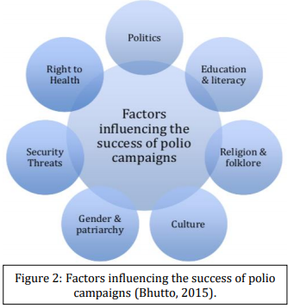
To evaluate the impact of Khan’s government on PE, we will be using an indepth analysis of the challenges to PE campaigns in Pakistan (Bhutto, 2015) as our framework. This incorporates key social determinants of health within the Walt and Gibson (1994 cited in Bhutto, 2015) policy triangle - which allows for a systematic approach. Khan’s 100-day plan, progress report and other sources, will be juxtaposed into the framework to analyse the impact on these factors, and hence PE. The author categorised these factors into seven groups and each will be discussed in turn (see right).

Results
Politics – The GPEI suggested there was insufficient engagement from political leaders with ignorance towards PE being a public health emergency. Khan has chaired and set up a PE Task force and publicly voiced his commitment towards PE.
Rights to health – Pakistan had previously underspent on healthcare by GDP however Khan has spent 1bn rupees to upgrade health care centres, create public insurance and increase the capacity of healthcare workers, all of which should aid PE.
Security threats – Bolochistan and KPK are the two strongholds key to PE where tribal leaders dismissed PE as a “Western conspiracy”. Khan has championed reconcillation with Balochistan leaders and a political merger with the KPK.
Religion, folklore and culture – Khan aimed to address religious concerns regarding vaccine by recruiting local religious leaders with large scale media and awareness campaigns.
Education and literacy - Khan’s government has approved an education blueprint, that will be enrolling 25m children which will be supported with a cash transfer system. Health-seeking behaviour is expected to rise with literacy levels, aiding in PE
Gender and patriarchy - The government has developed a bill plan with an equality enhanced criminal justice reform, protection of women’s inheritance rights, and women empowerment packages. With widespread work underway to tackle gender inequalities and patriarchy, this barrier should reduce, and vaccination campaigns will be more likely to reach children through both parents, rather than having to rely on fathers alone

Discussion
Much work has been done to address PE, however only time will tell whether Khan’s vast commitment will prove to be successful and finally achieve eradication.

Presenting author details
Full name: Dr Raees Lunat
Contact number: 07969677417
Twitter account:Nil
Linked In account: -
Session name/ number: -
Category: (Oral presentation/ Poster presentation) Either

Full name: Mr Naveed Suhail Khan
Contact number: 07837659849
Twitter account:Nil
Linked In account: -
Session name/ number: -
Category: (Oral presentation/ Poster presentation) Either

Full name: Mr Adam Jan
Contact number: 07954214669
Twitter account:Nil
Linked In account: -
Session name/ number: -
Category: (Oral presentation/ Poster presentation) Either

