Bioavailable metals following 3 extraction methods (BCR, Tessier and Protease K) in sediments from Huelva estuary (Southwestern Spain)
Daniel Rosado, PhD, Universidad de Sevilla, Spain
Jose Usero, PhD, Universidad de Sevilla, Spain
Jose Morillo, PhD, Universidad de Sevilla, Spain

Abstract (300 word limit)
We estimated the bioavailable fraction of metals (Zn, Cu, Cd, Mn, Pb, Ni, Fe, and Cr) in sediments of the Huelva estuary and its littoral of influence by carrying out the most popular methods of sequential extraction (BCR and Tessier) and a biomimetic approach (extraction with protease K) and compared the results obtained with enrichments factors found in Arenicola marina. The linear correlation coefficients (R2) obtained between the fraction mobilized by the first step of the BCR sequential extraction, by the sum of the first and second steps of the Tessier sequential extraction, and by protease K, and enrichment factors in Arenicola marina, are at their highest for protease K extraction (0.709), followed by BCR first step (0.507) and the sum of the first and second steps of Tessier (0.465). This observation suggests that protease K represents the bioavailable fraction more reliably than traditional methods (BCR and Tessier), which have a similar ability.

Image
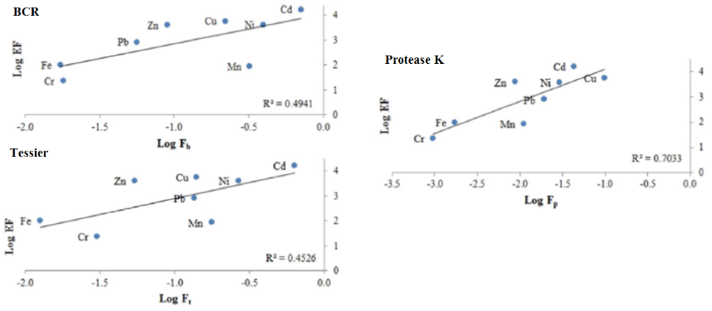
Recent Publications (minimum 5)
- Morillo J, Usero J, Rosado D, El Bakouri H, Riaza A, Bernaola FJ (2014). Comparative study of brine management technologies for desalination plants. Desalination 336 32–49.
- Rosado D, Usero J, Morillo J (2015). Application of a new integrated sediment quality assessment method to Huelva estuary and its littoral of influence (Southwestern Spain). Marine Pollution Bulletin 98 106–114.
- Rosado D, Usero J, Morillo J (2016). Ability of 3 extraction methods (BCR, Tessier and protease K) to estimate bioavailable metals in sediments from Huelva estuary (Southwestern Spain). Marine Pollution Bulletin 102 65–71.
- Rosado D, Usero J, Morillo J (2016). Assessment of heavy metals bioavailability and toxicity toward Vibrio fischeri in sediment of the Huelva estuary. Chemosphere 153 10-17.
- Usero, JA, Rosado D, Usero J, Morillo J (2016). Environmental quality in sediments of Cadiz and Algeciras Bays based on a weight of evidence approach (southern Spanish coast). Marine Pollution Bulletin 110 65–74.
- López-Rodriguez F, Rosado D (2017). Management effectiveness evaluation in protected areas of southern Ecuador. Journal of Environmental Management 190 45-52.

 Biography (150 word limit)
Daniel Rosado has completed his PhD in chemical and environmental engineering at the University of Sevilla, focusing on water and sediment pollution. Currently, he is full-professor at the Universidad Técnica Particular de Loja in Loja, Ecuador. He has published papers in reputed journals such as Desalination, Chemosphere, Marine Pollution Bulletin and Journal of Environmental Management.
Email: danrosalc@alum.us.es

Notes/Comments:

