Fabrication of Semi-Automatic Dish Washing Machine

Vrushali Hude¹, Gayatri Awagan¹, Amruta Daundkar¹, Shweta Shende¹, Dr. D R Panchagade¹, B N Sadavarte²
¹Department of Mechanical Engineering, DYPatilCOE,Ak (Savitribai Phule Pune University)
²Disha Engineering Automation, Kothrud, Pune 411038

Abstract- This research paper describes the simplest form of a dish-washing machine. The disadvantages of a conventional dish washing machines such as more time consumption and electricity consumption are overcome in this model of semi-automatic dish washer. As we all are aware that the dish washing process is very time consuming and the most commonly done household chore. If it is carried through a automatic dish washer, it consumes more time, water and is costly. Hence by adopting the concept of a semi-automatic dish washer, we can save our time, money, water and electricity. The efforts required for washing dishes will be reduced gradually and we can avoid the problems faced in an automatic dish washing machine.

Keywords- Dish washing machine, pump, motor, brushes, gears.

INTRODUCTION
Dish washing is the most commonly done household chore, which is mostly done by the women of the house. This process of cleaning dishes can be harmful, time consuming and also may cause muscle straining if heavy utensils are washed. It is also considered to be unhygienic and sterilization of utensils cannot be done in most cases. This process is very time consuming and water is wasted a lot in this process. So if a machine can handle this work we can improve our lifestyle by changing the way of washing dishes. Using a semi-automatic dish washing machine we can change the aspect of all methods of washing dishes. In this paper, one will find a new approach towards dish washing. By making the most of engineering design, the basic technique of dish washing can be formulated in a simple system which includes brushes, pump, motor, gears, mechanical linkages and bearings etc. This simple components make washing dishes a bit easy and efficient. In this era of automation, one should always look into reducing efforts for human and also meliorate rate of production and be efficient to the mankind.

OBJECTIVE
Our basic principal objective used in this semi-automatic dish washing machine is mainly to immaculate many dishes possible while making less use of water, electricity and also to define the process in less time. This machine is mainly designed for the hotel liners as well as for caterers with less costing and strictly no usage of hot water is done.

COMPONENTS
The figure represents the 2D design layout of the assembly of the semi-automatic dish washing machine. The proposed drawing is generated using CATIA software.
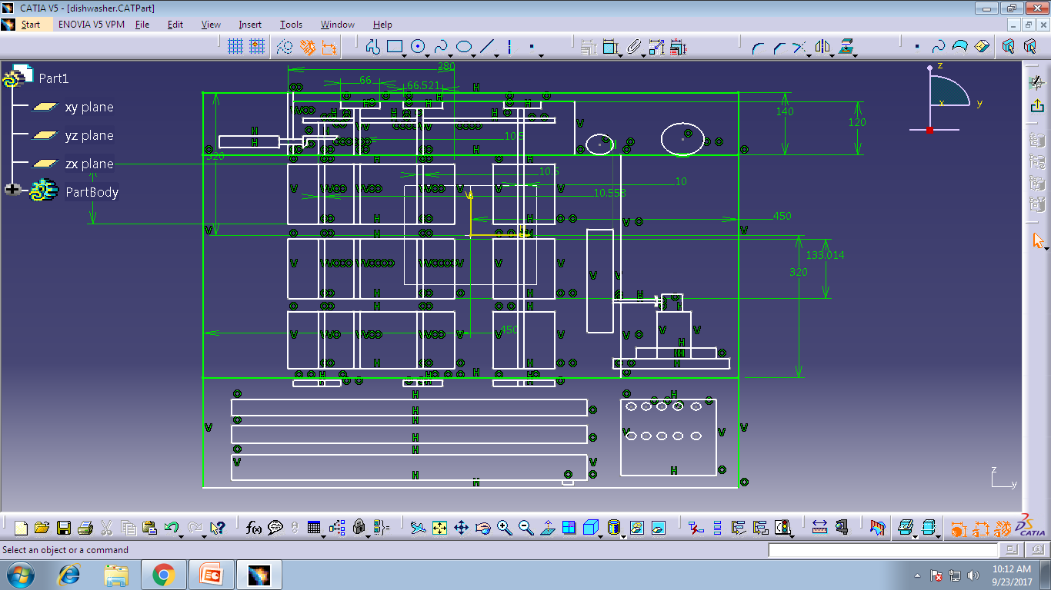
Fig 1: 2D Drawing of the experimental setup

1. Gear: Due to good efficiency we have used spur gears in our model. They also tend to have better working performance at low and medium speeds. Rather than high speeds as they tend to be noisy. The radial load of the spur gear is imposed on the shafts. We have used EN8 here for the gears. They are cheap in costing and have a better wear resistance also. Here spur gear are used to transmit power to the brushes and to increase speed in some amount.

2. Gear Bush: Gear bush are made of mild steel, they are cheaper and have low density and are hard also. They are mainly used to hold the gear and shaft together and transmit power.

3. Brushes: Brush with hard bristles is used here in our model. These bristles are used for proper cleaning of the dishes and also provide a support to the moving dish. In total 5 brushes were used. The main reason of usage is to clean the dishes and remove oils and left over food particles and provide support for moving dishes further.

4.Bearings: Bearings are used to transmit motion with lesser frictional force. They are used to attach shaft to plates here and also to rotate easily.(also to move in a single direction) While with-standing the force and weight load against them.

5. Aluminum Plates and Trays: Aluminum is light material with good strength and it has low density and low weight and also excellent corrosive resistance properties and good thermal, electrical conductivity.

6. Shaft: Here shafts are used to transmit motion and support brushes. The loads acting on shaft are balanced. They transmit motion from one shaft to another by various other members such as pulleys, gears, sprockets etc. Shaft is also used for transmitting torque and bending moment.

7. DC Motor: A DC motor is used here for power generation which is converting the electrical energy to mechanical rotary motion.

WORKING
The working of semi-automatic dish washer is simple and fast. The water is supplied through a jet used and then provided to the washing zone. The gears are rotated with the help of motor attached and so torque is transmitted to the brushes and entire system is set in motion.
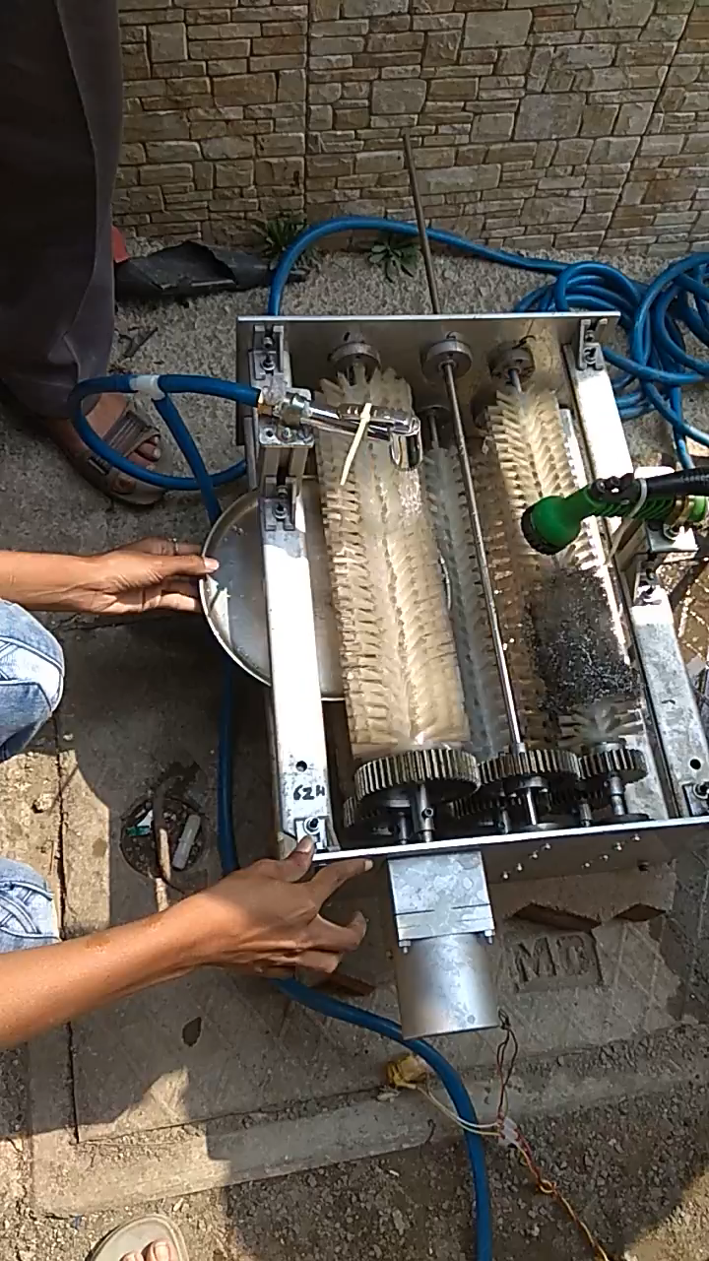
Fig 2: Experimental Setup of the dish-washing machine

The figure.2 above explains the working (setup) of machine. For this we have to manually first put a dish from one end of machine into the clearance provided between two brushes. This dish will move forward along with its cleaning done by bristles of the brush. The water will be poured through the nozzles will be washed away with the leftover food particles from the dishes. The cleaning is done in lesser time interval than the conventional automatic machine. But it requires more water consumption than the conventional one.

DESIGN CALCULATION
Motor Calculations: (Genset control)
Power ratings :12 W
Voltage:230 V
Speed:1440 RPM
Reduction ratio: 180

Pump Calculations:
Maximum Power=230 Watts
Maximum head=2.5 mtr
Maximum Capacity=22 lit/min
Maximum Pressure=2.2 bar

EXPERIMENTAL RESULTS

CONTENT | RESULTS
No. of plates | 2 | 4 | 9 | 12 | 15
Water in litre | 1 | 2 | 4.5 | 6 | 7.5
Time (sec) | 12 | 24 | 54 | 72 | 90
Table.1: Experimental results

FACTOR | HUMAN | MACHINE
Time | 40sec per plate | 6sec per plate
Water | 1litre per plate | 0.5litre per plate
Cost | 500rs per month | Approximately 50rs per month
Reliability | less | more
Capacity | 90 dishes per hour | Around 255 dishes per hour
Table.2: Comparison between human and machine

ADVANTAGES
- Environment friendly and non polluting
- Efficient in operation
- Less human efforts required
- Low cost
- Robust in construction
- Lesser time consumption

DISADVANTAGES
- Needs a manual help
- More in weight
- Only dishes can be washed
- Size of plate to be washed is limited

SCOPE OF IMPROVEMENT
There is a lot of scope for improvement in this design of the system. Weight reduction can be done by using future materials with lesser weight and good strength and endurance power. The water consumption can also be reduced by recycling the water after its filtering is done. Brushes of strong and hard bristles can be used for long life usage. Costing of the machine can be reduced by taking such measures. Use of sensors can be done and also control panel can be used for better performance and results. Drying process can be carried out for the dish to be dried before it comes out of the machine. This machine can be used in hotels and used by caterers too.

REFERENCES
- J.Houghton, ‘Table-furniture cleaning machine’, 7,865. Patented May 14, 1850.
- J. G. Goohran, Dish washing ‘machine. No. 355,139. Patented Dec. 28, 1886.
- Shaila S. Hedaoo, Dr. C.C. Handa, V.D.Dhopte “Design and fabrication of semi- automatic dish and utensil washing machine. International Journal of Engineering Development and Research Volume 4, Issue 3 2016.
- Shilpa N. Dehedkar, “Design of basic model of semi-automatic dish washer machine”. National Conference on Innovative Trends in Science and Engineering (NC-ITSE'16) Volume: 4 Issue7, 2016.
- Pranali Khatake, “Design of gears in Semiautomatic Dishwashing machine”. International Journal for Scientific Research & development Vol.3, Issue 3, May-June,2015.

- Cullen M. Moleejane, Kazeem O. Sanusi, Member, IAENG, Olukayode L. Ayodele, Graeme J. Oliver - “Microstructural Features and Mechanical Behavior of Unalloyed Medium Carbon Steel (EN8 Steel) after Subsequent Heat Treatment.” Proceedings of the World Congress on Engineering and Computer Science 2014 Vol II WCECS 2014, 22-24 October, 2014.

- Mr. G. B. Jambukar, Prof. Dr. Y. R. Kharde- “Study on Influences of Addition of Alloying Elements on Properties of Aluminum – Silicon Alloys: A Review” /International Journal of Engineering Research and Applications (IJERA) ISSN: 2248-9622Vol. 3, Issue 1, January -February 2013.Viramgama Parth D- “Analysis of Single Row Deep Groove Ball Bearing” (2014).

