“Safety Measures during product development & testing in an Engine Test Bed”
Gaurav Yadav¹, Adarsh Raj², Salvin Jeffy³, Newel Francis Thomas⁴
^{1,2,3,4}Vel-Tech Rangarajan Dr. Sagunthala R&D Institute of Science and Technology, Chennai, India
gaurav14aug932@gmail.com

Abstract: Safety, both for machines and operators, should always be the first thing one must consider while the engine testing is carried on. The operators and the machines are one’s biggest assets and their safety directly impacts your productivity. Neglecting safety may prove fatal for both technicians and machines. Ensuring safety maximizes productivity by reducing operator fatigue and discomfort. Introducing smart features enabling new data acquisition techniques and monitoring features may help mitigating potential harm to dynamometers and the testbed. This will help in reducing the downtime and increase customer services. In this paper we have discussed few methodologies that will help companies in reducing incidents which hamper the testing, produce and capital.

Introduction:

Engine testing is a complex mechanism involving complex controls and data acquisition.For this the system required is also complex and much detailed planning is required before setting up such facility.Current requirements like changing emission norms needs to satisfy the elevated status of an engine test cell into a typical laboratory.The apparatus required should be equally sophisticated with reliable support services and utilities providing the expected outputs.Also, the norms regarding parameters such as temperature, humidity, vibration control etc. needs to be taken care of. Most importantly the test cells are required to comply with the international standards and governmental requirements such as Health and Safety at work regulations (1999). The Indian Standard automotive rating, as per IS:1603 – 1960, for an automotive engine shall be the maximum brake horsepower which the engine can deliver at the speed involves specified by the manufacturer under the standard operating conditions. Indian Standard Methods of Tests for Internal Combustion Engines, IS: 10000
has 12 parts consisting of power determination, engine efficiency, fuel and lubricating oil consumption.
The BS AU 141:1967, this British Standard is used for compression ignition engines making use of liquid fuel only for moving vehicles.It specifies standard test conditions, test procedure, the equipments to be used on the engine for standard tests and the smoke density of exhaust gases. A type of test, incorporating a 100 hour test, is included.

There are certain points which has to be checked regularly in a test cell.
1. The complete house keeping of a test cell has to be checked for cleanliness.
2. All the bolts and nuts which are related to alignment of the components of the engine has to be checked.
3. The level of engine oil has to be maintained.
4. The coolant level in the C.C.U has to be checked.
5. The shaft guard has to be ensured that it is locked.
6. The test cell equipments like Dynamometer panel, Air handling unit, Combustion air handling unit, emission analyzer has to be turned ON.
7. The dynamometer offset at no load condition has to be checked.
8. The cooling water level for the dynamometer has to be ensured. It should be around 3-6 kg/cm².
9. The fuel line, exhaust manifold, exhaust bend has to be checked for any leakages.
10. The engine configuration has to be checked as per the plan.
11. All the sensors and other instrumentations that are required has to be checked.
12. Engine fuel in and the return valve has to be opened.
13. The position of the component in the rack has to be proper.
14. Anti vibration mount pads has to be checked.
15. It should be ensured that the rectifier is switched off after the start of engine and the cables are insulated.
16. Test conditions like Ambient temperature, relative humidity, fuel temperature has to be checked.
17. If there is any emission heated filter, then that too has to be checked.

DYNAMOMETER :

A dynamometer or "dyno" for short, is a device for measuring force, moment of force (torque), or power.

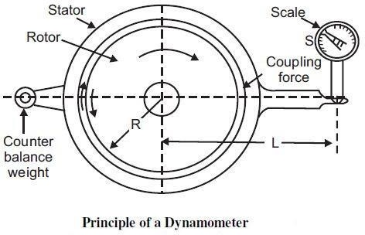

As the engine is running on the dyno it develops torque. There are sensors attached to the dyno which can detect the amount of movement (actual twisting of the device itself) which is produced from the coupling device. This force is then computed into the amount of torque produced. During the testing, the engine is pushed into wide open throttle (WOT). The dyno produces resistance against the engine as it climbs through the rpm range. To measure the amount of torque, the resistance must be enough to hold the engine at a given speed, yet not overpower the engine (impeded it's progress through the rpm range). As the engine climbs in rpm, the sensor do their thing and read the amount of torque which is being produced.

Damping in Coupling of Engine-Dynamometer:

  - The engine–dynamometer system is susceptible to torsional oscillations.
  - The internal combustion engine is a powerful source of forces calculated to excite such oscillations.
  - The magnitude of these undesirable disturbances in any given system is a function of the damping capacities of the various elements: the shaft, the couplings, the dynamometer and the engine itself.
  - The couplings are the only element of the system the damping capacity of which may readily be changed.

Let us assume that there are two identical flexible couplings, of stiffness Cc, one at each end of the shaft, and that these are the only sources of damping.
  - Torque in these couplings is transmitted by way of a number of shaped rubber blocks or bushes which provide torsional flexibility, damping and a capacity to take up misalignment.
  - These differ in three important respects from those of, say, a steel shaft in torsion:
  - The coupling does not obey Hooke’s law.
  - The shape of the torque–deflection curve is not independent of frequency.
  - The dissipation energy of amount W is proportional to the area of the hysteresis loop that is responsible for the damping characteristics of the coupling.

Damping energy dissipated in this way appears as heat in the rubber and can, under adverse circumstances, lead to overheating and rapid destruction of the elements.

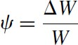
  - Damping energy ratio:

  - Dissipation Energy:

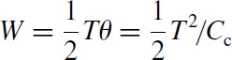

BASIC CONSIDERATION WHILE COUPLING THE DYNAMO:

Some of the basic considerations made while coupling are as follows:

  - Torsional Oscillations and Critical Speeds
  - Design of Coupling Shafts
  - Stress Concentrations, keyways and keyless hub connection
  - Shaft Whirl
  - Couplings
  - Flywheels

Torsional Oscillations & Critical Speeds:

  - In its simplest form, the engine–dynamometer system may be regarded as equivalent to two rotating masses connected by a flexible shaft.
  - The two masses can vibrate 180 out of phase about a node located at some point along the shaft between them.
  - The oscillatory movement is superimposed on any steady rotation of the shaft.

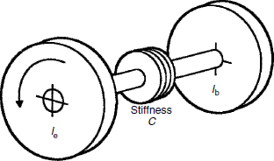

Two Mass System

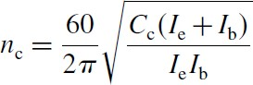
The resonant or critical frequency of torsional oscillation of this system is given by:

  - The relation between the amplitude of the induced oscillation and the ratio n/nc is as shown in following fig:
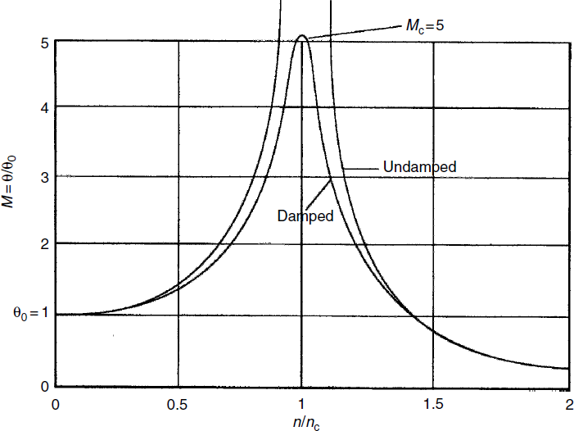

Design of Coupling Shafts:
  - The maximum shear stress induced in a shaft, diameter D, by a torque T Nm is given by:
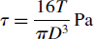
  - And in case of Tubular shafts, 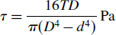
  - A typical choice of material would be a nickel–chromium–molybdenum steel, to specification BS 817M40 (previously En 24) heat-treated to the ‘T’ condition.
  - The various stress levels for this steel are roughly as follows:
  - ultimate tensile strength not less than 850 MPa (55 t.s.i.)
  - 0.1% proof stress in tension 550 MPa
  - ultimate shear strength 500 MPa
  - 0.1% proof stress in shear 300 MPa
  - shear fatigue limit in reversed stress ±200 MPa

Stress concentrations, keyways and keyless hub connection:

There are two particularly critical locations to be considered:

  - At a shoulder fillet, such as is provided at the junction with an integral flange. For a ratio fillet radius/shaft diameter=0.1 the stress concentration factor is about 1.4, falling to 1.2 for r/d=0.2.

  - At the semicircular end of a typical rectangular keyway, the stress concentration factor reaches a maximum of about 2.5× nominal shear stress at an angle of about 50 from the shaft axis. The authors have seen a number of failures at this location and angle.

  - Cyclic stresses associated with torsional oscillations is an important consideration.

  - In view of the stress concentration inherent in shaft keyways and the backlash present that can develop in splined hubs.

SHAFT WHIRL

The coupling shaft is usually supported at each end by a universal joint or flexible coupling.
  - The whirling speed of a solid shaft of length L is given by: 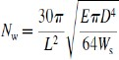
  - It is desirable to limit the maximum engine speed to about 0.8Nw.
  - The whirling speed of a shaft is identical with its natural frequency of transverse oscillation.
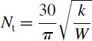
  - The transverse critical frequency of the shaft plus two half couplings is found by:

Couplings
  - The choice of the appropriate coupling for a given application is not easy.
  - The main types of coupling used are as follows:
  - Quill shaft with integral flanges and rigid couplings
  - Quill shaft with toothed or gear type couplings
  - Conventional ‘cardan shaft’ with universal joints
  - Multiple membrane couplings
  - Elastomeric element couplings

  - Loads that act on couplings:
  - Shock loading of couplings due to cranking, irregular running and torque reversal
  - Axial shock loading

  - Apart from these, the other factors which has to be taken care are,
  - Selection of coupling torque capacity
  - Retaining the clutch
  - Balancing of drive line components
  - Alignment of engine and dynamometer
  - Guarding of coupling shafts

Flywheels
  - No treatment of the engine/dynamometer drive line would be complete without mention of flywheels which may form a discrete part of the shaft system.
  - A flywheel is a device that stores kinetic energy.
  - The storage capacity is directly related to the mass moment of inertia which is calculated by:

I = k × M × R2
  - In the case of a flywheel taking the form of a uniform disk, which is the common form found within dynamometer cells and chassis dynamometer designs:

I = (½) x M x R2

  - The engine or vehicle test engineer would normally expect to deal with flywheels in two roles: 1.As part of the test object, as in the common case of an engine flywheel where it forms part of the engine/dynamometer shaft system and contributes to the system’s inertial masses taken into account during a torsional analysis.

- As part of the test equipment where one or more flywheels may be used to provide actual inertia that would, in ‘real life’, be that of the vehicle or some part of the engine driven system.
  - No mention of flywheels should be made without consideration of the safety of the application.
  - The most common hazard of test rig mounted flywheels is caused by bearing or clutch failure where consequential damage is exacerbated by the considerable energy available to fracture connected devices.

