Noncontact and noninvasive driver’s monitor: Measurement of heart rate and heart rate variability using microwave reflectometry
Mase A. GIC, Kyushu University, Japan; Electronics Res. Lab., Fukuoka Institute of Technology, Japan Kogi Y. Fukuoka Institute of Technology, Japan Maruyama T. Faculty of Arts & Sci., Kyushu University, Japan

Abstract
It is known that a driver’s physiological state is reflected by vital signals, such as heart rate, respiration, blood pressure, body temperature. Specifically, the heart rate and its fluctuation can be used for the mental and physical states of drivers. Several methods have been developed such as electrocardiogram (ECG), piezoelectric sensor, ultrasonic sensor, and infrared and microwave reflectometry sensors. Reflectometry measures remotely the human skin and internal organs movements when breathing and heartbeat are present. It is completely noninvasive and feasible even through clothing.
The heartbeat is fluctuating by autonomous nerve activity comprised of sympathetic and parasympathetic nerve activity. The time variation can be regarded as the short-term variation of the heartbeat frequency, i.e., heart rate variability (HRV). The peak ratio or area ratio of the HRV spectrum in the LF (0.03-0.15 Hz) to the HF (0.15-0.45 Hz) components is used to evaluate the stress condition. The coefficient of variation of R-R intervals (CVRR) can also be introduced as one of the indices to evaluate autonomous nerve activity. The HRV is evaluated by using newly developed algorithms.
In Fig. 1 physical load is applied to a subject during the time of 90-150 and 210-270 sec. It is observed that the values of HR and LF increase, and CVRR starts to decrease with some time delay during the time. The time behaviors of CVRR, LF and LF/HF agree between microwave and ECG although there is a difference in absolute values.
In the driving condition, the microwave signal includes random and large body movements due to road noise and steering wheel control. Auto-gain control of the receiver, template matching and cross-correlation among multiple reflectometers enabled motion artifact elimination. We have succeeded in reducing the spurious components and have extracted the signals. The success rate of the heart-rate measurement is ~80% as shown in Fig. 2.

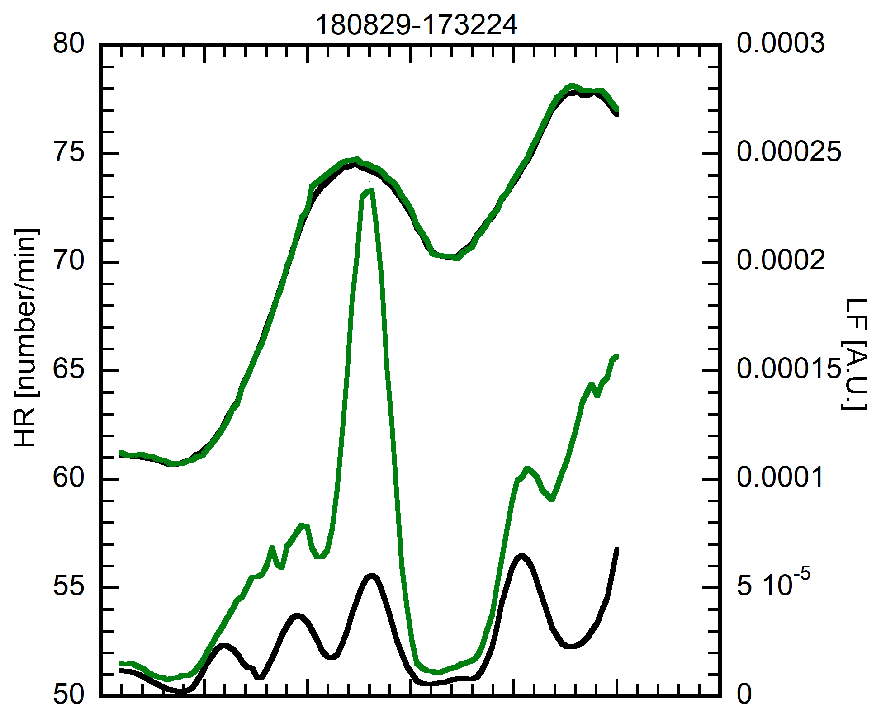

MW & ECG

MW

MW

ECG

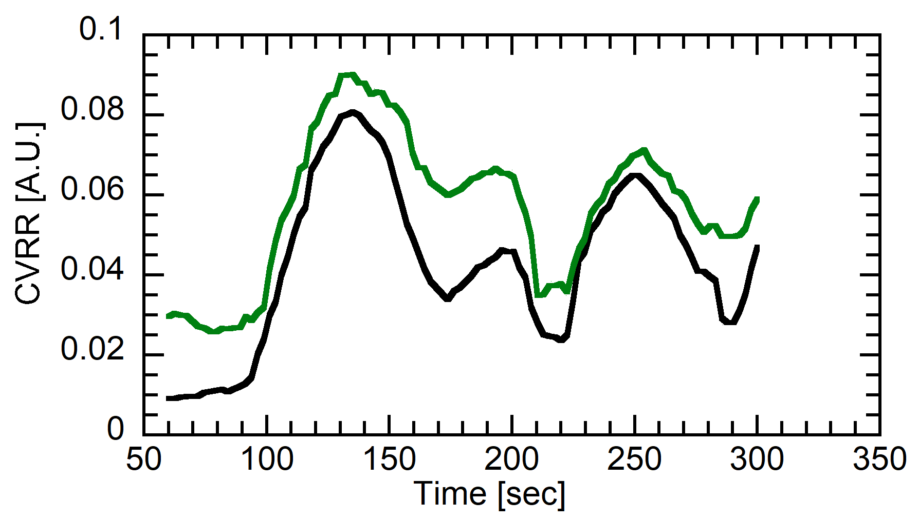

MW

ECG

Figure 1. Measurement of HR and HRV during artificial stress adding.
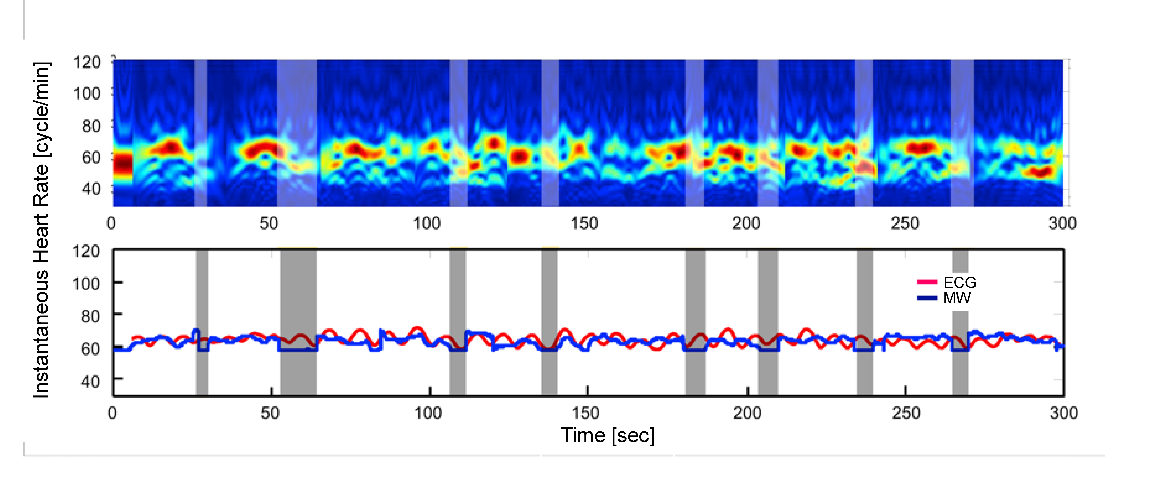
Figure 2. Wavelet spectra of the HR during driving condition.

Recent Publications
- Mase A et al. (2018) Advances in Physics: X, 3: 633-675.
- Maruyama T, Yasuda S, Mase A (2018) The 2018 Int. Cong. on Electrocardiology, Makuhari, Japan.
- Mase A, Kogi Y, Maruyama T (2018) IEEE MTT-S Int. Microwave Biomedical Conf., Philadelphia.
- Zhang D, Zong C, Mase A (2018) PIER Lett., 75:19-24.
- Wang Y et al. (2017) Nucl. Fusion, 57: 072007/1-19.

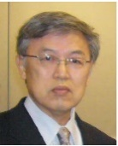Biography
Atsushi Mase, now is an Emeritus Professor at Kyushu University, and a Research Fellow at Electronics Research Laboratory at Fukuoka Institute of Technology. He got his B.S. and M.S. and PhD in Electrical and Electronics Engineering from Nagoya University in 1968, 1970, and 1976, respectively. He had been a research associate at Faculty of Engineering, Nagoya University from 1973-1981, an associate professor, at Institute of Applied Physics, University of Tsukuba from 1981-1999, a professor at Advanced Science and Technology Center for Cooperative Research, Kyushu University from 1999-2014. His research interests include microwave to infrared devices and systems for application to biomedical measurement, fusion plasma diagnostics, and airborne synthetic aperture radar. E-Mail: mase@gic.kyushu-u.ac.jp

Notes/Comments

