Internal & External Audit and Production Patrol Applications on production efficiency and costs at Automotive Industry
Dr. Ahmet FEYZIOGLU Ayhan TEMIZOZ
Marmara University, Faculty of Technology, 34722, TURKEY,
Occupational Health and Safety is being applied at the highest level in Automotive Industry in Turkey. Top management of the companies emphasized their commitment by progressing management systems such as OHSAS 18001 OHS Man. System with targeting “0” nonconformity.
Systems applied for high quality and efficient production in addition to protection of workers’ health & safety are audited by both internal and external parties. Health & safety audits are performed by legal external parties such as Ministry of Labour & Social Security, MoH, Directorate of Civil Defence, Directorate of Fire Brigade and OHSAS 18001 OHSM System audits are performed by third parties in periodically planned or unplanned.
Apart from external audits global systems are audited by internal parties such as Headquarter office, regional coordination office and as a requirement of OHSAS 18001, internal audits are performed by company associates. In addition, safety patrols are conducted daily, weekly and monthly with the contribution of management. Safety patrols are not only conducted by S&E Department but also production departments perform their own patrols independently.
The non-conformities defined in internal audits, external audits and safety patrols are recorded according to the TQM and ISO 9001 standards, analysed in detail and reported in different formats. Several methods have been used to analyse problems according to quality technics such as root–cause analysis and the measures are identified both in reactive and proactive way in order to prevent repeating and similar non-conformities. The sustainability of this proactive approach is maximized through new, technological and systematic improvements which go beyond complying legal requirements.
This case study illustrates the effect of audits, patrols and controls to eliminate unsafe acts and conditions on production efficiency. The studies will demonstrate unsafe acts and conditions. It will also suggest appropriate methods in order to create safe and more efficient working methods.
Recent Publications
1. Ahmet Feyzioglu (2017). Experimental evaluation of optimum process parameters for spinning of metals, MP Materials Testing, Part 18
2. Ahmet Feyzioglu, A. Kerim Kar (2017). Axiomatic Design Approach for Nonlinear Multiple Objective Optimization Problem and Robustness in Spring Design, Bulgarian Academy of Sciences, Cybernetics and Information Technologies, Volume 17, No 1, DOI: 10.1515/cait-2017-0005 Sofia
3. Ahmet Feyzioglu, A. Kerim Kar (2016). Development of Control Strategies and Implementation to Electrical Water Heaters for Energy Conservation, Bulgarian Academy of Sciences, Cybernetics and Information Technologies, Volume 16, No 4, DOI: 10.1515/cait-2016-0071, Sofia
4. Bülent Ekici, Ahmet Feyzioğlu, Fatih Perveli (2015,) Germany, Comparison of Fiber Reinforced Gypsum and Polyurethane Materials,Lambert Academic Publishing , ISBN-13: 978-3-659-67848-6
5. Müzeyyen Marsoglu , Ahmet Topuz , Ali Erdogmus , Ahmet Feyzioglu , Oguzhan Yurdalan, Sertaç Bilgin , Polat Topuz , Tuba Karahan, (2011). Cleaning Sea Water from Petroleum Products by Using Rubber Powder. MP Materials Testing For Recylıng., 53(5), 303-310.

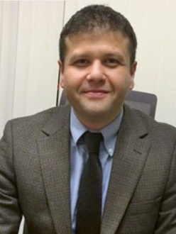

Biography
Ahmet FEYZIOGLU has completed his PhD in 2012 from Marmara University and postdoctoral studies from University of Manchester, Manchester Institute of Innovation Research He has been working in Marmara University Mechanical Engineering Dept since 2013.
Full name: Ahmet FEYZIOGLU
Contact number: 00 90 532 225 40 74
Twitter account:
Linked In account: https://tr.linkedin.com/in/ahmet-feyzioğlu-51261610
Session name/ number: Manufacturing Engineering
Category: Oral presentation
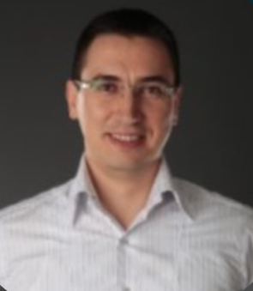

Biography
Ayhan Temizöz has completed his MBA at Kocaeli University in 2009, particularly focusing his studies on Occupational Health & Safety. Currently, he is carrying out his PhD studies at Marmara University Occupational Health & Safety Department. He is also working as an Occupational Health & Safety Manager and a Safety Specialist (A Class) at an international company.
Full name: Ayhan TEMIZOZ
Contact number: 00 90 534 776 60 77
Twitter account:
Linked In account: https://www.linkedin.com/in/ayhan-temizöz-07089110/

