Sedimentology and Mineralogy of Evaporate Deposits in coastal of Northern Oman Sea

Mohyeddin Ahrariroudi^{*1}, ^{2*} M.A.Zainudini, Oreinab Hasanzadeh³
¹Asistant Professor, Department of Basic Sciences, Faculty of Marine Sciences, Chabahar Maritime University, Iran, E-mail: m.ahrari@cmu.ac.ir,mazainudini@yahoo.com
^{2*}Department of Basic Sciences, Faculty of Marine Sciences, Chabahar MaritimeUniversity,Iran
³ Master of Science in Geology, Teacher, Department of Education of Chabahar
Abstract
Tis the northern coast of the Oman Sea is located in the northern Chabahar in southern Sistan and Baluchistan province. The geographical location of the study area is 25° 18´ in north latitude and eastern longitude 60° 37´. In order to study geochemical, mineralogical and sedimentological evaporite deposits of non-systematic method were taken 15 samples. The samples analyzed by National Geological Organization in Karaj. Statistical studies on geochemical data was performed using the software SPSS17. Was calculated Correlation coefficients, cluster and Factor analyses. According to the results of chemical analysis and field observations, the study area is located in Supratidal. And are directly affected by sea water. The main source of the basin has been affected by external factors basin (large evaporate and sea water fed) are placed. The amount of sodium and chlorine are the maximum amount and the rest less than 1. The amount of boron and lithium in the sediments show significant correlation (average between 338.8 and 738.5) that the correlation is similarly changed. The extent of these changes can be affected by seasonal rivers of Shoor and tis or related environmental factors. There are also significant differences between the amount of lithium and boron (average between 399.7 and 738.5), probably affected by coastal erosion and transport margins have been deposited by flowing water and This makes boron from earlier upland areas neat and lithium stacked in margins remain high in areas where has accumulated. One important result of this research is to identify evaporite minerals that are mainly halite. However, given the known elements can be said study area prepared for all three categories evaporite minerals (chloride, sulfates and carbonates) is in low amounts. According to cluster and factor analysis, three sources were identified included biogenic, eugenic (continental) and environment .Finally we can say is done sedimentation in the study area in a semi-enclosed coastal sedimentary environment (Sabkha).
Keywords: Tis; Evaporite minerals; Geochemical analysis; Eenvironmental factors.

- Introduction
Evaporates are sediments chemically precipitated due to evaporation of an aqueous solution. Common evaporates can be dominated by halite (salt), anhydrite and gypsum. Evaporates may be marine or non-marine. Marine evaporates formed by evaporation of water within an ocean basin with increasing evaporation produce calcite and dolomite (~10% evaporation), gypsum (~80% evaporation), and halite (~90% evaporation). Anhydrite can be precipitated at temperatures >40ºC. Minerals such as sylvite (KCl), carnalite (KMgCl₃.6H₂O) and langbeinite (K₂Ca₂Mg (SO₄)₆.H₂O) are typical minor components of marine evaporates. Restricted ocean basins with limited circulation of sea water and coastal plains (sabkhas) during marine regression are typical depositional environments for marine evaporates. Non-marine evaporates may be dominated by halite, gypsum or anhydrite and also can contain borax (Na₂B₄O₇.10H₂O), epsomite (MgSO₄.7H₂O), and gaylussite (Na₂Ca (CO₃)₂.5H₂O). Non-marine evaporates typically form in arid to subtropical environments in basins with limited fluvial input and output (e.g. playa lakes).
Alteration of evaporates after deposition is common. Anhydrite can replace gypsum by dehydration during burial whilst gypsum can form by hydration of anhydrite by interaction with groundwater. Gypsum and anhydrite can also be found as concretions formed during diagenesis. Halite deposits are capable of flow as diapirs on burial and rise through overlying sedimentary sequences. Anhydrite and gypsum commonly form a cap rock on diapers due to dissolution of halite. Halite diapers can extrude at the Earth’s surface to form salt glaciers. Evaporates often form important denouement layers in fold thrust belts. Evaporates are often interbedded with other sedimentary rocks such as mudstones, marls and siltstones. Where evaporates have been removed by dissolution but pseudomorphs remain deposits are often termed evaporate (Boggs, 2006).
In warm and arid climates, water evaporating from landlocked, or playa, lakes may result in the development of various minerals. As the lake waters evaporate, they become naturally enriched in the different soluble chemicals carried into them by streams. These chemicals have been obtained through weathering and erosion of nearby rock materials. Continued evaporation concentrates these chemicals to the point where they precipitate and accumulate at the bottom and shores of lakes as a group of distinctive minerals (Adabi & Asadi, 2008).
Considering that so far accurately and evaporate deposits of the southern region of Sistan-Baluchistan province has been less studied and extraction of these deposits, 70 years old, It is necessary be a full scientific study of sediments to the type of minerals, trace elements, their origin and their impact on the environment to be assessed.

- Geographical location and access roads to the area
The port of Chabahar is located in the south-east of Iran, north-west of the Indian Ocean, and north-east of the Oman. Chabahar is situated on the Makran Coast of the Sistan and Baluchestan province of Iran. The Port of Chabahar (or Chah Bahar) is a seaport in Chahbahar in southeastern Iran. Its location lies in the Gulf of Oman. It is the only Iranian port with direct access to the ocean. The port was partially built by India in the 1990s to provide access to Afghanistan and Central Asia, bypassing Pakistan. Study area in southeast Iran, the extreme south of the coastal Makran region and is part of the city of Chabahar. Because of its establishments and ease of access to ocean as well as Oman Sea and Persian Gulf, long ago it was the center of business, trade and navigation. Chabahar coastal town with an area of 14 square kilometers located in this zone. Chabahar with a population of more than two hundred thousand largest and most active coastal city of Zahedan, Iranshahr Iran by land ways, NikShahr, Chabahar, Konarak and related Jask. It is also possible air flights from Tehran to Zahedan, Bandar Abbas or Chabahar is possible.
Paleogeographic the oldest deposits in Chabahar belonging to Middle Miocene has been from collection of sandstone, mudstone and Conglomerate (Figure 1). These deposits and the fossils found in them, represent the facies are shallow (intertidal and possibly to 30 meters deeper than the sea) and then the upper Miocene sedimentary Basin in a little deeper and marl unit was deposited in those circumstances lower Pliocene continued (Aghanabati, 2010).
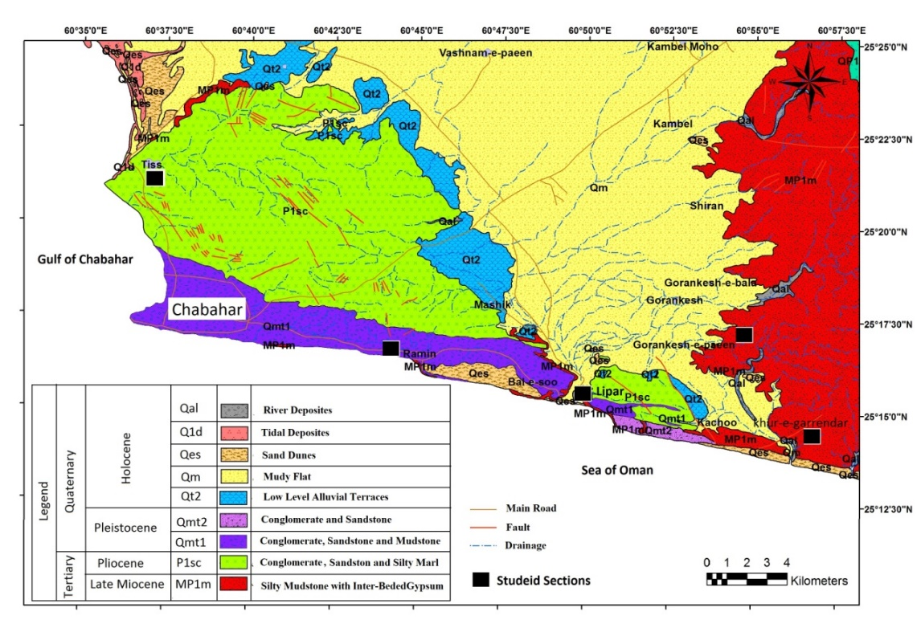
Figure 1) The portion of the Geologic map of the study area

The marl unit also contains large quantities of molluscs shells that can be represented neritic sedimentary environment. Late Pliocene orogenic phase in the performance of a shallow basin become again a set of sandstone and conglomerate deposited in study area. There are primary sedimentary structures in the sediments signs and high-energy shallow sedimentary environments and is also fast deposition of sediment in it. In early Quaternary deposits and dry environment by advancing sea, the beach for progressive and unconformity deposits has been formed in a coastal part of the study area. The effect next orogenic movements and mild, sediment has formed as marine terraces (Aghanabati, 2010; Alshahran & Kendall, 2008). Highlands region of east-west trend and often are flat.
- Material and Methods
In order to investigate the geochemical and sediment logical and mineral identification evaporation in this area, with the use of reviews Office includes research reports, student theses, scientific papers presented at seminars and publications and so on. Also geological maps and geochemistry related to this area were collected and investigated. After the study is to gather research information geological map of the study area, all the information and previous work conducted on the region's geology was investigated. Field studies including repeated visits regional and surface sampling 15 samples of sediment Tis areas, Pozm and park on the northern coast of Chabahar, study the sedimentary structures and institutions of the region. When you navigate in the area of evaporates, formed crystals, morphology, and vegetation, in order to investigate and more precision, photos were taken (Figure 2).
In order to determine the geographic location of the sampling was used GPS and the results were recorded in Table 1. The samples sent for chemical analysis to laboratories of Geological Survey of Iran in Karaj and results were received. To identify evaporate minerals samples, XRF and XRD studies were performed. To identify evaporate minerals samples, XRF and XRD studies were performed. To analyze the data was used from Excel and Version 17 software.

Table 1) Geographical location sediment samples with GPS
No. | Longitude | Latitude | Area
At-01-93 | E 60○ 37' 28" | N 25 18' 16" | Tis
At-02-93 | E 60○ 37' 32" | N 25 18' 20" | Tis
At-03-93 | E 60○ 37' 36" | N 25 18' 24" | Tis
At-04-93 | E 60○ 37' 40" | N 25 18' 28" | Tis
Ap-01-93 | E 60○ 19' 08" | N 25 27' 14" | Pozm
Ap-02-93 | E 60○ 19' 12" | N 25 27' 20" | Pozm
Ap-03-93 | E 60○ 19' 14" | N 25 27' 24" | Pozm
Ap-04-93 | E 60○ 19' 20" | N 25 27' 30" | Pozm
Ap-05-93 | E 60○ 19' 24" | N 25 27' 34" | Pozm
Apa-01-93 | E 60○ 33' 47" | N 25 26' 26" | Parak

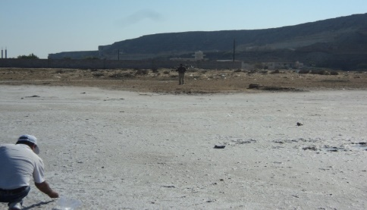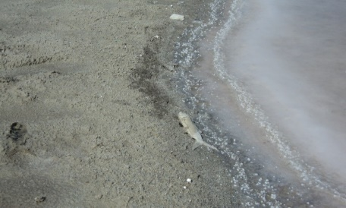
Figure 2) surface sediments in the region Pozm (photo right) and Tis (photo left)

- Discussion and conclusion
Evaporate Reserves that with main high thickness have been deposited in marine basins (Jacob). These deposits and the continuation of sedimentation in the region by factors such as weather conditions and changes in static basin, hydrographic and tectonic linked. When the basin is out of equilibrium, evaporates will deposit (Ahrari-Roudi et al., 2012). Laminated anhydrite and halite will precipitate in the center of the field. Congestion (feeding) of alternating will allow the water mass to be formed thick sequence. If this does not happen, sediments on the basin floor dry and evaporate minerals will come into existence. One sedimentary basin uplift above sea level can again start a new cycle (Burwash et al., 2000; Blatt et al., 1980).
The average amount of lithium in the earth's upper crust is about 70 ppm economic factor to form lithium in internal environments (such as pegmatites) and external (eg, ground salt, Sabkha and clay). In both cases, under certain circumstances, after the deposition of lithium is less soluble and can be focused to an economic deposit. Lithium occurs in a variety of rocks and water but usually low concentrations. Curves and the values of lithium and boron were measured in the study area (Table 2 and Figure 3).
Table 2) Value measured boron and lithium
Sample No. | boron | lithium | Location of sampling
At-01-93 | 3.86 | 3.34 | Tis
At-02-93 | 2.96 | 3.33 | Tis
At-03-93 | 0.86 | 10.01 | Tis
At-04-93 | 6.2 | 8.46 | Tis
Ap-01-93 | 0.5 | 8.43 | Pozm
Ap-02-93 | 4.4 | 2.55 | Pozm
Ap-03-93 | 3.24 | 3.32 | Pozm
Ap-04-93 | 5.64 | 4.25 | Pozm
Ap-05-93 | 0.76 | 6.58 | Pozm
Apa-01-93 | 1.06 | 23.58 | Parak

According to Table 2 and Figure 3, variations Boron is between 0.1 and 6 and variations Lithium is between 3 and 24. The highest value of Lithium is in the area park and the lowest value of that in the area Pozm. The highest value of Boron is in the area Tis and the lowest value of that in the area Pozm. Figure 4 and 5 shows the amount of boron, lithium, major elements and Location of samples on map in the study area. According to the map that was drawn with GIS software, has determined that the samples were influenced by seawater and are totally dependent on it. Of course, in the area surrounding the study area is changed to a value indicating not great abundance. The amount of boron in the center of the basin will increase, but reduced the amount of that in the margins of the basin indicate that the influence of sea water.
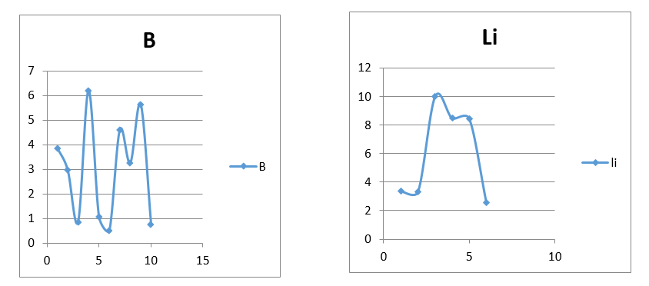
Figure 3) Diagrams boron and lithium variations

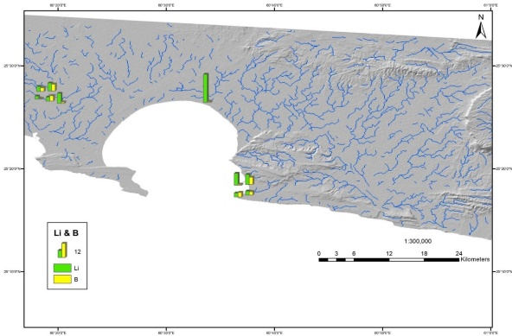
Figure 4) Values of boron and lithium on map in the study area using GIS software

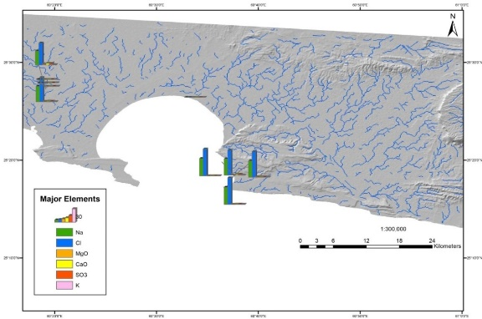
Figure 5) Values of Major Elements on map in the study area using GIS software

Variations the abundance of elements show that with away from the sea, basin are affected by fresh water river seasonal and the amount of Lithium will more and The salinity of seawater is more implicated, the amount of boron increases in the basin.
According to Figures 4 and 5, the region most affected Pozm lowest seasonal rivers, and sea water, thus is provided conditions for the accumulation of boron element. Due to seasonal river discharge into the sea, the amount of boron is deposited on the margins of the sea. The amount of Lithium because more weight, the concentration in the upstream. In Pozm area in addition to the amount of boron, lithium and the amount of major elements compared to other regions increasing trend that can be said probably be the origin of environmental pollutants.
By using the XRD analysis, 12 kinds of chemical composition (include So₃, Na, SiO₂, Al₂0₃, Fe0, Ca₂O₃, MgO, B, Li, K, CL, Br) were identified in studied area. According to Table 3 and figure 6, Halite is the mineral found in sedimentary basins studied (Pozm and Tis). The graph in Figure 6 shows three ranges is the most abundant mineral halite.

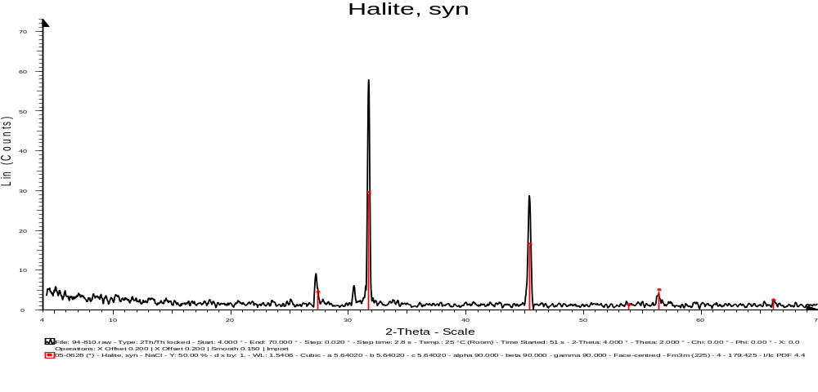
Figure 6) The graph of the results of XRD analysis

Table 3) XRD analysis of samples
S.N | AT-01-93 | AT-02-93 | AT-03-93 | AT-04-93 | AP-01-93 | AP-02-93
Na* | 37.00 | 34.85 | 36.53 | 31.62 | 38.45 | 39.5
Mgo | 0.6 | 1 | 0.4 | 1.8 | - | $$<1$$
$${Al}_{2}O_{3}$$ | 0.1 | 0.6 | 0.2 | 0.8 | 0.1 | $$<1$$
$${SiO}_{2}$$ | 0.2 | 1.9 | 0.4 | 2.5 | 0.2 | 0.1
$${SO}_{3}$$ | 0.5 | 1.1 | 2.2 | 3.4 | 0.6 | 0.1
K* | 0.23 | 0.33 | $$<1$$ | 0.74 | $$<1$$ | $$<1$$
Cao | 0.5 | 1.6 | 2.4 | 0.4 | 0.6 | 0.1
$${ZrO}_{2}$$ | $$<1$$ | $$<1$$ | 0.1 | $$<1$$ | $$<1$$ | -
Cl* | 57.44 | 54.71 | 56.43 | 49.41 | 59.57 | 60.28
Br | $$<1$$ | $$<1$$ | $$<1$$ | $$<1$$ | $$<1$$ | $$<1$$
Humidity | 3.17 | 3.09 | 0.87 | 5.02 | 0.22 | 0.14
$${CeO}_{2}$$ | 0.1 | 0.2 | 0.2 | 0.2 | - | -
$${Fe}_{2}O_{3}$$ | $$<1$$ | $$<1$$ | $$<1$$ | $$<1$$ | $$<1$$ | $$<1$$

Table 4 shows the amount of each element in the six samples analyzed that the following will be discussed to determine the mean, median and variations weight percent the elements. In order to analysis and interpret more, were calculated the correlation coefficient, clustering and factor analyze for samples. The results of elemental analysis shows that the study area, the conditions of the evaporates is formed. But these conditions to prepare for the mineral halite given the amount of Na, Cl.

Table 4) the results of elemental analysis by using the software SPSS₁₇
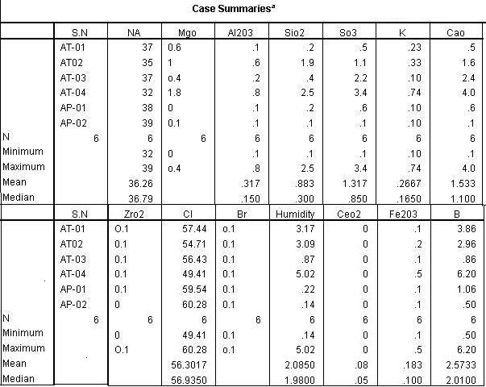

Histograms in figures 7 to 10 shows that the amount of elements and their variations P-P. The objective is to determine the effective distribution data. Of course the median and standard deviation determined above each histogram. According to the figures 7 to 10, between the median and standard deviation of the data, there is little difference in one point to reach their greatest amount. But at the end of the diagrams can be seen a decreasing trend.
This variations increased and then decreased ppm in combination, caused by the effect of external factors (such as erosion and classic particles entering the basin and the influence of sea water in front of the sea) are on conditions of the sedimentary basin. Though, environmental agents are effective on the basin.

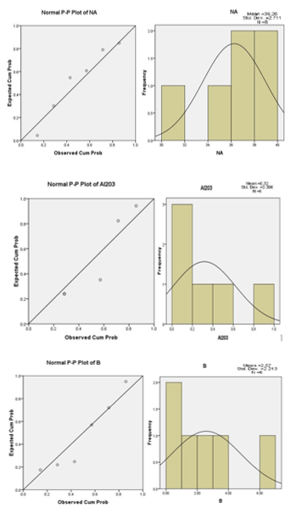
Figure 7) Histograms of B, Na and Al₂O with their variations P-P
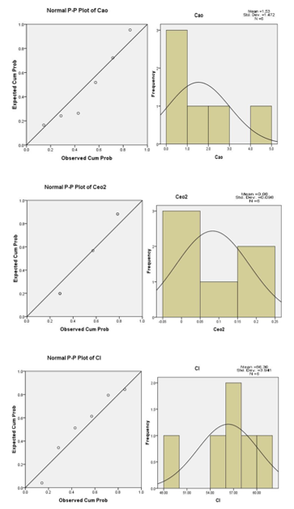
Figure 8) Histograms of Cal, Cano and CeO₂ with their variations P-P
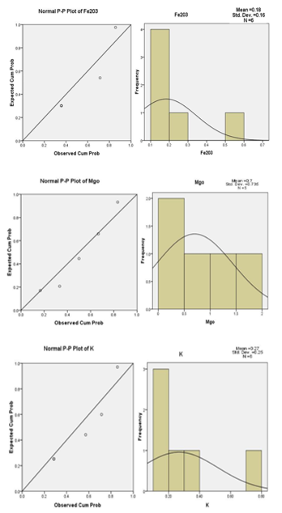
Figure 9) Histograms of K, Mg and Fe₂O₃ with their variations P-P
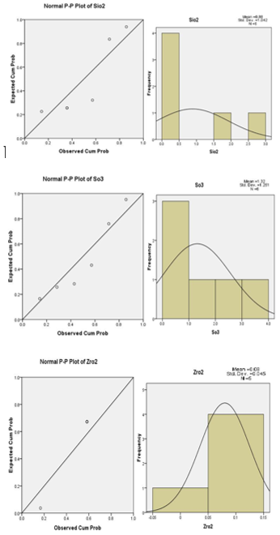
Figure 10) Histograms of ZrO, SO₃ and SiO₂ with their variations P-P
Table 5 shows the model of Pearson's the correlation coefficient of elements. Since both elements are included, the effects of the elements can be shown as a numeric value and adaptive coefficient. This amount is always between -1 and +1. In the event that exists positive linear correlation between the two elements, this factor is +1 and in the case of a negative linear relationship exists, this amount is -1 and the relationship between the elements is determined by the numeric value of zero. On the other hand these factors, meaning that at specified confidence level.
In this table, the elements that have the most correlation show with red color and ones that have low correlation with green color and the elements that have lacking in the correlation coefficient do not have any symbols. Therefore, carbonates and chlorides the correlation is significant and is related to the mechanism of their formation. In the region of Pozm, these elements due to the little distance to the coastline and the effect of upstream sediment basin is probably a result of external basin activities.
Table 5) Results of the correlation coefficient between the elements
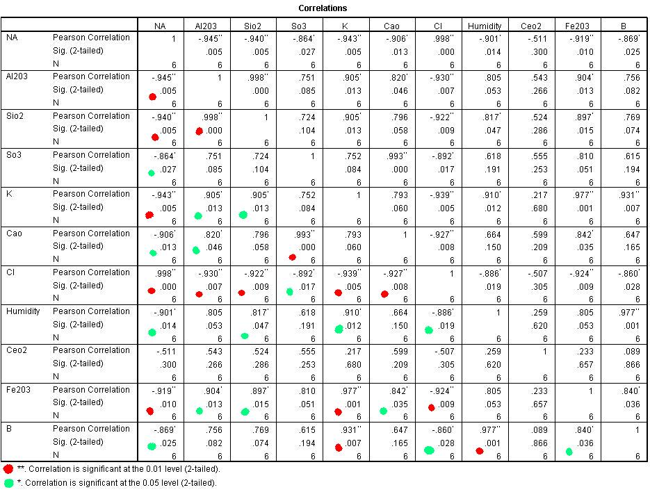

Cluster Analyses is indicated in Figure 11. The results of these studies (Dendritic) in the study area, shows three groups of elements.
The first group: includes elements Na and Cl are highly correlated together and B with lower relationship the origin of this group is within the basin (inner Basin).
The second group: includes elements SiO₂, Al₂O₃ and MgO are highly correlated together the origin of this group is Geogenic and by rivers or wind (erosion rocks) have been imported into the basin.
The third group: includes elements Fe₂O₃, SO₃, K, B and CaO are highly correlated with each other the origin of this group is Biological origin and due to environmental pollution.
Of course, Ceo₂ combined with high difference between the second and third groups are linked and also Zro₂ combined with more distance associated with the second and third groups.
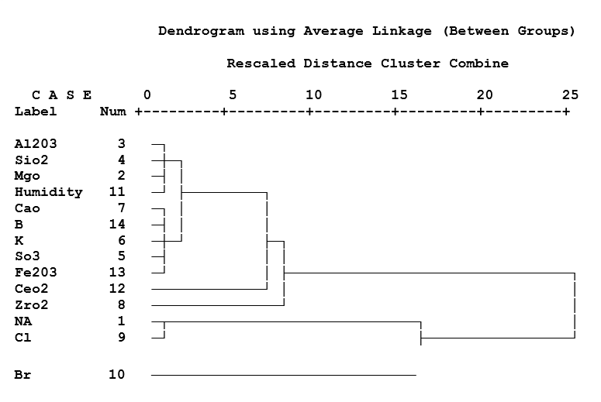
Figure 11) Cluster Analyses of elements in study area

The evaporative crystallization of minerals in accordance with the results of chemical analysis are as follows:
Initially carbonates (including CaCO₃, Ca SO₄) then chloride (NaCl includes a solid solution with chloride, KCl, MgCl_{2,} B and Mg) and sulfates (including MgSO₄, KCl MgCl₂ +6H₂O) formed are. Therefore, the necessary conditions for the formation of three groups of evaporate minerals (including chloride, sulfates and carbonate) are available in the study area. But according to the elements Na and Cl, the necessary conditions for the formation of chlorides (especially halite) is much better than in the studied area.
- Interpret the depositional environment and presenting a model
Arid environments (hot with limited precipitation) are ideal for developing brines. Semiarid playa lakes, sabkhas (supratidal flats), salt pans, estuaries, and lagoons are all environments where brines forms. Evaporates have uneven spacial and temporal distribution, with widespread appearance in broad, shallow basins with minimal competing sediment flux in arid climates. Although we have no modern analogues, huge evaporate deposits suggest that ancient environments contained large evaporating basins. Because suitable climate conditions are usually between 10° and 30° latitude (a global band of desert), evaporate deposits can assist in reconstructing prehistoric continent positions.
Evaporates in non-marine settings (closed lakes, ephemeral lakes, or playas in arid or semi-arid climates) are most likely to demonstrate a bulls-eye pattern of minerals, with gypsum rims and bitter borate centers. The most common trace minerals are borax, throne, epsomite, gaylussite, and glauberite. Evaporates in shallow marine settings can be divided into supra- and intratidal deposits, and marine shelves. In both instances, the brine is refreshed by seawater and groundwater, and deposits are layered by adjacent facies during as sea level changes adjust shoreline position (Tucker, 1986; Pettijohn, 1975; Milner, 1962, Rahimpor & kalantarzadeh, 2005).
Typically, evaporate deposits occur in closed marine basins where evaporation exceeds inflow. The deposits often show a repeated sequence of minerals, indicating cyclic conditions with a mineralogy determined by solubility. The most important minerals and the sequence in which they form include calcite, gypsum, anhydrite, halite, polyhalite, and lastly potassium and magnesium salts such as sylvite, carnallite, kainite, and kieserite; anhydrite and halite dominate. These sequences have been reproduced in laboratory experiments and, therefore, the physical and chemical conditions for evaporate formation are well known.
The outcrops in the area are calcareous mudstone (former marls) and marine terraces and plateaus which are composed of two levels, and the city of Chabahar, is located on them. Silty sand and sandy silt are two sediment types in Chabahar Bay. The sands and silts are dominated by Siliciclastic sediments of quartz, calcite, feldspar, rock and oyster shell fragments. These sediments have a moderate to well sorting, platykurtic kurtosis and positive skewness. Some of shell fragments come from intra-basin and others are clastic. The clastic shell fragments are mostly originated from the upper part of the marine terraces and have been transported into the Bay by the wind or water erosion. The calcite grains are also abundant clastic sediments (Pararas, 2006;, Leeder, 1982; Bobbes et al., 2006).
The evaporator is a heat transfer system, and is that part of a refrigeration cycle in which liquid refrigerant is evaporated for the purpose of removing heat from the refrigerated space or product (Jacob & Quittmeyer, 1979; Edvards, 2001.
Sabkha is a phonetic translation of the Arabic word for a salt flat. Sabkhas are supratidal, forming along arid coastlines and are characterized by evaporate-carbonate deposits with some siliciclastics. Sabkhas form subaerial, prograding and shoaling-upward sequences (Warren, 1999; Dean & Schhreiber, 1978; Chan et al., 2002) that have an average thickness of a meter or less. Sabkha are common in modern supra- and intratidal settings, with evaporates intermixed with siliclastic debris washing down from inshore erosion, and offshore sand tossed up by storms. Sabkha commonly demonstrate chicken wire structure, elongate anhydrite clumps separated by strings of carbonate or siliclastic mud. In the other hand, in the study area, the basin is Sabkha model which is connected by tidal basin and then because of the sand dunes (like a bar) and prevent the return of water. Basin compounds concentrated and after evaporating in the study area are formed evaporates (Figure 12)

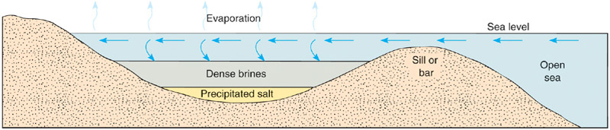
Figure 12) Cross-sectional diagram of a barred basin, illustrating the deposition of evaporates (Depositional model suggested).

- Results
Since both elements are included, the effects of the elements can be shown as a numeric value and adaptive coefficient. This amount is always between -1 and +1. In the event that exists positive linear correlation between the two elements, this factor is +1 and in the case of a negative linear relationship exists, this amount is -1 and the relationship between the elements is determined by the numeric value of zero. On the other hand these factors, meaning that at specified confidence level.
The results of these studies (Dendritic) in the study area, shows three groups of elements. The first group: includes elements Na and Cl are highly correlated together and B with lower relationship the origin of this group is within the basin (inner Basin). The second group: includes elements SiO₂, Al₂O₃ and MgO are highly correlated together the origin of this group is Geogenic and by rivers or wind (erosion rocks) have been imported into the basin.The third group: includes elements Fe₂O₃, SO₃, K, B and CaO are highly correlated with each other the origin of this group is Biological origin and due to environmental pollution. Of course, Ceo₂ combined with high difference between the second and third groups are linked and also Zro₂ combined with more distance associated with the second and third groups.
In the study area, the basin is Sabkha model which is connected by tidal basin and then because of the sand dunes (like a bar) and prevent the return of water. Basin compounds concentrated and after evaporating in the study area are formed evaporates.
The evaporative crystallization of minerals in accordance with the results of chemical analysis that is show initially carbonates (including CaCO₃, Ca SO₄) then chloride (NaCl includes a solid solution with chloride, KCl, MgCl_{2,} B and Mg) and sulfates (including MgSO₄, KCl MgCl₂ +6H₂O) formed are. Therefore, the necessary conditions for the formation of three groups of evaporate minerals (including chloride, sulfates and carbonate) are available in the study area. But according to the elements Na and Cl, the necessary conditions for the formation of chlorides (especially halite) is much better than in the studied area.
- References
- Adabi, M.H. and Asadi Mehmandosti, E., 2008, Microfacies and geochemistry of the Ilam Formation in the Tang-e- Rashid area, Izeh, Journal of Asian Earth Sciences, V.33, 267-277pp.
- Aghanabathi, A., 2010, Geology of Iran, The Geological Survey of Iran, Third Edition, 586p.
- Al-Farraj, A., 2005. An evolutionary model for sabkha development on the north coast of the UAE, Journal of Arid Environments, v. 63, 740p.
- Alsharhan, A.S. and Kendall, C.G.St.C, 2003, Holocene coastal carbonates evaporates of the Southern Arabian Gulf and their ancient analogues, earth Science Reviews, V.61, Issues 3-4, 191-143pp.
- Ahrari Roudi, M.; Moussavi-Harami, R.; Lak, R.; Mohboubi, A. and Motamed, A., 2012, Using of Ground Penetrating Radar (GPR) AND Sediment Cores As Method Interpretation os Sedimentary Environments the Estuaries of North west oman Sea, Research Journal of Environmental and Earth Sciences, V.4, 500-510pp.
- Blatt, H., Middleton, G. and Murray, R.., 1980, Origin of sedimentary rocks,Prentice Hall PUB.Co.,780P.
- Boggs, S., 2006, Principles of Sedimentology and Stratigraphy (4th ed.), Pearson Prentice Hall, Upper Saddle River, NJ, 662p.
- Burwash, R.A., Kupricka, J. and Wijbrans, J.R., 2000, Metamorphic evolution of the Precambrian basement of Alberta; Canadian Mineralogist, v. 38, 423–434pp.
- Chan, L.H., Starinsky, A. and Katz, A., 2002, the behavior of lithium and its isotopes in oilfield brines; Geochimica ET Cosmochimica Acta, v. 66, no. 4, 615–623pp.
- Dean, W.E. and Schreiber, B.C, 1978, Marine evaporates, lecture notes for short course No.4, soc. econ. paleont. Mineral. 188P.
- Edvards, A.C., 2001, Grain size and sorting in modern sands. Jornal of Coastral Research, Vol. 17 (1), 38-52pp.
- Leeder, M.R., 1982, Sedimentary, Process and Products, Umwin, Hymna Pub. Co., 344p.
- Jacob, K, H, and Quittmeyer, R.C., 1979, The Markan region of Pakistan and Iran are system with active plate subduction. Geodynamics of Pakistan, 305-318pp.
- Milner, H.B., 1962, Sedimentary Petrography, Vol. 1, 2nd Ed., The Mac Mollan Co., 643p.
- Pararas-Garayannis, G., 2006, Potential of tsunami generation along the markan subduction zone in the northern Arabian sea. Case study: the earthquake and tsunami of November 28 1945, Presentation at 3 Tsunami Symposium of Tsunami Society.
- Pettijohn, F.J., 1975, Sedimemtary rocks, Harper Pub. Co., New York, p.434-441
- Sharma, G.S.1978, Upwelling off the southwest coast of India, Indian Journal of Marine Science, V.78-19
- Rahimpour-Bonab, H. and Kalantarzadeh, z., 2005, Origik of secondry Potash deposits:Acase from Miocene evaporates of Central Iran,Jour.ofAsianErth Sciences,v.25, 157 – 166pp.
- Tucker, M.E., 1986, Sedimentary Petrology, An Introduction, 5th Ed.
- Warren, J. K., 1999.Evaporites, their evolution and economics, Blackwell, 438p.

