Phenomena observed during intense irradiation by braking gamma quanta with threshold energy up to 23MeV of Me - D₂(H₂) systems and in pure gases D₂, H₂ also in He and Xe, in CuBe2 and 1H18N9T high pressure chambers, up to 4kbar
Roland Wiśniewski, Prof., Physics Faculty of Warsaw University of Technology, Poland
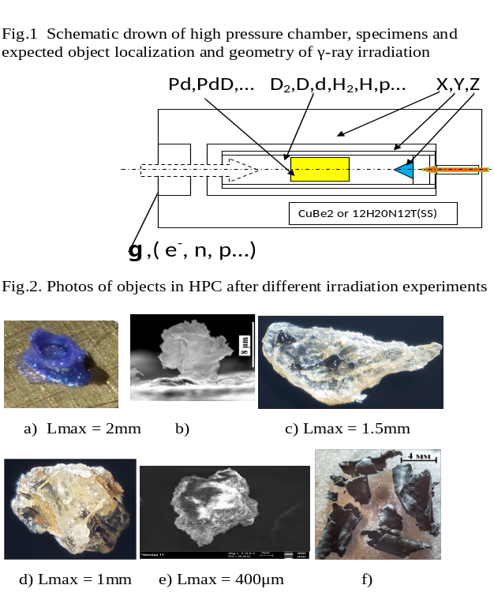
Gennady Myshinsky, dr, Laboratory of Nuclear Reaction, Joint Institute for Nuclear Research, Dubna, RF

The new concept of atomic-nuclear investigations is presented: Synthesis of chemical elements and solid structures upon irradiation with gamma rays of gases at high pressure (HP). Large dimensions metal specimens being under high pressure of chosen gas is irradiated by intensive flux of high energy braking γ-rays. First experiment was done with Pd and D₂ under pressure 3kbar. That was connected with our idea for obtaining the highest concentration of protons (deuterons) in Pd [1]. Fig.1 shows a main part of gas HP chamber. The element compositions of the synthesized objects as well as a new solid structures on inner surfaces of the gas HPC have been studied on samples of a number of metals and alloys as Pd, Al, V, Re…, YMn2, SS (in the shape of cylindrical rods and wires), using scanning electron microscope and x-ray microprobe analysis methods, in three independent Laboratories. Braking γ-rays had maximum energies of 10MeV [2] and 23MeV [3] (before and in giant nuclear dipole resonance range). As the source of gamma rays an electron accelerator (up to 25μA) with 2mm W braking target disk and 25mm Al electron absorber was used. Fig.2a shows the synthesized solid structure for energy 10MeV (Pd-D₂) [2]. The example of observed structure, for energy 23MeV (V-D₂), in form of “micro protuberance” from V surface is shown in fig.2b. Analogous investigations using hydrogen HPC in presence of palladium and tin rods [4], as well as with hydrogen only, without any metallic samples inside, under irradiation with 10MeV braking γ-rays were carried out. Examples of observed macro objects are shown in fig.2c,d. Result for pure deuterium is presented in fig.2e. Also a HPC filled with pure helium under initial pressure about 1.1bar was irradiated [5] – Carbon-like foils (fig.2f) and other multiple objects were observed. In all cases we have observed more lighter and more heavy nuclei than initial nuclei of metals. For example in the case of irradiated ₄₆Pd-D₂ such nuclei as ₆C, ₂₂Ti, ₈₂Pb, ₉₁Pa were found in quantity. Experiments with pure ₅₄Xe fully confirm our concept. In our reflections on the mechanism of reactions, we are inclined to the idea of multi atomic and multi nuclear interactions.
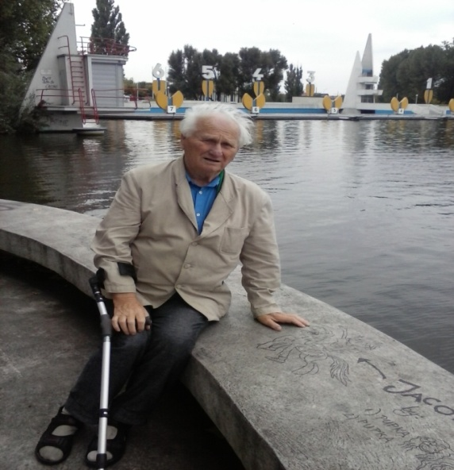

Publications:
1/ Wiśniewski R, Rev. Sci. Instr., 41, 464 (1970).
2/. Didyk A.Yu. and Wisniewski R. EPL. 2012. 99. 22001- 6.
Didyk A.Yu. and Wiśniewski R. EPL. 2013. 103. 42002- 6.
3/ Didyk A.Yu. and Wiśniewski R. Phys. Part. and Nucl. Lett. 2014. 11, No 2.169-179.
Didyk A.Yu. and Wiśniewski R. Phys. Part. and Nucl. Lett. 2014.11, No 3. 309-328.
4/ Didyk A.Yu.and Wisniewski R. Preprint R15-2014-6. Dubna. JINR. 2014. 34 P .; J. Part. Nucl. Lett. 2015).Didyk A.Yu., Wisniewski R. Preprint R15-2014-7. Dubna. JINR. 2014. p. 24;
5/. Didyk A.Yu. and Wisniewski R. and Wilczynska-Kitowska T. EPL. 2015. 109. .22001-6.
Wisniewski R., Didyk A.Yu. and Wilczynska-Kitowska T. JPSA, 5(4)(2015) 268-27
Roland Wiśniewski, has born in Warsaw (Poland). He has expertise in nuclear methods in Solid State Investigation, other interest - physics of high pressure technology. He has completed his PhD at the age of 35 years from Warsaw University of Technology. Professor in WUT from 1983, professor in National Center for Nuclear Research, Poland, 2004-2014. Author of large numbers of scientific publications also of 21 patents. Participant of many international conferences. Chief of a small research team focusing on new nuclear nanotechnology. From 1952 to 2000 academic teacher in WUT. Email: roland.wisniewski@gmail.com
Notes/Comments:
Presenting author details
Full name: Roland Wisniewski
University/Industry/Organization name: Physics Faculty of Warsaw University of Technology.
Designation (Director/Prof/Assistant or Associate prof/Researcher/Student): professor.
Country: Poland
Telephone (+) 48 513 067 792
Email: roland.wisniewski@gmail.com
Track name: experimental physics
Category (Oral presentation/ Poster presentation/Young researcher forum/E-poster): oral presentation
Research interest: High Pressure Physics, Nuclear Methods in Solid State
Linked In account:
Note: Please fill up the Red mark fields so that it would be easier for us to cite your details in the conference particulars. (Please do not forget to fix your photo above the title)

