Phenomena observed during intense irradiation by braking gamma quanta with threshold energy up to 23MeV of Me - D₂(H₂) systems and in pure gases D₂, H₂ also in He and Xe, in CuBe2 and 1H18N9T high pressure chambers, up to 4kbar

Roland Wiśniewski, Prof., Physics Faculty of Warsaw University of Technology, Poland
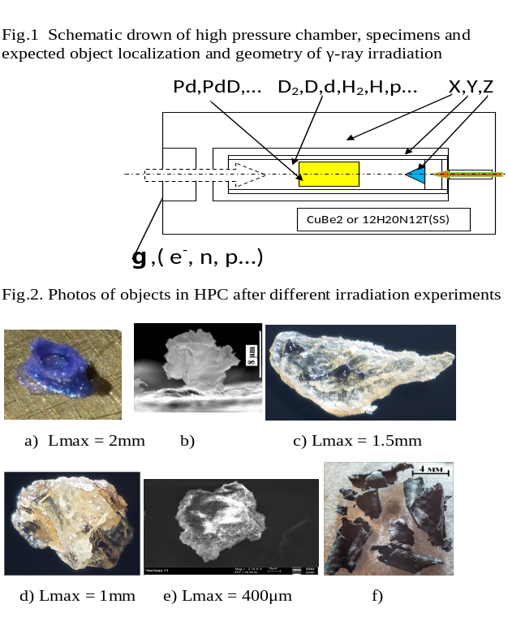
Gennady Mishinsky, dr, Laboratory of Nuclear Reaction, Joint Institute for Nuclear Research, Dubna, RF

The new concept of nuclear investigations is presented. Large dimension metallic specimens, being under high pressure of chosen gas, were irradiated by high energy, intensive, braking γ-rays flux. First experiment was done with Pd and D₂ under pressure of to 4kbar. That was connected with our concept for obtaining the highest concentration of protons (deuterons) in Pd [1]. Main part of designed by authors HP chamber shows Fig.1. The element compositions of the synthesized objects as well as the surface structure of the deuterium HP chamber elements have been studied using samples of a number of metals and alloys as Pd, Al, V, Re…, YMn2, SS (in the shape of cylindrical rods and wires) and using scanning electron microscope and x-ray microprobe analysis methods, in two independent Laboratories. Braking γ-rays had threshold energies of 10MeV [2] and 23MeV [3] (before and in giant nuclear dipole resonance range). As the source of gamma quanta an electron accelerator (MT25) with 2mm V braking target foil and 25mm Al electron absorber was used. Example of effects for energy 10MeV (Pd, D₂) shows fig.2a. The example of observed effects, for energy 23MeV (SS, V, D₂), in form of “micro protuberance” from V surface, shows fig.2b. Analogous investigations using hydrogen HPC in presence of Pd and Sn rods [4], as well as with hydrogen only, without any metallic samples inside, under irradiation with 10MeV braking γ-rays were carried out. Example of observed macro objects are shown in fig.2c,d. Results for pure deuterium is presented in fig.2e. Also a helium high-pressure chamber filled with gaseous helium under initial pressure about 1.1bar was irradiated [5]. Black foils (fig.2f) and other multiple objects were observed. In all cases we have observed much lighter and more heavy nucleus then initials (fission and fusion reactions), for example in the case of irradiated ₄₆Pd numerous such nuclei as ₆C, ₂₂Ti and ₈₂Pb, ₂₃₁Pa were found. Experiment with ₅₄Xe fully confirms the idea of our concept. Interpretation of observed by us complex phenomena is an open problem.
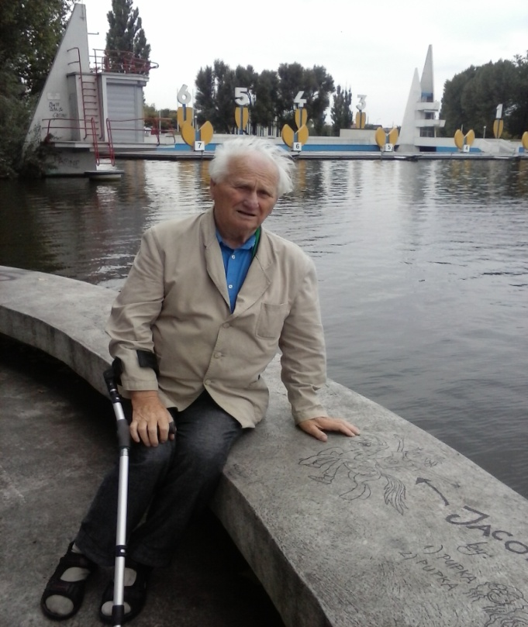

Publications:
1/ Wiśniewski R, Rev. Sci. Instr., 41, 464 (1970).
2/. Didyk A.Yu. and Wisniewski R. EPL. 2012. 99. 22001-6.
Didyk A.Yu. and Wiśniewski R. EPL. 2013. 103. 42002-6.
3/ Didyk A.Yu. and Wiśniewski R. Phys. Part. and Nucl. Lett. 2014. 11, No 2.169-179.
Didyk A.Yu. and Wiśniewski R. Phys. Part. and Nucl. Lett. 2014.11, No 3. 309-328.
4/ Didyk A.Yu.and Wisniewski R. Preprint R15-2014-6. Dubna. JINR. 2014. 34 P .; J. Part. Nucl. Lett. 2015).Didyk A.Yu., Wisniewski R. Preprint R15-2014-7. Dubna. JINR. 2014. p. 24;
5/. Didyk A.Yu. and Wisniewski R. and Wilczynska-Kitowska T. EPL. 2015. 109. .22001-6.
Wisniewski R., Didyk A.Yu. and Wilczynska-Kitowska T. “JPSA, 5(4)(2015) 268-27

Roland Wiśniewski, born in Warsaw (Poland). He has expertise in nuclear methods in Solid State Investigation, other interest - physics of high pressure technology. He has completed his PhD at the age of 35 years from Warsaw University of Technology. Professor of WUT since 1983, professor 2004-02014 in National Center for Nuclear Research, Poland. Author of numerous of scientific publications. Participator in many international conferences also author of 21 patents. Chief of a small research team focusing on new nuclear nanotechnology. From 1952 to 2000 academic teacher in WUT. Email: roland.wisniewski@gmail.com Notes/Comments:
Presenting author details
Full name: Roland Wisniewski
University/Industry/Organization name: Physics Faculty of Warsaw University of Technology.
Designation (Director/Prof/Assistant or Associate prof/Researcher/Student): professor.
Country: Poland
Telephone (+) 48 513 067 792
Email: roland.wisniewski@gmail.com
Track name: Experimental Methods
Category (Oral presentation/ Poster presentation/Young researcher forum/E-poster): oral presentation
Research interest: High Pressure Physics, Nuclear Methods in Solid State
Linked In account:
Note: Please fill up the Red mark fields so that it would be easier for us to cite your details in the conference particulars. (Please do not forget to fix your photo above the title)

