Source velocity at relativistic beams of ⁴He
S.P. Avdeyev, JINR, Dubna, Russia

Abstract

The main decay mode of very excited nuclei (E* ≥ 4 MeV/nucleon) is copious emission of intermediate mass fragments (IMF), which are heavier than α-particles but lighter than fission fragments. An effective way to produce hot nuclei is reactions induced by heavy ions with energies up to hundreds of MeV per nucleon. But in this case the heating of the nuclei may be accompanied by compression, rotation, and shape distortion, which can essentially influence the decay properties of hot nuclei. The picture becomes clearer when light relativistic projectiles are used. In this case, fragments are emitted by only one source - the slowly moving target spectator. Its excitation energy is almost entirely thermal. Light relativistic projectiles provide therefore a unique possibility for investigating thermal multifragmentation. The decay properties of hot nuclei are well described by statistical models of multifragmentation and this can be considered as an indication that the system is in thermal equilibrium or at least close to that. In the present work the source characteristics of multifragmentation are investigated for the ⁴He+Au collisions at 4 and 14.6 GeV using the 4π FASA detector on Dubna superconducting accelerator NUCLOTRON. Evidence that at least “kinetic equilibrium” of the system is achieved before fragmentation take place is found in the results of rapidity analyses. Decrease in energy of the incident particles from 14.6 GeV to 4 GeV leads to increases momentum transfer and source velocities. Data in ⁴He(14.6 GeV)+Au reaction are consistent with the INC+SMM calculations and can be described by one source with fixed velocity. There is broad range source velocities distribution in case of ⁴He(4 GeV)+Au where the speed of the source increases with IMF energy that not predicted by INC+SMM.
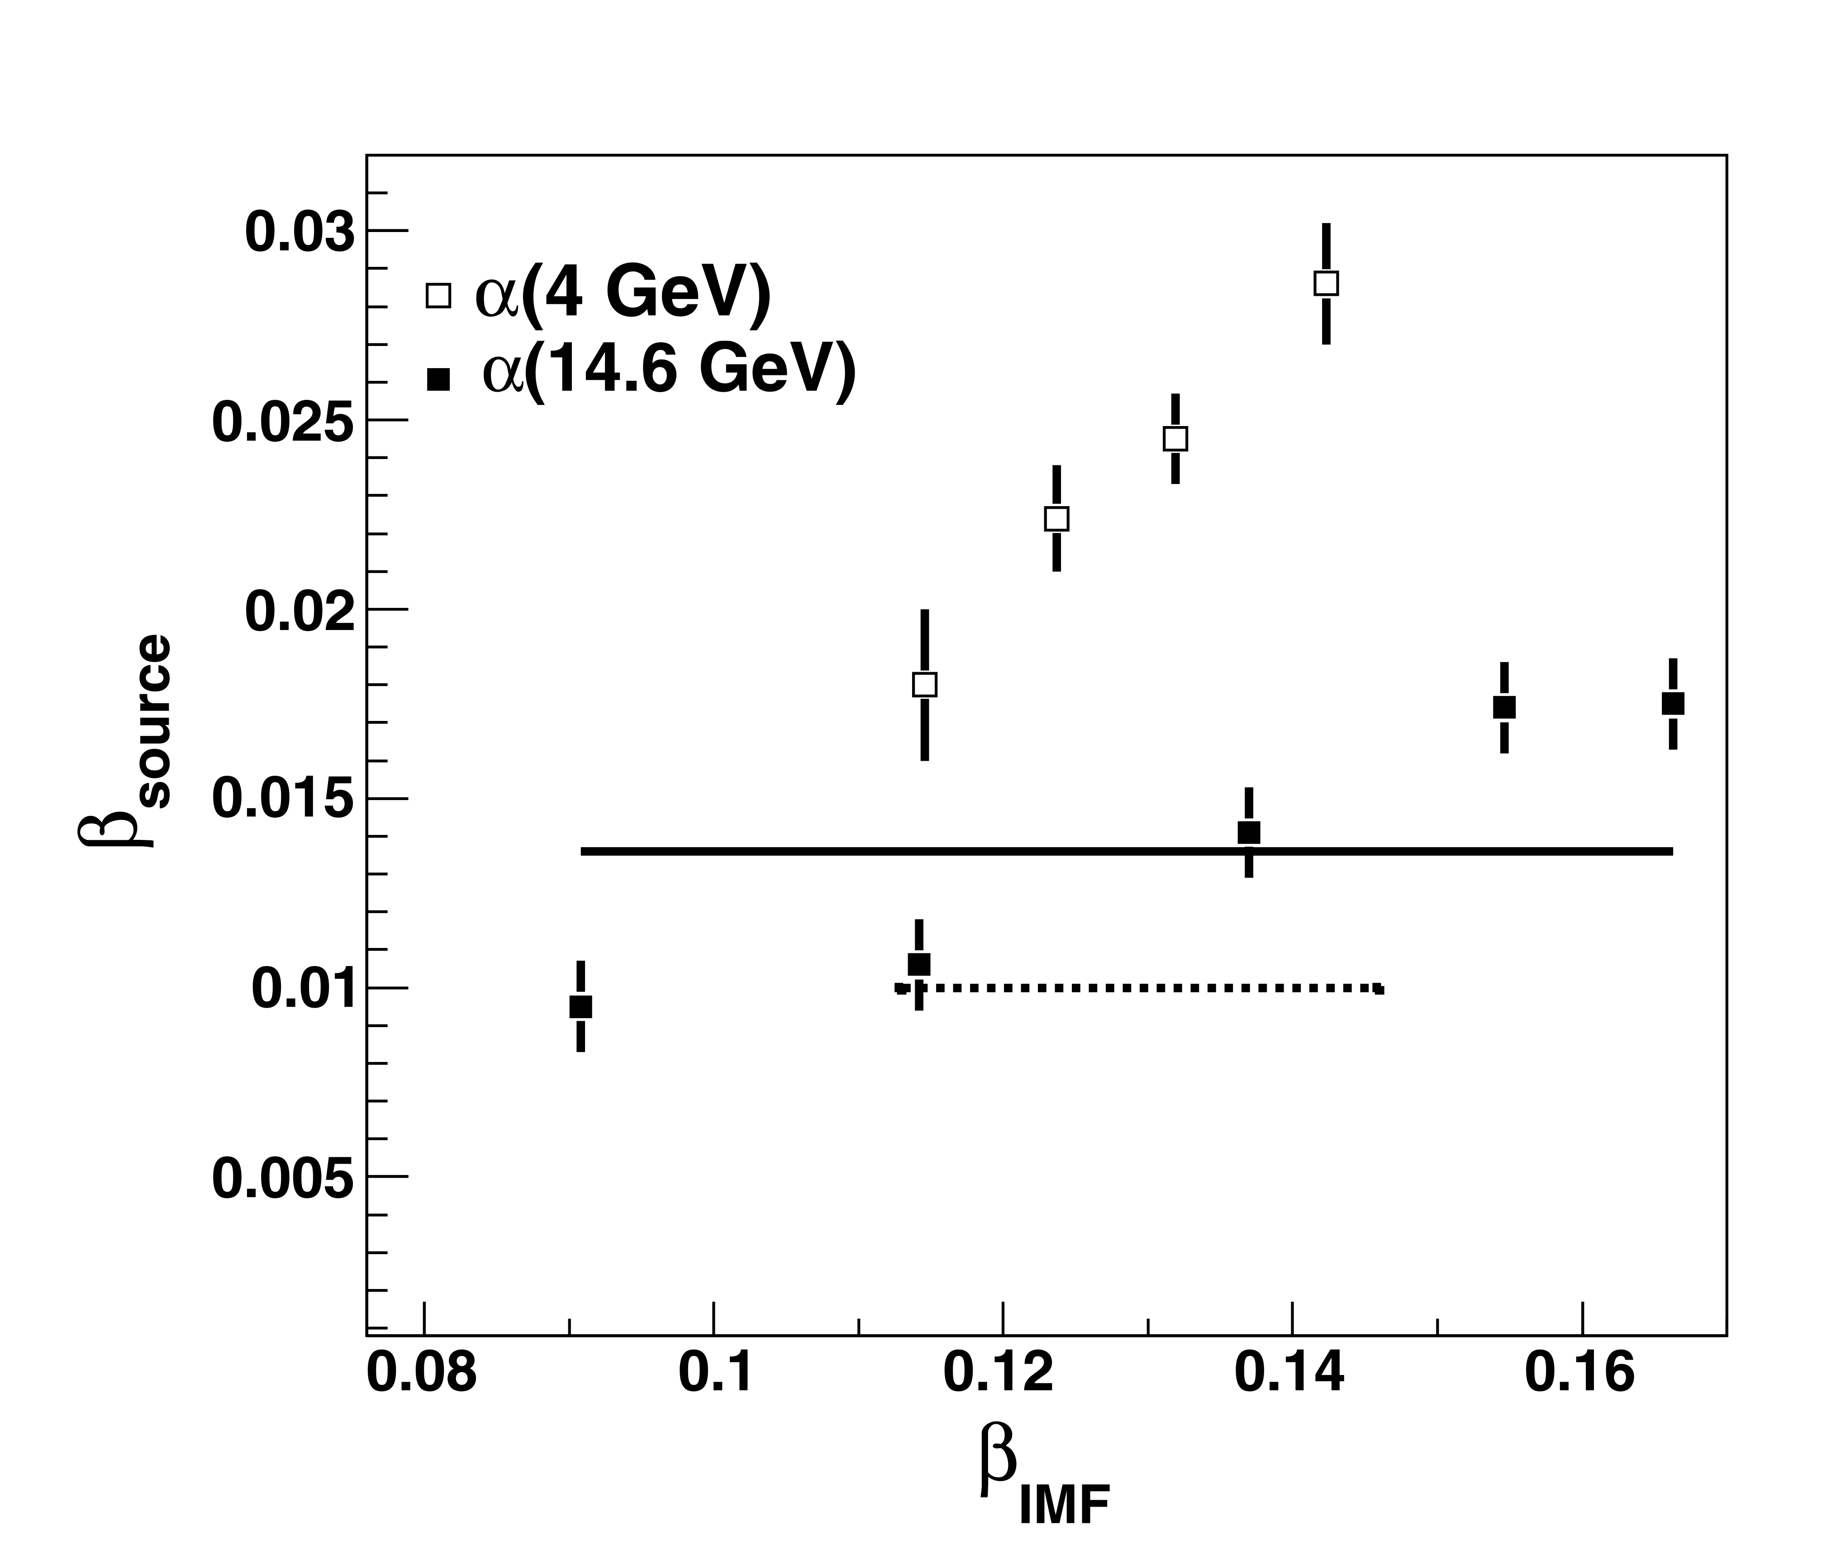
The source velocities as a function of IMF velocities. Points – experiment. Solid line – ⁴He with 14.6 GeV (calculations), dotted line – ⁴He with 4 GeV (calculations).
Recent Publications (minimum 5)

Source velocity at relativistic beams of ⁴He
S.P. Avdeyev, V.A. Karnaukhov, W. Karcz, V.V. Kirakosyan, P.A. Rukoyatkin, V.I. Stegaylov, H. Oeschler, and A.S. Botvina.

Expansion time of hot nuclei produced by a relativistic deuteron beam

V.A. Karnaukhov, S.P. Avdeyev, W. Karcz, V.V. Kirakosyan, P.A. Rukoyatkin, V.I. Stegaylov, H. Oeschler, A.S. Botvina

Electrical properties of deuteron irradiated high resistivity silicon
Jerzy Krupka, Waldemar Karcz, Sergej P. Avdeyev, Paweł Kamiński, Roman Kozłowski

From sequential processes to multifragmentation in proton reactions with gold
Sergej P. Avdeyev, Victor A. Karnaukhov, Helmut Oeschler, Waldemar Karcz, Vahan V. Kirakosyan, Pavel A. Rukoyatkin, Edwin Norbeck, Alexander S. Botvina

Time scale of nuclear multifragmentation induced by light relativistic ions V.A. Karnaukhov, S.P. Avdeyev, A.S. Botvina, V.V. Kirakosyan, O.V. Strekalovsky, P.A. Rukoyatkin, W. Karcz, E. Norbeck, H. Oeschler

Biography (150 word limit)
Sergej Avdeyev has his expertise in nuclear physics. He has completed his PhD at the age of 31 years from Joint Institute for Nuclear Research. 2007 – Doctor of Science (Phys. and Math.). He is research team leader focusing on Nuclear multifragmentation at Joint Insitute for Nuclear Research.
Email: avdeyev@aol.com

Notes/Comments:

Presenting author details
Full name: Dr. Sergej P. Avdeyev
University/Industry/Organization name: Joint Institute for Nuclear Research
Designation: Researcher
Country: Russia
Telephone: +79160355162
Email: avdeyev@aol.com
Track name: Track 9-7 Deep inelastic reaction
Category : Oral presentation
Research interest: multifragmentation
Linked In account:

Note: Please fill up the Red mark fields so that it would be easier for us to cite your details in the conference particulars. (Please do not forget to fix your photo above the title)

