Spontaneous spherical symmetry breaking in atomic confinement under general “not going out” boundary condition
K. Sveshnikov and A. Tolokonnikov,
Department of Physics, Moscow State University, Russia

Abstract

Motivated by the development of modern technologies, the confinement of quantum systems in cavities of different geometry has recently attracted a considerable amount of theoretical and experimental activity [1].

Starting from the works of Michels, de Boer and Bijl (1937), Sommerfeld and Welker (1938), until now the main attention has been devoted to the properties of atoms and molecules, confined by an impenetrable or partially penetrable potential wall. In such models with spherical symmetry the atomic nucleus resides always in the center of cavity. However, a more realistic model of atomic confinement inside a cavity implies imposing more general “not going out” or third type boundary conditions on the electronic wavefunction [2]-[4]. For an H-like atom, confined in the spherical cavity with such a condition, one obtains that depending on the cavity parameters, the atomic nucleus could reside either be in stable equilibrium at the center of the cavity, or is shifted towards the cavity boundary [5]. This shift is accompanied by the spontaneous breaking of the initial SO(3)-symmetry, accompanied by the emergence of corresponding Goldstone modes, representing fluctuations of spontaneous average under group transformations. In turn, these modes coincide with rotations around the cavity center and so restore the original symmetry, while the atomic states acquire rotational quantum numbers and some additional nontrivial properties. In particular, the atomic position in the ground state turns out to be spread over a spherical shell in the vicinity of the cavity boundary, while the trapping of the atomic nucleus inside the cavity proceeds dynamically due to the boundary condition imposed on the electronic wavefunction. Namely, when the nucleus moves towards the boundary, the deformation of the electronic wavefunction works as a spring, which returns the nucleus back inside the cavity.

Image

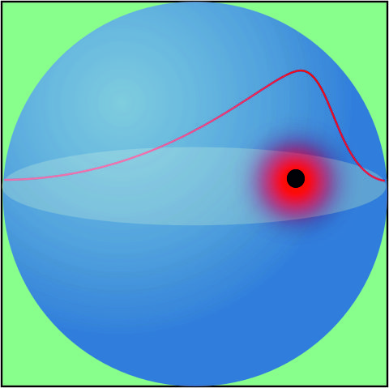

Recent Publications (minimum 5)
- Electronic Structure of Quantum Confined Atoms and Molecules, edited by K.D. Sen. (Springer, Berlin, 2014).
- K.D. Sen, V.I. Pupyshev, and H.E. Montgomery (2009). Adv. Quant. Chem. 57, 25.
- M.H. Al-Hashimi and U.-J.Wiese (2012). Ann. Phys. 327, 1; ibid. 327, 2742.
- K. Sveshnikov, A. Roenko (2013). Physica B 427, 118.
5. K. Sveshnikov, A. Tolokonnikov. Eur. Phys. J. D (2017) 71: 193

 Biography (150 word limit)
1985 has completed his PhD at the age of 25 years from Department of Physics of Moscow Lomonosov State University and postdoctoral studies from the same institution. He is the full-time Professor in theoretical physics at the Department of Physics of Moscow Lomonosov State University, director of the Institute of Theoretical Problems of MicroWorld of MSU. He has published more than 115 papers in reputed journals and has been serving as editorial member of such reputed journals as “Theoretical and Mathematical Physics”.
Email: costa@googol.bog.msu.ru

Notes/Comments:

