Title: Challenges in Assessing Therapeutic Equivalence of Nano-Similars

Dr. Beat Flühmann Director Vifor Pharma Ltd
Member of the Non-Biological Complex Drugs Working Group steering committee

Abstract
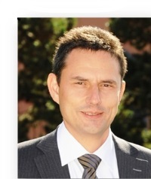
Showing therapeutic equivalence of nanomedicine follow on products to a reference drug is like for biosimilars more challenging than for low molecular weight drugs. The pharmacokinetics and especially the biodistribution can among other parameters depend on the size/size distribution and composition of the nanoparticle, having implications on the efficacy and safety of the drug. Today, the interaction of this nanoparticles with the body is not fully understood and the clinically meaningful physicochemical parameters are only partially identified.
In two clinical studies in chronic kidney disease patients depending on hemodialysis, a lack of therapeutic equivalence was demonstrated for the first time for an nanomedicine, namely Venofer® (iron sucrose) a nanoparticulate iron preparation for iv use, and its follow on products -or better called iron sucrose similars (ISS)- approved on a generic pathway in Europe. Upon switch from the originator iron sucrose to the ISS a rapid drop in Hb level and iron parameters was observed and higher doses of iv iron as well as ESA was required to stabilize the patient’s Hb levels. Further clinical reports also showed different safety outcomes such as increased levels of inflammation markers in hemodialysis patients and a significantly higher number of adverse events in gynecology patients.
The generic paradigm, lacking the clinical and non-clinical safety and efficacy requirements, is therefore not appropriate to assess nanomedicine follow-ons. Although ISS share the international nonproprietary name with the originator, they can exhibit clinically meaningful differences. Alarmed by these findings, the FDA and EMA have issued draft guidelines and reflection papers that propose a multi-step in vitro, non-clinical and clinical testing to evaluate the extent of similarity as a prerequisite to define the therapeutic position and the interchangeability or switchability of such nanomedicines.

Biography
Dr. Beat Flühmann Pharmacist, MBA (Ph.D.-molecular biology) now is Director of Vifor Pharma and Steering committee member of the Non-Biological Complex Drugs Working Group hosted at Lygature a non for profit organization. Dr Flühmann’s current main interest is in regulatory science aspects of nanomedicines. Before that Dr. Flühmann was working at Hoffman La Roche R&D in the area of diabetes and lipid metabolism.
.
Email: beat.fluehmann@viforpharma.com

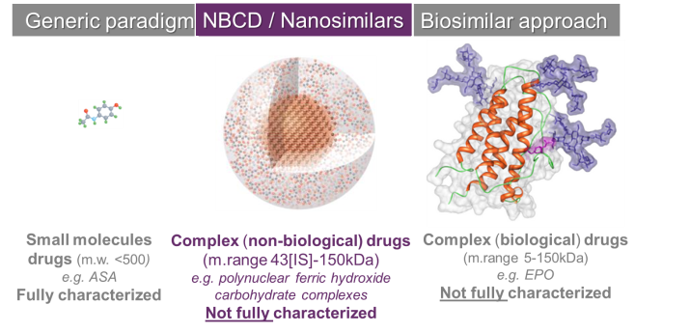Image

Notes/Comments:
Recent Publications (minimum 5)
- Knoeff J., Mühlebach S., Flühmann B., Medication practice in hospitals: are nanosimilars evaluated and substituted correctly? (EJHP in print)
- Daan J Crommelin, Vinod P Shah, Imre Klebovich, Scott E McNeil, Vera Weinstein, Beat Flühmann, Stefan Mühlebach, Jon de Vlieger. The similarity question for biologicals and non-biological complex drugs Eur J Pharm Sci. 2015;23:76:10-17
- Walson Ph., Mühebach S., Flühmann B. First Asia-Pacific Educational Workshop on non-biological complex drugs (NBCDs), Kuala Lumpur, Malaysia, 8 October 2013 GaBI Journal. 2014. 10/2014; 3(1).
- Huub Schellekens, Sven Stegemann, Vera Weinstein, Jon S.B. de Vlieger, Beat Flühmann, Stefan Mühlebach, Rogério Gaspar, Vinod P. Shah and Daan J.A. Crommelin How to regulate Non‐Biological Complex Drugs (NBCD) and their follow‐on versions: Points to Consider AAPS Journal 2014 Jan;16(1):15-21
- Flühmann B., Vulto A., Mühlebach S., Weinstein V., Shah V. The authorization of non-biological complex drugs (NBCDs) follow-on versions: specific regulatory and interchangeability rules ahead? GaBI Journal. 2013;2(4):204-7
- Borchard, G., Flühmann, B., Mühlebach, S., Nanoparticle iron medicinal products - Requirements for approval of intended copies of non-biological complex drugs (NBCD) and the importance of clinical comparative studies. Regulatory Toxicology and Pharmacology 2012, 64 324–328

