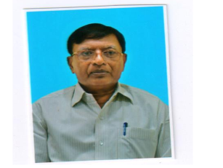
Title: Phytotherapy leads in the abatement of peptic ulcer and healing of dermal wounds in albino mice
Nandjee Kumar
Magadh University, Bodhgaya, Gaya- 824234, India.

The present paper reports the anti-ulcer potential of extract of the plant Azadirachta indica A. Juss and dermal wound healing potential of Aloe vera Tourn ex Linn. Studies were carried out selecting albino mice as experimental material because of their physiological activities and 90% genes similar to humans.
Ranitidine and different doses of leaf extract of Azadirachta indica were administered in ulcer induced albino mice and observations were noted at different intervals in each treatment. It was interesting to note that higher doses of leaf extract significantly reduced ulceration even surpassing the efficacy of ranitidine. Further the synergistic effect of ranitidine and even lower doses of the leaf extract significantly inhibited the ulcerogenesis. Thus leaf extract of Azadirachta indica possesses unique power of abating peptic ulcer.Further surgically created dermal excision in albino mice were treated separately with chemical drug betadine and varying doses of Aloe vera juice and observations were noted at different intervals in each treatment. Interestingly 1.0 % Aloe vera juice was significantly effective for healing dermal wounds (P< 0.01).
Conclusively phytotherapy may be superior and natural substitute of chemical drugs, however detailed molecular studies can reveal whether the plant extracts help repair the DNA responsible for ulcerogenesis/wound healing mechanism or suppress the action of chemical drugs.
Biography
Prof Nandjee Kumar completed his Ph D in 1984 and appointed Professor of Botany in 1987 at Magadh University, Bodhgaya, India. Further he was appointed Director, Institute of Biochemistry in the same organization. He has been actively engaged in research with publication of over 70 research papers and reviews in reputed national and international journals and four standard books. He has been serving as Vice-President of EMSI, EC member of AICGG and IBS.

Presenting author details
Full name: Nandjee Kumar
Contact number: 91 9431073451
Email: kumarnandjee@gmail.com
Category: Oral presentation

