Antineoplastic Drug NSC631570 Inhibits C6 Glioma Growth in Rats Through the Re-education of Tumor-Associated Microglia
Larysa Skivka, Taras Sevchenko National University of Kyiv, Ukraine
Mariia Rudyk,Taras Sevchenko National University of Kyiv, Ukraine
Ievgenia Opeida, Taras Sevchenko National University of Kyiv, Ukraine
Vitalina Svyatetska, Taras Sevchenko National University of Kyiv, Ukraine
Kateryna Stepura, Taras Sevchenko National University of Kyiv, Ukraine
Niccola Funel, University of Pisa, Pisa, Italy
Ascold Nowicky, Ukrainian Anticancer Institute, Vienna, Austria
Wassil Nowick, Ukrainian Anticancer Institute, Vienna, Austria

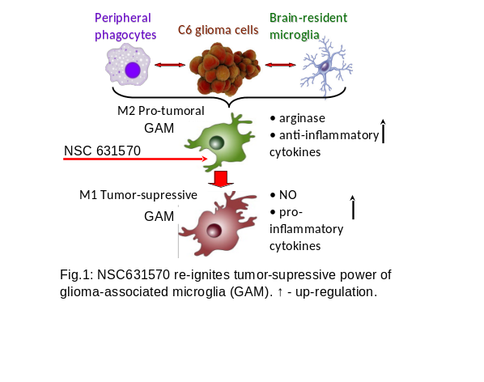

Abstract
Statement of the Problem: Glioblastoma (GB) is one of the most devastating and fatal tumors. Therapeutic approaches targeting tumor cells have failed. GB is heavily infiltrated with myeloid cells, that are collectively referred to as glioma-associated microglia/macrophages or GAM. GAM acquires the alternative, pro-invasive phenotype and create favorable conditions for disease progression. GAM re-education seems to be an attractive therapeutic approach to GM treatment. NSC631570 is an anticancer agent that influence phagocyte migration and functional polarization. This study was aimed to investigate the effect of NSC631570 on C6 glioma growth in rats and microglia metabolic profile in vitro and in vivo. Methodology : For tumor-associated hypoxia induction experiments, the rat microglial cells were treated under either normoxia (21% O2) or hypoxia (3% O2) for 48 h in vitro. Intracranial drug delivery device was developed for the local treatment of glioma-bearing rats with NSC631570. Tumor-bearing animals received seven intracranial injections of the drug at 3 days interval starting from the second day after C6 cell transplantation. Findings: NSC631570 re-polarized hypoxic microglia to pro-inflammatory metabolic profile in vitro. The treatment of tumor-bearing rats with NSC631570 was associated with prolongation of their life by 18%. This effect was accompanied by the increase in the number of phagocytizing CD14+ cells in the microglia fraction without the alteration in their endocytosis intensity. The frequency of CD206+ cells was moderately increased in the fraction of both CD14+ and CD14- microglial cells. Oxidative metabolism of GAM was moderately down-regulated by the drug. Intracranial introduction of the preparation was associated with the sharp increase of NO generation by microglial cells. Conclusion & Significance: Locally introduced NSC631570 can re-educate GAM. This repolarizing effect is associated with moderate tumor growth inhibition and might be considered as an important part of the mechanism of tumor-inhibitining action of the drug.

Image

Recent Publications
- Svitlana Prylutska, Larysa Skivka, Rostyslav Panchuk et al. (2017) C60 fullerene enhances cisplatin anticancer activity and overcomes tumor cell drug resistance. Nano Research.10(2):652-71.
- Mariia Rudyk, Olexander Fedorchuk, Yaroslav Susak, Yaroslav Nowicky, Larysa Skivka (2016) Introduction of antineoplastic drug NSC631570 in an inpatient and outpatient setting: Comparative evaluation of biological effects. Asian Journal of Pharmaceutical Sciences 11 (2):308–17.
- Prylutska SV, Skivka LM. et al. (2015) Complex of C60 Fullerene with Doxorubicin as a Promising Agent in Antitumor Therapy. Nanoscale Res Lett. 10(1):499.
- Skivka LM, Fedorchuk OG, Susak YM, Susak MY, Malanchuk OM, Rudyk MP, Nowicky YW (2015) Physical activity interferes with the immunomodulatory effect of the antineoplastic drug NSC631570. Current Pharmaceutical Biotechnology 15(1):49-59.
- Larysa M. Skivka et al. (2014) The effect of antineoplastic drug NSC63150 on immunogenicity of B16 melanoma. J Exp Integr Med. 4(2):93- 105.

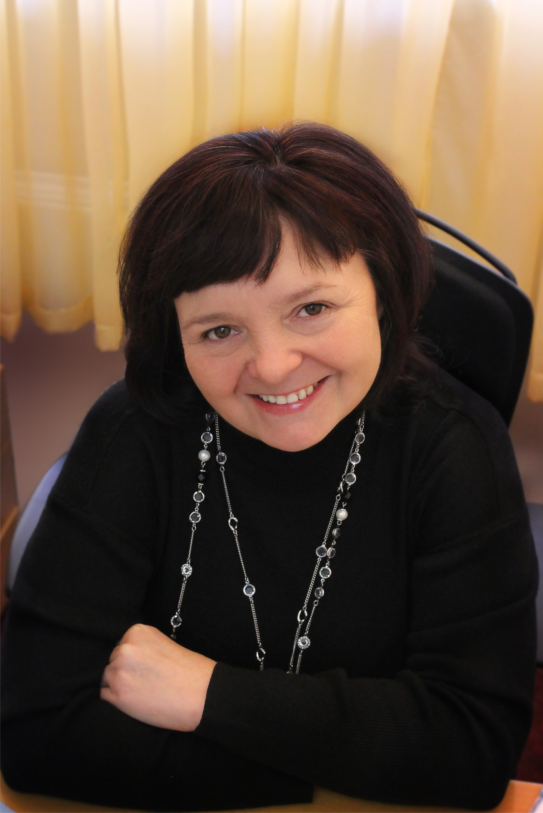 Biography
Larysa Skivka – ScD., PhD. She has completed her PhD at the age of 28 years from R.E. Kavetsky Institute of Experimental Pathology, Oncology and Radiobiology, NAS of Ukraine and postdoctoral studies from Taras Shevchenko National University of Kyiv. She got a Research Award from 23th International Congress on Anti-Cancer Treatment (ICACT) held in Paris, February 2012. Currently Larysa Skivka is a professor of the Educational and Scientific Centre “Institute of Biology and Medicine” of Taras Shevchenko National University of Kyiv (Ukraine), head of the Department of Microbiology and Immunology. Area of scientific activity – immunomodulation as a component of adjuvant cancer therapy, functional polarization of phagocytes in the pathogenesis of inflammatory diseases.

Email: realmed@i.com.ua

