Analysis of MRSA combining aptamer-modified magnetic nanoparticles and mass spectrometry
Yu-Tsen Liu, Yen-Peng Ho*
Department of Chemistry, National Dong Hwa University, Hualien 974, Taiwan

Abstract
In recent years, the abuse of antibiotics has led to bacterial variation in drug resistance, which has become a major risk for public health safety. The present work applied magnetic nanoparticles modified with highly specific aptamers to the capture of antibiotic-resistant bacteria, methicillin resistant Staphylococcus aureus (MRSA). The affinity probe is easy to synthesize and reusable. After silica and polyacrylic acid was modified on the surface of magnetic nanoparticles, and the highly specific DNA of MRSA was covalently bound to the particles. Antibiotic-resistant bacteria can be quickly captured by the probes. The probe is superior to antibody probes in stability and cost. The 60-minute capture time for MRSA has a capture rate of more than 90% while the capture rate for the antibiotic-susceptible Staphylococcus aureus is less than 15%. The bacteria species were further identified by mass spectrometer. The proposed method can be applied to quickly screen clinical samples and reduce the analysis time compared to the conventional methods.

Image
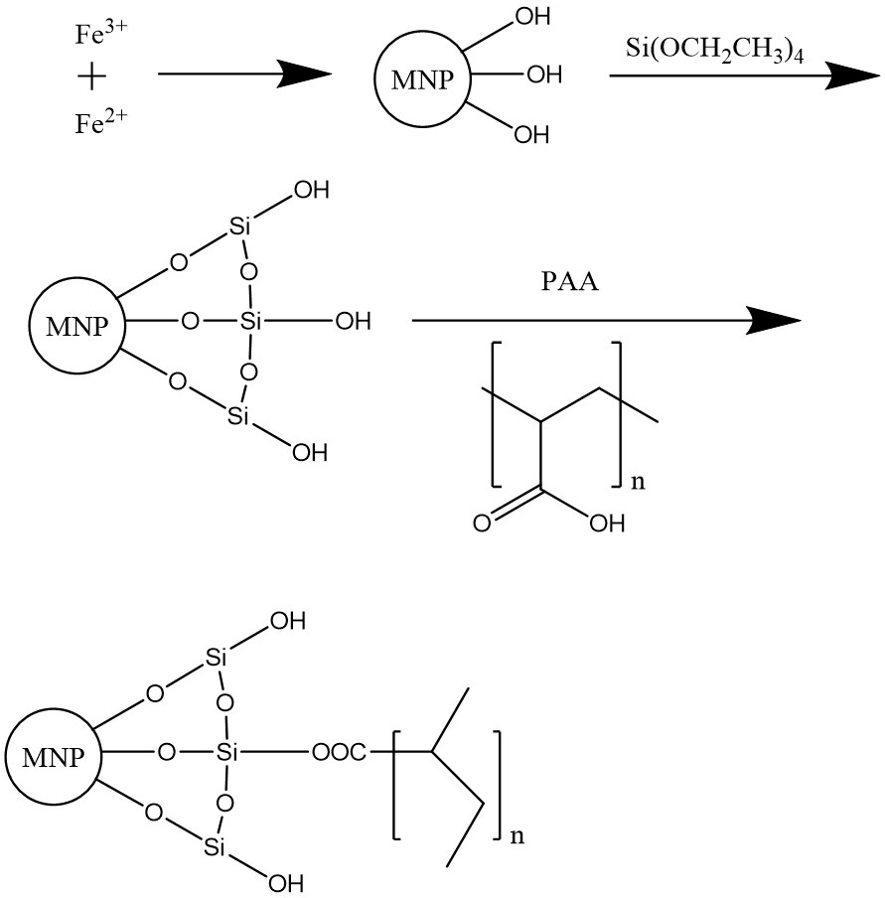
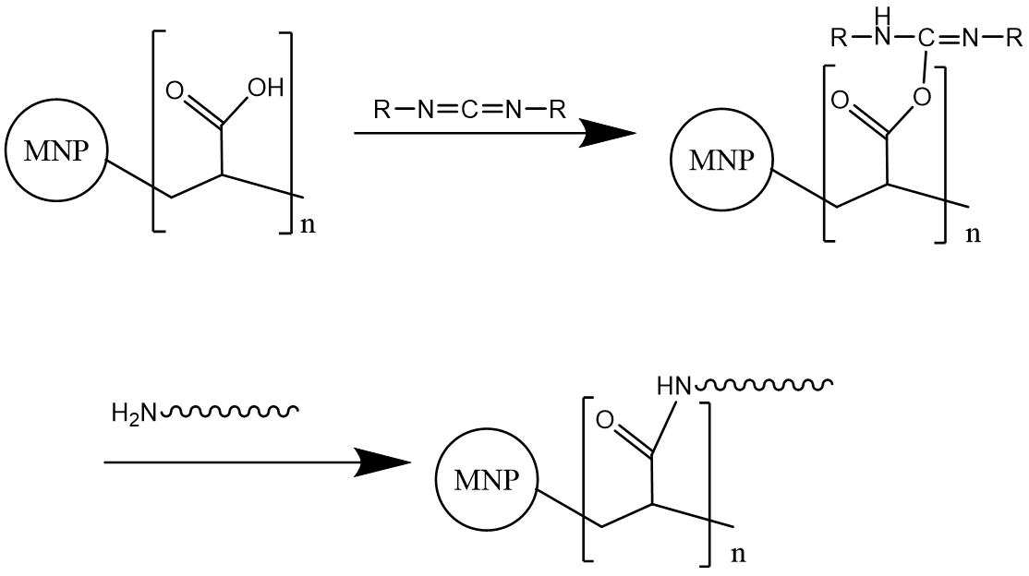
(a)
(b)
Figure 1,(a) Schematic experimental process flow chart.
(b) Schematic representation of the preparation of MNP@Aptamer.

Biography

Yu-Tsen Liu from Hualien,Taiwan .Now is a master student of Chemistry, National Dong Hwa University,

Email: drXXXXXXX@xxxmail.com

Notes/Comments:

