Smart Regulation of Surface Adhesion for Multifunctional Applications
Liping Heng, Beihang University, China

Abstract (300 word limit)
Adhesion between solid and liquid can be seen everywhere in our human life, agriculture and industry, such as oil-water separation, lab on the chip, high efficiency heat exchanger, water collection. Although great progress has been achieved in this field. There are still some unsolved problems. The first one is unstable adhesive properties mainly caused by the structural damage during the use. That is the surface structure is unstable during the use. To solve this issue, we introduced nanoscale layered structures and heterostructures into surface microstructure to improve anti-adhesive stability and mechanical stability [1-3], and then extend the life of the material. The second one is difficult to achieve in situ reversible adhesion regulation between surface and liquid because most of the interface response is slow response. For this issue, we obtained fast reversible regulation of the adhesion between surface and liquid by applying an electric field, photoelectric synergistic stimulation and temperature. Then we use them in smart driven of the liquid motion [4-5].

Image
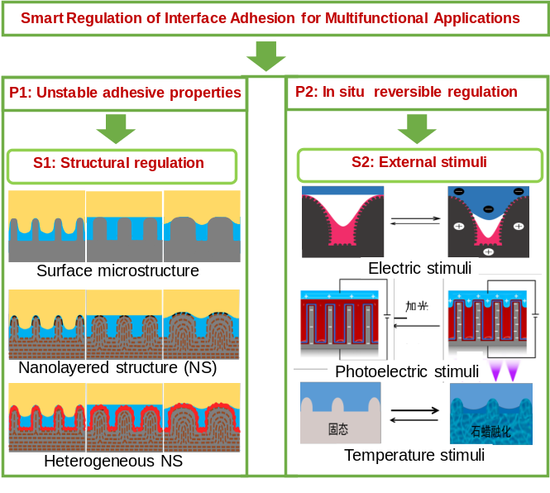
Recent Publications (minimum 5)

[1] Keyu Han, Liping Heng*, Lei Jiang, ACS Nano, 2016, 10, 11087
[2] Tianqi Guo, Liping Heng*, L. Jiang, Adv. Mater. 2016, 28, 8505.
[3] Xiangfu Meng, Liping Heng*, L. Jiang, Adv. Mater. 2018, 1706634.
[4] Pengda Che, Liping Heng*, Lei Jiang, Adv. Funct. Mater. 2017, 27, 1606199.
[5]Tianqi Guo, Pengda Che, Liping Heng*, Lei Jiang, Adv. Mater. 2016, 28, 6999


Liping Heng is currently a professor at Beihang University. She received her B.S. degree in chemistry and chemical engineering from Henan University of China in 2003. Then she joined Professor Lei Jiang’s group as a Ph.D. candidate. She received her Ph.D. in physical chemistry from ICCAS in 2008. After that, she worked as an assistant researcher and then an associate professor at ICCAS. In 2014, she moved to Beihang University. Her current scientific interests are focused on porous materials, self-cleaning materials and smart materials.
Email: henglp@iccas.ac.cn

Notes/Comments:

