Transition metal oxide nanostructures and their novel properties
Kalyan Mandal, PhD, S. N. Bose National Centre for Basic Sciences, Block JD, Sector III, Salt Lake, Kolkata-700106, India

Abstract
Iron and other transition metal oxides nanostructures receive considerable attention due to their extensive technological applications in high density magnetic storage media, high frequency devices, magnetically assisted drug delivery, cell isolation, MRI contrast agents, immobilization of proteins and enzymes, biosensors and so on. We observed many novel and enhanced properties in those oxides depending on their shapes and sizes [1, 2]. They can be functionalized with suitable ligands to get biocompatible and water soluble nanostructures with interesting multifunctional properties. For example, intrinsic multicolour fluorescence in MnFe₂O₄ nanoparticles (NPs)/hollow spheres (NHSs) from blue, cyan, and green to red is observed upon functionalization with a small organic ligand such as Na-tartrate because of ligand-to-metal charge transfer from tartrate ligand to lowest unoccupied energy level of Mn^{2+/3+}or Fe³⁺ of the NPs and Jahn−Teller distorted d−d transitions centered over Mn³⁺ ions in the Nanostructures as shown in Fig.1 [3,4]. CoFe₂O₄ nanoparticles functionalized with surfactants having π-acceptor/π-donor head group along with different chain-length show much higher coercivity compared to bare particles due to NP-ligand interaction which modifies the splitting of d-orbital energy levels as well as spin motion of surface Co⁺² ions [5]. Many of the above oxide nanostructures show excellent photocatalytic activities and potential for various biomedical applications depending on their shape, size and surface functionalizations as shown in Fig.2 [6, 7].

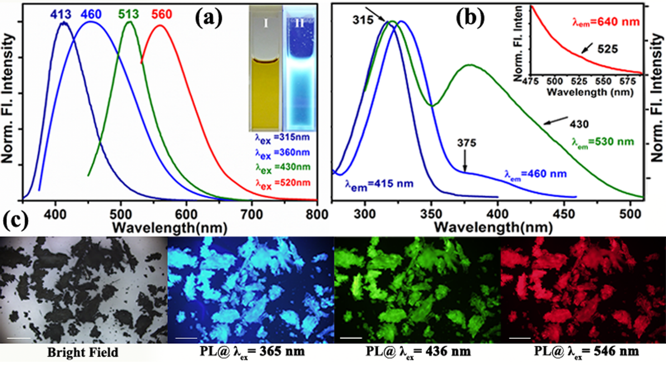
Figure1: Fluorescence properties of sodium tartrate functionalized MnFe₂O₄

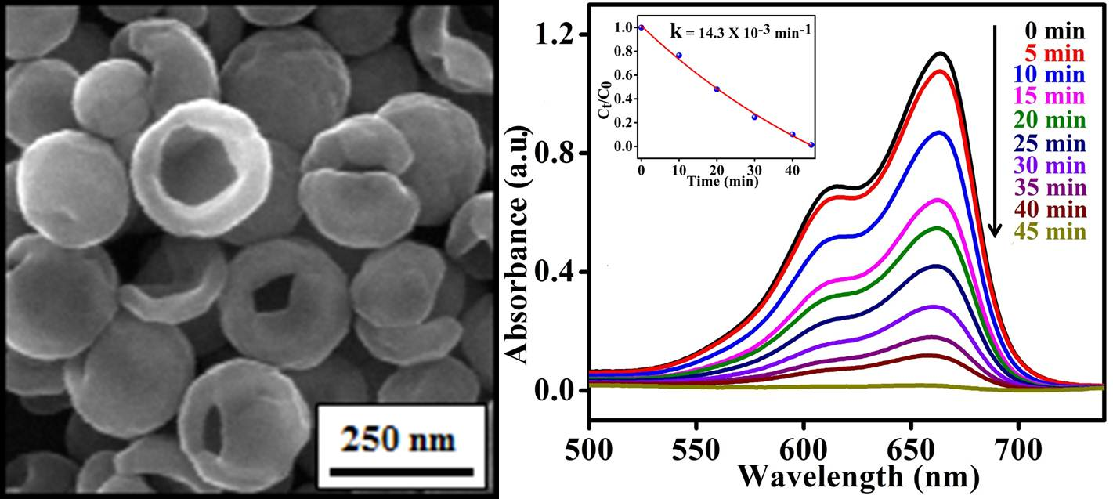

Figure 2: Sodium tartrate modified CoFe₂O₄ Nano hollow spheres and their Catalytic Property showing decay of Methelene blue.

References
- S Chakraverty, S Mitra, K Mandal, PMG Nambissan, S Chattopadhyay, Physical Review B, 2005, 71, 024115.
- S Mitra, S Das, K Mandal, S Chaudhuri, Nanotechnology, 2007, 18, 275608.
- M. Pal, R. Rakshit, K. Mandal, Applied Physics Letters, 2014, 104, 233110.
- M. Pal, R. Rakshit, K. Mandal, ACS Applied Materials and Interfaces, 2014, 6, 4903.
- R. Rakshit, M. Mandal, M. Pal, K. Mandal, Applied Physics Letters, 2014, 104, 092412.
- S. Talukdar, D. Mandal, K. Mandal, Chemical Physics Letters, 2017 672, 57-62.
- R. Rakshit, M. Pal, A. Chaudhuri, M. Mandal, K. Mandal, APL Materials, 2015, 3, 110701.

 Biography
Professor Kalyan Mandal, a “Senior Professor” in S. N. Bose National Centre for Basic Sciences, Kolkata, India, mainly works on Magnetism and magnetic materials including magnetic nanomaterials. He received his Ph.D. degree from the Indian Institute of Technology-Kharagpur, India and performed his post doctoral research in Queen’s University, Canada and Institute de Magnetismo Aplicado, Mdrid, Spain. He received Humboldt Fellowship from Germany and worked in IFW-Dresden and other universities/institutes in Germany as a Humboldt Fellow. He received UK-India Education and Research Initiative Award to work in Durham University, UK. He also worked in Osaka University, Japan as a Visiting Professor. He received “Materials Research Society of India Award” in 2016.
Email: kalyan@bose.res.in

Notes/Comments:

