Tuning the nanostructure of rGO laminate membranes for low pressure osmosis process
Qiuze Wang, Masdar Institute, Khalifa University of Science and Technology, Abu Dhabi, 54224, UAE
Cyril Aubry, Masdar Institute, Khalifa University of Science and Technology, Abu Dhabi, 54224, UAE
Linda Zou,* Masdar Institute, Khalifa University of Science and Technology, Abu Dhabi, 54224, UAE

Abstract (300 word limit)
In this research, rGO laminates were prepared by a controlled partial reduction step, aimed to avoid aggregation and tune the interlayer spacing (d) between the rGO layers (Fig. 1). The mild reducing agent vitamin C (L-AA) and cross-linker polycarboxilic acids were used to improve the stability of the assembled rGO laminate membranes. AFM was used for the first time to further investigate the statistical size distribution of spacing between rGO layers. Topographical images of the edges of the rGO layers were obtained with an AFM instrument, interlayer spacing profiles were extracted and then the data was plotted and fitted with Gaussian curves. We confirmed that the differently sized spacing co-existed, and their size distribution was affected by the reduction degree of rGO. At greater levels of reduction, more interlayer spacing were formed in the smaller size range, while few large gaps were still present. The obtained rGO laminate composite membranes were evaluated in a low pressure osmosis process such as forward osmosis (FO). The water permeation was higher in the rGO membrane prepared with a medium reduction degree (1.2-R) than the sample prepared by higher reduction degree (2.0-R) due to well-balanced nanochannels in hydrophilic regions and hydrophobic walls for fast transport of water molecules. The solute flux of the FO membrane was inversely correlated to the reduction degree. These findings helped in developing future strategies for designing high water flux and low reverse solute flux rGO membranes that are ideal for a FO process.

Image
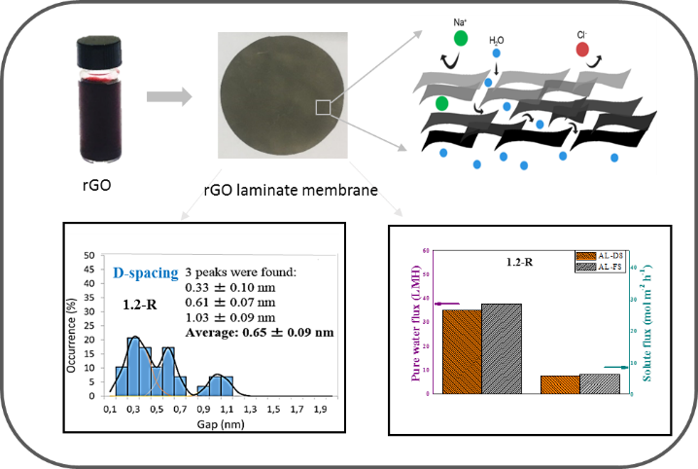
Figure 1 Concept of the stacked rGO laminate membranes with controlled interlayer spacing

Recent Publications (minimum 5)
- Z. Zhang, L. Zou, C. Aubry, M. Jouiad, Z. Hao. Chemically crosslinked rGO laminate film as an ion selective barrier of composite membrane. Journal of Membrane Science 515 (2016), Pages 204–211
- H. M. Hegab, A. ElMekawy, T. G. Barclaye, A. Michelmore, L. Zou, C. P. Saint, M. Ginic-Markovic, Effective in-situ chemical surface modification of forward osmosis membranes with polydopamine-induced graphene oxide for biofouling mitigation. Desalination 385 (2016) 126–137.
- H. M. Hegab, A. ElMekawy, L. Zou, D. Mulcahy, Christopher P. Saint a, Milena Ginic-Markovic. The controversial antibacterial activity of graphene-based materials Carbon 105 (2016) page 362-376
- H. M. Hegab, L. Zou, “Graphene Oxide-assisted Membranes: Fabrication and Potential Applications in Desalination and Water Purification” Journal of Membrane Science. 484 (2015), 95–106.
- H. M. Hegab, Y. Wimalasiri, M. Ginic-Markovic, Linda Zou, “Improving the Fouling Resistance of Brackish Water Membranes via Surface Modification with Graphene Oxide Functionalized Chitosan” Desalination, 365 (2015), pages 99-107. (W)

Biography (150 word limit)
Professor Linda Zou’s current research interests focus on using nanotechnology and membrane science to develop novel desalination solutions. Her research outcomes have been published in more than 100 journal articles and presentations, and are frequently cited. Professor Zou is the chief investigator of many frontier research projects sponsored by Australian Research Council and the Centre of Excellence in Desalination Australia. Now she works with United Arab Emirates government and industry on developing novel graphene based membranes and integrating capacitive deionization process with RO desalination plant.
Email: lyuanzou@masdar.ac.ae

