Fabrication and Characterization Of Hybrid Composite Hydrogels Based On Collagen-Type II, Polyethylene Glycol- Dimethacrylate And Hydroxyapatite for tissue engineering
Qurat UlAinª, Ahmad Nawaz Khanª
ªSchool of Chemical and Materials Engineering, NUST, Islamabad, Pakistan.

Abstract (300 word limit)
Bioactivity and mechanical properties of Collagen/PEG/hydroxyapatite hybrid composites and collagen/PEG composites are evaluated for tissue engineering applications. Spherical shaped hydroxyapatite is synthesised and characterized to make nanocomposites. PEG concentrations are varied from 10 to 30 wt% in collagen and photocrosslinked with UV light to develop hydrogels. With increasing PEG concentration, the network density of the collagen is increased to improve the mechanical properties. The compressive modulus is increased from 10 to 25.5 kPa along with the improvement in cell viability and proliferation with increasing PEG concentration in collagen. For hybrid composites hydrogels, the HA concentration is varied from 1 to 10 wt% in collagen/PEG-20 wt% which is improved further not only the network density but also the sample fidelity. The modulus of the hybrid composites is further enhanced up to 30 kPa. Cell proliferation and viability is significantly increased up to 100 % and cells reached to 99 % confluency particularly in collagen/PEG/HA (10wt %) system. Moreover, the morphology of cells changed from spherical to flattened spread morphology with increasing concentrations of HA indicating clearly the migration of the cells for the formation of interconnected cellular network. Overall, the hybrid composites hydrogels show superior mechanical properties along with enhanced cytocompatibility for tissue engineering applications.

Image
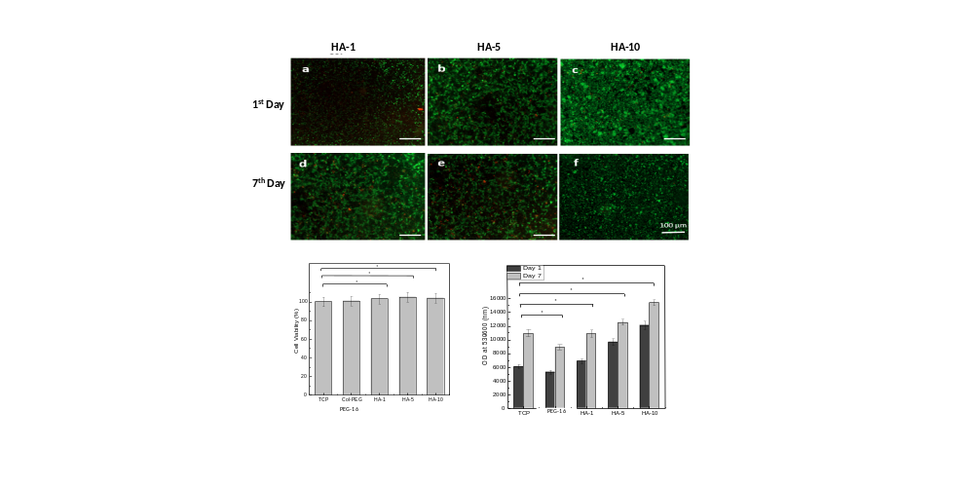
Figure1. Effect of Nano hydroxyapatitie on cell proliferation, cell viability and cell density
Recent Publications (minimum 5)
- Qurat Ul Ain, Ahmad Nawaz Khan, Mahboubeh Nabavinia, Mohammad Mujahid (2017) Enhanced mechanical properties and biocompatibility of novel hydroxyapatite/TOPAS hybrid composite for bone tissue, Materials Science and Engineering C 75 (2017) 807–815.

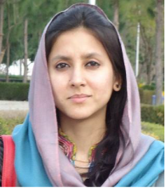 Biography (150 word limit)
Email: qurat.ulainphd66@gmail.com

Qurat UlAin is a PhD Scholar at SCME, NUST and Higher Education Commission, (HEC) has submitted her PhD thesis and going to defend her PhD in December 2017. She has completed her PhD research work on Split PhD program under IRSIP Scholarship from HEC to Harvard-MIT Health Sciences and Technology, USA and published 2 articles from her PhD research work in reputed journals.

