Biomodulatory Effects Of Lllt On Bone Regeneration.

Author:
¹Dr. Mohammad Nazrul Islam,
MBBS, M.Sc.(BME).
Co-authors
²Professor Golam Abu Zakaria, ph. D.
³Dr.kazi Shamimuzzaman, MBBS, MS.
⁴Dr.Quamrul Akhter Sanju, MBBS, FCPS, MRCS.
⁵Dr. Moitreyee Majumder, MBBS,MPH,MD(Bioch.)

¹Head-Biomedical Science And Medical Biotechnology Department, Shaheed Suhrawardy Medical College And
Hospital, Dhaka-1207. Bangladesh (BD). E-mail: abbirr@icloud.com
²Dept. of Medical Radiation Physics, Kreiskrankenhaus Gummersbach, Teaching Hospital of the University of
Cologne, 51643 , Germany. And -Dept. of Medical Physics and Biomedical Engineering,
Gono - Bishwabidyalay (Gono University), Nayarhat, Savar, Dhaka-1344, Bangladesh.E-mail:aliviamadhu@yahoo.com
³Associate Prof., Department of Orthopedic and Trauma Surgery, Shaheed Suhrawardy Medical College And Hospital,
Dhaka-1207, Bangladesh. E-mail: abbirr@gmail.com
⁴Associate Prof., Department of Surgery, Shaheed Suhrawardy Medical College And Hospital, Dhaka-1207,
Bangladesh. E-mail:bdbiomedical@gmail.com
⁵Department of Biochemistry,Shaheed Suhrawardy Medical College And Hospital, Dhaka-1207.E-mail:abbirr@yahoo.com
.

Keywords:
Low Level Laser,
Laser Therapy,
Human Bone Regeneration.

Background Data:
Tissue healing is a complex process that involves both local and systemic responses, and the healing process of bone is much slower than that of soft tissues which is a great challenge of medical science. The use of Laser Therapy (LLLT) for wound /bone healing has been shown to be effective in modulating both local and systemic response by enhancing- cellular & mitochondrial ion exchange, bone mineralization, nitric oxide formation, lymphatic circulation, osteoblast proliferation, effects on osteoblast gene expression, osteoclast inhibition (prevents bone mineral resorption) and by bone engraftment on synthetic materials.
Objective:
Laser (Semiconductor diode, Ga-Al-As, 830nm) is effective in human bone regeneration, i.e. it enhances bone fracture healing.

Methods:
40 (Twenty in laser & Twenty in control group) otherwise healthy men and women with, closed appendicular bone fracture (Radius/ ulna, or Femur / Tibial shaft / Clavicle / Meta carpal / Meta-tarsal) was enrolled for fracture management by laser therapy adjunctive to regular management, and was determined by clinical and radiological findings (X-ray)/at 2nd , 3rd, 4th and 6th week post fracture.

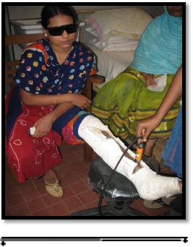
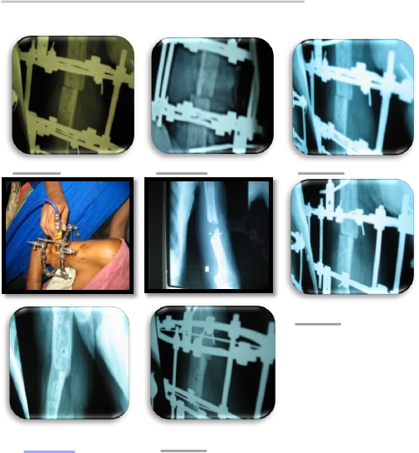

Assessment included fracture line/margins, fracture gap, external callus appearance, callus-to-cortex ratio, bridging, and radiological union as well as clinical assessment of the fracture- compliance of patient, and onwards follow-up of patients, in comparison to controlled group.
Results:
Early significant bone regeneration /callus formation achieved by early application of Low Level laser therapy (Ga-Al-As, 830 nm) on human fractured long (appendicular) bone.

Conclusions:
Treatment with 830 nm diode laser has substantially reduced the fracture healing time as well as improved the quality/quantity of callus formation of the patient, thus enhancing fracture healing. Laser biostimulative effects on bone could be a new dimension for bone regeneration which significantly reduce healing period, lessen cost of treatment, and enhance patient compliance in medical science.

RECENT PUBLICATIONS:
- Bipolar Sternomastoid Tenotomy for infantile (Congenital)Torticollis.The Journal of Bangladesh Orthopedic Society, Volume-24/ Number-2 /July2009.
- A Case report on treatment of 'Shepherd Crook deformity' in fibrous dysplasia. The Journal of Bangladesh Orthopedic Society. Volume-24/ Number-2/ July2009.
- Management of chronic Osteomyelitis of Femur with Interlocking Intramedullary Nail in a Young Man-A Case Report. www.banglajol.info/index.php/JSF.Journal of Science Foundation, January 2013, Vol.11,No.1, ISSN 1728-7855
- Low Level Laser Therapy(LLLT) on Soft Tissue Healing: A Case Report With Literature
Revew. www.banglajol.info/index.php/JSSMC,dECEMBER 2013,vOL. 5. No.2 page: 117121. ISSN 2306 2843(Online) ISSN 2226-5368(Print).
- Open Reduction and Internal Fixation of Displaced Fractures of Lateral Malleous by tension wiring And Plating in Bi-malleolar Fractures in Adulds. Journal of Shaheed Suhrawardy Medical College, December 2013, Volume 5 Number 2,ISSN 2306-2843,2226-5368,Page:81-83.
6. Low Level Laser Therapy (LLLT) On Soft Tissue Healing. ISSN 1728-2152, Vol.18, No.1, jam-
2014-Journal of Surgical Sciences (2014) Vol.18 (1):38-42@2012 Society of Surgeons of
Bangladesh.

Biography:
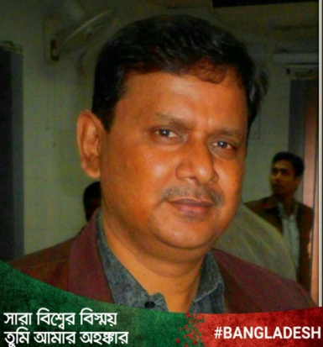
Mohammad Nazrul Islam
MBBS (DU), M.Sc. (BME).
Head, Biomedical And Medical Biotechnology Department.
Shaheed Suhrawardy Medical College Hospital. Dhaka-1207,
Bangladesh.
Dr. Mohammad Nazrul Islam has completed his MBBS degree from Dhaka University, and later M.Sc. (BME) from Gono-biswabidyalaya, Dhaka, Bangladesh. His professional intern/training was done at Carnegie Hill Institute, New York, USA.
He is the foundinding head of Biomedical and Medical Biotechnology Department of Shaheed Suhrawardy Medical College and Hospital, Dhaka. He has published papers in reputed professional, national/international forum/ journals and continues academic/ research work at Shaheed Suhrawardy Medical College and Hospital since 2007.
Here is a brief description of his academic achievement and work placement over the past years.
Education:
• Bachelor of Medicine & Surgery, University of Dhaka-1989.
• M.Sc., Biomedical Engineering, Gono-Biswabidyalay, Dhaka, Bangladesh.
Work Placement:
• Sher-E-Bangla Medical College Hospital, 1990-91.
• Dhaka Shishu (Children) Hospital, Dhaka-1207, 1991-94.
• Dhaka Community Hospital, Dhaka, 1995-1996.
• Shaheed Suhrawardy Medical College and Hospital, Dhaka-1207, 1997-2005.
• Carnegie Hill Institute, 86- East Manhattan, New York, USA-2005-2007.
• Shaheed Suhrawardy Medical College and Hospital, Dhaka, 2007- Present.
Contact:
Telephone-
+880 9130800-19, Ext. 240 (Office). +880 1733381819 (Cell).
E-mail: bdbiomedical@gmail.com, abbirr@gmail.com
Social Contact:
Twitter account: @bdBiomedical
LinkedIn account: https://www.linkedin.com/in/islamdr?trk=nav_
Facebook account: https://www.facebook.com/Labbib

