A New Drug Carrier: Magnetite Nanoparticles Coated with Amphiphilic Block Copolymer
Yunpeng Bai, Yu Chang, Bao Teng, Zhaolong Li*
Department of Chemistry, Tsinghua University, 100084, Beijing, P.R.China
Preparation of Magnetite Nanoparticles Coated with Amphiphilic Block Copolymer: A Potential Drug Carrier with Core-Shell-Corona Structure for Hydrophobic Drug Delivery The amphiphilic block copolymer (PEMA-b-PHEMA) is grafted from the surfaces of nanoparticles by ATRP. A new core-shell-corona structural material of 4.6nm was obtained with narrow molecular weight distribution of the hydrophobic segment (PDI=1.10). The release of hydrophobic drugs loaded in the hydrophobic shell can be controlled due to the hydrophobic interaction.
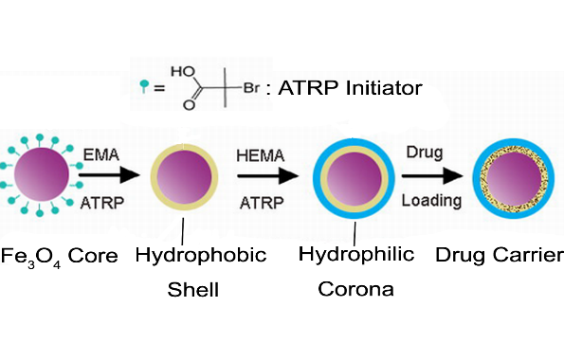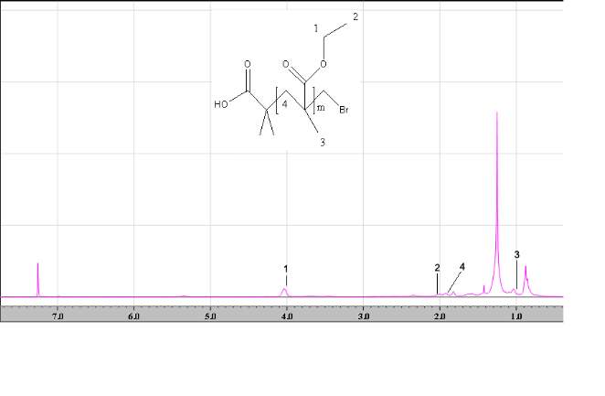
Fig.1 The synthesis of amphiphilic block copolymer Fig 2. ¹H-NMR of PEMA cleaved
from magnetite nanoparticles.
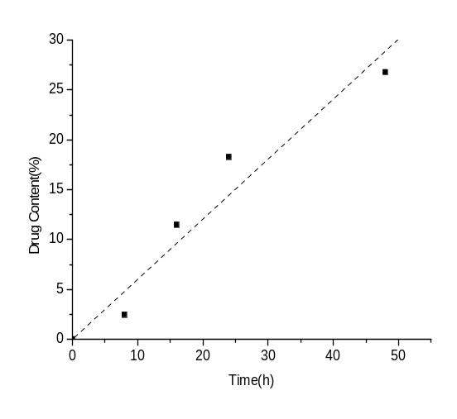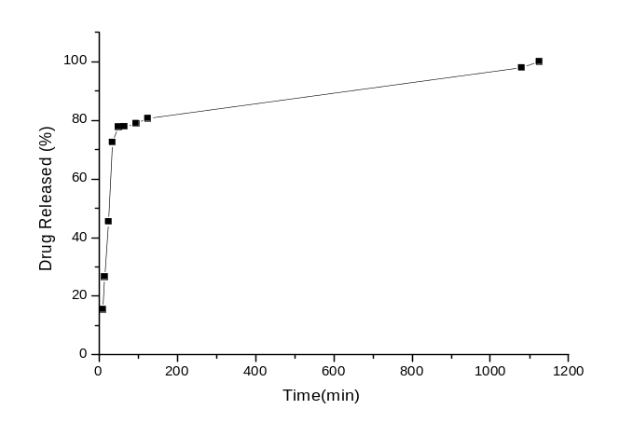 Fig.3 The linear relationship plot of drug loading . Fig 4. In vitro release profile of (-)-Isoproterenol
amount and chain length of hydrophobic segment hydrochloride at pH 7.0, 37℃ in PBS

(* Zhaolong Li E-mail; zhlli@tsinghua.edu.cn)

