A Novel Bioprocess for Value-added Products from Carbon Dioxide and Renewable Power
Jian Yu, University of Hawaii at Manoa, USA

Abstract (300 word limit)
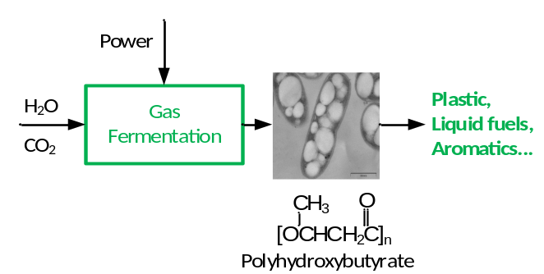
Carbo dioxide (CO₂) is a prime green-house gas emission from industrial processes. It can be converted into bio-oil by microalgae via conventional photosynthesis. The CO₂ fixation rate, however, is quite low and affected by the intermittent solar radiation. Cupriavidus necator, a hydrogen-oxidizing bacterium, was grown on CO₂ and H₂ in dark gas fermentation to produce single cell proteins and polyhydroxybutyrate (PHB). Sunlight is captured by photovoltaic modules and immediately converted to H₂ as a stable energy source via water electrolysis. The clean H₂ and O₂ are used by C. necator in CO₂ assimilation. Under the chemolithotrophic conditions, the average CO₂ uptake rate was 1.2 kg m⁻³ h⁻¹. The molar ratios of H₂/CO₂ was 7.3 and the biomass/H₂ yield was 1.4 g g⁻¹. The overall energy efficiency from H₂ to biomass was 22.4%. Under nutrient control, the PHB content of dry cell mass was 65 wt%. The polymer productivity was 1.87 g L⁻¹ d⁻¹, 14 times higher than oil productivity by a typical bio-oil-producing microalga. PHB is a biodegradable thermoplastic that can find various environmentally friendly applications. The biopolyester can also be converted into small functional chemicals (C3-C4). Specifically, PHB was degraded and deoxygenated on a solid phosphoric acid catalyst, generating a hydrocarbon oil (C6-C18) from which a gasoline-grade fuel (77 wt% oil) and a biodiesel-grade fuel (23 wt% oil) were obtained via distillation. Aromatics and alkenes were the major compounds, depending on the reaction conditions. This work demonstrated a bioprocess through which bioplastics and high-grade liquid fuels can be directly produced from carbon dioxide. The novel bioprocess can be continuously operated regardless the intermittency of renewable powers.

Image

Recent Publications (minimum 5)
- Yue Lu, Jian Yu (2017) Comparison analysis on the energy efficiencies and biomass yields in microbial CO₂ fixation. Process Biochemistry, 62:151-160.
- Yue Lu, Jian Yu (2017) Gas mass transfer with microbial CO₂ fixation and poly(3-hydrobybutyarte) synthesis in a packed bed bioreactor. Biochemical Engineering Journal, 122:13-21.
- Kang S, Yu J (2015) A gasoline-grade biofuel formed from renewable polyhydroxybutyrate on solid phosphoric acid. Fuel 160:282-290.
- Kang S, Yu J (2015) Reaction routes in catalytic reforming of poly(3-hydroxybutyrate) into renewable hydrocarbon oil. RSC Advances 5:30005-30013.
- Yu J (2014) Bio-based products from solar energy and carbon dioxide. Trends in Biotechnology 32:5-10.
- Shimin Kang, Jian Yu (2014) One-pot production of hydrocarbon oil from poly(3-hydroxybutyrate). RSC Advances 4:14320-14327.
- Yu J, Dow A, Pingali S (2013) The energy efficiency of carbon dioxide fixation by a hydrogen-oxidizing bacterium. International Journal of Hydrogen Energy 38:8683-8690.

Biography (150 word limit)
Jian Yu graduated from University of British Columbia (PhD, 1991), Zhejiang University (MSc, 1985) and Zhejiang Institute of Technology (BEng, 1982). He was an assistant professor at Hong Kong University of Science & Technology (1994-2001) and is now a research professor at University of Hawaii at Manoa (2001-present). His research interest is in the area of biochemical engineering for production of value-added products from renewable resources. He has published more than 70 research papers in peer-reviewed journal as the first and/or corresponding author, in addition to numerous book chapters and conference papers and presentations. His H-index of Google Scholar is 29. He has three patents that have been licensed to companies and one technology has been successfully scaled up to commercial production.
Email: jianyu@hawaii.edu

- Full name: Jian Yu
- Personal Email: jianyu@hawaii.edu
- Mobile number: 1-808-271-7322
- Session name/number: Trends in Biochemical Engineering
- Category: oral presentation
- Date of Birth: August 22, 1956
- Postal Address: 1680 East-West Rd. POST104, Honolulu, HI 96822, USA
Notes/Comments:

