Optimizing Financial Technical Indicators: Evolutionary Learning Approach in optimizing advertise learning experts.
CHAOUACHI Wassim, Quantitative Portfolio Management, LFIS Capital, Paris, France

Abstract

Within the framework of expert advice learning strategies, one needs to have good enough experts in terms of performance, causality and stability. Indeed, an expert advice online learning algorithm is an algorithm, which deduces its prediction from the advice of its experts. Having well-performing experts increases the performance of our algorithm; therefore, it is necessary to improve their performance.

In order to achieve this objective, we were able to create an objective function, which reflects the performance of our experts and we created a causality inspired from brain neurons causality.

In the case of our experts (technical indicators), we cannot determine with certainty the regularity of our objective functions which differs from one expert to another. This lack of information on regularity and the large number of functions to be optimized has pushed us to see beyond classical convex optimization and to think of a type of optimization, evolutionary learning.
Image
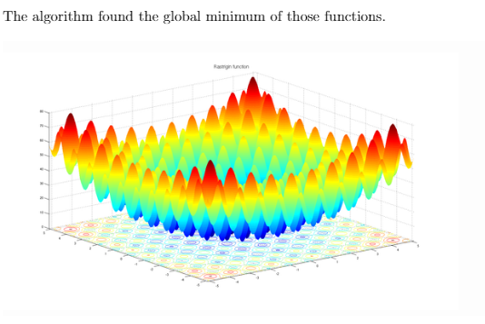
Recent Publications (minimum 5)
- CHAOUACHI Wassim (2020) Fast Pricing Exotic products using machine Learning Techincs, Journal of Telecommunications System & Management page 10

Biography

CHAOUACHI Wassim has completed his Master degree at the age of 24 years from Ecole Normale supérieure and Paris-Dauphine University in Applied Mathematics and Machine Learning. He is a Quantitative Portfolio Manager at LFIS Capital, one of th best hedge funds in Europe
Email:wassimchaouachi46 @gmail.com

Notes/Comments:

