Title: Demographic parameters and exploitation rate of Sardinella maderensis (Pisces: Lowe 1838) in the nearshore waters of Benin (West Africa) and their implication for management and conservation
Gildas Djidohokpin^{1*}, Edmond Sossoukpe¹, Emile D. Fiogbe¹ and Anne Haour²
¹ Laboratory of Research on Wetlands (LRZH), Department of Zoology, Faculty of Sciences and Technics, University of Abomey-Calavi (UAC), B.P. 526 Cotonou, Benin.
² Sainsbury Research Unit for the Arts of Africa, Oceania and the Americas, University of East Anglia, Norwich NR4 7TJ, UK.

Keywords: Sardinella maderensis, growth parameters, mortality, recruitment patterns, conservation

- Abstract Body
Most fisheries in Africa are overexploited or are at the peak of exploitation. A key contributor to this overfishing is poor data on fisheries, inefficient management strategies and unenforced policies. This paper deals with growth, mortality parameters and the exploitation rate of Sardinella maderensis collected between August 2018 and July 2019 from the nearshore waters off Benin to contribute to sustainable management of this fishery. Growth parameters and performance index ϕ' estimated based on the von Bertalanffy model using routine ELEFAN1 FiSAT gave the asymptotic length L∞, the growth coefficient K, the theoretical age at length zero and the performance index ϕ' 33.6 cm, 0.65 per year, 0.24 per year, and 2. 86 per year respectively. S. maderensis grew isometrically with an abundance of medium size specimens. This species recruits twice a year indicating probably two spawning periods.
The estimated average value of instantaneous rate of total mortality was 3.92 per year, natural mortality was 1.30 per year, giving fishing mortality of 2.62 and the rate of exploitation (E = 0.67) showing an overexploitation of the stock of this species. Several immediate management actions, such as size-limit regulation by gradually increasing fishing gears mesh size and time-limit regulation by restricting fishing during the spawning seasons and in nursery areas, are considered necessary for sustainable exploitation and conservation of this species.

- Image:
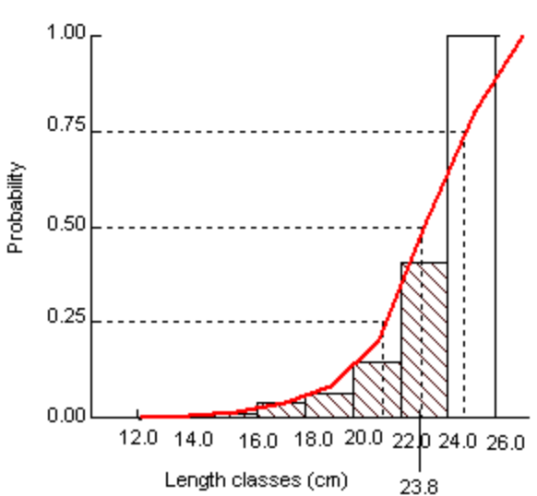
Fig. FISAT output of probability of capture and length at first capture de S. maderensis in the nearshore waters of Benin
- Reference:
- Pauly D., 1983. Some Simple methods for the assessment of tropical fish Stock. FAO Fish. Tech. Pap, 234:52.
- Ricker W.E., 1975. Computer and interpretation of biological statistics of fish population. Bull – res. Board-Cam., 315-318.
- Schaefer M.D., 1954. Some aspects of the dynamics of populations important to the management of the commercial marine fishes. Bull Inter-Am. Trop. Tuna. Comm, 1(2):27-56.
- Wang Y. and Q. Liu, 2006. Estimation of natural mortality using statistical analysis of fisheries catch-atage data. Fish. Resear, 78:342-351.
- Djidohokpin G., Sossoukpè E. and E.D. Fiogbé 2017. Population parameters nd exploitation rate of two major fish species in Tovè River (Southern Benin). Journal of Fisheries and Life Sciences, 2 (2): 10-17.
- Sossoukpè E., Nunoo F.K.E., Ofori-danson P.K., Fiogbé E.D. and H.R. Dankwa, 2013. Growth and mortality parameters of P. senegalensis and P. typus (Sciaenids) in nearshore waters of Benin and their implications for management and conservation. Fish. Resear, 137:71-80.
- Biography:
Gildas DJIDOHOKPIN has completed his PhD at the age of 31 years from Benin University and Postdoctoral Studies on the ecology and systematic of African fish are currently underway in the Biology department of Royal Museum for Central Africa–Tervuren, Belgium. He is a research assistant at department of Zoology, Faculty of Sciences and Technics, University of Abomey-Calavi (UAC), Benin. He has published more than 08 papers in reputed journals and has been serving as an editorial board member of repute.

- Presenting author details


Full Name: DJIDOHOKPIN Gildas
Contact number: (00229) 97 88 90 96 /
Whatsapp: +32 465 94 82 04
Twitter account:
Linked In account:
Session name/ number:
Category: Speaker
Passport Number: B0525850

