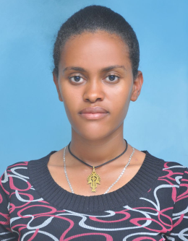

Habitat Use and Characterization of Young-of-the-Year (YOY) Labeobarbus spp. in Gumara River, Lake Tana Sub-basin, Ethiopia

Felegush Erarto Trfie
Bahir Dar Uiversity, Ethiopia
Although spawning migration of Labeobarbus species to Gumara River has been reported by various studies, organized information on abundance, distribution, habitat use and preference of young-of-the-year were not available. Such information is very important for the management of the declining endemic Labeobarbus species of Lake Tana. So, habitat use and characterization of young-of-the-year of the migratory riverine spawning Labeobarbus species of Lake Tana were studies in Gumara River and its tributaries from November 2018 to April 2019. Physico-chemical parameters were measured at all sampling points using probes. Fish sampling was conducted using point abundance sampling by electrofishing. A total of 945 specimens were collected from all sampling sites. The result showed that the species prefer at a mesohabitat scale riffles and later pools in Gumara River and this is mainly due to the drying of riffle habitats during the dry season and hence forced to shift to pool habitats. At a microhabitat scale also juveniles prefer moderate water depth, low to medium water velocity, gravel substrate type and vegetation cover. Pool habitat served as the only option until the next rainfall comes. Therefore, emphasis should be given to the factors which may lead to the collapse of the pool habitats, especially water abstraction through pumping for irrigation. Detailed study on the habitat modeling and the habitat suitability index should be done to be used for management.

Biography

Felegush Erarto has completed her MSc. degree at the age of 26 years from Addis Ababa University. She has published more than 2 papers in reputed journals and has been serving as lecturer at Bahir Dar University, Ethiopia.
Presenting author details
Full name: Felegush Erarto
Contact number:+251909030921
Twitter account:@erarto_felegush
Linked In account: https%3A%2F%2Fwww.linkedin.com%2Fin%2Ffelegush-erarto-095b09151
Category: (Oral presentation)

