Studies of prevailing fish diseases in the examined fishes at ismaillia province,Egypt.
Ahmed IE Noor El Deen
Hydrobiology department, National Research Center, Egypt
Drahmednoor200254@gmail.com
Abstract
Objective of this study was assessment of prevailing fish diseases in examined fish in Ismailia province,Egypt. This study was carried out on 1080 premature fish (360 D. labrax (225±25 g) and 360 S aurata (150±25 g) and 360 M cephalus (125±25) collected from assimilatory ponds of studies for examining at the end of treatment.in addition to examined nontreated fish (1080 premature). The infested fish showed dark colour and respiratory signs. The recorded P.M. lesions were presence of single cymothoid or rarely parasite per fish in the opercular cavity covering gills with congestion or paleness and destruction of gill filaments, in other cases cymothoid parasites were found in buccal cavity in seabass or on the skin of Mugil Cephalus and seabream. The total prevalence of infestation was the total prevalence of parasitic infection of nontreated fishes was 45.83 %. The highest percentage was in D labrax 56.94 % followed by S aurata 47.22 %, the lowest percentage in M cephalus 33.33 %., where the prevalence rates. The total prevalence of parasitic infection in premature treated with 2 g algae was 28.79%, followed by 3 g algae was 23.60 %, while the lowest percentage with 5 g algae 20.37 %. respectively. The detected species of parasites were protozoal parasites, Amyloodinium ocellatum Riboscyphidia and marine monogenean, Lamellodiscus dipolicus crustacean Lernanthropus kroyeri, Caligus minimus and elongatus, isopoda, Nerocila orbignyi isolated from D Labrex, Mugil Cephalus and S aurata. The histopathological alteration was recorded.
Key word: D. labrax, S aurata, M cephalus, parasites, histopathology.
Introduction
Marine aquaculture represents one of the fastest growing food producing sectors Muthenna et al. (2012).Parasitic infestations represent the majority of the known infectious diseases affecting fish. The clinical signs of most examined fishes revealed no pathognomonic abnormalities on some of the infested fishes except showing congestion, excessive mucous secretion, sticky or pale gills and grayish coloration with hemorrhage all over the body surface especially at the base of fins and the abdomen (Eissa et al.,2010). The skin and gills showed focal erosion, the parasites induced severe inflammatory reactions, degenerative and hyperplastic changes in skin. The gills revealed congestion of lamellar vessels and adhesion of most gill filaments and lamellae ( Noor El Deen et al., 2013).
Parasitic diseases can be affected on wild and cultured fishes directly (mortality rate) or indirectly (morbidity rate) causing increase economic cost (Lagrue, and Pouline,,2015 and: Shaheen et al., 2017). Parasitic infections cause morbidity in the signs of: absence of reflex, off food, rates of conversion become more less and prolonging the period of growth that causes more expenses (Noor El Deen et al., 2010 and Trujillo-Gonzalez et al.,2015).Parasitic infestations represent the majority of the known infectious diseases affecting fish (Noor El Deen et al., 2013). Ggills of naturally infected fish revealed that hyperplasia of the secondary gill lamellae with odema and infiltration of inflammatory cells (Engi, .(2013). El-Lamie (2007) showed severe vacuolar degeneration along with few leucocytic infiltration. Algal biomass would play a positive role in enhancement of growth performances of edible ﬁshes, their disease resistance and the skin color especially of the colored ﬁshes (El-Feky et al.,2017).

The aim of this work was to understand the effects of supplementing microalgae with iron and macroalgae in the diets of some mediterranean fish species, gilthead seabream (S aurata) , seabass ( D. labrax ) and mullet (M cephalus).
Methodology:
Fish sampling
A total of 1080 fingerlings (360 D. labrax (20±2 g) and 360 S aurata (15±1 g) and 360 M cephalus (10±1 g) collected from fiberglass tanks of studies for examintion at the end of treatment and examined nontreated fish (1080 fingerlings).
A total of Fish were collected from cement ponds at Fish Res. Center of Faculty 1080 premature fish (360 D. labrax (225±25 g) and 360 S aurata (150±25 g) and 360 M cephalus (125±25) collected from asumilatory ponds of studies for examining at the end of treatment.in addition to examined nontreated fish (1080 premature).of Agriculture, Suez Canal Univ. in Ismailia province. The collected specimens were carefully examined for signs of diseases with special focus towards the lesions on gills, eyes, abdominal, skin as blisters, ulcers , hemorrhages, They were transported of infected fishes in battery aerated tanks to the wet Lab. to National Research Center, Giza for isolation and identification of microbial agents.
Clinical picture:
First, weight and total length of the examined fishes were recorded and then clinical examination was done on live fish ones. Fish specimens under investigation were grossly examined for determination of any clinical abnormalities and any external infections or visible lesions according to Noga (2010). For demonstration of the internal abnormalities, the postmortem examination was performed on all fish according to Woo (2006) and Rebort et al., ( 2012.).
Identification of the isolated protozoal and monogentic trematode identified according to Paperna (1996).While,crustacean parasites (Copepoda) identified according to Kabata (1985).
In preparation for scanning electron microscopy (SEM), live isolated parasite specimens were kept for 30 min in a refrigerator prior to their fixation in a 4% aqueous glutaraldehyde solution (4 cº for 48 h) . The specimens were then washed thoroughly with cacodylate buffer and post-fixed for 4 h with aqueous osmium tetroxide, dehydrated through acetone, and dried in a critical point drying apparatus (Polaron E300; Polaron Equipment, UK) using liquid CO2. The specimens were whole-mounted on an aluminum stub and fixed by double- phase sticker. The specimens were then coated with gold palladium in a sputter coating unit (Polaron E5000; Polaron Equipment, UK) and examined using a scanning electron microscope (JEOL SEM T330; JEOL, Japan) operating at 20 Kev according to Rania and Rehab (2015).
Result and Discussion
In Egypt, fish diseases affected fish production specially parasitic infections which are about 80% of fish diseases (Eissa , 2002). This record attributed to the longtime of warm climate and weather of characteristic sustenance to reproduction of the intermediate hosts for parasitic life cycle (Younes et al., 2016). The clinical signs in the naturally infected fishes (D. labrax, S aurata and M.cephalus) revealed no pathognomonic clinical abnormalities. Some infected fish showed dark colour and respiratory signs (photo.,1 and plate,1). These results nearly agree with that recorded by Badawy, (1994). These results may be attributed the lower respired oxygen of gill epithelium which causes by attached of parasites causing mass distraction of gill epithelium cells.
The post-mortem view, haemorrhagic areas on gill cover, abdomen and on the bases of fins , abrasions and ulcers on the body surface (plate,2 and 3) These results nearly agree with that recorded with Noga (2010). These results may be attributed to irritation caused by crustacean parasitic infestations they often remain attached on skin, fins, buccal and branchial cavity.
Marbling appearance with excessive mucus secretion. Gill tips were sticking with greyish coloration in D. Labrax and S aurata and in M. cephelus (Plate. 4). These results may be agree with El Lamie (2007) who recorded that areas of congestion and paler as mosaic in M labrex .These results may be attributed to distraction of the efferent vessels by protozoal or monogenean parasites where the blood pressure is low and extensive haemorrhages are causes very hard cloted of blood brings about rapid occlusion of the infested vessels, thrombus is formed resulting in ischemia which in turn leads to necrosis in some areas occurred due to the inflammation and congestion of some areas with progressive degeneration of the other parts of the gill filaments causing the appearance of such phenomena (Eissa,2002).
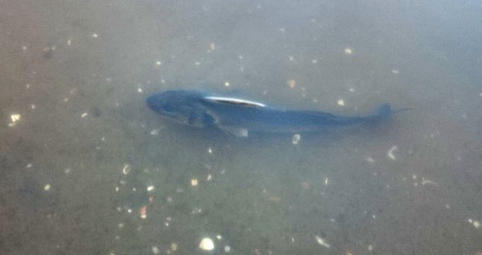 | 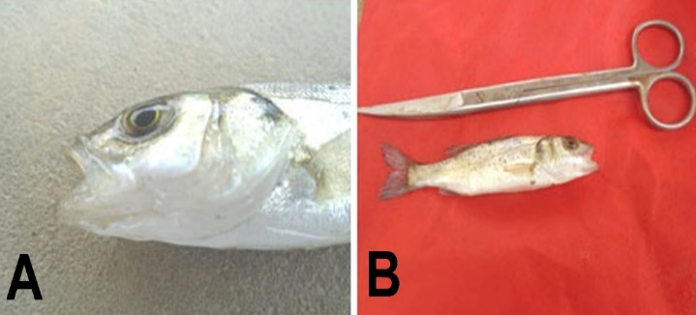
Photo. (1): Showing a dark color of premature D. labrax | Plate. (1): Showing open mouth respiratory signs in (A) premature and (B) fingerlings of D. labrax .
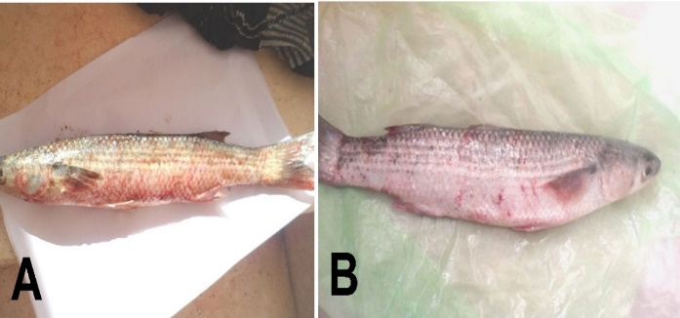 | 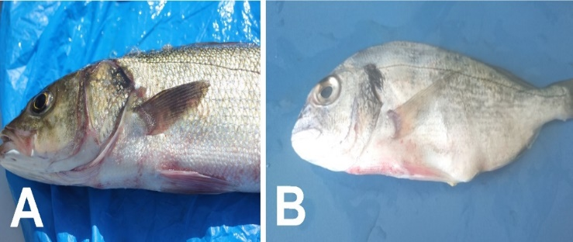
Plate. (3): Haemorrhages all-over the body surface of mugil cephalus( A and B). | Plate.,(2). Showing (A) Haemorrhages all-over the body surface and at the bases of fins of D. labrax and (B) S aurata
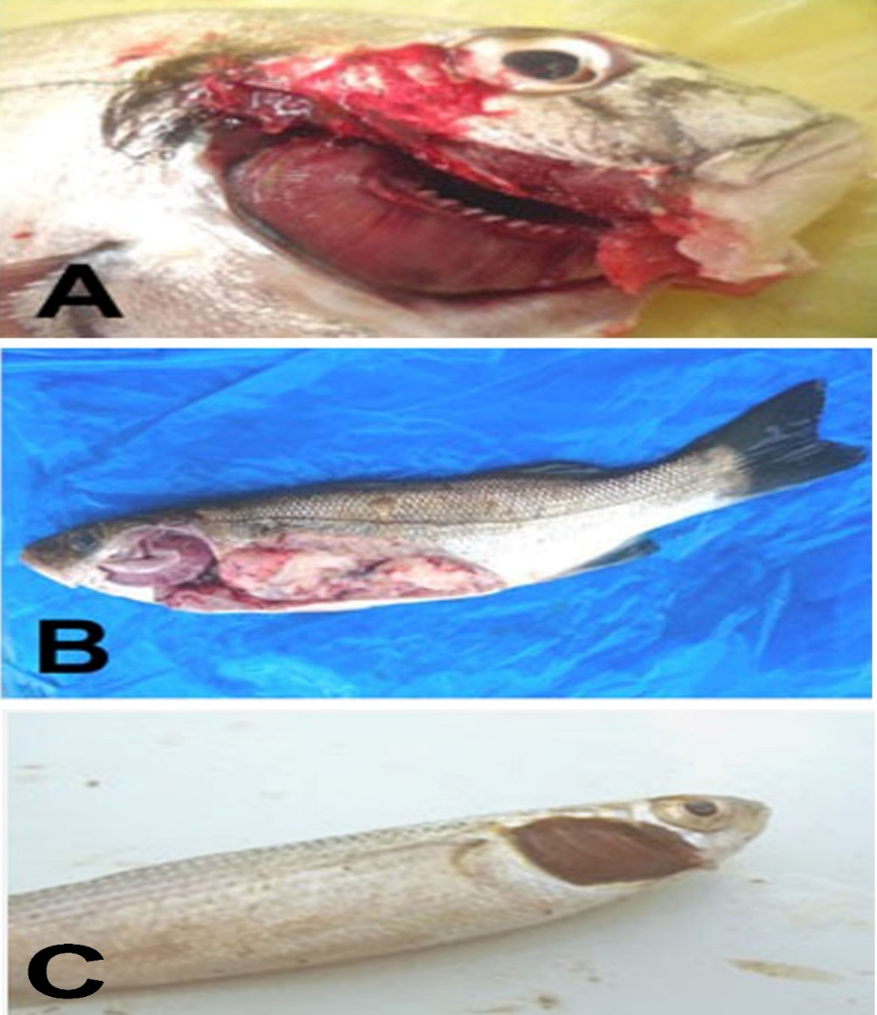

Plate. (4): Showing (A) gills of S aurata with mosaic appearance, sticking of the gills. and (B) gills of D labrax with mosaic appearance, sticking of the gill, (C) gills of M Cephalus with mosaic appearance and sticking of the gills.
Parasitological examination:
Fish specimens were examined parasitologically (macroscopically and microscopically). Identification of the parasites was carried out according to its morphometric measurements as follows: (Photo. 2-6 ) and plate (5 ).
Amyloodinium ocellatum was first described by Brown, 1931 and it is one of the most important pathogenic parasitic disease affecting cultured marine and brackish water fish. The parasite produced a powdery or velvety appearance on infected fish, and the resulting disease was commonly known as “marine velvet,” velvet disease, or Amyloodiniosis. The organism is a dinoflagellate ectoparasite and has been reported in a wide range of marine and estuarine fish. It is one of a very few organisms that can infect both teleosts and elasmobranchs (Noga, 2010; Alvarez-Pellitero , 2008).
Behavioral signs might include anorexia or complete lack of feeding activity, flashing (rubbing against hard objects in the tanks or on the bottom substrate) and coughing (back flushing water across the gills). The skin of heavily infected fish could have a dull gold or brown sheen. Examination of skin might reveal scale loss and patchy accumulation of mucus. Respiratory distress, gulping the atmospheric air could occur or even jumping outside water of the pond. The result nearly agree with that obtained by Noga (2010); Paperna et al. (1981); Noga and Levy (2006).
The sessile, solitary, ectocommensal ciliates Riboscyphidia attach to the skin or gills with a holdfast (scopula) (Lom 1973b). Attachment apparently causes only superficial damage to the epithelium (Lom and Corliss 1968), which belies the ectocommensal nature of these organisms. Like the sessile, colonial ectommensals, they reproduce by binary fission and use the host primarily for attachment and nutrition. They feed also on bacteria and suspended organic debris, which is prevalent in nutrient - rich (i.e., polluted) water. Thus, they are good indicators of poor water quality. Many of these ciliates can probably be free - living. They are only moderately pathogenic, but high numbers on the gills can physically impede gas exchange. They may also act as a nidus for bacterial colonization. Attachment probably causes little damage to the epithelium, but heavy infestations can cause mechanical blockage of respiration. Capriniana feeds on ciliates and suspended organic debris. Capriniana is not taxonomically related to Riboscyphidia reproduces by budding, forming motile, ciliated stages that can colonize a new host (Lee et al. 1985 and Badawy,2001 ).
The monogenian infestation in naturally infested S aurata and D. labrax fishes showing marine monogenea (Lamellodiscus dipolicus) whole worm with anterior end and posterior. The Monogenea is a class of platyhelminthes, common parasites of the skin and gills of both marine and freshwater fish (Eissa, 2002; Trujillo-González et al., 2018). There are many different species, most of which have a narrow host range in nature restricted to one species, genus, or family (Thoney and Hargis, 1991, Noga, 2010 and Osman et al., 2013).

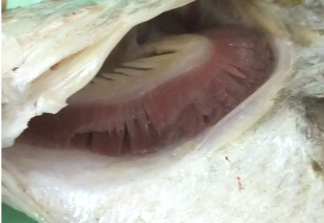 | 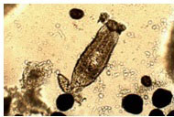
Photo. (2).: Showing gills of D. labrax suffered from sloughing of primary gill lamellae infected with Amyloodinum ocellatum . | Photo (3): Showing mixed infection Amyloodiniosis and monogenea (arrows) in S aurata
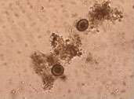 | 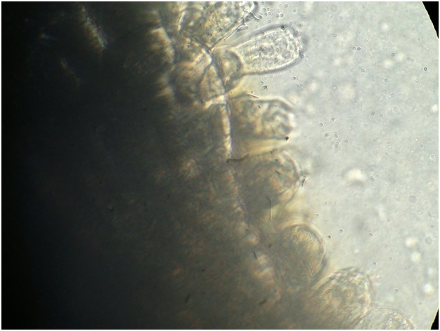
Photo. (4).: Infestation with Amyloodinium ocellatum trophonts (arrows) isolated from S aurata. | Photo. (5).: Magnifid showing Riboscyphidia sp heavy infestation on gills of D. labrax (arrows).
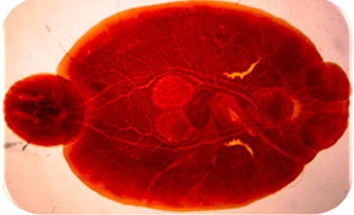 | 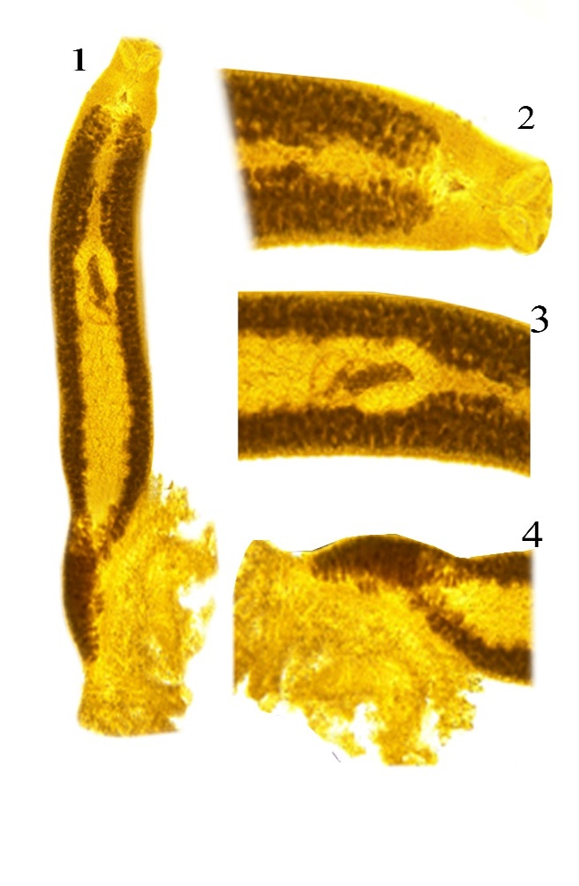
Photo. (6).: Showing Benedenia sp. isolated from gills of S aurata fish stained by alum carmin whole worm, Anterior end and posterior end. | Plate. (5).: Showing marine monogenea (Lamellodiscus dipolicus) whole worm with anterior end and posterior end isolated from D. labrax .

The parasites under examination were collected from gills of S aurata. Based on the morphological and parasitological examinations, the isolated crustacea was belonged to Lernanthropus kroyeri (plate 6). The members of this genus are parasitic on the gills of marine teleosts (D. labrax). these results agree with Manero and Dezfuli (2003) and Toksen (2007). The isolated crustacean parasite from gills of D. labrax was identified as Lernanthropus psciaenae. This is in agreement with Akmrza (2003) , Noor El Deen et al. (2013 ) who isolated the same genus and site of D. labrax. The site of infestation was in accordance with that mentioned by Badawy (1994) as well as the parasite measurements as morphological characters are nearly similar.
The parasites under examination were collected from the mouth of D. labrax. Based on the morphological and parasitological examinations, the isolated crustacea was belonged to family Caligidae, genus Caligus, species Caligus minimus (Photo.,7) and plate (7). These agree with Ragias et al. (2004) and Noor El Deen et al. (2013) who isolated it from buccal cavity of D. labrax .
The parasites under examination were collected from the skin of S aurata. Based on the morphological and parasitological examinations, the isolated crustacea was belonged to family Caligidae, genus Caligus, species Caligus elongatus (plate 8 and 9).
The parasites under examination were collected from the skin of M cephalus. Based on the morphological and parasitological examinations, the isolated crustacea was belonged to family Caligidae, genus Caligus, species Caligus elongatus (Photo.,8 ) and plate (10 and 11).
The crustacean species was collected from the buccal cavity of D. labrax . Based on the morphological and parasitological examinations, the isolated crustacea was belonged to order Isopoda, Cymothoa spp. (Photo.,9) and plate,(12).
. These finding agree with Easa and Abu El-Wafa (1993) and Noor El Deen et al. ( 2012 ) who isolated it from skin of M cephalus. Comparing the present data with the previous findings, it is clear that the parasite has nearly all morphological characters and measurements of Caligus elongates.

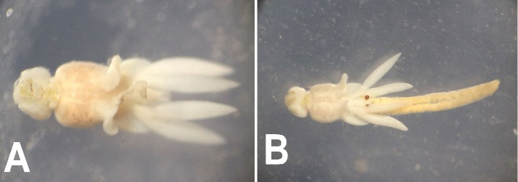 | 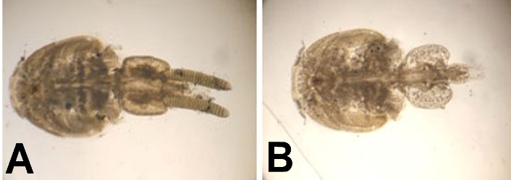
Plate. (6).: Showing Light photomicrograph of (A) male and (B) female Lernanthropus kroyeri , isolated from D. labrax . | Plate (7).: Showing Caligus minimus (Whole copepode), (A) female and (B) male isolated from D. labrax
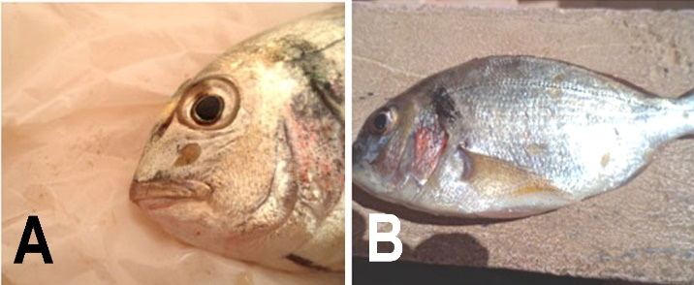 | 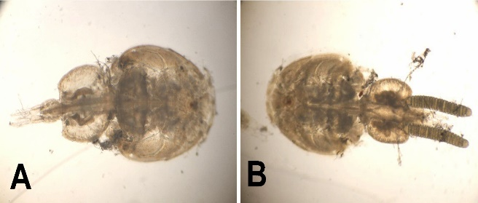
Plate (8).: (A&B) Showing Caligus elongates (Whole coispepode), on Sparus aurata (arrows). | Plate (9).: Showing )A) male and (B) female Caligus minimus (Whole copepode), isolated from S aurata .
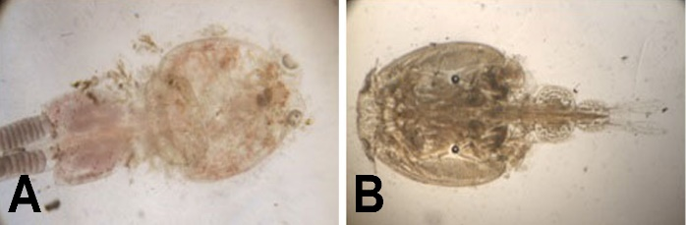 | 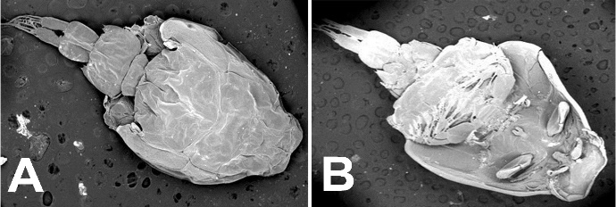
Plate (10).: Showing Caligus elongates (A) female and (B) male (copepode), isolated from M cephalus | Plate (11): showing Scaning Electron Microscope (SEM) for male caligus elongates. (A) Dorsal surface (B) Ventral surface isolated from M cephalus .
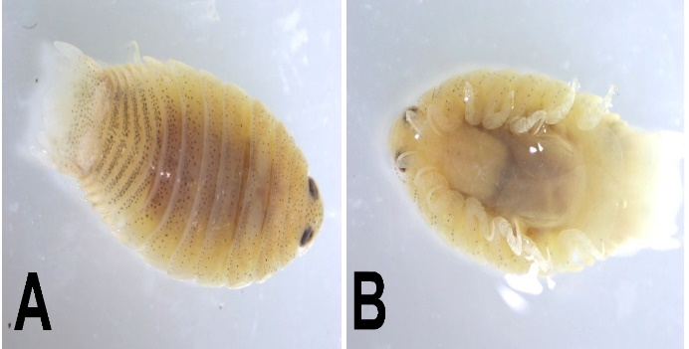 | 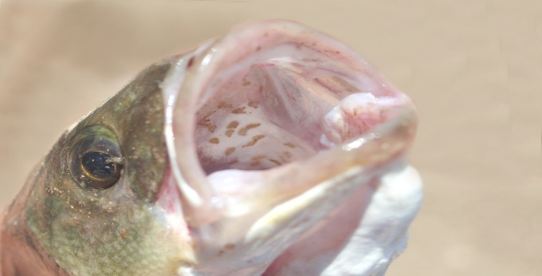
Plate (12).: Showing Light photomicrograph of Nerocila orbignyi (Dorsal view, (A) and ,(B) Venteral view. | Photo. (7).: Showing copepode Caligus minimus in buccal cavity of D. labrax (arrows)
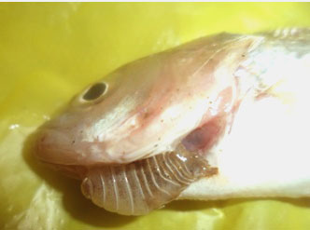 | 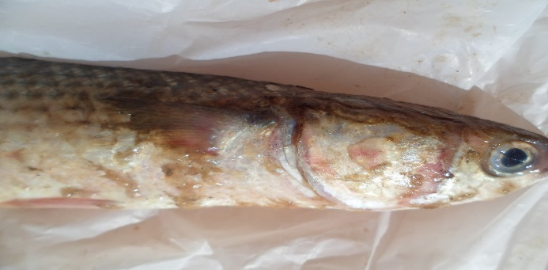
Photo. (9).: Showing infested D. labrax with isopoda embedded in gill filament and arch (arrows). | Photo. (8).: Showing M cephalus heavy infestation of Caligus sp. on skin ( arrows)

These results nearly agree with the finding of Eissa (2002) isolated Lironeca spp. (Cymothoidae) from the operculum (gill cover) of Centropristis filamentosus. Rajkumar et al. (2005) isolated Cymothoa indica from the body surface of the cultured D. labrax .Isopoda consider the more dangerous crustation parasite causing mass mortality. These results nearly agree with that recorded by Shaheen et al . ( 2017) who recorded isopoda in M cephalus in lake Qaroun causing mass mortality.Also, the mortality may be attributed to secondary infection by bacteria . These results nearly agree with that recorded by Younis et al .(2016) who reported that mass mortality due to secondery infection by vibroiosis in some marine fishes in lake Qaroun causing mass mortality.
Concerning histopathological examination of the infested D. labrax with harmful crustaceans (Lernanthropus psciaenae). revealed presence of congestion and mild to moderate hyperplasia of gill lamellae ( Plate. 10). In addition, heavy infestation revealed presence of severe hyperplasia of gill lamellae and leucocytic infiltration mainly lymphocytes and few macrophages. Furthermore, showed severe vacuolar degeneration and congsions in intestine,liver,spleen and kidney with little leucocytic infiltration ( Plate. 11-15).
Dealing with the histopathological findings resulting from the affections of crustacea (Lernanthropus psciaenae), the gills showed in mild infestation, congestion and mild to moderate hyperplasia of gill lamellae. While in heavy infestation, severe hyperplasia of gill lamellae and leucocytic infiltration mainly lymphocytes and few macrophages. Furthermore, showed severe vacuolar degeneration along with few leucocytic infiltration. This result is in agreement with that obtained by El-Lamie (2007).
Regarding to the histopathological alterations in naturally infected fish with parasitic infections,in the present study revealed that, liver of D labrax was congestion of central vein and hepatic cells showed hydropic degeneration. Others showed fatty changes in which the cells showed circumscribed vacuoles in the cytoplasm. Some hepatic cells revealed signs of coagulative necrosis. There were multi-focal areas of hemorrhages in-between the hepatic cells. These findings agree with that recorded by Darwish et al., 2000 and disagree with (Monir and Rahman, 2015) who found massive necrosis in the hepatic cells revealed signs of coagulative necrosis. while, renal tubules of kidney showed different necrobiosis changes as cloudy swelling, hydropic degeneration and even necrosis. The spleen was studded with large numbers of erythrocytes. There were increase in numbers of melanomacrophages centers, with haemociderosis and depletion of lymphocytes. Gills showed hyperplasia of the secondary gill lamellae with odema and infiltration of inflammatory cells, the obtained results were supported by Mai, 2009 and showed increase in numbers of melanomacrophages centers, with haemociderosis and depletion of lymphocytes. These results go with (Darwish et al., 2000 Zhou et al., 2014) who found increase in numbers of melanomacrophag centers, depletation of lymphocytes and congestion of blood vessels. Regarding gills of naturally infected fish revealed that hyperplasia of the secondary gill lamellae with odema and infiltration of inflammatory cells. These results nearly agree with that recorded by (Engi, .(2013):) and disagree with (Woo and Bruno, 2011) who found granulomas in examined fish. This may be attributed to different site and kind of study and kind of fish and environmental condation.

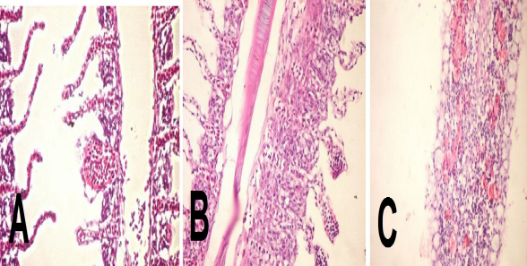 | 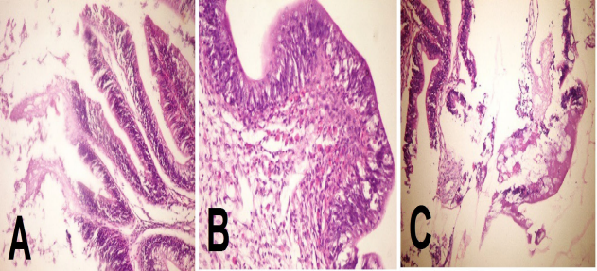
Plate. (10).: Gills of D. labrax showing ( A)congestion and mild to moderate hyperplasia of gill lamellae, (B) severe hyperplasia of gill lamellae and leucocytic infiltration mainly lymphocytes and few macrophages,(C) severe vacuolar degeneration along with little leucocytic infiltration | Plate. (11).: intestine of D. labrax showing hyperplasia of goblet cells cells lining the intestinal villi with sever infiltration of leucocytic inflammatory cells (A,B and C).
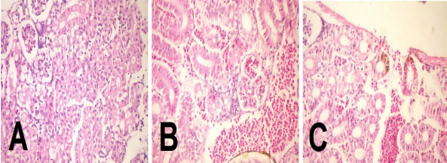 | 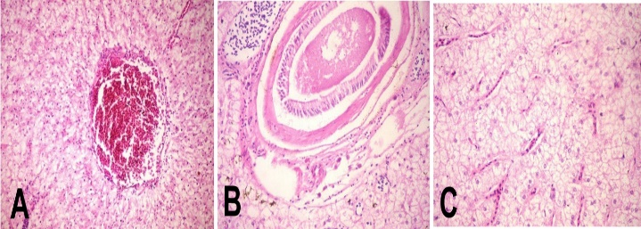
Plate. (12):: kidney of D. labrax showing severe degenerative and necrotic changes in the tubular epithelium, endothelial linning the glomerular tuft and in the interstitial hemopoietic tissues, congestion in renal blood vessels and peritubular and periglomerular edema also detected(A,B and C). | Plate. (13) : liver of D. labrax showing (A,B and C) liver of D. labrax showing vacuolation and necrotic changes in the hepatocytes, congestion in the hepatic blood vessels, hyperplasia in the wall of blood vessels and infiltration of chronic inflammatory cells and fibrous connective tissues between the hepatic parenchyma.
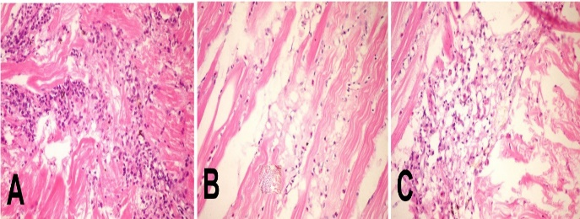 | 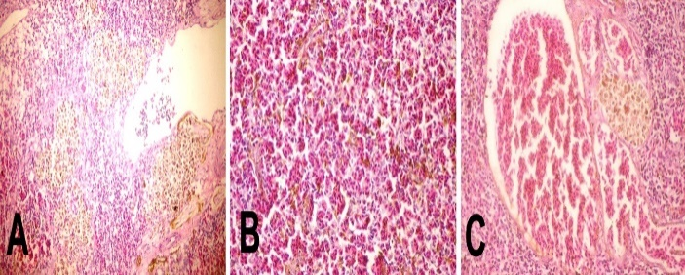
Plate (14).: Musculature of D. labrax showing (A,B&C) Showing infilteration of infilammatory cells withedema in between the muscle fibers accompanied with Zenker's necrosis of muscle bundles | Plate. (15).: Spleen of D. labrax showing congestion in the splenic blood vessels, depletion in the hemopoietic tissues associated with hyperplasia in the wall of splenicbloodvessels (A,B &C).

Prevalence of parasitic infestation among different examined fish.
From data in table (1) it is clear that the total prevalence of parasitic infection of nontreated fishes was 45.83 %. The highest percentage was in D labrax 56.94 % followed by S aurata 47.22 %, the lowest percentage in M cephalus 33.33 %. The present investigation indicated that the total prevalence of parasitic infections in examined fish vary from species than other. These variations may be due to behavior of habitate of each fish. These results nearly similar to that recorded by Shaheen et al, 2017.

Table (1): Showing total parasitic infestation in non-treated premature examined fish .
Fish specis | No of examined fish | No of infected of non treated fish | %
D labrax | 360 | 230 | 63.88
S aurata | 360 | 193 | 53.61
M cephalus | 360 | 133 | 36.94
Total | 1080 | 556 | 51.48
Documented results of fish diseases befor treatment.
Fish species. A total of 540 premature fish (180 D. labrax (225±25 g) and 180 S aurata (150±25 g) and 180 M cephalus (125±25) collected from randamlly pond and lake of Temsah. The collected specimens were carefully examined for signs of diseases with special focus towards the lesions on gills, eyes, abdominal, skin as blisters, ulcers , hemorrhages, They were transported in battery aerated tanks to the wet Lab. to National Research Center, Giza for isolation and identification of microbial agents
Clinical picture:Fish specimens under investigation were grossly examined for determination of any clinical abnormalities and any external infections or visible lesions according to Noga (2010).
Parasitological studies: They were examined microscopically for protozoal and monogentic trematodes were they identified according to Paperna (1996).Crustacean parasites (Copepoda) identified according to Kabata (1985).
Results and Discussion Before treatment with microalgae
Parasitological examination:
Fish specimens were examined parasitologically (macroscopically and microscopically). Identification of the parasites was carried out according to its morphometric measurements into:-
Protozoal diseases: Alvarez-pellitero et al., (1993) who recorded that in mediterania sea areas were found ectoparastic protozoal parasitic infested seabass were Ceratomyxa spp. ,Sphaorospora dicentrarchi and S. testicularis and Amyloodinium spp. In addition to, either ciliophoran (Trichodina spp.), diniflagigellida (Amyloodinium spp.) and Zoo flagellida (Cryptobia spp.).While, endo parasites represented by members of Apicomplexa (Hemogregarina, Eimeria , microspore,myxospora and sphaerospora lesticularis spp.).While, Amyloodinium ocellatum was first described by Brown,( 1931) and it is one of the most important pathogenic parasitic disease affecting cultured marine and brackish water fish. The parasite produced a powdery or velvety appearance on infected fish, and the resulting disease was commonly known as “marine velvet,” velvet disease, or Amyloodiniosis. The organism is a dinoflagellate ectoparasite and has been reported in a wide range of marine and estuarine fish. It is one of a very few organisms that can infect both teleosts and elasmobranchs (Alvarez-Pellitero 2008 and Noga, 2010 and 2012).
Behavioral signs might include anorexia or complete lack of feeding activity, flashing (rubbing against hard objects in the tanks or on the bottom substrate) and coughing (back flushing water across the gills). The skin of heavily infected fish could have a dull gold or brown sheen. Examination of skin might reveal scale loss and patchy accumulation of mucus. Respiratory distress, gulping the atmospheric air could occur or even jumping outside water of the pond. The results nearly agree with that obtained by Paperna et al. (1981); Noga and Levy (2006) and Noga (2010).
Ribocyphidiosis. The sessile, solitary, ectocommensal ciliates Riboscyphidia species attach to the skin or gills with a holdfast (scopula) (Lom 1973). Attachment apparently causes only superficial damage to the epithelium (Lom and Corliss 1968). Like the sessile, colonial ectommensals, they reproduce by binary fission and use the host primarily for attachment and nutrition. They feed also on bacteria and suspended organic debris, which is prevalent in nutrient - rich (i.e., polluted) water. Thus, they are good indicators of poor water quality. Many of these ciliates can probably be free - living. They are only moderately pathogenic, but high numbers on the gills can physically impede gas exchange. They may also act as a nidus for bacterial colonization. Attachment probably causes little damage to the epithelium, but heavy infestations can cause mechanical blockage of respiration.
Monogenean parasitic diseases: The main clinical signs in naturally infested S. aurata and D. labrax fishes showing congesion and mucus on gill filament. Monogenea is a class of platyhelminthes, common parasites of the skin and gills of both marine and freshwater fish (Eissa, 2002 and Trujillo-González et al., 2018). There are many different species , most of which have a narrow host range in nature restricted to one species, genus, or family (Thoney and Hargis, 1991 ).Heavy monogenean infestations are usually indicators of poor sanitation and deteriorating water quality (overcrowding, high ammonia or nitrite, organic pollution, or low oxygen) (Osman, 2005 and Osman et al., 2013). Monogeneans can rapidly reproduce under such conditions. The doubling time for viviparous monogeneans can be as little as 24 hours. Reproductive rate is also controlled by temperature, which, although not variable in a tropical aquarium (which should have a narrow range of temperature), is important in less controlled environments (Jia, et al,2010 and Noga, 2010 ). The examind parasites were collected from gills of S. aurata. Fish were examined parasitological recorded that by EL-Lamie 2007. Gill monogenia Paranella diplodae, pseudo haliotrematoids polymorphous eilaticus, acanthostomum imbutiforms. erileputurus hamatai, propycnadenoids secundus, Peudocreadium sahali, podocotyle, tangiopsischinensis, pacificreadiumserrani. Intestinal nematodes paracamallanus indorenates, intestinal acanthocephalans (nerohadinorhynchus macrospinosus (Eissa et al.,2012).
Parasitic Crustaceans diseases which is disease due to infested with Lernanthropus psciaenae of who gills of D. labrax. This is in agreement with Akmrza (2003) , El-Lamie (2007) and Noor El Deen et al. (2013 ) who isolated the same genus and site of D. labrax. The site of infestation was in accordance with that mentioned by Badawy (1994) as well as the parasite measurements as morphological characters are nearly similar. The parasites under examination were collected from the mouth of D. labrax. Based on the morphological and parasitological examinations, the isolated crustacea was belonged to family Caligidae, genus Caligus, species Caligus minimus. This agree with Ragias et al. (2004) and Noor El Deen et al. (2013) who isolated it from buccal cavity of D. labrax. While, the parasites under examination were collected from the skin of S aurata. Based on the morphological and parasitological examinations, the isolated crustacea was belonged to family Caligidae, genus Caligus, species Caligus. The parasites under examination were collected from the skin of M cephalus. Based on the morphological and parasitological examinations, the isolated crustacea was belonged to family Caligidae, genus Caligus, species Caligus elongatus.
The crustacean species was collected from the buccal cavity of D. labrax. Based on the morphological and parasitological examinations, the isolated crustacea was belonged to order Isopoda, Cymothoa spp. Based on the morphological and parasitological examinations, the isolated crustacea was belonged to Lernanthropus psciaenae. The members of this genus are parasitic on the gills of marine teleosts (D. labrax). These results agree with Manero and Dezfuli (2003) and Toksen (2007).
Prevalence of parasitic infestation among different examined premature marine fishes before and after treatment.
The total prevalence of parasitic infestation of nontreated premature fishes was 45.83 %. The highest percentage in D.labrax was 56.94 % followed by S.aurata 47.22 %,the lowest percentage in M.cephalus 33.33 %. The present investigation indicated that the total prevalence of parasitic infestations in examined fishes vary from species than other. These results nearly similar to that recorded by Shaheen et al. (2017). These variations may be due to behavior of habitate of each fish. While, the total prevalence of parasitic infection of treated premature fish was 21.48 %. The highest percentage was in D.labrax 23.88 % followed by S.aurata 23.61 %, the lowest percentage in M.cephalus 16.94 % These results nearly similar to that recorded by Noor El Deen et al. (2013) and Shi et al,2017 who recorded that feeding by supplement of β-carotene from D. salina by reason of enhancement β-carotene due to complement activity increased, and on the other hand, serum lysozyme activity increased, and the result indicated that body immune levels increased (Amar et al., 2004). In the other trial Japanse parrotfish (Oplegnathus fasciatus) and spotted parrot fish (Oplegnathus punctatus) larvae were fed with β–carotene supplement rotifers, resulted in survival rates of β–carotene supplemented groups of both Japanese and spotted parrotfish higher than the control (Tachibana et al., 1997 and).Also,survival, skin, flesh-color, and also antioxidant capacity factors in rainbow trout were increased due to Dunaliella supplementation. Also, the effects of Dunaliella salina dry powder on growth, immune function and disease resistance were determined in black tiger shrimp penaeus monodon, showed higher weight gain and resistance to white spot syndrome virus infection and also demonstrated significantly higher stress resistance. The color intensity of shrimp was correlated with the level of D. salina in the diet (Wang et al., 2006). Pirarat et al.,2006 were detected that the significantly higher lysozyme activities for supplementation levels of A. coffeaeformis compared to control one.
. These variations may be due to cultured ponds riches with microalgae thatalso, may be attributed to antiparasitic effect of algae on parasitic infestation due to presence of polysaccharides
that act as complement activity increased and on the other hand, serum lysozyme activity increased, and the result indicated that body immune levels increased.
The present study concluded that, replace of fish meal in fed of marine fishes decrease parasitic infestation comparing that fed on ration free algae.

Acknowledgment.
Thanks for STDF that supported this paper from project 5717 members, PI dr Ahmed Noor El Deen

References
Akmrza, A. (2003): Arthropod parasite (Lernanthropus brevis Richiardi, 1879) found on the D. labrax (Dicentrarchus labrax). Turkiye Parazitoloji Dergisi. 27(3): 214-216.
Alvarez-pellitero,A; Sitia-Bobodilla and Franco-Sierra,(1993): protozoal parasites of wild and culcured Seabass, Dcentrachus labrax(L) from the Mediterranean area. Aquaculture and Fisheries management . 24 :101-108.
Alvarez-Pellitero, P. (2008): Diseases caused by flagellates. In: Eiras, J., Segner, H., Wahli, T., Kapoor, B.G. (Eds.), Fish Diseases, vol. 1. Science Publishers, Enfield, NH, USA, pp. 421–515.
Amar, E.C., V. Kiron, S. Satoh and T. Watanabe, (2004). Enhancement of innate immunity in rainbow trout (Oncorhynchusmykiss) associated with dietary intake of carotenoids from natural products. Tokyo University of Marine Science and Technology, Minato, Japan. pp: 527-537.
Badawy, G. A. (1994): Some studies on ectoparasite infecting marine fish in Egypt. Ph. D. Thesis, parasitology department, Fac. of Vet. Med., Zagazig Univ.
Badawy, G. A. (2001): Some studies on ectoparasites of some marine fish in Egypt. Suez Canal Vet. Med. J., IV (2): 417-435.
Brown, E.M. (1931): On Oodinium ocellatum, a parasite dinoflagellate causing epidemic disease in marine fish. Proceedings of the Zoological Society of London Part 3:583– 607.
Darwish, A, Plumb, J.A. and Newton, J.C.( 2000): Histopathology and pathogenesis of experimental infection with Edwardsiella tardain channel catfish; J. Aquatic Animal Health 12, 255 -266.
Easa, M. El-S. and Abu El-Wafa, S. A. (1993): Caligus curtus: an ectoparasite affecting marine fish. Egy. J. Comp. Path. & Clinic. Path., 6(2): 349-360.
Eissa, I. A. M. (2002): Parasitic fish diseases in Egypt. Dar El-Nahda El-Arabia Publishing.
Eissa, I. A. M.; Gado,M.S; Lila,A.M. and Noor El Deen, A I.E. (2010): The External Parasitic Diseases Prevailing in Male and Monosex Tilapias in Kafr El-Sheikh Governorate Fish Farms. The 5th Inter. Conf. Vet. Res. Div., NRC, Cairo, Egypt, 22-24.
Eissa I A M, Maather El-Lamie & Mona Zakai. (2012): Studies on Crustacean Diseases of Seabass, Morone Labrax, in Suez Canal, Ismailia Governorate. Life Sci J;9(3):512-518]
El-Feky AM, Aboulthana WM, El-Sayed AB, Ibrahim NE. 2017. Chemical and therapeutic study of Nannochloropsis oculata on spleen of streptozotocin induced diabetes in rats. Der Pharma Chemica, 9(18):36-43.
El-Lamie, M. M. T. (2007): Studies on the parasitic diseases in some marine fish. Ph. D. Thesis, Fac. of Vet. Med. (Dept. of Fish Diseases and Management), Suez Canal Univ.
Engi, A. E.(2013):Studies on the prevalling external parasitic diseases in some marine fishes .Ph.D.of Vet.Med.,Suez Canal Univ.
Kabata, Z. (1985): Copepods parasitic on fishes. Kermarck DM, Barnes RSK, Crothers JH. eds. Synopses of British Fauna (New Series). Universal Book Services / Dr.W. Backhuys, 158-161 pp.
Jia, A., Woo, N. Y. S., & Zhang, X.-H. (2010): Expression, purification, and Characterization of Thermolabile Hemolysin (TLH) from Vibrio alginolyticus. Diseases of Aquatic Organisms. 90(2): 121-7.
Kabata, Z. (1985): Copepods parasitic on fishes. Kermarck DM, Barnes RSK, Crothers JH. eds. Synopses of British Fauna (New Series). Universal Book Services / Dr.W. Backhuys, 158-161 pp.
Lagrue, C. and Pouline,R. (2015): Measuring fish body condition with or without parasites: does it matter? Journal of fish biology. 87(4) :836-847.
Lee, J.J.; Hutner,. S.H. and Bovee, E.C. (1985). An Illustrated Guide to the Protozoa . Society of Protozoologists , Lawrence, KS .
Lom J . (1973) . The mode of attachment and relations to the host in Apiosoma piscicola Blanchard and Epistylis lwoffi Faure - Fremiet, ectocommensals of freshwater fi sh . Folia Parasitologica (Praha) 20 : 105 – 112 .
Lom, J. and Corliss, J.O. (1968): Observations on the fi ne structure of two species of the peritrich ciliate genus Scyphidia and on their mode of attachment to their host . Transactions of the American Microscopic Society 87 : 493 – 509 .
Mai, M.A M (2009): Studies on the prevalling external parasitic diseases among Fishes in North Sinai .Ph.D.of Vet.Med.,Suez Canal Univ.
Manero, M. and Dezfuli, B. S. (2003): Lernanthropus kroyeri infections in farmed D. labrax (Dicentrarchus labrax): pathological features. Dis. Aqua. Org., 57(1-2): 177-180.
Monir MS and Rahman (2015): Effect of stocking density on growth, survival and production of shing (Heteropneustes fossilis) fingerlings under nursery ponds in Northern region of Bangladesh. International Journal of Fisheries and Aquatic Studies, 2: 81-86.
Muthenna P, Akileshwari C, Reddy GB. (2012). Ellagic acid, a new antiglycating agent: Its inhibition of Nϵ-(carboxymethyl)lysine. Biochem J, 442(1):221-230.
Noga, E.J and Levy, M.G. (2006). Phylum Dinoflagellata .In: Fish Diseases and Disorders, (1) . Protozoan and Metazoan Infections , 2nd ed . PTK Woo , ed.),CABI ,Oxford , pp. 16– 45 .
Noga, E.J., (2010): Fish disease Diagnosis andTreatment. Mosby-yearbook, Inc. Watsworth Publishing Co., USA. 2nd edition.
Noga, E. J. (2012): Amyloodinium ocellatum. InFish Parasites – Pathobiology and Protection (ed. Woo, P.T. K. and Buchmann, K.), pp. 19–29. CAB International, Wallingford, UK.
Noor El-Deen, A.E., Mona, S. Zaki and Shalaby, I. S. (2013) : Some Investigations observed in Culture D. labrax (Dicentrarchus labrax L.) infested with Lernanthropus kroyeri and Nerocila orbignyi and Exposed to Cadmium Pollution during different seasons at Dammaitte province. Life Sci J; 10(3): 1877-1884]
Noor El Deen, A.I., Mona M. Ismaiel, Mohamed A. E. and OmimaA.A.El-Ghany(2010): Comparative studies on the impact of Humic acid and formalin on ectoparasitic infestation in Nile tilapia Oreochromisniloticus. Nature and Science. 8(2):121-125.
Osman, H. A. E. M. (2005): Studies on Monogeneasis among fish. Ph. D. Thesis, Fac. of Vet. Med., Dept. of Fish Diseases and Management, Suez Canal Univ.
Osman, H. A.M., Abd El-Mohsen, H. M. and Ahmed M.E., El-Refaey (2013): Infestation of Red Sea Cultured Plectropomus areolatus Broodstock with Benedenia epinepheli (Yamaguti1937) Parasite in Saudi Arabia with Some Treatment Trails Global Veterinaria 11 (2): 160-167, 2013.
Paperna I , A Colorni , B Ross and B Colorni . (1981): Diseases of marine fish cultured in Eilat mariculture project based at the Gulf of Aqaba, Red Sea . European Mariculture Society Special Publication 6: 81 – 91.
Paperna I , A Colorni , B Ross and B Colorni . (1981): Diseases of marine fish cultured in Eilat mariculture project based at the Gulf of Aqaba, Red Sea . European Mariculture Society Special Publication 6: 81 – 91.
Paperna, I. (1996): Parasites infections and diseases of fishes in Africa. CIFA Technical paper. FAO, No. 31: 192-193.
Pirarat, N.; Kobayashi, T.; Katagiri, T.; Maita, M. and Endo, M. (2006). Protective effects and mechanisms of a probiotic bacterium Lactobacillus rhamnosus against experimental Edwardisella tarda infection in tilapia (O. niloticus). Vet. Immunol. and Immunopathol., (113): 339-347.
Ragias, V.; Tonis, D. and Athanassopoulou, F. (2004): Incidence of an intense Caligus minimus Otto,1821; C. pageti Russel,1925; C. mugilis Brian,1935; and C. apodus Brian,1924; infection in lagoon cultured D. labrax (Dicentrarchus labrax L.) in Greece. Aquaculture, 242: 727-733.
Rajkumar, M.; Perumal, P. and Trilles, J. P. (2005): Cymothoa indica (Crustacea, Isopoda, Cymothoidae) parasitizes the cultured larvae of the Asian D. labrax Lates calcarifer under laboratory conditions. J. Dis. Aquat. Org., 66: 87-90.
Rania, A.A and Rehab, R.A (2015):Some studies on parasitic isopods of some marine fishes. Egypt. J. Chem. Environ. Health, 1 (1):400-420.
Robert, S, Botebol H, Pierre-Louis B, Thibaut L, François-Yves B, Jean-Michel C, Lesuisse E. ( 2012): A Comparative Study of Iron Uptake Mechanisms in Marine Microalgae: Iron Binding at the Cell Surface Is a Critical Step.Envronomental stress and adaptation to stress.DOI: https://doi.org/10.1104/pp.112.204156.
Shaheen AA, Abd EL Latif AM, Elmadawy RS and Noor Eldeen AI (2017): Isopodiosis in Some Fishes From Egyptian Qaroun Lake: Prevalence, Identification, Pathology and In Vitro Trials to get rid of it. Research Journal of Pharmaceutical, Biological and Chemical Sciences 8(1) : 1973-1978..
Shi, X., Luo, Z., Chen, F., Wei, C. C., Wu, K., Zhu, X. M., & Liu, X. (2017).Effect of fish meal replacement by Chlorella meal with dietary cellulase addition on growth performance, digestive enzymatic activities,histology and myogenic genes expression for crucial carp Carassiusauratus. Aquaculture Research, 48, 3244–3256.
Tachibana, K., M. Yagi, K. Hara, T. Mishima and M. Suchimote, )1997(. Effects of feeding of β-Carotensupplemented rotifers on survival and lymphocyte proliferation reaction of fish larvae Japanese parrotfish (Oplegnathusfasciotus) and spotted parrotfish (Oplegnathupunctatus): preliminary trials. Hydrobiologia, 358: 313-316.
Taguchi H, Tamai T, Numata M, Maeda H, Ohshige A, Iwaya H. (2014). Endoscopic ultrasonography-guided transmural drainage of an infected hepatic cyst due to Edwardsiella tarda : a case report. Clin J Gastroenterol., 7:422.
Thoney, D.A; Hargis, W.J. Jr. (1991) Monogenea (Platyhelminthes) as hazards for fish in confinement. Annual Review of Fish Diseases 1, 133–153.
Toksen, E. (2007): Lernanthropus kroyeri van Beneden, 1851 (Crustacea: Copepoda) infections of cultured D. labrax (Dicentrarchus labrax L.) Bull Eur. Ass. Fish Pathol., 27(2): 49.
Trujillo-González A , Becker J A, Vaughan D B, Hutson K S (2018): Monogenean parasites infect ornamental fish imported to Australia. Parasitol Res.117 (4):995-1011.
Wang, Y.J., Y. Huchien and Ch. Hugpan (2006): Effects of dietary supplementation of carotenoids on survival, growth, pigmentation and antioxidant capacity of characins, (Hyphessobrycallistus). Department of Aquaculture, National Taiwan Ocean University Keelung, Taiwan, 202.
Woo, P.K.(2006): Fish diseases and disorders. CAB, Int. Wallingford, Oxon, Uk., pp: 78-83.
Woo P.T.K and Bruno, D.W. (2011): Fish diseases and disorders. Volume 3(viral, bacterial and fungal infections. In Edwardsiella septicemias.2nd editionEdited by EvansJJ; Kliesus PH.; and Shoemaker CA. Wallingford:CABI international: 512-534.
Younes AM, Noor Eldin A I, Abd Ellatif MA ( 2016): A contribution of crustacean isopodoa, bacterial infections and physicochemical parameters in mass mortalities among fishes in Lake Qarun. RJPBCS 7(2) 1910 -1911.
Zhou Z.: Geng Y., Wang K., Huuang X., Chen D., Peng X., Zhong Z., and Chen Z. (2014): Edwardsiella tarda infection in cultured Ya-fish, Schizothorax prenanti, in China. John Wiley and Sons Ltd Aquaculture Research, 1-6.

