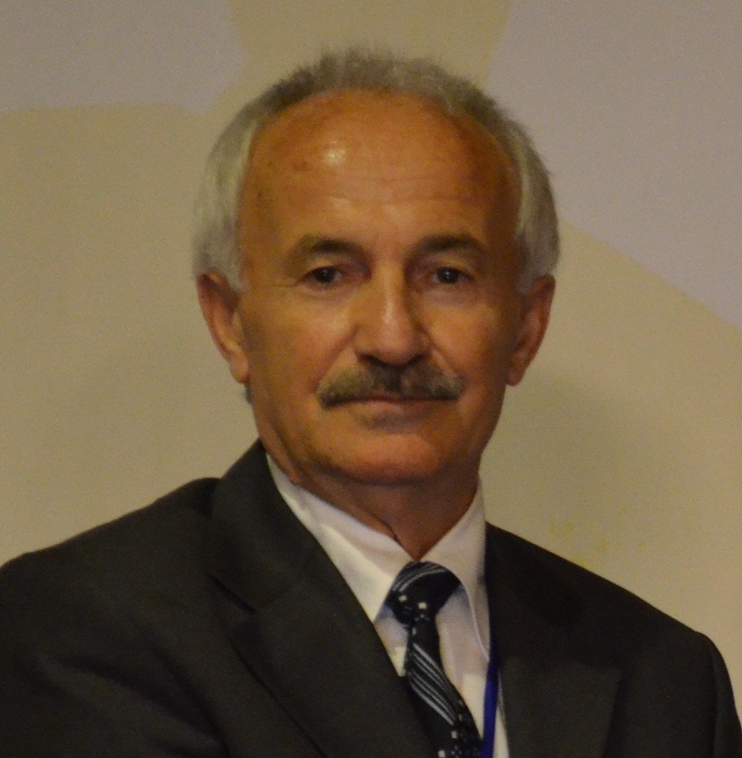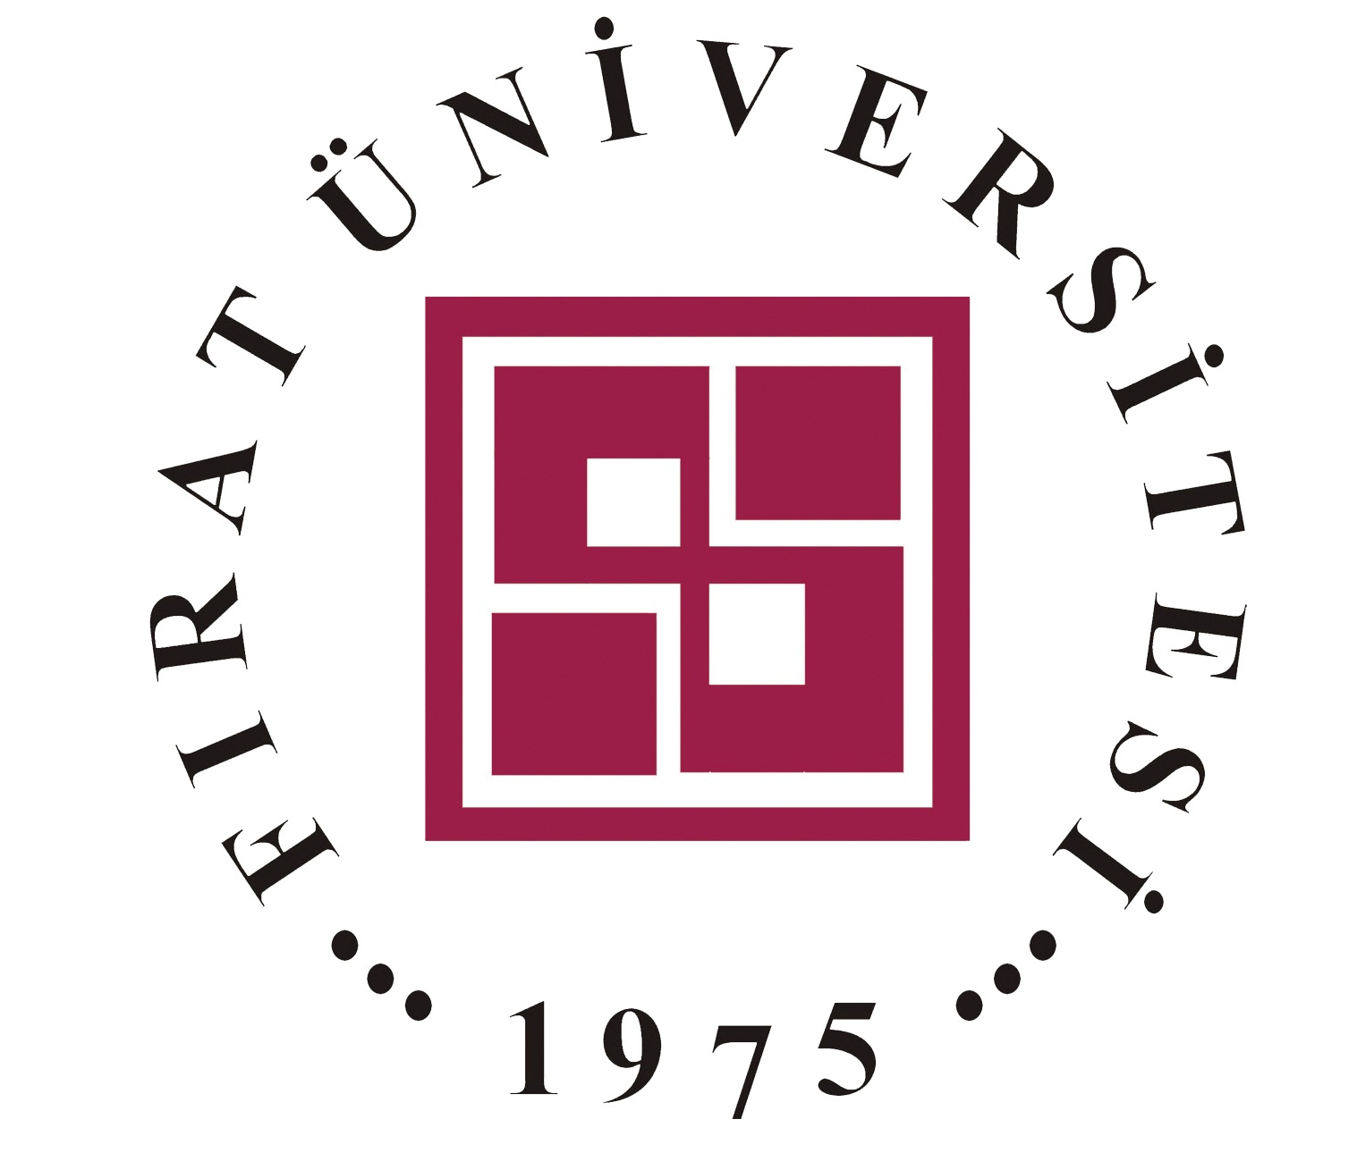
Physical Aspects of Shape Memory Effect and Reversibility in Shape Memory Alloys
Osman Adiguzel, Firat University, Department of Physics, 23169 Elazig, Turkey

Abstract
Shape memory alloys take place in a class of smart materials by exhibiting a peculiar property called shape memory effect. This property is characterized by the recoverability of two certain shapes of material at different temperatures. These materials are often called smart materials due to the functionality and their capacity of responding to changes in the environment. Shape memory materials are used as shape memory devices in many interdisciplinary fields such as medicine, bioengineering, metallurgy, building industry and many engineering fields.
Shape memory effect is performed thermally by heating and cooling after first cooling and stressing treatments, and this behavior is called thermoelasticity. Shape memory effect is based on a solid state phase transition, martensitic transformation, and this transformation is characterized by changes in the crystal structure of the material.
Shape memory effect is result of successive thermally and stress induced martensitic transformations. Shape memory alloys exhibit thermoelasticity and superelasticity by means of deformation in low temperature product phase and high temperature parent phase region, respectively. Superelasticity is another characteristic of shape memory alloys and performed by stressing and releasing the material in parent phase region.
Loading and unloading paths are different in stress strain diagram, and cycling loop reveals energy dissipation. The strain energy is stored after releasing, and these alloys are mainly used as deformation absorbent materials in control of civil structures subjected to seismic events, due to the absorbance of strain energy during any disaster or earthquake.
Thermal induced martensitic transformation is first order lattice-distorting phase transformations, and thermally occurs as martensite variants with cooperative movements of atoms by means of lattice invariant shear. Lattice invariant shears occur in two opposite directions, <110 > -type directions on the {110} - type planes of austenite matrix which is basal plane of martensite. Thermal induced martensite occurs as twinned martensite, and the twinned structures turn into the detwinned structures by means of stress induced martensitic transformation by stressing the material in the martensitic condition.
Copper based alloys exhibit this property in metastable β-phase region, which has bcc-based structures at high temperature parent phase field. Lattice invariant shear and twinning is not uniform in copper based ternary alloys and gives rise to the formation of complex layered structures, depending on the stacking sequences on the close-packed planes of the ordered parent phase lattice.
In the present contribution, x-ray diffraction and transmission electron microscopy (TEM) studies were carried out on two copper based CuAlMn and CuZnAl alloys. X-ray diffraction profiles and electron diffraction patterns reveal that both alloys exhibit super lattice reflections inherited from parent phase due to the displacive character of martensitic transformation. X-ray diffractograms taken in a long time interval show that diffraction angles and intensities of diffraction peaks change with the aging duration at room temperature. In particular, some of the successive peak pairs providing a special relation between Miller indices come close each other. This result refers to the rearrangement of atoms in diffusive manner.

Key words: Shape memory effect, martensitic transformation, superelasticity, twinning, detwinning and lattice invariant shear

Recent Publications
- O. Adiguzel, Phase Transitions and Microstructural Processes in Shape Memory Alloys, Materials Science Forum Vol. 762 (2013) pp 483-486, (2013) Trans Tech Publications, Switzerland
- O. Adiguzel, Nano-Scale Mechanisms in the Formation of Displacive Transitions in Shape Memory Alloys, http://adsabs.harvard.edu/cgi-bin/author_form?author=Adiguzel,+O&fullauthor=Adiguzel,%20O.&charset=UTF-8&db_key=PHYPhysics, Chemistry and Applications of Nanostructures - Proceedings of the International Conference Nanomeeting - 2013. Edited by Borisenko Victor E et al. Published by World Scientific Publishing Co. Pte. Ltd
- O. Adiguzel, Self-accommodating Nature of Martensite Formation in Shape Memory Alloys, Solid State Phenomena Vol. 213 (2014) pp 114-118, © (2014) Trans Tech Publications, Switzerland, doi:10.4028/www.scientific.net/SSP.213.114
- O. Adiguzel, Ageing dependence and martensite stabilization in copper based shape memory alloys, IOP Conf. Series: Materials Science and Engineering 60 (2014) 012001, Proceedings of International Symposium on Advanced Materials(ISAM2013), 23-27, September 2013, Islamabad, Pakistan
- O. Adiguzel, Nanoscale Aspects of Phase Transitions in Copper Based Shape Memory Alloys, Nanotechnology in the Security Systems, NATO Science for Peace and Security Series C: Environmental Security 2015, pp. 131-134
- O. Adiguzel, Phase Transitions and Elementary Processes in Shape Memory Alloys, Advanced Materials Research Vol. 1101 (2015) pp 124-128, Trans Tech Publications, Switzerland

Biography
Dr Adiguzel graduated from Department of Physics, Ankara University, Turkey in 1974 and received PhD- degree from Dicle University, Diyarbakir-Turkey. He has studied at Surrey University, Guildford, UK, as a post doctoral research scientist in 1986-1987, and studied on shape memory alloys. He worked as research assistant, 1975-80, at Dicle University and shifted to Firat University, Elazig, Turkey in 1980. He became professor in 1996, and he has already been working as professor. He published over 60 papers in international and national journals; He joined over 100 conferences and symposia in international and national level as participant, invited speaker or keynote speaker with contributions of oral or poster. He served the program chair or conference chair/co-chair in some of these activities. In particular, he joined in last five years (2014 - 2018) over 50 conferences as Keynote Speaker and Conference Co-Chair organized by different companies. He supervised 5 PhD- theses and 3 M.Sc- theses.
Dr. Adiguzel served his directorate of Graduate School of Natural and Applied Sciences, Firat University, in 1999-2004. He received a certificate awarded to him and his experimental group in recognition of significant contribution of 2 patterns to the Powder Diffraction File – Release 2000. The ICDD (International Centre for Diffraction Data) also appreciates cooperation of his group and interest in Powder Diffraction File.

Presenting author details
Osman Adiguzel
Firat University
Professor
Country: Turkey
Mobile number: +90 536 5638403
Email: oadiguzel@firat.edu.tr , oadiguzel@hotmail.com
Track number: Materials Sciences and Engineering
Category: Keynote
Research interest: Shape memory effect and displacive phase transformations in shape memory alloys and other alloys, molecular dynamics simulations, alloy modeling, electron microscopy, x-ray diffraction and crystallography.

