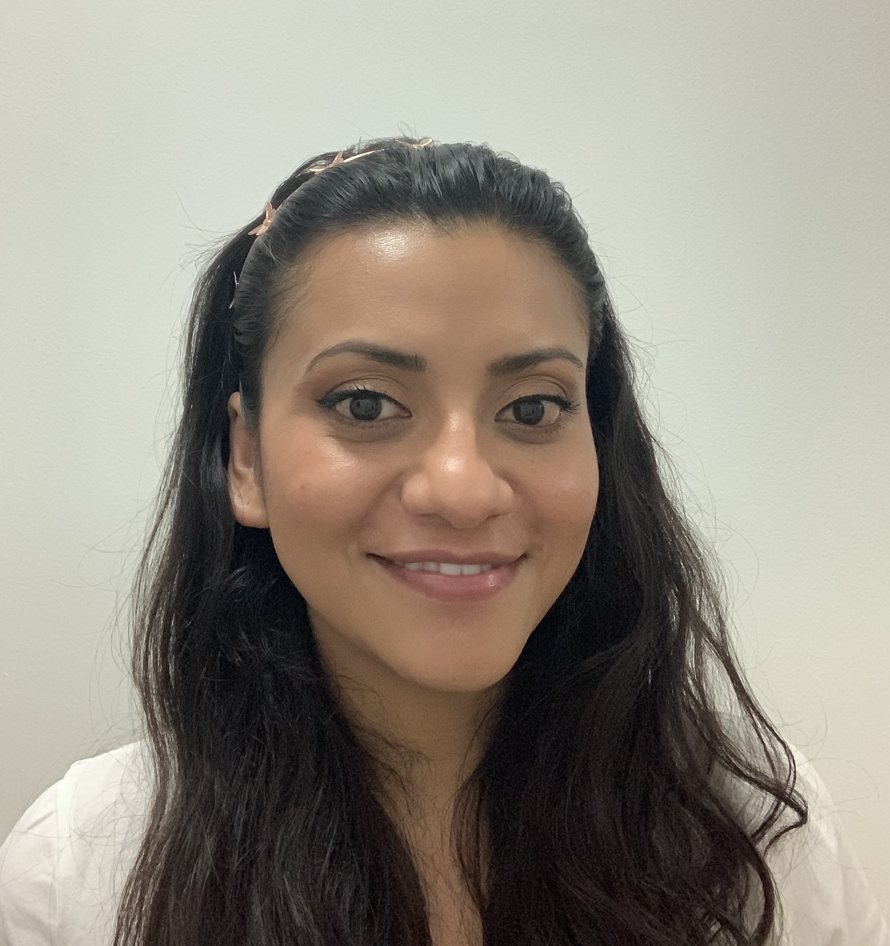
Title: Influence of Land Use on Stream Water Quality and Microbial Communities in the Panama Canal Watershed

Name: Karina A. Chavarria
Smithsonian Tropical Research Institute

The widespread and increasing occurrence of urbanization, agriculture, pasture conversion and deforestation, among others, represent a real threat to the conservation of lotic ecosystems and water quality. Different land cover/use can significantly impact the physical, chemical and bacteriological properties and dynamics of stream ecosystems. A better understanding of how land use can influence the ways in which microbes move through tropical watersheds is essential for implementing best practices for managing microbial contaminants in freshwater systems, such as through buffer zones along streams. This talk will focus on work being carried out at the Smithsonian Tropical Research Institute to: 1) characterize taxonomic and functional profiles of microbial communities of surface waters in parts of the Panama Canal Watershed that are influenced by different land uses, including mature and secondary forests, traditional pastures and silvopastures; 2) evaluate potential associations among microbial taxa and various environmental and land use factors; and 3) characterize long-term spatial and temporal changes in water quality. We aim to determine if microbial communities, as characterized with 16S rDNA metabarcoding, can serve as a bioindicator of stream health.

Biography
Karina is a postdoctoral fellow at the Smithsonian Tropical Research Institute in Panama. She completed her bachelor’s degree in civil and environmental engineering at the University of California Los Angeles and her PhD at the University of California, Berkeley. Her work focuses on microbial communities in drinking water and water resources in Latina America and the Caribbean. Her research interests include the effects of intermittent water supply on drinking water microbiomes and water source protection.

PI: Dr. Kristin Saltonstall
Presenting author details
Full name: Karina A. Chavarria
Contact information: kari07cha@gmail.com
Session name/ number: Environmental Microbiology (soil & water microbiology)
Category: Oral presentation

