Environmental stress responses in lactic acid bacteria strains isolated from traditional Romanian fermented products
Stefana M. Petrut, Ph.D student, University of Bucharest, Faculty of Biology, Department of Genetics, Aleea Portocalelor no. 1-3, 060101 Bucharest, Romania
Viorica M. Corbu, Ph.D student, University of Bucharest, Faculty of Biology, Department of Genetics, Aleea Portocalelor no. 1-3, 060101 Bucharest, Romania
Diana Pelinescu, Ph.D, Associate Professor, University of Bucharest, Faculty of Biology, Department of Genetics, Aleea Portocalelor no. 1-3, 060101 Bucharest, Romania
Ionela Sarbu, Ph.D, Lecturer, University of Bucharest, Faculty of Biology, Department of Genetics, Aleea Portocalelor no. 1-3, 060101 Bucharest, Romania
Tatiana E. Vassu-Dimov, Ph.D, Professor, University of Bucharest, Faculty of Biology, Department of Genetics, Aleea Portocalelor no. 1-3, 060101 Bucharest, Romania

Abstract
Statement of the Problem: Spontaneous fermentation has been applied for thousands of years especially as a method for food preservation. Lactic acid bacteria (LAB) are an important part of the microbiota of fermented food and beverages from all over the world due to their contribution to preservation of food and also for giving these products desirable textures and aromas.
When selecting strains for food fermentation, different aspects, including safety, functional and technological characteristics, have to be taken into consideration. Methodology & Theoretical Orientation:
The aim of the present study was to assess growth parameters profile in different environmental stress conditions of some LAB strains isolated from traditional Romanian fermented products.
In order to achieve the main objective of this study, the growth of 10 newly isolated LAB strains- previously characterized and taxonomically classified into Lactobacillus, Leuconostoc and Enterococcus genera, selected for their biotechnological potential- was evaluated in different stress conditions (low/ high initial pH, reduced/increased growth temperature or NaCl concentrations). Findings: During food industrial and biotechnological processes, LAB strains are exposed to different stress conditions and therefore, in order to resist to all these challenges, functional bacteria have developed different mechanisms of adaptation to this environment. Our data collected during this study revealed different responses of LAB strains to various types of stress factors. All analyzed strains grew well under their optimal conditions, except extreme parameters- very low pH or very increased temperature. Conclusion & Significance: The results of the present study revealed that the growth requirements of LAB strains are different and complex. The above-mentioned results concerning the capacity of LAB strains to adapt to stressful environmental conditions, helped us to select the best adaptative strains for further studies concerning the production of several metabolites important for food texture or health (exopolysaccharides or biologically active compounds).

Image
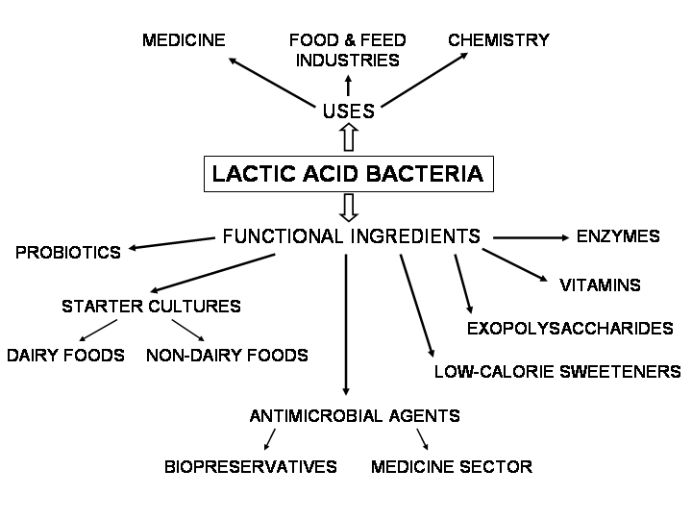
Figure 1: Roles of Lactic Acid Bacteria in food industry (Florou-Paneri et al., 2013)
Recent Publications
- Farahani Z., Rasooli I., Owlia P., (2017) Isolation, identification and characterization of indigenous lactic acid bacteria for flavor improvement. Int. Food Res. J., 24(1), 428- 436
- Florou-Paneri P., Christaki E., Bonos, E., (2013) Lactic acid bacteria as source of functional ingredients. In Lactic Acid Bacteria-R & D for Food, Health and Livestock Purposes. IntechOpen
- Khandelwal P., Bustos Gaspar F.B., Barreto Crespo M.T., Upendra R.S., (2016), Ch. 6, Lactic Acid Bacteria, in Fermented Foods. Part 1. Biochemistry and Biotechnology, D. Montet, R.C. Ray, eds., CRC Press, 413.
- Shangpliang H.N.J., Sharma S., Rai R., Tamang J.P. (2017) Some technological properties of lactic acid bacteria isolated from Dahi and Datshi, naturally fermented milk products of Bhutan. Front. Microbiol., 8, 116.
- Ștefan I.R., Cornea C.P., Grosu-Tudor S.S, Zamfir M., (2018) Physiological and metabolic responses of functional lactic acid bacteria to stress factors. AgroLife Scientific Journal, 7(2), 139-148.
- Tamang J.P., Watanabe K., Holzapfel W.H., (2016) Review: Diversity of Microorganisms in Global Fermented Foods and Beverages. Front. Microbiol. 7, 377

 Biography
Stefana M. Petrut is a PhD student in the Biology Doctoral School, University of Bucharest and she’s also currently working as a Research Assistant at MICROGEN Research Centre, Department of Genetics, Faculty of Biology, University of Bucharest. Her particular research interests concern Microbial Genetics, more specifically studies on lactic acid bacteria strains and their probiotic and biotechnological potential. The PhD thesis is focused on the complex characterization - biochemical, microbiological and molecular - of newly isolated lactic acid bacteria strains, from Romanian fermented products, as starter cultures in biotechnological processes and for their biosynthesis compounds, in order to improve the desired properties of food products and also to preserve these products natural and healthy. Many of the results obtained during her work in 4 national grants and 1 Research Stage at Sichuan University (Chengdu, China) have been published in scientific papers: 3 ISI Thomson Reuters scientific articles (1 as main author), 3 IDB journals (1 as main author) or presented in various conferences (13 participations- 7 as main author).
Email: stefana.petrut@gmail.com

Notes/Comments:

