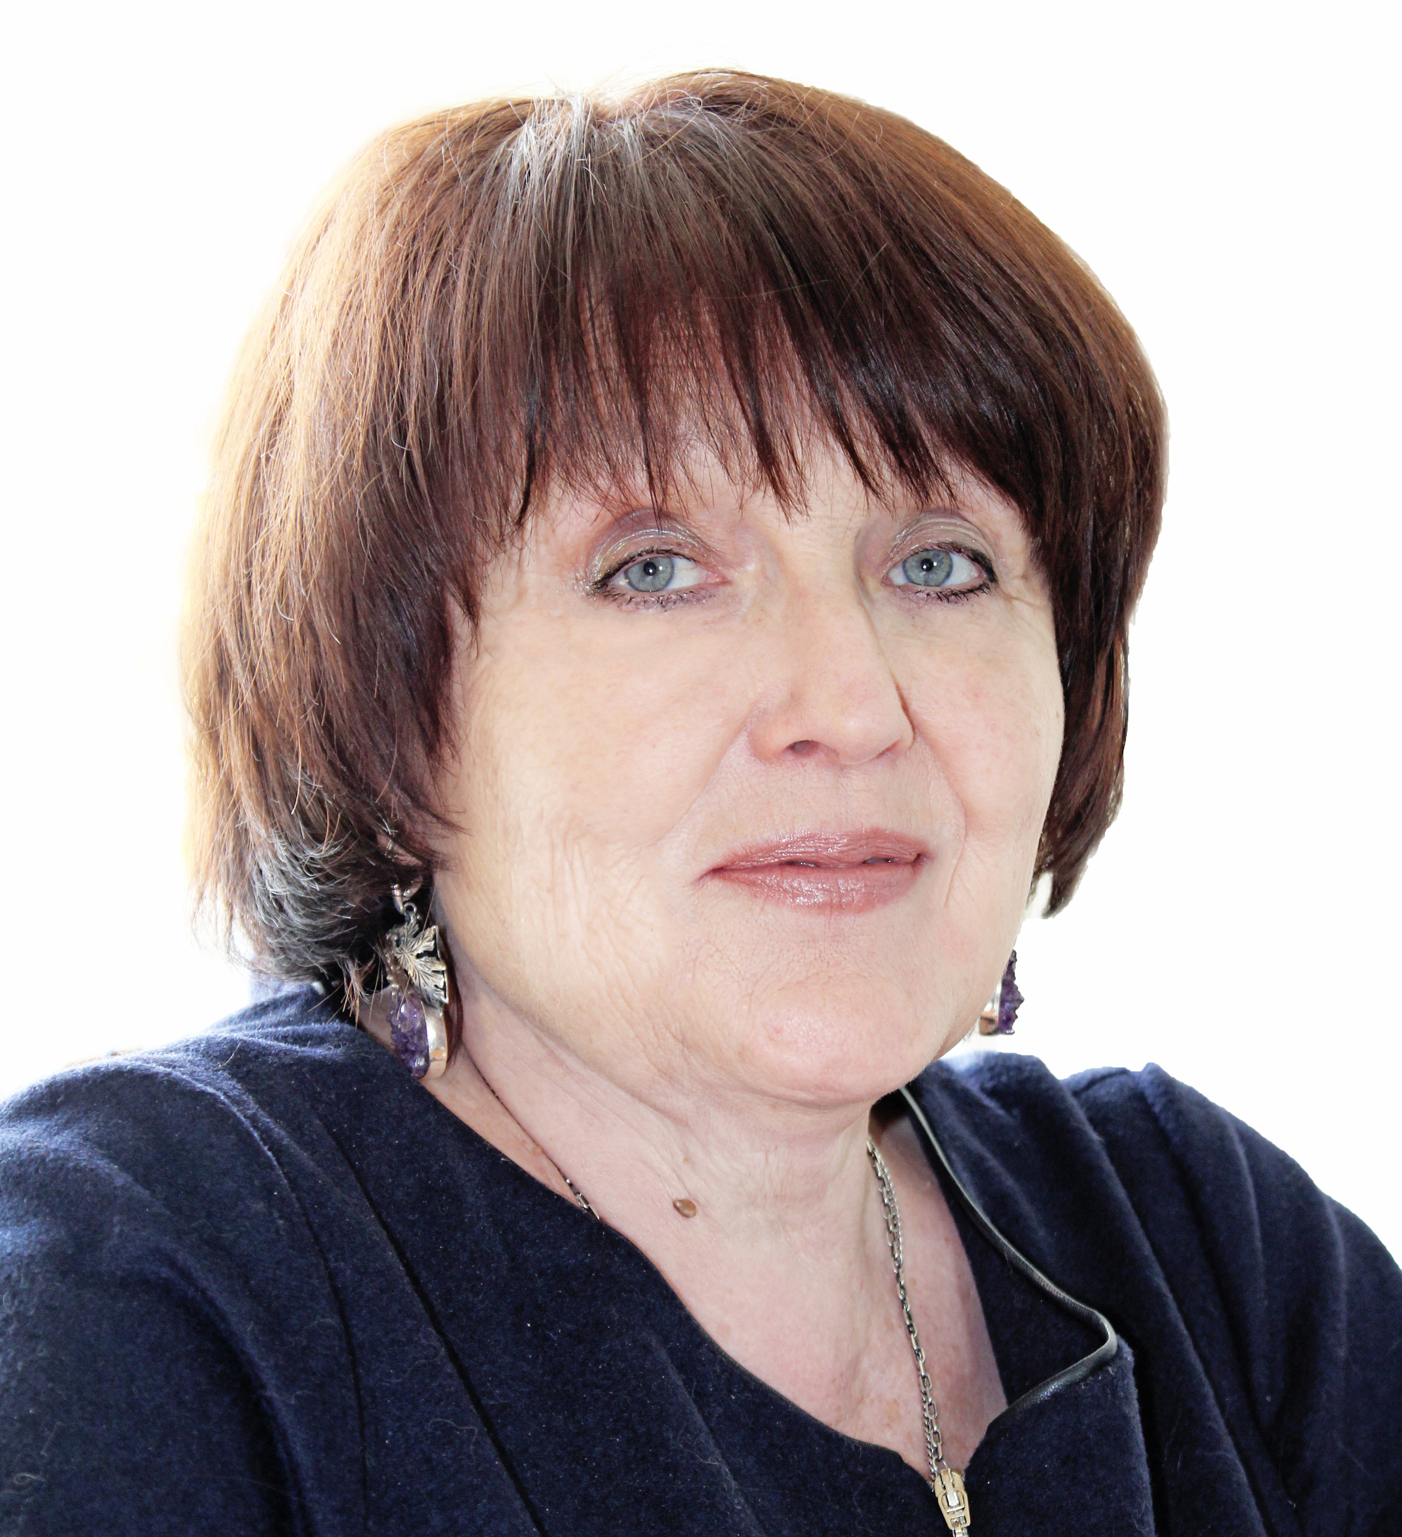
Title: Nitrogen-fixing and phosphate-solubilizing bacteria resistant to technogenic soil salinization
Aleschenkova Z., Naumovich N.
Institute of Microbiology, National Academy of Sciences, Minsk, 220141, Belarus

Potash mining region is a vivid example of techngenic soil salinization in Belarus. The daily salt particle precipitation is 100 g/ha (the annual discharges of potash excavation plant constitute approximately 600 t). Since excessive salt levels in soil are toxic for most plants, the use of halotolerant growth-promoting bacteria appears a promising method to withstand deleterious impact of technogenic salinization. 10 bacterial strains resistant to up to 12% sodium chloride concentration, distinguished by presence of nif H gene and nitrogenase activity plus 8 bacterial strains capable to transform calcium orthophosphate, forming 5-7 mm halo zones on glucose-asparagine agar and tolerating 15% NaCl levels were isolated from soil sampled around Belaruskali mines. Treatment of Lotus corniculatus seeds by nitrogen-fixing and phosphate-solubilizing bacteria in saline environment stimulated germination rate and increased length of seedlings by 7-20% as compared to the control. Introduction of haloresistant nitrogen-fixing and phosphate-solubilizing bacteria into rhizosphere caused favorable effect on population of agrovaluble microbial species and promoted growth and development of Lotus corniculatus in saline soil. Halotolerant isolates of nitrogen-fixing and phosphate-solubilizing bacteria are potentially attractive agents for application in phytoremediation of soils exposed to technogenic salinization.
Biography of Dr. Zinaida Aleschenkova:
Position - Head, laboratory of soil microorganisms - plants interactions, Institute of Microbiology, Belarus National Academy of Sciences
January 1988 - Ph.D. degree in Microbiology, January 2001 - Doctor of Biological Sciences title for the theses on microbial degradation of phthalate esters.
Scientific interests: soil microorganisms - plants interactions, phytoremediation of contaminated soil, development of microbial preparations stimulating growth of cultivars and decomposition of xenobiotics. She is the author of 300 publications and 18 patents. During the last 5 years she coordinated development of 5 microbial preparations promoting plant growth and contributing to environmental protection.

Presenting author details
Full name: Aleschenkova Zinaida
Contact number: +375 17 2659967
Session name/number: Soil Microbiology & Agricultural Microbiology
Category: Poster presentation

