Molecular biological analysis of 3D8 VL, a nucleic acid hydrolyzing recombinant antibody derivative

Yongjun Lee1, †, Seungchan Cho1, Dongjun Kim1, Eui-Joon Kil1, Kangsan Roh1, Sang-Ho Cho1, Sungrae Cho1, Hee-Seong Byun1, Haneul Seo1, He Jiang1, Hocheol Shin1, and Sukchan Lee1

1Dept. of Genetic Engineering, Sungkyunkwan University, Suwon, 440-746, Korea

Abstract

3D8 single chain variable fragment (scFv) is recombinant antibody. 3D8 scFv consists of variable heavy chain domains (VH) and variable light chain domains (VL) that linked by flexible peptide linker. 3D8 scFv was isolated from autoimmune-prone MRL-lpr/lpr mouse. It has DNase and RNase activities without significant sequence specificity. It internalizes by caveolae-mediated endocytosis and is accumulated in the cytosol. In previous studies, WT 3D8 scFv showed the antiviral effects against pseudorabies virus (PRV) and herpes simplex virus type 1 (HSV-1). Similar to WT 3D8 scFv, 3D8 VL could hydrolyzes DNA and RNA substrates and it also penetrates into cytoplasm. In this study, I compared the DNA and RNA hydrolyzing activity between 3D8 VL and WT 3D8 scFv. I measured the stability of 3D8 VL in a variety of pH ranges and temperatures by using FRET (Fluorescence resonance energy transfer) assay. I also confirmed the cell penetration activity into cytoplasm through the cell membrane and I demonstrated that 3D8 VL has no cytotoxic effect against host cell shown by WT 3D8 scFv (in vitro). 3D8 VL protein was detected in several organs (liver, lung and brain) and blood when I injected the protein to mouse through intraperitoneal injection. Using in vivo imaging, I confirmed that 3D8 scFv and VL could be absorbed into blood and then circulated to whole body, and finally they reached to several organs. The results indicate that 3D8 VL has similar biochemical and biological properties with WT 3D8 scFv. Taken together, 3D8 VL can be replace WT 3D8 scFv for a potent antiviral protein.

Image
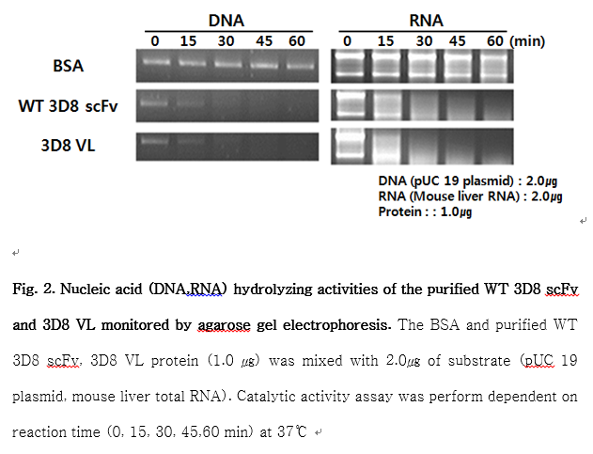
Recent Publications
- Lee, G., et al. (2015). "Therapeutic Strategy for the Prevention of Pseudorabies Virus Infection in C57BL/6 Mice by 3D8 scFv with Intrinsic Nuclease Activity." Molecules and cells 38(9): 773.
- Lee, G., et al. (2014). "A nucleic-acid hydrolyzing single chain antibody confers resistance to DNA virus infection in hela cells and C57BL/6 mice
- Jang, J., et al. (2009). "A nucleic acid-hydrolyzing antibody penetrates into cells via caveolae-mediated endocytosis, localizes in the cytosol and exhibits cytotoxicity." Cellular and molecular life sciences 66(11-12): 1985-1997

- Park, S. Y., et al. (2008). "Crystal structure of single‐domain VL of an anti‐DNA binding antibody 3D8 scFv and its active site revealed by complex structures of a small molecule and metals." Proteins: Structure, Function, and Bioinformatics 71(4): 2091-2096.
- Kim, Y.-R., et al. (2006). "Heavy and light chain variable single domains of an anti-DNA binding antibody hydrolyze both double-and single-stranded DNAs without sequence specificity." Journal of Biological Chemistry 281(22): 15287-15295.

 Biography
Yongjun Lee is graduate student in the course of Ph.D, in Sungkyunkwan University Korea republic. He received master degree in Sungkyunkwan university. He research about antiviral protein(3D8 scFv protein) using E.coli expression systems. Using this protein, he would like to see the universal antiviral effect on non-specific various viruses. He is also studying the proteins transport through Blood brain barriers. Through various conference he want to study about stable and effective protein expression method using various microorganisms.
Email: 88yjl11@naver.com

Notes/Comments

