Existence of Odd-Even Effect in Symmetrical Chiral Liquid Crystal Dimers Containing Terminal Vinyl Group and Ester Linked Biphenyl-Naphthyl Mesogenic Cores
Lakshmi C. Kasi Viswanath PhD, Oklahoma Baptist University, USA

Abstract (300 word limit)
A series of symmetrical chiral, liquid crystal dimeric molecules possessing ester-linked, biphenyl-naphthyl cores with varied spacer lengths and terminal vinyl groups have been synthesized. (S)-(+)-2-(6-Methoxy-2-naphthyl)propionic acid was used as the synthetic precursor to achieve the target dimers. The synthesized symmetrical chiral dimers were characterized by ¹H NMR spectroscopy, and their liquid crystalline behavior was confirmed by DSC and HOPM studies. Structural effects on the mesomorphic and physicochemical properties were investigated in terms of variation of chiral chain length. The synthesized dimeric compounds exhibited SmX*, SmC*, SmA*, N*, BP_{I}*, and BP_{II}* mesophase sequences. An odd-even effect was observed in which the dimers with an even number of spacers generated SmX*, SmC*, SmA*, N*, BP_{I}*, and BP_{II}* phases whereas dimers with an odd spacers exhibited SmX*, SmA*, N*, BP_{I}*, and BP_{II}* phases, and the duration of the mesophase decreased with increasing spacer length. The differences in transitional properties for odd- and even-numbered dimers could be attributed to the difference in conformation of the molecules of the liquid crystalline dimers. When the number of methylene units in the bridging chain (spacer) is odd, then the spacer will be in its cis conformation, which causes the two aromatic units to be tilted in the same direction with respect to eachother (Fig. 1A). In the even membered dimers since the aromatic units are tilted in the opposite directions, a bent structure is produced which when packed with other dimers together will lead to a zig-zag layer-like structure. In general, the trans conformation (Fig. 1B) always leads to layer regularity and promotes the crystal-crystal polymorphism. This kind of layer formation may assist the formation of SmC* phase. However, the cis conformation destroys the regularity and as well as the polymorphism in the liquid crystal melt.
The synthesized vinyl substituted liquid crystalline dimers are particularly useful in understanding liquid crystal polymorphism and act as model compounds for liquid crystal polymers.

Image

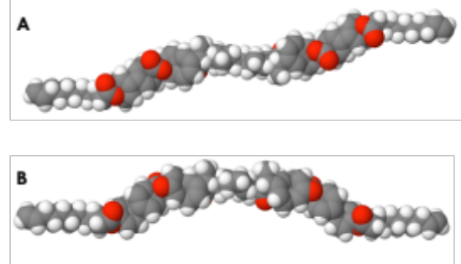

Figure 1: (A) Trans- Conformation of odd spaced dimer
(B) Cis-Conformation of even spacer dimer

Recent Publications
- Viswanath, L. C. K., Bernhardt, J., Gnanasekaran, KK., Want, C., Frank, J., Faulkner, J., Sadagopan, K. (2016). Alkyl- and Aryl-Substituted Benzo[ghi]perylenetriimides: Synthesis, Characterization and Comparison of Electrochemical and Spectroscopic Properties. Dyes and Pigments, 134, 453-458.
- Viswanath, L. C. K., Shirtcliff, L. D., Krishnan, S., & Berlin, K. D. (2015). SubPc-ZnPorphyrin conjugates–Synthesis, characterization and properties. Dyes and Pigments, 112, 283-289.
- Viswanath, L. C. K., Shirtcliff, L. D., Krishnan, S., Handa, N. V., & Berlin, K. D. (2014). Synthesis, photophysical and electrochemical properties of bay-axial perylene diimide–subphthalocyanine dyads. Tetrahedron Letters, 55(30), 4199-4202.
- Viswanath, L. C. K., Shirtcliff, L. D., & Berlin, K. D. (2013). Synthesis of symmetrical and unsymmetrical subphthalocyanine dimers containing a hydroquinone bridge. Journal of Porphyrins and Phthalocyanines, 17(12), 1167-1172.
- Vinay R. Patel, Gerard G. Dumancas, Viswanath, L. C. K., Randall Maples, Bryan John J. Subong. Castor Oil: Properties, uses and optimization of processing parameters in commercial production. Lipid Insights. 2016:9 1-12.

Biography
Dr. Lakshmi C. Kasi Viswanath is currently working as an assistant professor at Oklahoma Baptist University. Her research focus lies on supramolecules,development of donor acceptor conjugates for organic solar cells and light harvesting systems. She has published many articles in international journals including a book chapter. She also serves as a reviewer for reputed journals and also a member of editorial board. She actively participates in ACS conferences.
Email: lakshmi.viswanath@okbu.edu.

Notes/Comments:

