Development of in-silico platform for TEM β-lactamase variants and prediction of newly emerging TEM variants using Machine Learning approach
Muskaan Bhambri, B.Tech. Biotechnology,
Indian Institute of Technology Roorkee
Saugata Hazra, Assistant Professor,
Indian Institute of Technology Roorkee

Abstract
“The world is heading towards a post-antibiotic era in which common infections and minor injuries, which have been treatable for decades can once again kill.” Antibiotic Resistance is the ability of the bacteria to become resistant to the effects of antibiotics that could once successfully treat them. β-lactam antibiotics constitute a significant class of antibiotics extensively used for antibacterial therapy. Because of their widespread usage, the antibiotic resistance to these antibiotics is growing. The most common mechanism for resistance against them is the bacterial production of β-lactamase enzymes. TEM β-lactamase, a class A β-lactamase, is one of the earliest β-lactamases to appear in the early 1960s. In this study, an in-detailed analysis of TEM is performed using various in-silico techniques. 478 existing mutants of TEM were studied, and sequence, structure, docking, mutational and molecular simulation studies were performed on all these variants. This study includes sequence collection and generation of a non-redundant database of TEM sequences. Sequence and structure analysis was performed, and amino acid frequencies at each position were calculated to know the conservation pattern that includes active site residues, secondary structure, and conserved folds. An automated modelling pipeline was developed to model the unknown structures of TEM. An automated docking pipeline was developed to dock these 478 structures with four classes of drugs; namely, penicillins, cephalosporins, carbapenems and mechanism-based inhibitors (MBIs) each. Binding energy calculation and pose rank predictions were done for the docked structures. The mutational landscape of the enzyme was studied, and a structure-function correlation was developed. The dynamic characterisation of the enzyme was performed using Molecular Dynamics Simulation. Structure, interaction and dynamic data would be utilised towards the development of salient features which would be extremely helpful in proposing models for further emergence of new drug-resistance using machine learning tools. Together, this study provides a holistic picture of TEM β-lactamase which provides a common platform of understanding for people from various fields, be it microbiologists, drug designers, structural biologists or biochemists.

Image
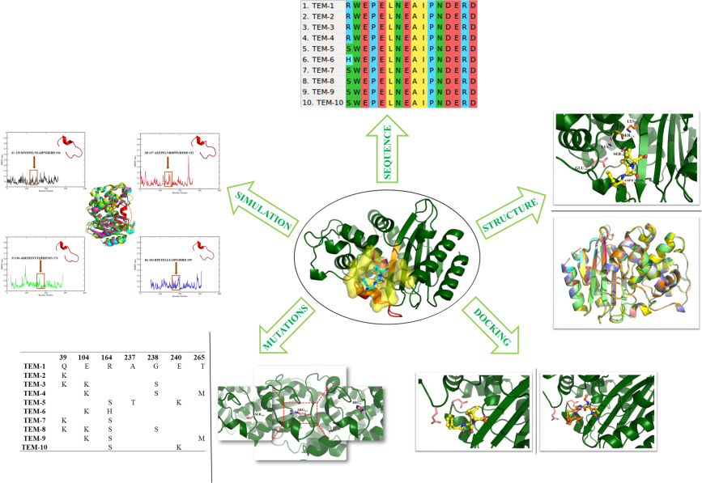
In-silico analysis of TEM β-lactamase: a.) Multiple Sequence Alignment of the first ten variants b.) Active site catalytic residues (primary in pink and secondary in orange) and ampicillin drug (in yellow); Structure alignment of first ten variants c.) Ampicillin (in yellow) and Cephotaxime (in orange) docked in TEM-1 d.) Mutant analysis of the first ten variants e.) Simulation data of the omega-loop region present in different organisms.

 Muskaan Bhambri
Muskaan Bhambri is a pre-final year undergraduate student pursuing her B.Tech. in Biotechnology at the prestigious Indian Institute of Technology Roorkee. She is interested in the field of antimicrobial resistance and the use of computational biology and structural bioinformatics to come up with novel solutions to this emerging global problem. She has taken up various projects on antimicrobial resistance in her institute and has been doing research in this field for over two years now. Her work focusses on β-lactamase based drug-resistance. She has also been a part of several conferences held on antimicrobial resistance and has presented her work there.

Muskaan Bhambri
Tel: +91-7011859656
Category: Poster presentation
Email: bhambrimuskaan@gmail.com, mbhambri@bt.iitr.ac.in

Notes/Comments:

