The Comparison of ica AD Genes in Methicillin resistant staphylococcus aureus (MRSA) Biofilm Producing Between Healthcare Workers in Hospital and General Population in Banyumas District, Indonesia
Gembong Satria Mahardhika. Jenderal Soedirman University. Indonesia

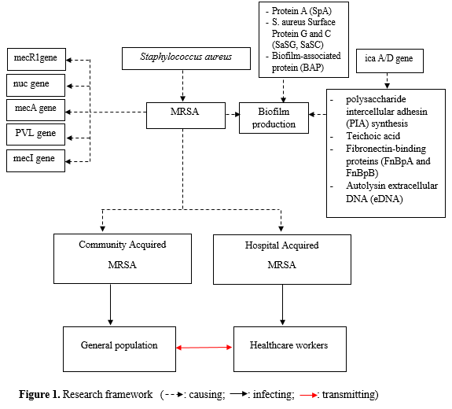
Abstract (300 word limit)
The emergence of strains of bacteria that are resistant to many antibiotics including Staphylococcus aureus bacteria, is a serious problem, moreover it is supported by the ability of these bacteria to form biofilms, causing antimicrobial agents and immune system responses are not effective in eliminating biofilm cells. The aim of this study is to understand the comparison of ica A/D genes in MRSA producing biofilms between health workers in hospitals and the general population in Banyumas.This study is a cross sectional study aimed at describing the ica A/D gene in biofilm-producing MRSA among health workers in TK Wijayakusuma Hospital compared to the general population in Banyumas. Samples were taken using the nasal swab method. Microbiological examination was carried out to identify MRSA strains. Biofilm identification uses a microtiter plate biofilm assay, after that it detects the ica A/D genes. A number of 120 samples were examined, one sample (0.008%) showed MRSA results and 6 samples (0.05%) showed MSSA results. A number of 7 samples were examined for biofilm showing one sample with moderate biofilm results, 2 weak biofilm samples, 4 non biofilm samples. Examination of ica A/D gene was performed on 3 samples that showed moderate biofilm and weak biofilm results. The results in 3 samples showed positive ica A/D gene results. Comparison between ica A/D genes in health workers in hospitals with the general population cannot be done, because MRSA samples are only found in the health care group in hospitals. The conclusion from this study is there was no difference in the ica A/D gene in MRSA producing biofilms between health workers in the hospital compared to the general population in Banyumas district, because only one MRSA sample was found, that was in the group of health workers

Image

Recent Publications
- Anjarwati, D.U., Rujito L (2011). Health Nurse as a career of methicillin resistant staphylococcus aureus (MRSA) in government hospitals and private hospitals in Banyumas regency. Mandala of Health. Volume 5 no 1.
- Clinical and Laboratory Standards Institute (CLSI). (2019). Performance Standards for Antimicrobial Susceptibility Testing. Clinical and Laboratory Standards Institute : 29th edition. USA
- Hassan, A., Usman, J., Kaleem, F., Omair, M., Khalid, A. and Iqbal, M. (2011). Evaluation of different detection methods of biofilm formation in the clinical isolates. Brazilian Journal of Infectious Diseases. Vol 15: 305-311.
- Kenneth JR, Ahmad Nafees, Alspaugh J Andrew, Drew W Lawrence, et al. (2018). Sherris Medical Microbiology. New York : McGraw Hill Education.
- Amirmorteza Ebrahimzadeh Namvar, Babak Asghari, Fatemeh Ezzatifar, Gholamreza Azizi, and Abdolaziz Rastegar Lari. (2013). Detection of the intercellular adhesion gene cluster (ica) in clinical Staphylococcus aureus isolates. German Medical Science Hygiene Infection Control. Vol 8:1-4



 Biography
Gembong Satria Mahardhika has done some researches on antibiotic resistance and its development while finishing his master degree. Being able to experience life in Asia, he is quite familiar with tropical medicine and it made him interested on that as well as infectious disease and any other internal medicine. His passion and dedication towards healthcare and education has made him fully committed on engaging his fellow doctors and junior on understanding human better. He is enthusiast on continuing his journey for medical research and pursuing further education
Gembong Satria Mahardhika
Tel: +6287837371515
Session Name/Number
Category: (Oral presentation)
Email: mahardhika.gembong@gmail.com

Notes/Comments:

